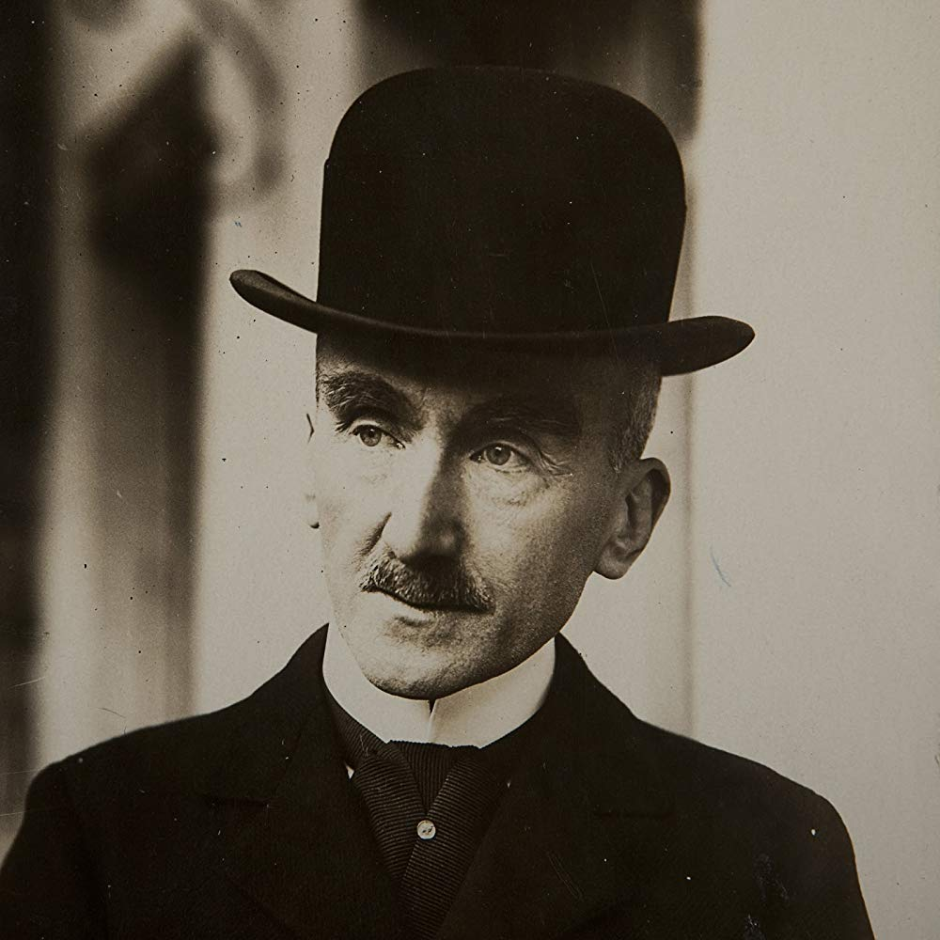
SUMMER 2019
Charles University
Department of Philosophy and Religious Studies
(BA Module + Erasmus students)

Daniele De Santis, Ph. D.

H. Bergson, Matière et mémoire. Essai sur la relation du corps à l’esprit
(Matter and Memory. An Essay on the Relation Between Body and Mind) (1896)

• The Possibility of Perception and is Structure

One of Bergson’s Central Theses:
The Qualitative Distinction between (Pure) Perception and (Pure) Memory

“The capiral error, the errot which, passing over from psychology into metaphysics, shuts us out in the end from the knowledge both of body and spirit, is that which sees only a difference of intensity instead of a difference of nature, between pure perception and memory” (67)

- What is pure perception?
- What is pure memory?
- What does “pure” actually mean?

Pure Perception (or Impersonal Perception)

“By this I mean a percepion which exists in theory rather than in fact and would be possesed by a being palced where I am, living as I live, be absorbed in the present and capable, by giving up every form of memory, of obtaining a vision of matter both immediate and instantaneous. Adoping this hypothesis, let us consider how conscious perception may be explained” (34-35)

What are we making abstraction from?

“However brief we suppose any perception to be, it always occupies a certain duration, and involves, consequently, an effort of memory which prolongs (qui prolonge), one into another, a plurality of moments. As we shall endevour to show, even the subjectivity of sensible qualities consists above all else in a kind of contraction of the real (contraction du réel), effected by our memory. In shory, memory in these two forms, covering as it does with the cloak of recollections a core of immediate perception (un fond de perception immédiate), and also contracting a number of external moments into a single internal moment, constitutes the principal share of individual consciousnes in perception, the subjective side of the knowledge of things (le côté subjectif de notre connaissance des choses) (34)

- MEMORY = (a) It constitutes the subjective side of consciousness in perception
(b) Double function:
(b’) Prolongation
(b’’) Contraction

- PURE PERCEPTION = (¬a) Impersonal
(¬b’) Instantaneous
(¬b’’) Immediate

How does pure perception take place? Or, What does it mean for an image to be perceived?

“It is true that an image may be without be without being perceived (it may be without being represented) and the distance between these two terms, presnce and representation, seems just to mesure the inerval between matter itself and our conscious perception of matter. (…) If there were more in the second term than in the first, if, in order to pass from presence to representation, it were necessary to add something, the barrier would be insuperable, and the passage from matter to perception would remain wrapped in impenetrable mystery”

“It would not be the same if it were possible to pass from the first term to the second by way of diminution, and if the representation of an image were less than its presence; for, it would suffice that the image present should be compelled to abandon something of themselves in order that their mere presence should convert into representation”

Pages 36-37 Perception = (i) It characterizes living beings as “centers of indetermination
(ii) It is virtual (vituality to actuality)
(iii) It consists in obscuring some of the object’s aspects that are of no interest whatsoever

The presence of such centers of indermination is equivalent to iii

t’

Direction of Interest

t’

“The reality of matter consists in the totality of its elements and their actions of every kind. Our representation of matter is the measure of our possible action upon bodies: it results from the discarding of what has no interest for our needs” (38)

“when we consider any other given place in the universe, we can regard the action of all matter as passing through it without resistance and without loss (…). Our zones of indetermination play in some sort the part of the screen. They add nothing to what is there” (39)

Matter
(Totality of Center of Indetermination
Images) Volition /Action
Obscuration

Perception

What interets us

“perception as a whole has its true and final explanation
in the tendency of the body to movement” (45)

Characterization of the “body” and the “person” (pages 47-47)

Body: the center of perceptions
Person: that to which these actions are referred

- “Our perception (…) is dissevered by the multiplicity of our needs”

• The Role of “Affections”

A necessary ingredient of perception (which hence is never really pure)

“There is then, in this aggregate of images, a privileged image, perceived in its depths and no longer only on the surface: the seat of affection and, at the same time, the source of action. It is the particular image which I adopt as the center of my universe and as the physical basis of my personality” (61)

