E-Learning Support Material for the Students of Medical Informatics
Electronic Information Resources
1. Web Portal of the Institute of Scientific Information
Website: https://uvi.lf1.cuni.cz/en/
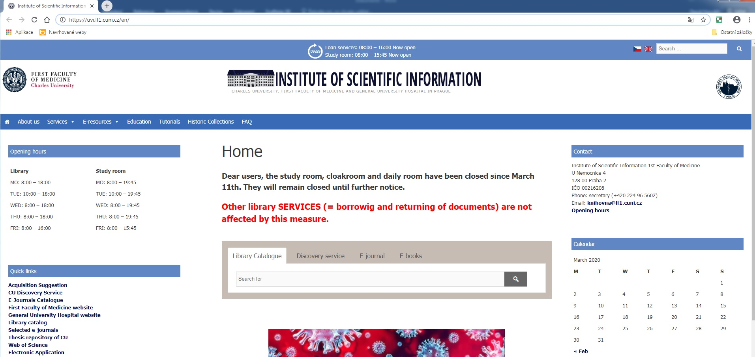
This website helps students find relevant information in electronic information resources
of the 1st Faculty of Medicine (1 FM). Section “E-Resources” is divided into several categories, such as Databases, E-journals, E-books, Citation managers, Digital library.
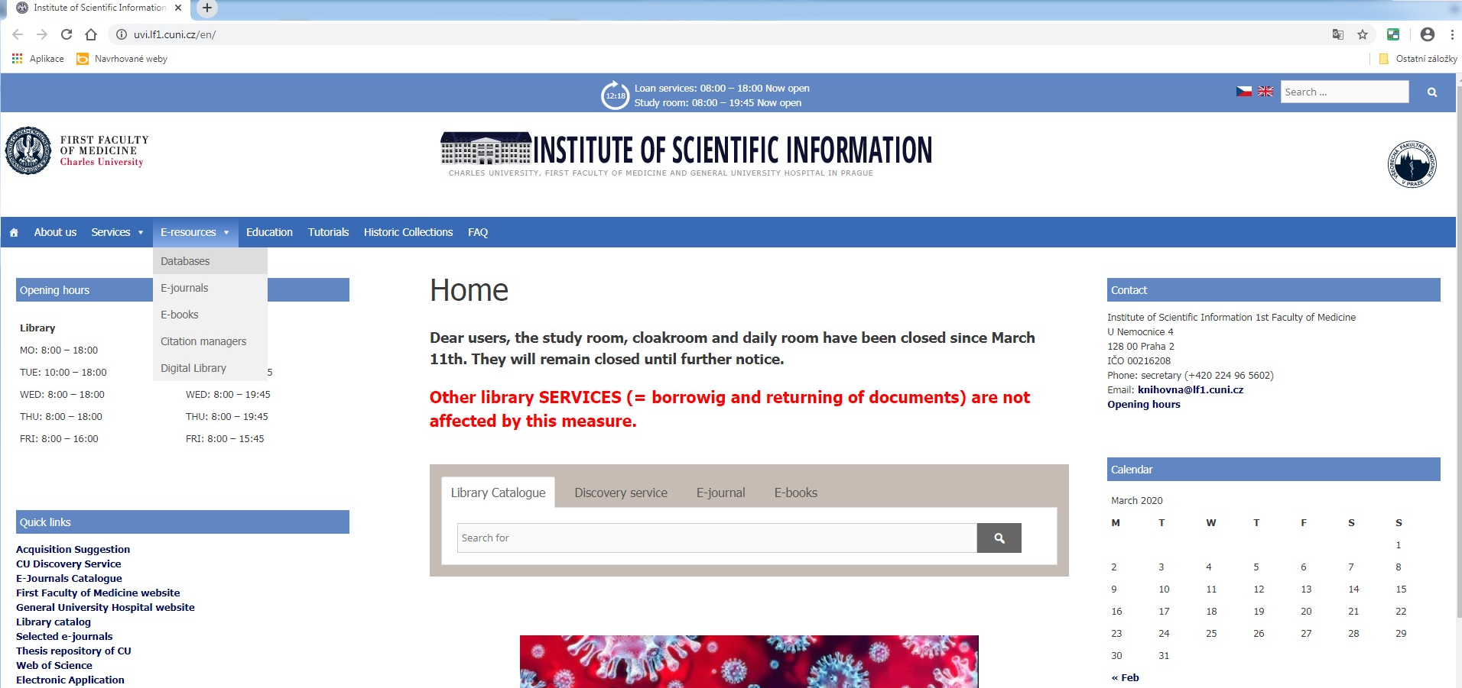
The most useful is section “Databases”. This section offers access into medical databases
and general interest databases. In these databases, you can find the most relevant articles for your assignments, self-study, etc.
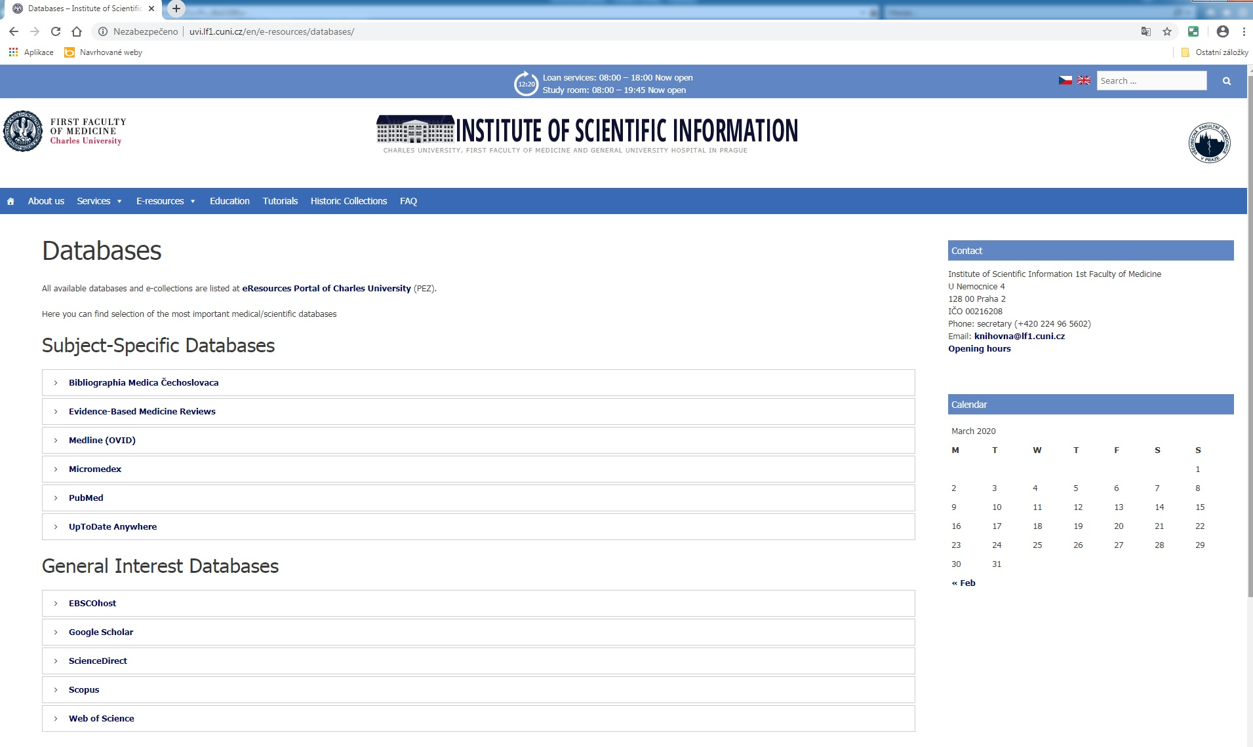
In order to find the articles, it is necessary to understand how database interfaces work. You can start search in well-known Medline database which is used both for preclinical and clinical studies. Medline, a commercial database, is the part of PubMed interface, which is
an American public interface. When looking for full texts of the articles at home, use
the remote access.
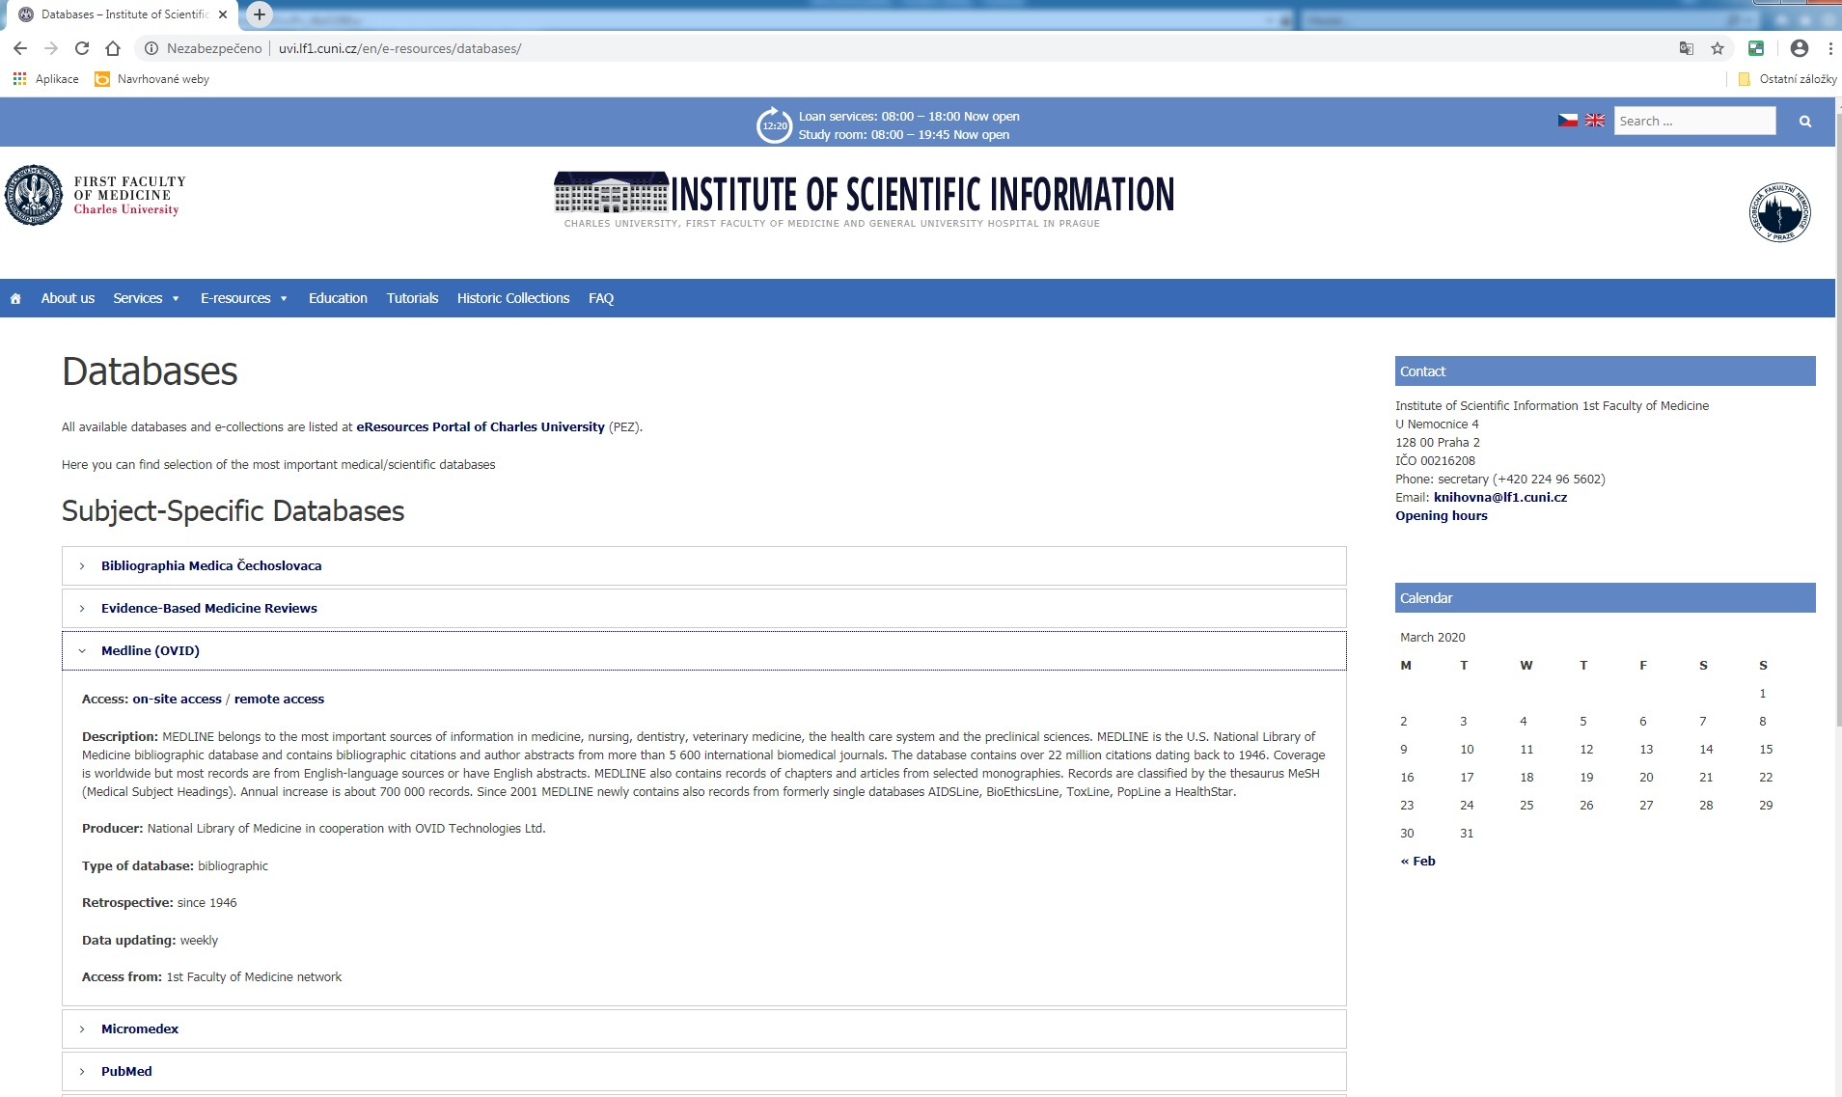
Then, you will be redirected to CAS – Central Authentication Service – where you will type
the same username and password that you usually use for login into SIS – Student Information System.
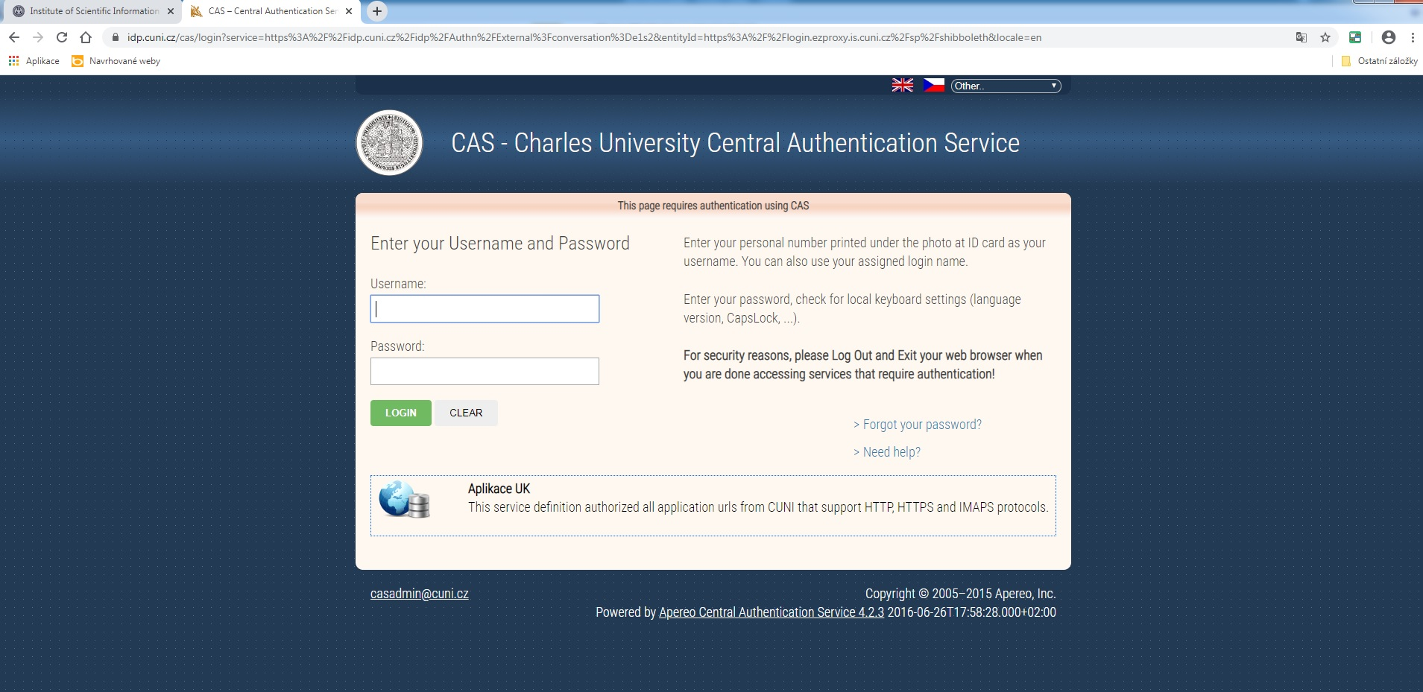
After that, you can start working with the database. There is Basic Search section – it used only to search for basic information.
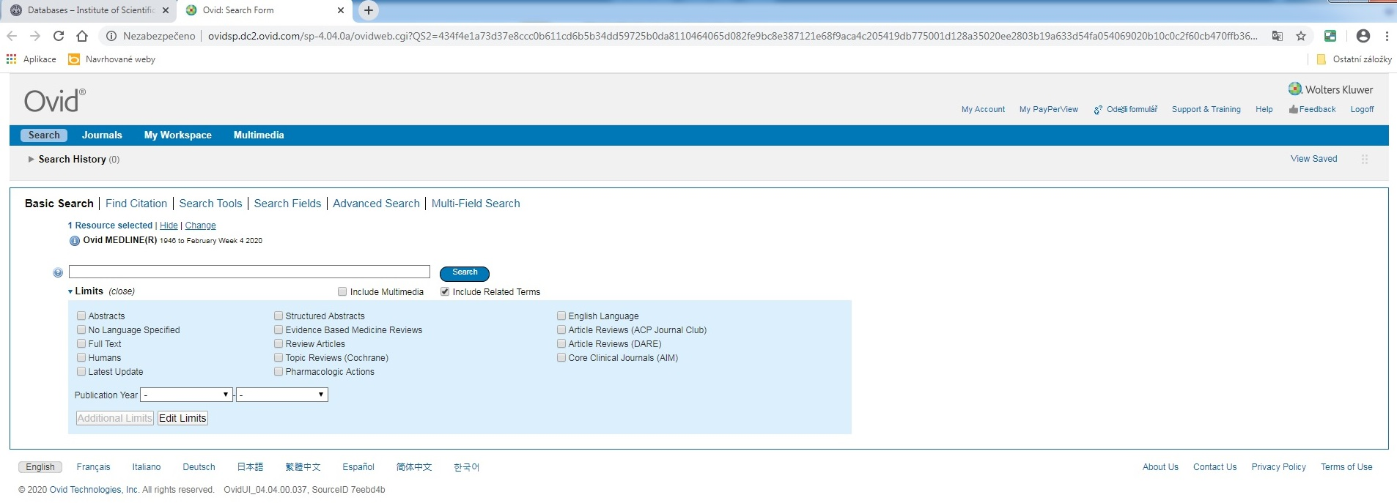
More specific is Multi-Field Search section – this section helps you find relevant articles
by combining different keywords, e.g. “internal carotid artery occlusion” and “surgery”. You can combine the keywords with different Boolean operators – AND, OR, and NOT. AND is used when both keywords are considered, OR when the first keyword or the second keyword is considered, or both keywords are considered, NOT when the second keyword is not considered. You can get less results, but more specific, when using AND in “Abstract field”.

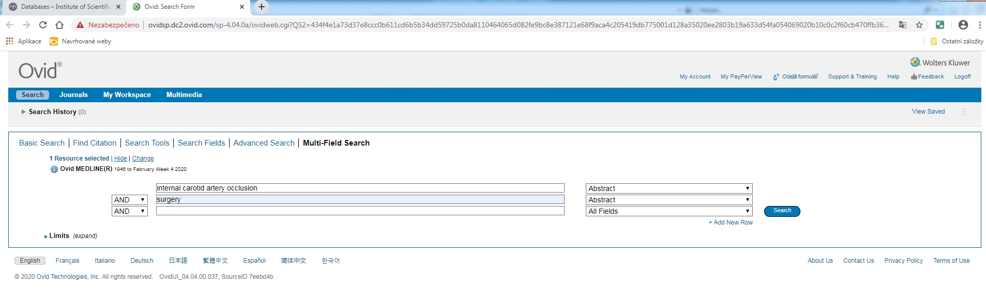
Click on “Search” button and you will get the results. You can also limit your results by using filters (Years, Subject, Author, Journal, Publication Type) on the left side.
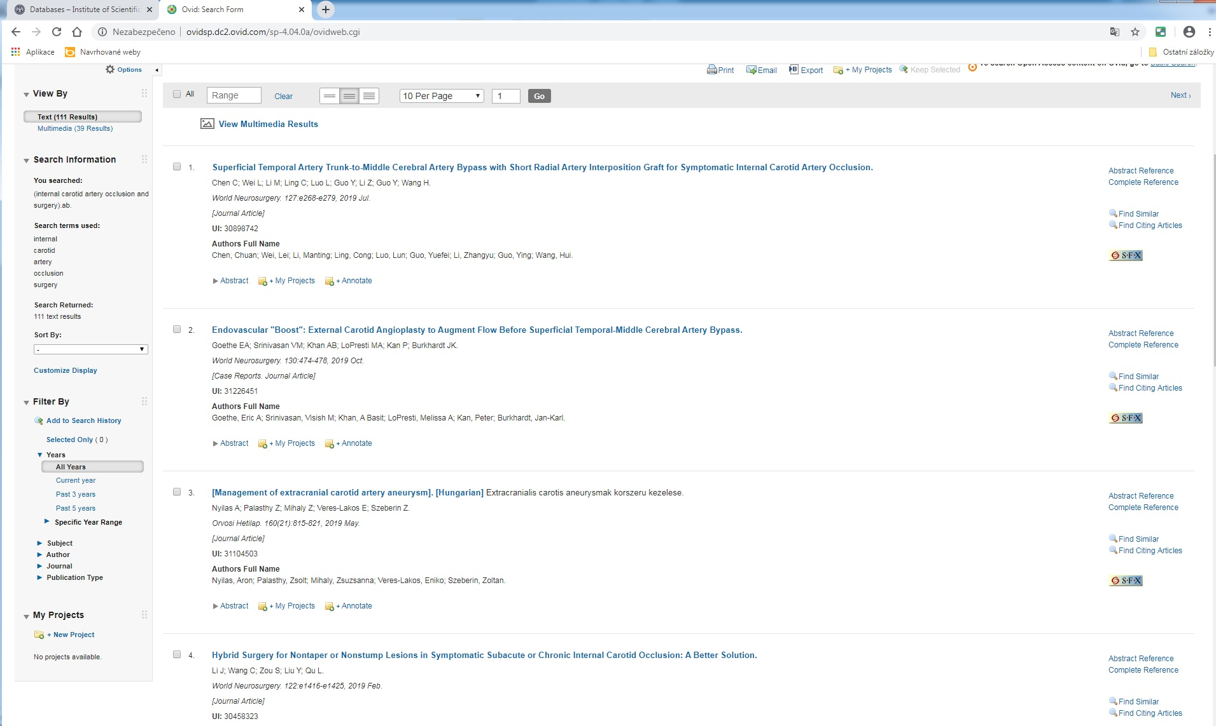
Or you can choose the articles by clicking on the blank square next to the number
of the article.
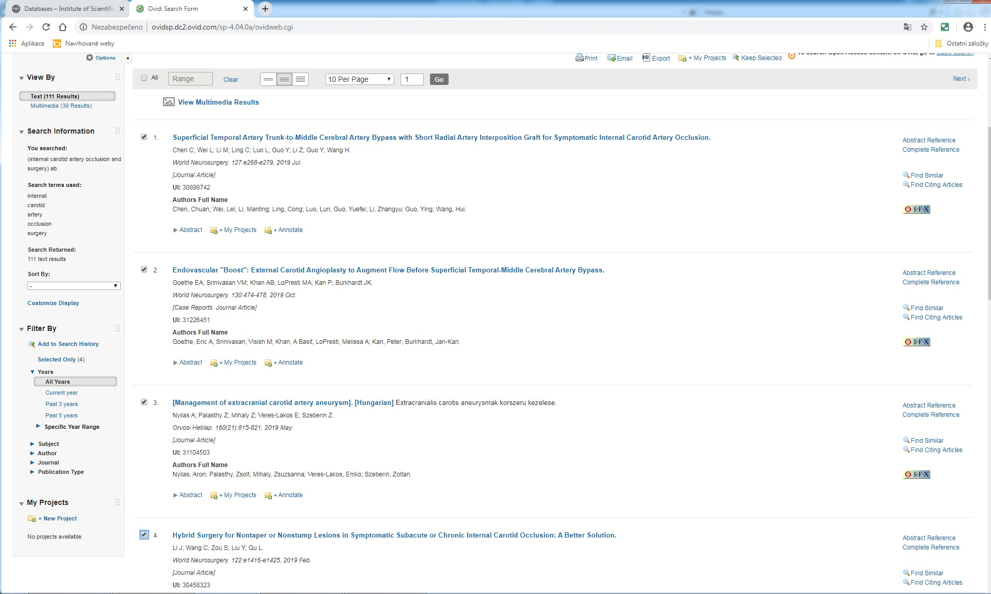
For exporting bibliographic records into Word Microsoft Office, click on the “Export” section in the top right bar. You can export the records into different formats or citation styles.
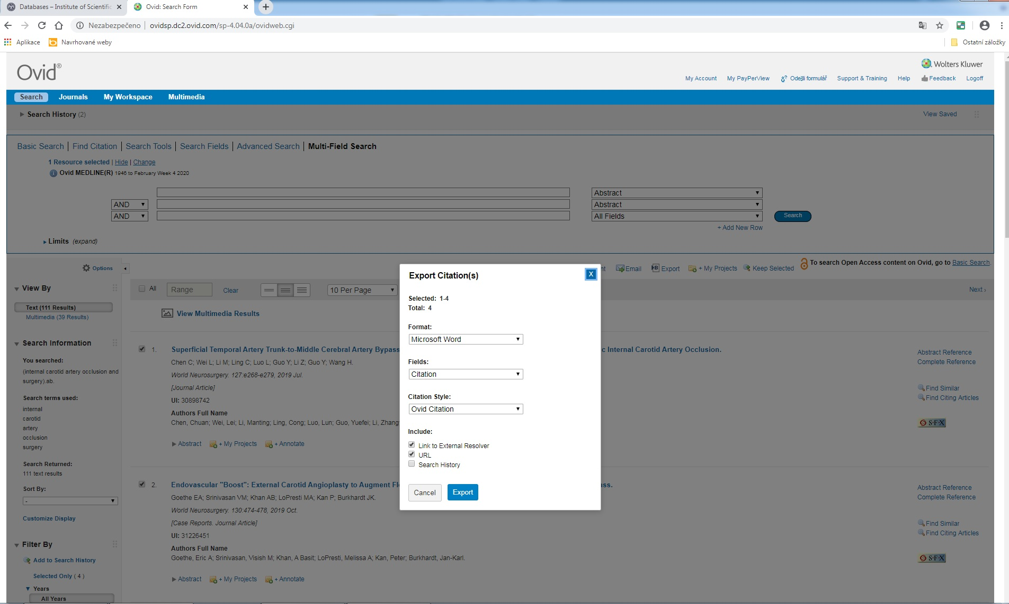
The results will be downloaded after clicking on the “Export” lower button.
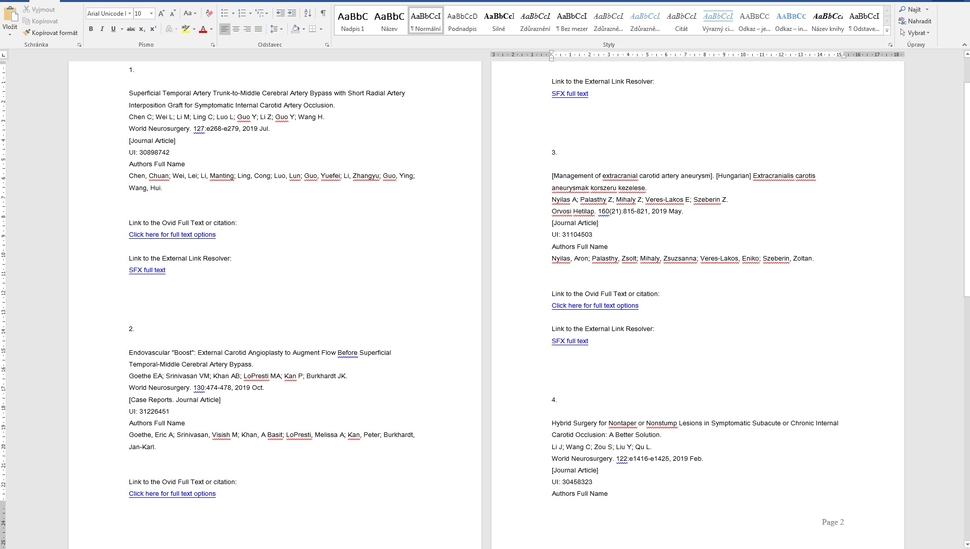
When looking for full texts of the articles, the most reliable is SFX service. It will navigate you towards different databases in which the full texts are available (according to the licence conditions of 1 FM or Charles University).
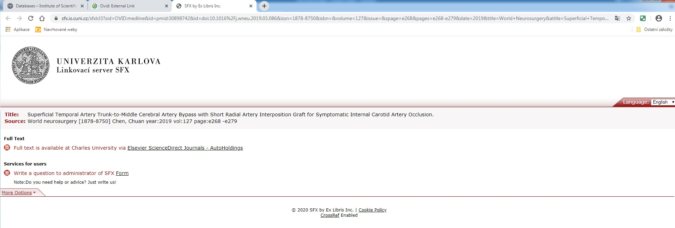
In Medline database, after clicking on SFX button, you will need to confirm the request – “click this link to open the document”.
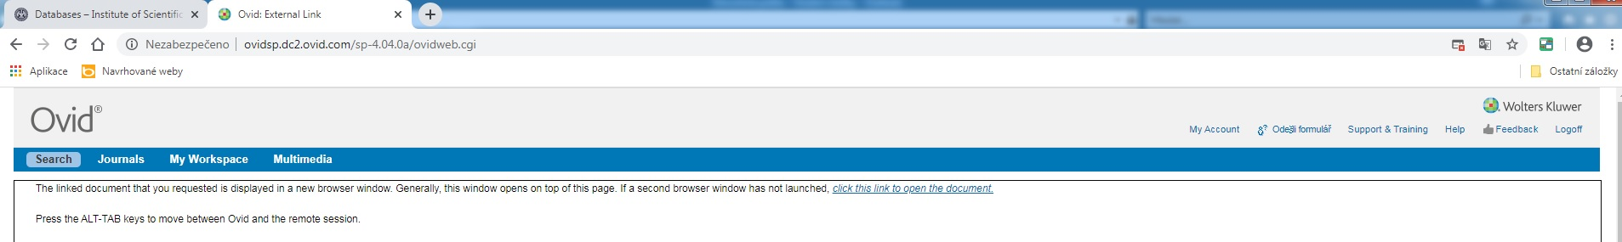
If you see the text “We are sorry but full text is not available at Charles University”, you can ask an interlibrary loan service for this article at kveta.castkova@lf1.cuni.cz or by completing “Order form” at the website of the Institute of Scientific Information in the “Services” section.
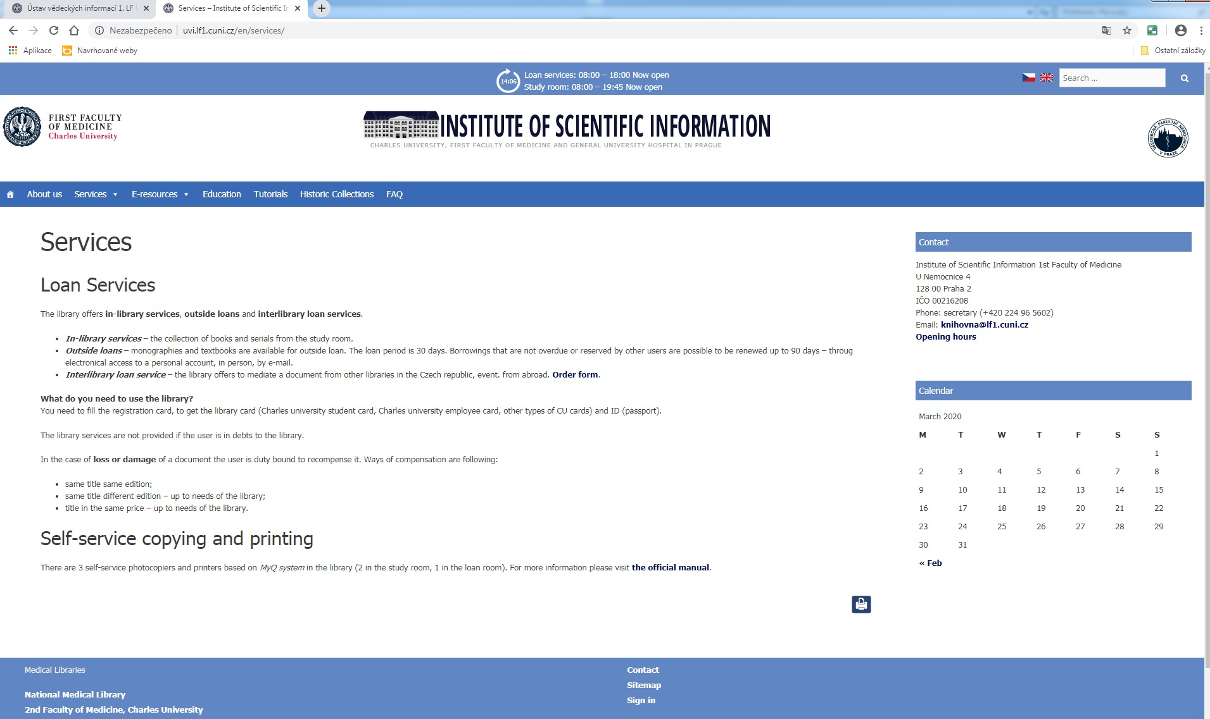
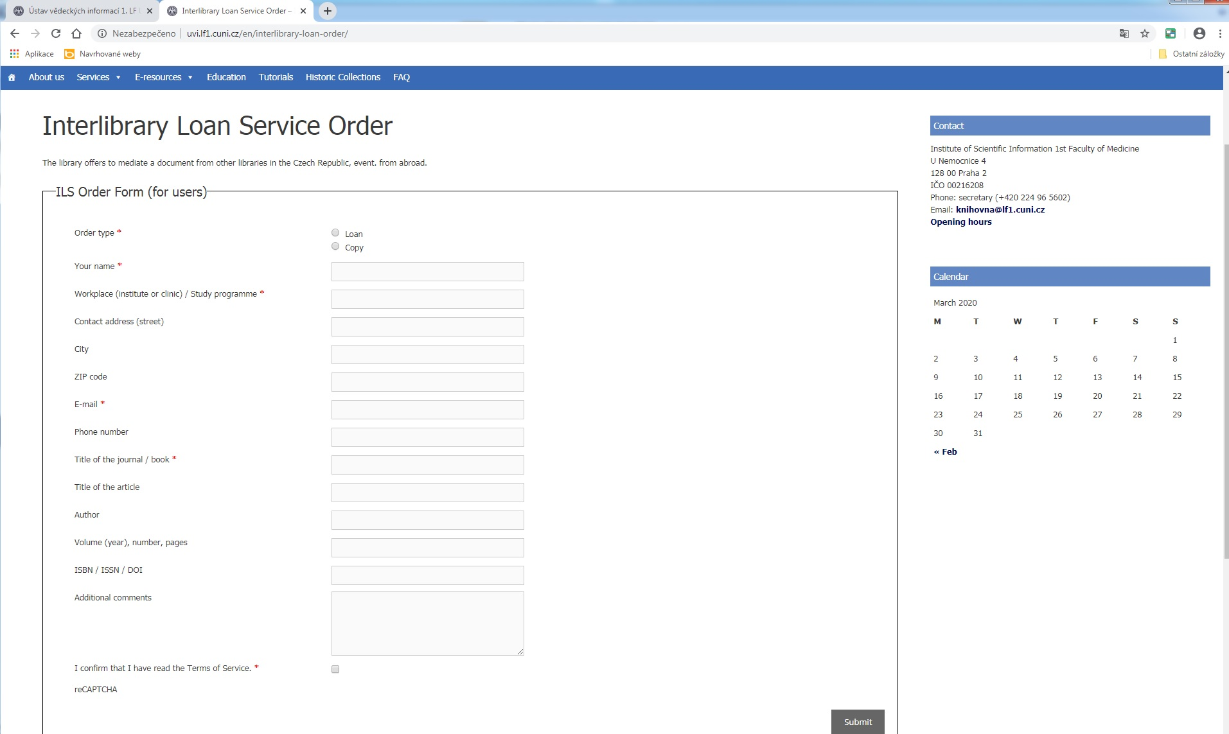
When looking for the specific journal, there are two ways how to find it on the website
of the Institute of Scientific Information. The first one is to write the name in the “E-Journal” section that appears in the grey molding. The searching process will take some time. The second option is to go through “Quick links” section on the left side and click on “E-journals Catalogue”.

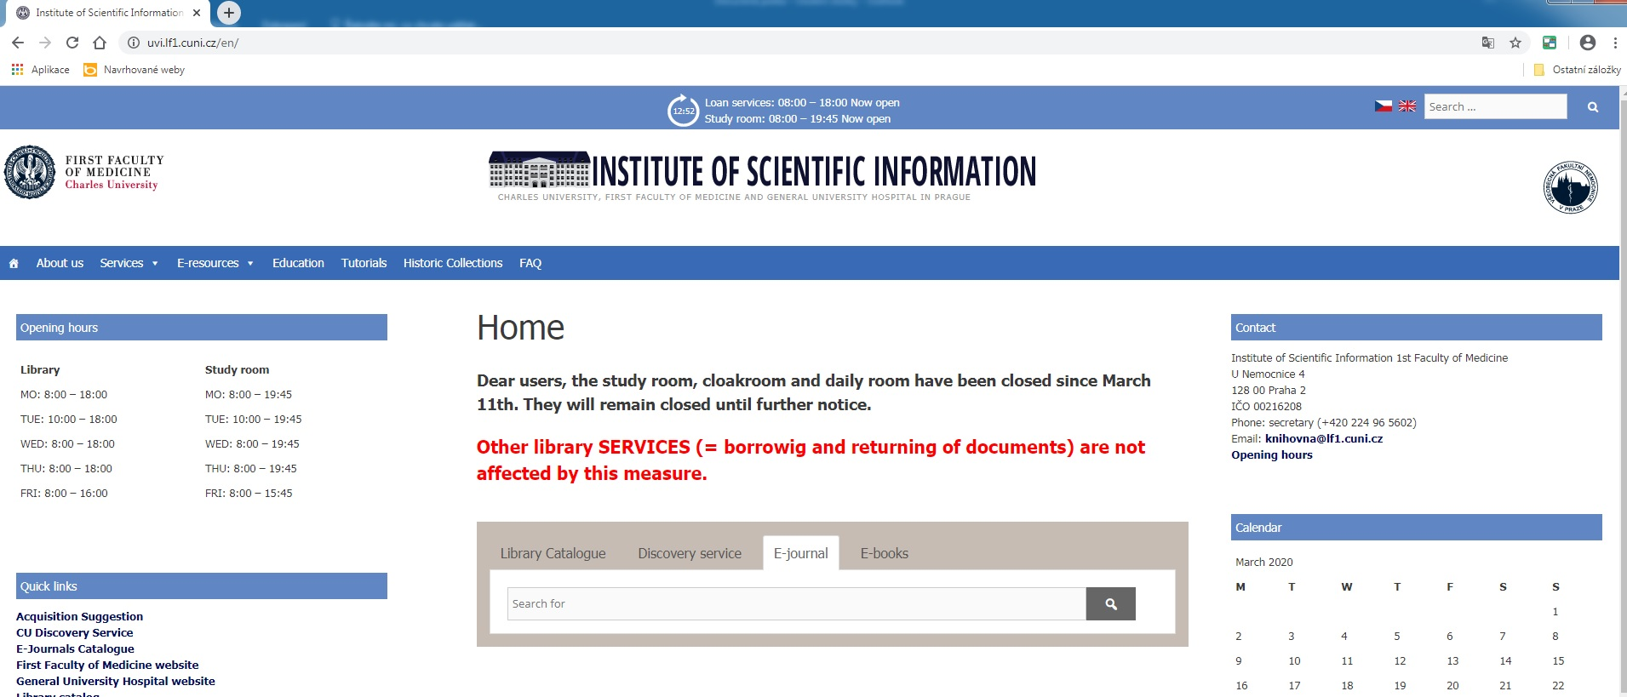
You will be automatically redirected to CAS and after completing login information, you will be in the interface of EZB Catalogue. Fill the name of the requested journal.
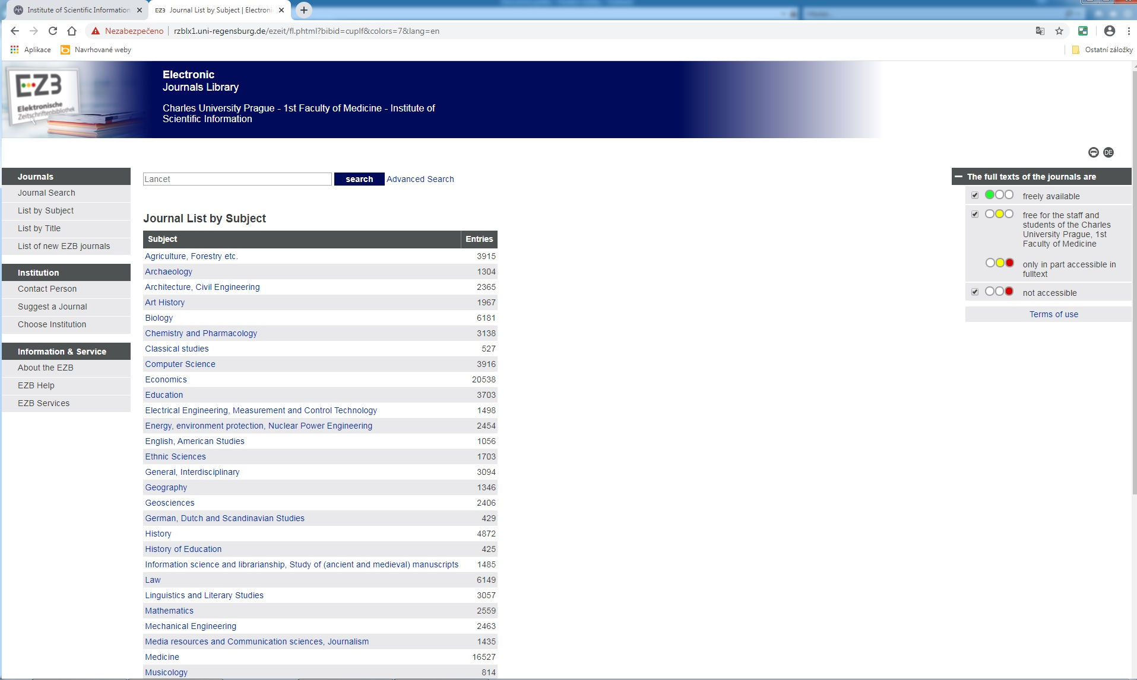
Then, click on “Search” button. You will get the information whether the journal is available at 1 FM or not.
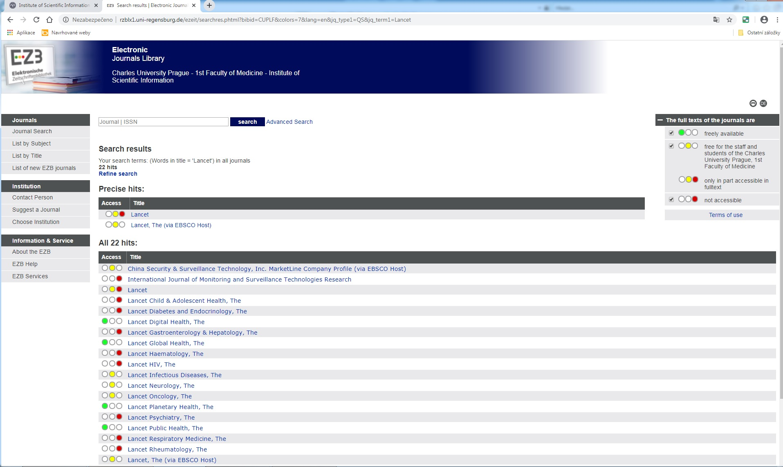
Choose one option according to your preferences.
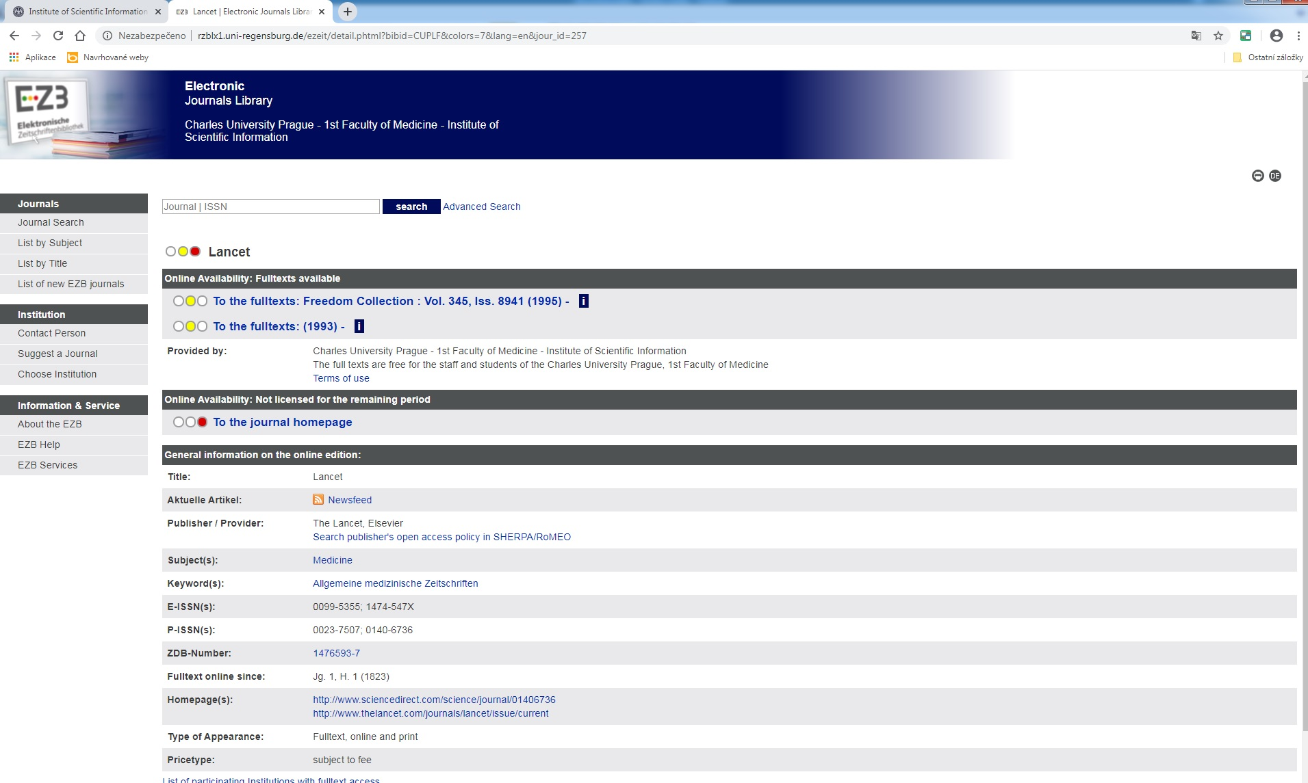
Then, go to the full texts through the archive of the journal.
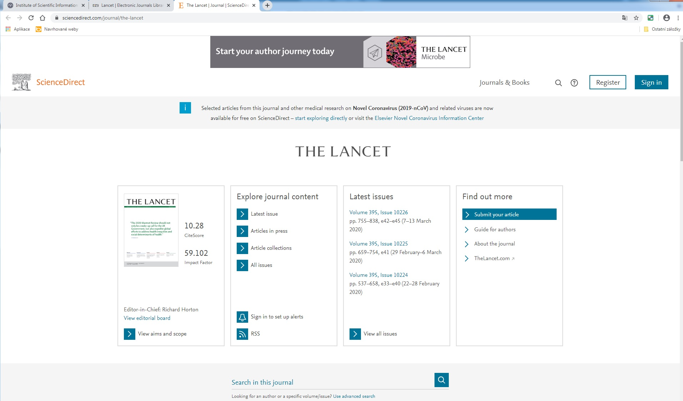
When looking for the specific e-book, you can click on the “E-books” section in the grey molding on the main website of the Institute of Scientific Information.
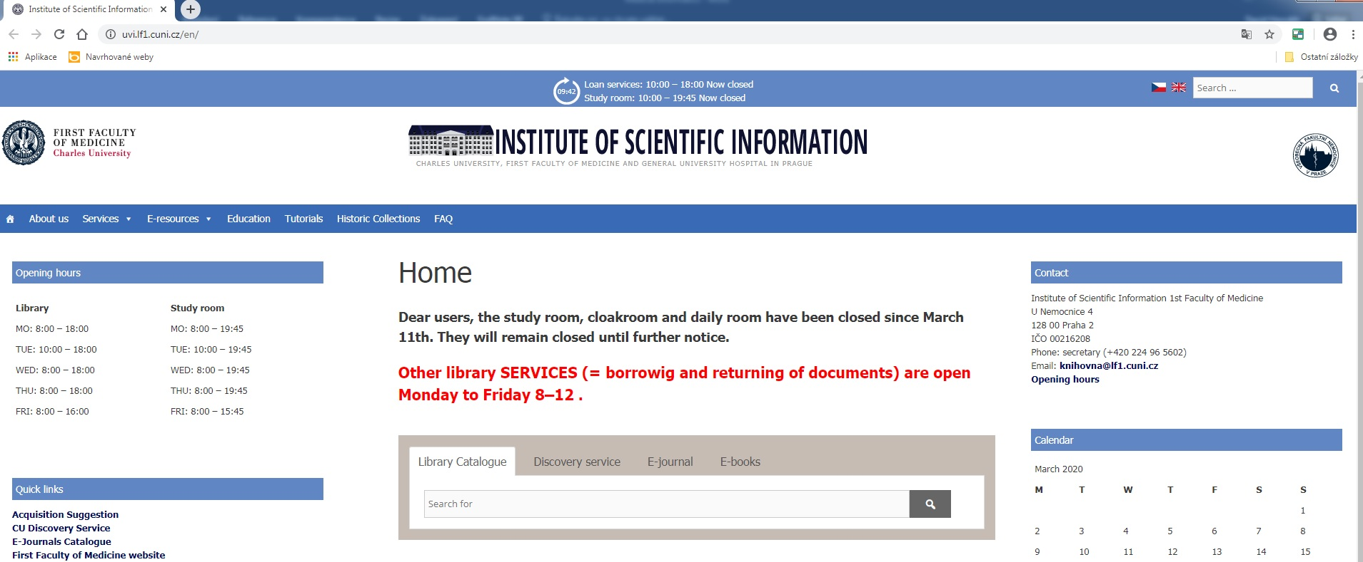
There are e-textbooks recommended for the students of 1 FM that are available at “Thieme MedOne Education”. Go to “E-resources” section and choose “E-books” category. Click
on on-site access to this collection. Registration is required from IP addresses of 1 FM (you can use PCs at the loan-desk in the library – it is open 8–12 every day).
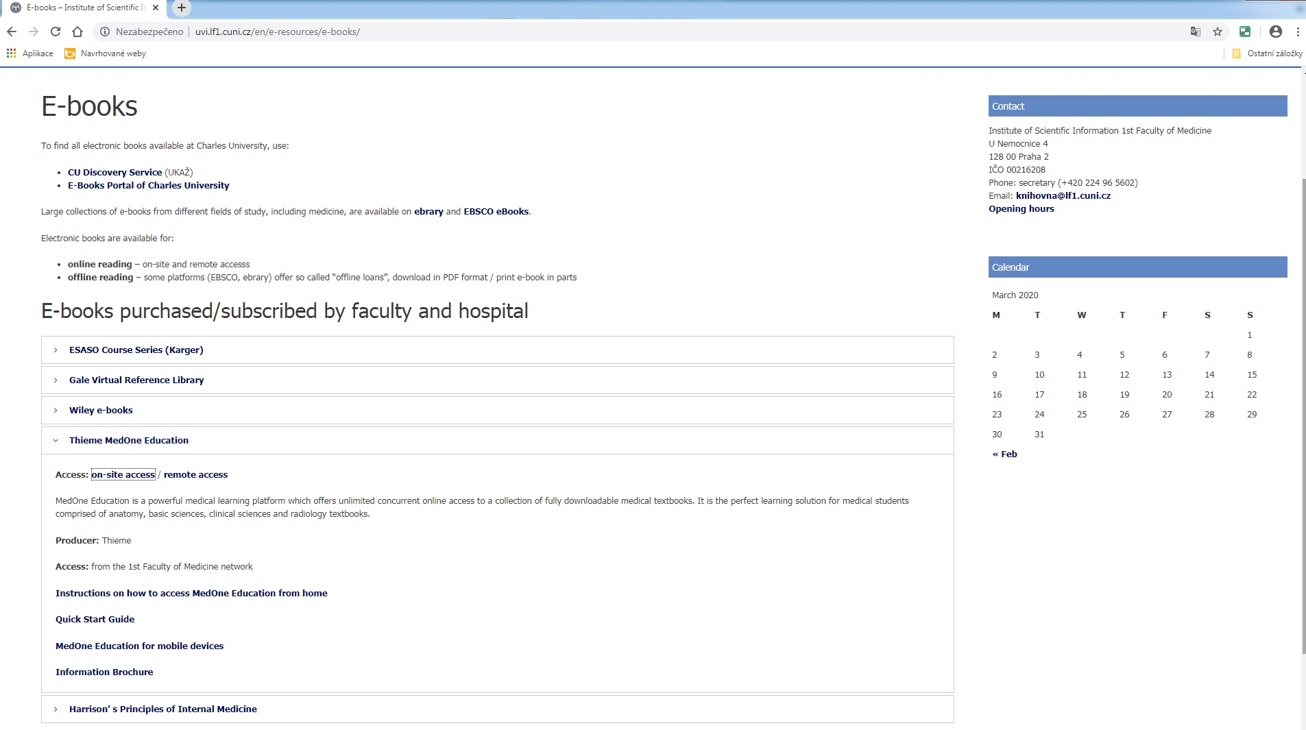
After completing the registration, you will get an access into more than 100 e-textbooks.
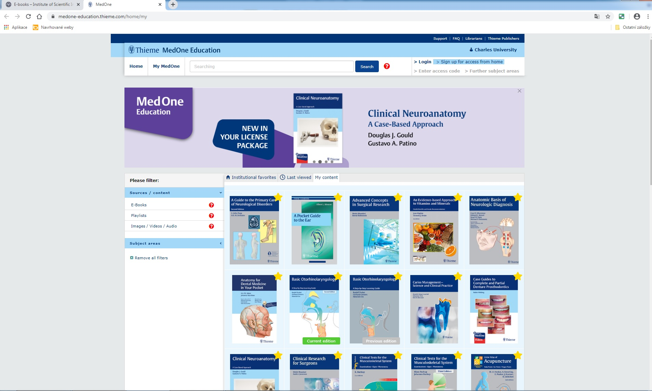

2. Web Portal of Charles University E-Resources
Website: https://ezdroje.cuni.cz
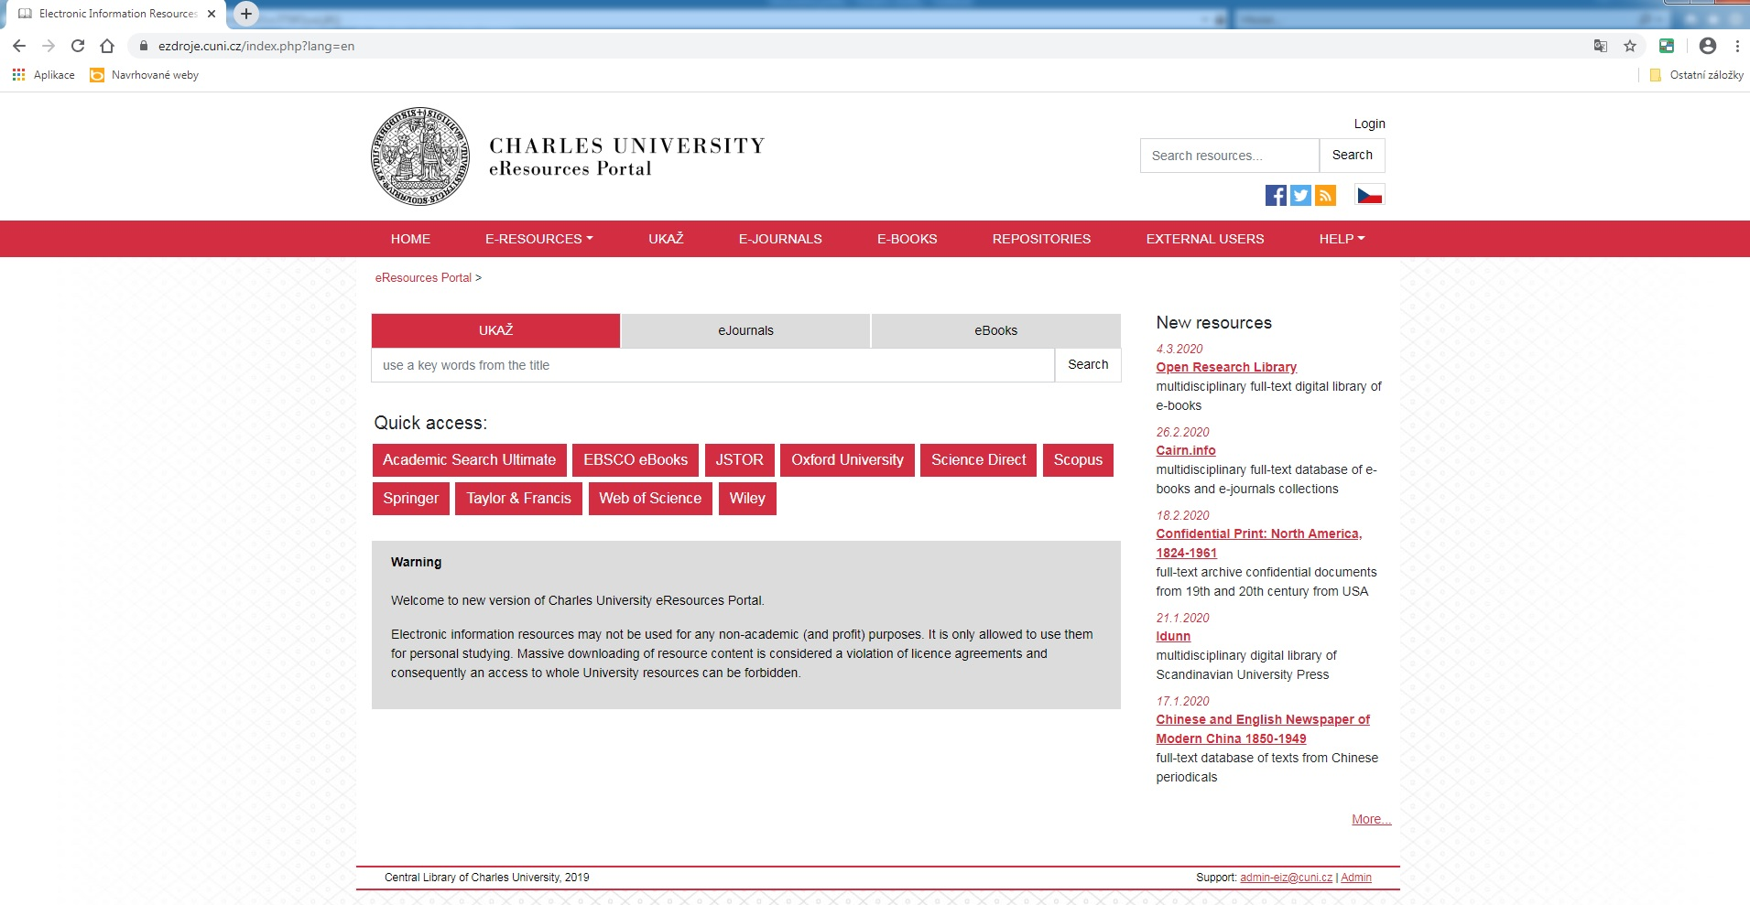
This website helps students find relevant information in electronic information resources
of Charles University, or in electronic information resources of 1 FM respectively.
Go to E-Resources section – e-resources are arranged by alphabet, faculties or by subjects. You can choose the option that is the most suitable for you.
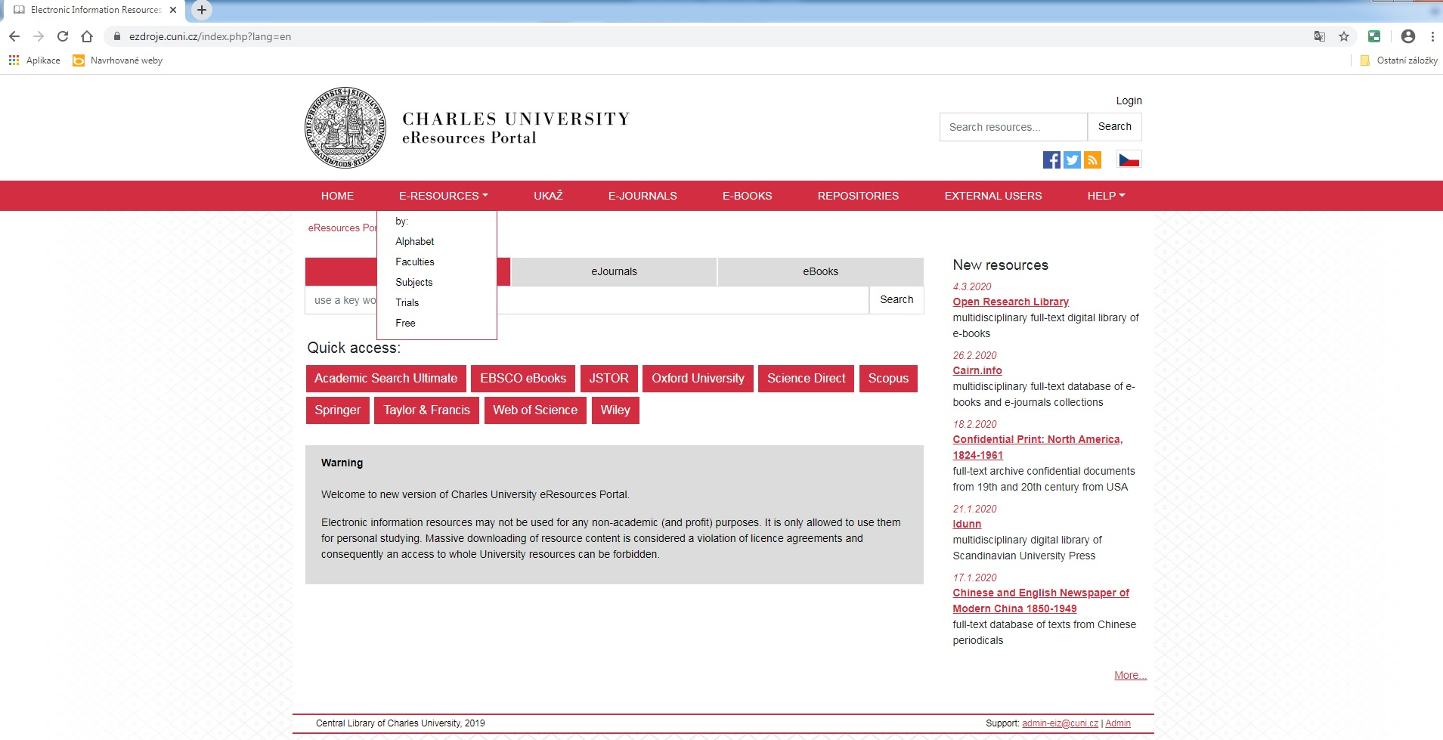
E-Resources by alphabet will appear in chronological order – there are all e-resources available at Charles University.
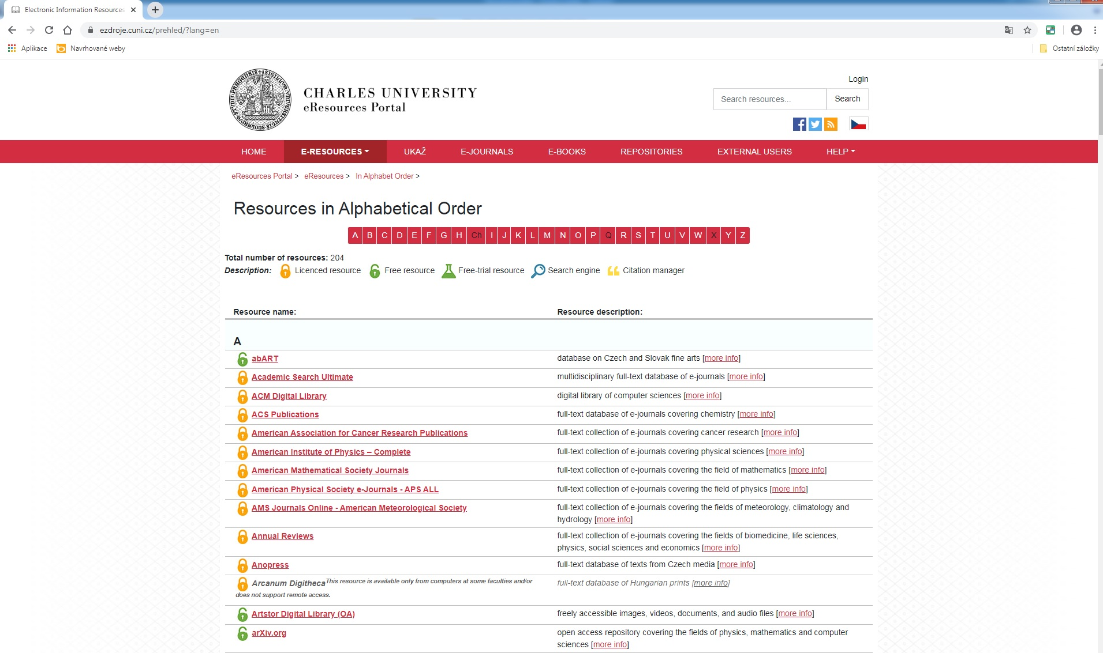
E-Resources by Faculty will display 162 resources from 1 FM.
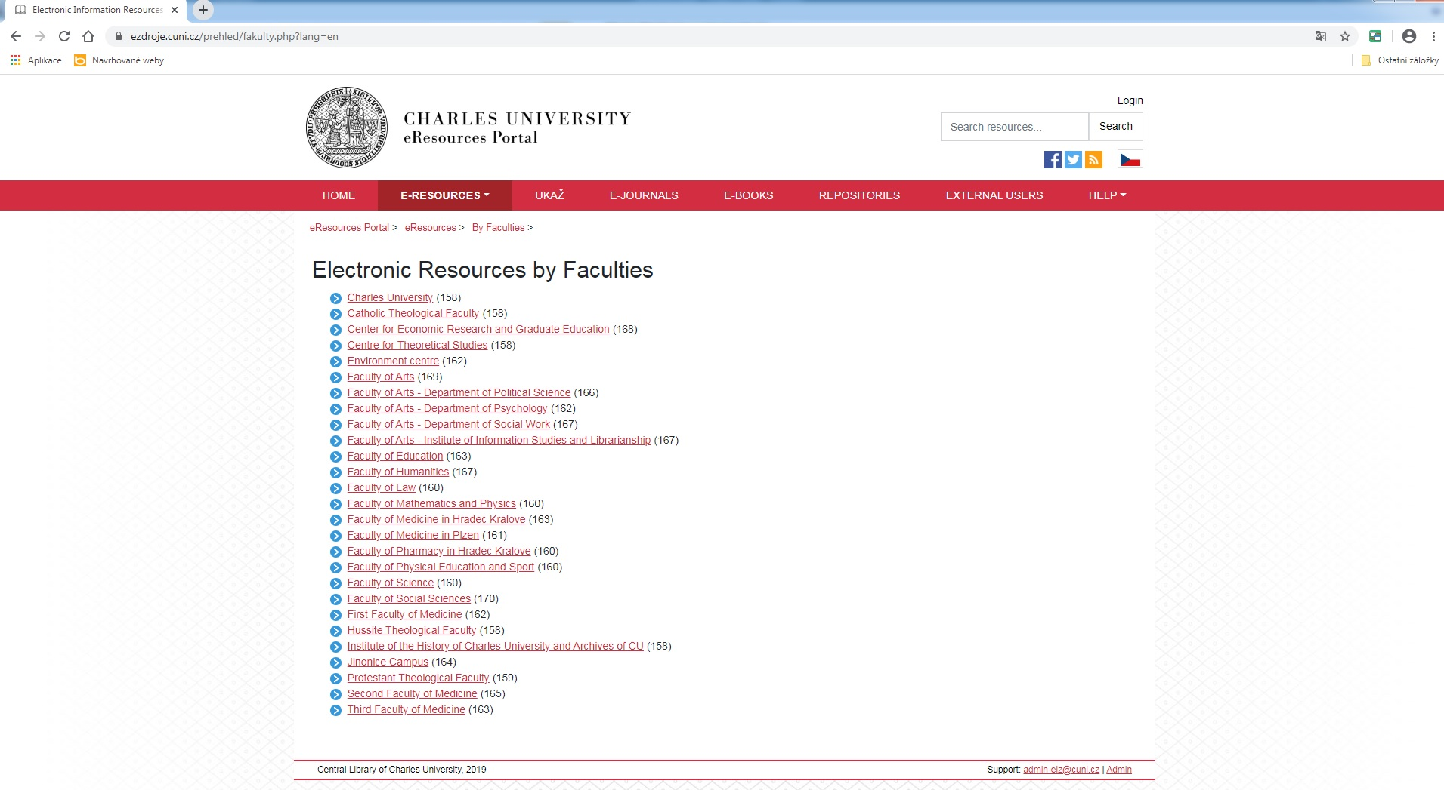
E-Resources by Subject will display 30 medical resources.
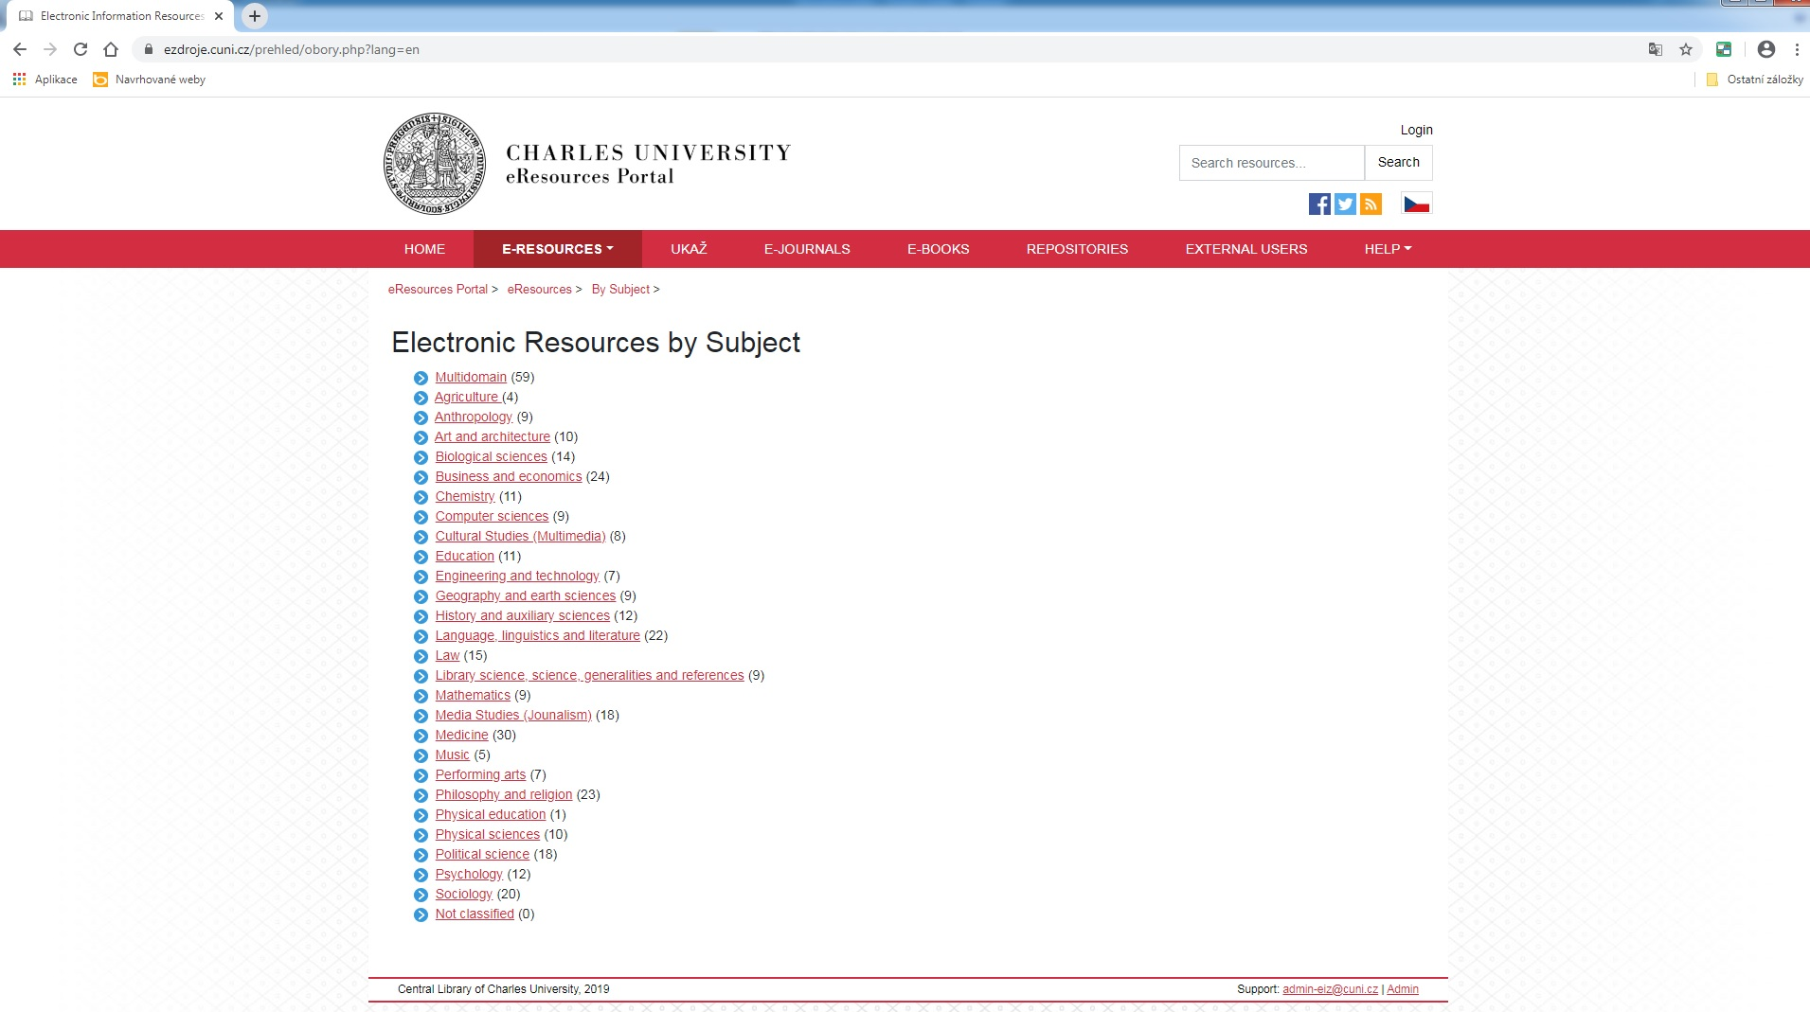
You can also find a particular e-journal in eJournals section.
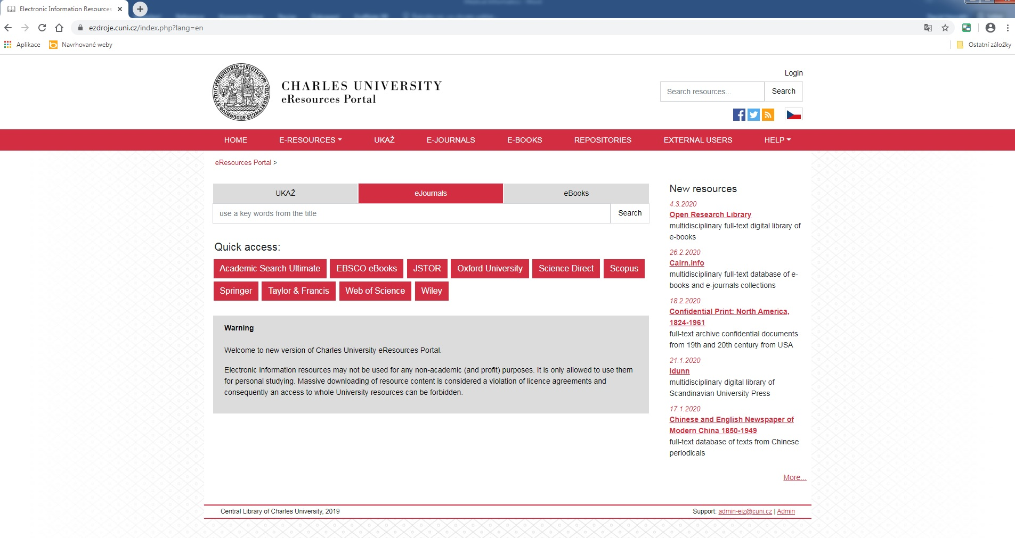
Or you can find a particular e-book in eBooks section.
