Version 2.5.2024
A: Download the sequence of the accession number for your version NM_...
- What does this sequence encode?
- Download the third exon of this sequence in FASTA format, how long it is?
- Is there a restriction enzyme that would cut the sequence of the third exon exactly once?
- Does respective protein contain any transmembrane helices?
- How many threonins (T) does respective protein contain?

- NM_017460.6
CYP3A4
53nt
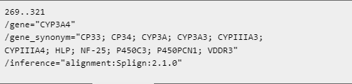
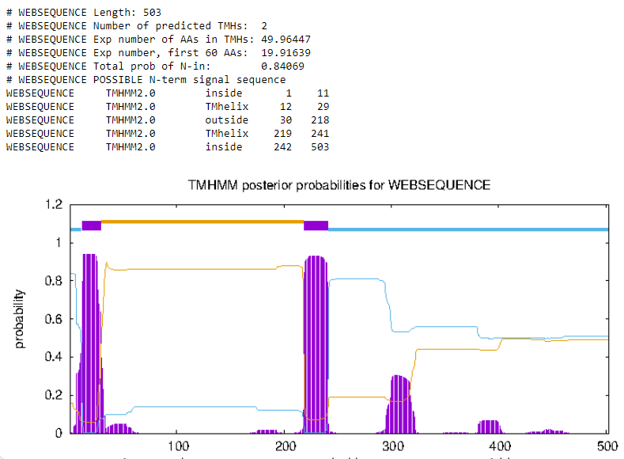
- NM_000106.6
CYP2D6
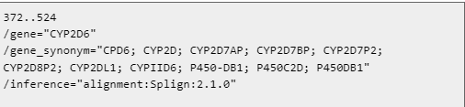
153nt
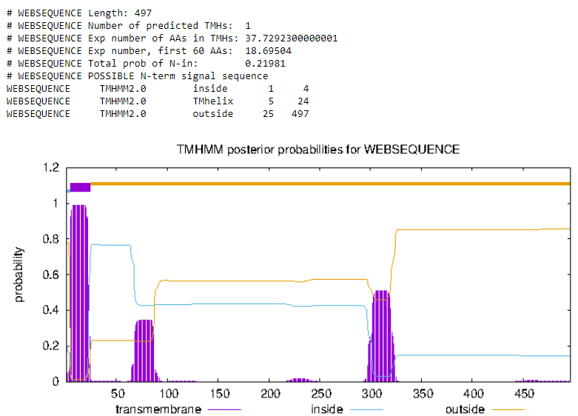
- NM_000499.5
CYP1A1
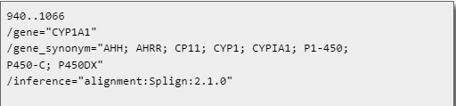
127nt
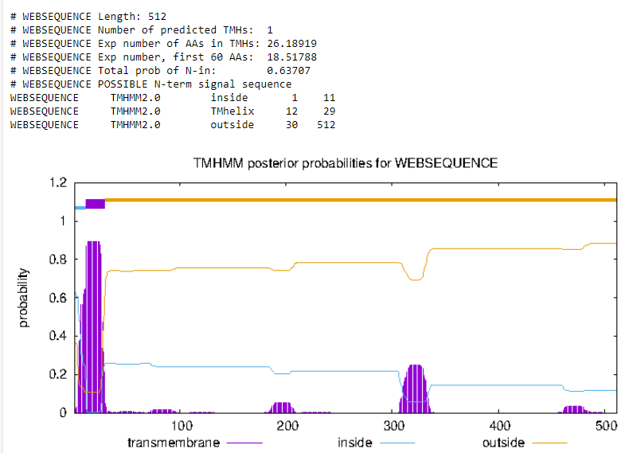
- NM_000761.5
CYP1A2
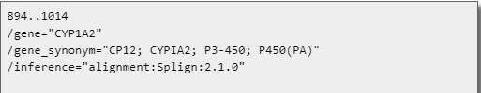
121nt
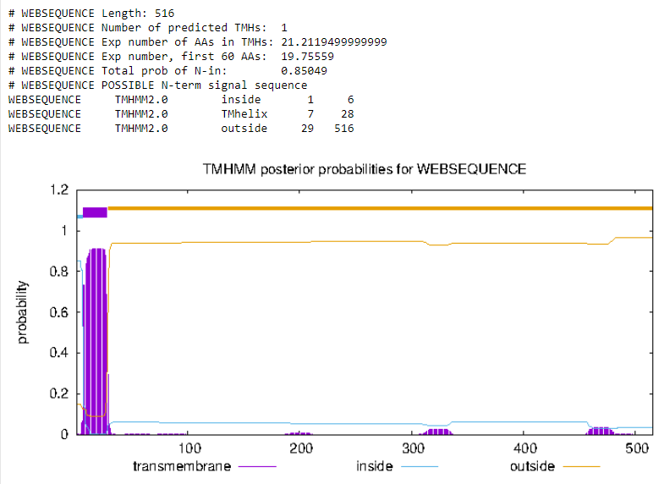
- NM_001072.4
UGT1A6
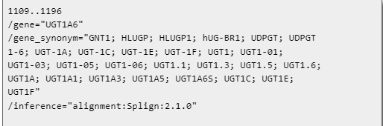
88nt
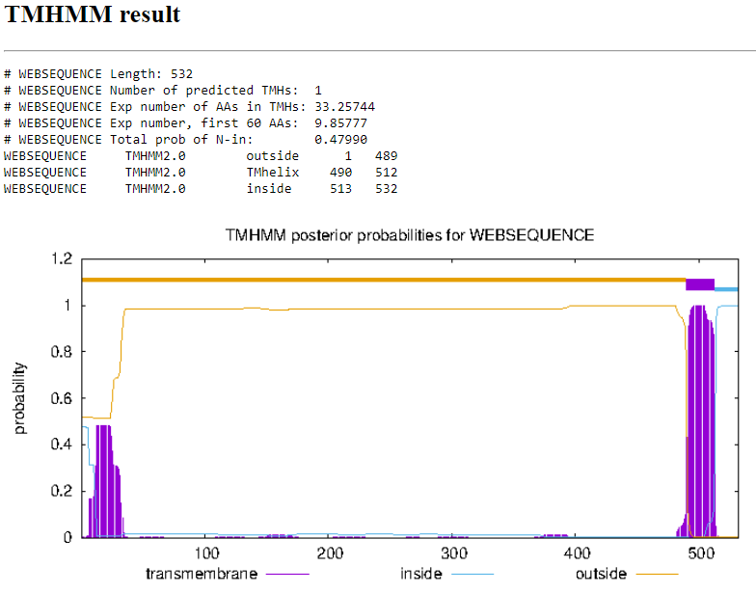
- NM_021027.3
UGT1A9
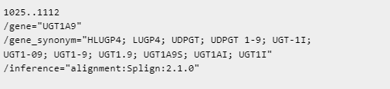
88nt
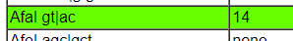
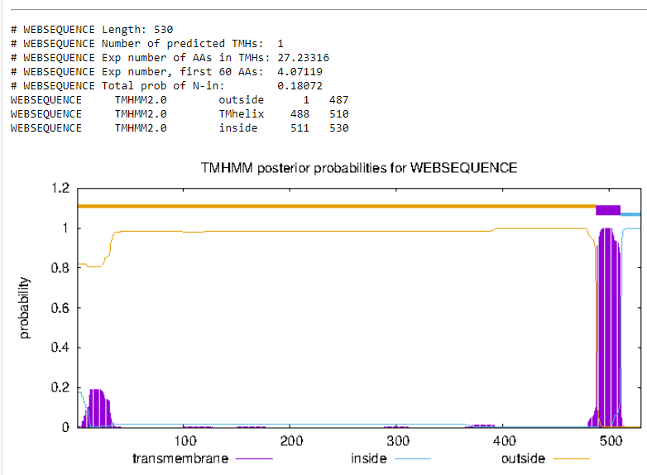
- NM_001512.4
GSTA4
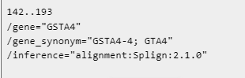
52nt
