Elene Khetaguri

The Governess by Rebecca Solomon 1854

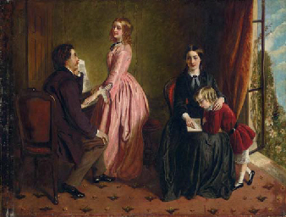
Erwin Panofsky's Three Stages of Iconographic/Iconological Analysis

- Pre-iconographical description (pseudo-format analysis)
The picture shows loving couple with the child, they must be rich and have servant for child education, both women are beautiful.

- Iconographical analysis in a narrower sense

- The distant relationship between parent and child.
- The mother passes her duties to other women who is responsible for the child.
- pink dress symbolize the ideal feminine image.
- The second women’s color black symbolizes the loneliness
- Reading symbolizes the knowledge of the women who tekes care of the child.

- Iconographical interpretation in deeper sense
The painting represent the typical familial scene of the time. It represents the duties in the family and the characteristics of the time. a beautiful, young woman plays the piano for her husband. They do not pay attention around them. The mother has clearly passed her maternal duties to a women who hes this duty to raise the child, and has not personal life and is dedicated to raise and aducate the child.

