The soul as forma corporis: examples of the union
Follow up and synthesis of ST Ia q. 76 a. 1 (Aquinas on the soul/body union)

The long “Answer” to the question “how the soul is united to the body”

- defines the role performed by the soul as “form” and its link to this body
- targets other hylomorphic models, such as Averroes’ and Avicenna’s, as wrong:
- Averroes: for if the form is outside this body, this man won’t think: I thinking is an immanent activity and cannot be placed outside the form/matter compound II otherwise its oneness, the unity of such compound would be compromised. This is “the way proposed by Aristotle: this man understands because an intellective principle is his form”
- Avicenna: for the soul is not the form united to the body, but a separate form, linked to the body “as the captain to the ship”, human being’s unity would be compromised
- In both cases (in a stronger way, for a, and a diminished way in the case of b), the point of Aquinas is to attribute the function “thinking” to one body
- This make of the soul/body (form/matter) compound a human being
- Why thinking and not breathing is the form of the body? (another function, another activity of the body): for, thinking (as the activity of the intellect) is the noblest, superior activity that we find in human beings and that identifies them as such (cf. text 1 of “Epilogue”)
- Circularity? Nope, much more a phenomenological observation [by Aristotle and after him, by Aquinas]

A couple of extra observations:
- the soul is united to the body essentially, as a substance, but it is also what makes of it a substance (cf. text 1)
- there is deep continuity between the bodily processes and the intellective processes (cf. text 2)

1. It can be inferred from the foregoing that the soul is united to the body immediately, no medium being required to unite the soul to the body, whether it be the phantasms, as Averroes holds, or the body’s powers, as some say, or the corporeal spirit, as others have asserted. For we have shown that the soul is united to the body as its form. Now, a form is united to matter without any medium at all, since to be the act of such and such a body belongs to a form by its very essence, and not by anything else. That is why, as Aristotle proves in Metaphysics VIII [6] there is nothing that makes a unitary thing out of matter and form except the agent which reduces the potentiality to act, for matter and form are related as potentiality and act. [Thomas Aquinas, Contra Gentiles, Book II, c. 71]

another version of 1: ST Ia q. 76 a. 6
But contrary to this: As Metaphysics 7 says, an accident is posterior to its substance “both temporally and conceptually.” Therefore, no accidental form can be thought of as existing in the matter prior to the soul, which is the substantial form.
I respond: If the soul were united to the body as its mover, then nothing would prevent its being the case—indeed, it would have to be the case—that certain dispositions mediate between the soul and the body, viz., (a) on the part of the soul, a power by which it moves the body, and (b) on the part of the body, a certain aptitude by which the body is able to be moved by the soul. However, if, as has already been explained (a. 1), the intellective soul is united to the body as its substantial form, then it is impossible for any accidental disposition to mediate (cadat media) between the body and the soul—or, for that matter, between any substantial form and its matter. The reason is that there is a certain order in which the matter is in potentiality to all its corresponding actualities, and so the actuality that is the first of all the actualities, absolutely speaking, must be thought of as the first one that is in the matter. But the first among all the actualities is esse. Therefore, it is impossible to think of the matter as being hot or quantified before thinking of it as existing in actuality. But esse in actuality is had through the substantial form, which makes a thing to exist absolutely speaking, as has already been explained (a. 4). Hence, it is impossible that any accidental disposition should exist in the matter prior to the substantial form or, consequently, prior to the soul.

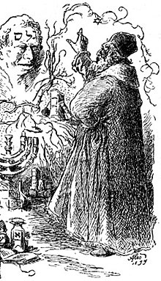
[to take for granted: of course, Aquinas does not have in mind this, which, yet, is a good example]

what is the Golem made by?
gelem: “raw material” (in this case, clay and sand)
the creative word (God) that the rabbi writes over such raw matter (shaped as a sort of human being) makes such matter alive, namely able to be independently active by using its parts.
The golem “thinks”: according to the tradition, his main function is to protect the Jewish ghetto from antisemitic attacks
The golem “moves”: it is independent from the rabbi whilst being active;
But it suffices that the rabbi erases the word giving life to it, to “die”: In this case, it goes back immediately to what it was before: sand and clay of the Vltava river

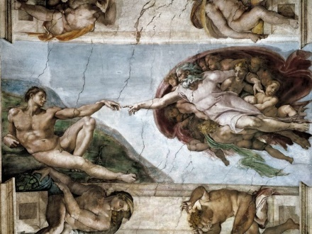
[this is better to represent what Thomas Aquinas had in mind!]
Nevertheless, many theologians and philosophers objected to him that his account of the union is “golem-like”:
After death, we should experience human beings returning immediately to raw matter, thereby losing all their accidents all of a sudden (shape, color, etc)

2. In the state of our present life, in which our intellect is joined to a passible body, it is impossible for it to have an actual intellective understanding of anything unless it turns itself toward phantasms. There are two indications that make this apparent. First of all, given that the intellect is a power that does not use a corporeal organ, if no act of a power that uses a corporeal organ were required for its act, then the intellect would not in any way be impeded in its act by an injury to a corporeal organ. But the senses, the imagination, and all the other powers that belong to the sentient part of the soul use a corporeal organ. Hence, it is clear that in order for the intellect to be actually engaged in intellective understanding—not only for attaining knowledge de novo, but also for making use of already acquired knowledge—what is required are acts of the imagination and of the rest of the powers. For we see that when the act of the power of imagining is impeded by an injury to an organ, as in the case of those who are delirious (in phreneticis) or, similarly, when the act of the power of remembering is impeded, as in those who are groggy (in lethargicis), a man is prevented from having actual intellective understanding even of those things that he previously had scientific knowledge of. [Thomas Aquinas, ST Ia, q. 84 a. 7, Answer, tr. A. J. Freddoso]

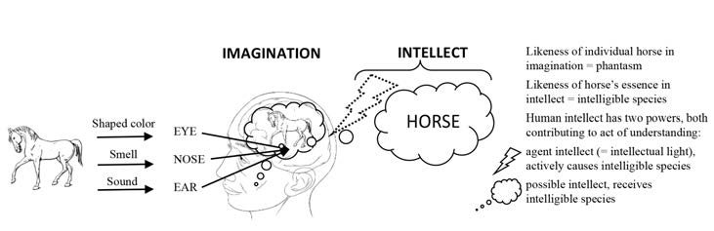

Soul+Body = they form a naturally harmonious compound. Once this unity is broken [the soul parts from the body], the human soul doesn’t function as well as before

3. […] as long as a soul is conjoined with its body, it cannot have intellective understanding of anything except by turning itself toward phantasms. This is clear from experience. Now if, as the Platonists held, this fact were not due to the nature of the soul, but instead belonged to the soul incidentally (per accidens) because it is tied to a body, then the question could easily be answered. For once the impediment of the body were removed, the soul would revert to its own nature, so that it would understand intelligible things directly (simpliciter) and without turning itself to phantasms—just as happens in the case of other separated substances. However, on this view, the soul would not be united to its body for the soul’s own good, given that its intellective understanding would be poorer (peius) when it is united with the body than when it is separated. Instead, the union would be solely for the sake of the betterment of the body. But this is ludicrous (irrationabile), since the matter exists for the sake of the form, and not vice versa. By contrast, if we hold that it is by its nature that the soul has to turn itself toward phantasms in order to have intellective understanding, then, since the soul’s nature is not changed by the death of the body, it seems that a [separated] soul cannot have intellective understanding of anything. For there are no phantasms at hand toward which it might turn itself. So to remove this difficulty, note that since nothing operates except insofar as it actualized, each thing’s mode of operating (modus operandi) follows upon its mode of being (modus essendi ipsius). But even while a soul’s nature remains the same, its mode of being when it is united with a body is different from its mode of being when it is separated from its body—not in such a way that the soul’s being united to a body is incidental (accidentale) to it, but rather in such a way that it is by reason of its nature that the soul is united to a body. [Thomas Aquinas, ST Ia, q. 89, q. 1, Answer]

4. Now it is clear that, according to the order of nature, human souls are the lowest among intellectual substances. The perfection of the universe requires this, so that diverse grades might exist among things. Therefore, if human souls had been constituted by God in such a way as to have intellective understanding in the mode in which separated substances have it, then they would not have had perfect
cognition, but would instead have had indistinct cognition in general. Therefore, in order for them to be able to have perfect and proper cognition of things, they were naturally constituted in such a way as to be united to bodies and so to receive their proper cognition of sensible things from the things themselves, in much the same way that uneducated men cannot be led to scientific knowledge except through sensible examples. So, then, it is clear that it is for the soul’s own good that it should be united to a body and have intellective cognition by turning itself toward phantasms. And yet the soul is able to be separated and to have a different mode of intellective understanding. [follow up of the “Answer” to ST Ia q. 89 a. 1]

Epilogue: Aquinas’ position is the authority

From a manuscript course On the soul dictated in Paris in 1564 at the Jesuit College: 2 examples
1. Our soul, according to Aristotle, is not matter, is not compound; is thus substantial form. Also, Aristotle thinks that every action is the effect of a form. Hence, the proper action through which one thing is essentially distinguished from the others is the effect of its proper form, through which that thing is substantially distinguished. But thinking is human being’s proper action, through which it is essentially different from animals: Ethics I c. 7; hence, this comes from some substantial form. It comes from the soul; thus, our soul is a substantial form. [§10: Whether the soul, according to Aristotle, is the form of the body]

2. Faith also teaches that our soul is form of the body not only in the wake of that part which is living and perceiving, but also in the wake of that which is thinking. This was established in the Council of Vienne and in the Clementina, De summa trinitate et fide catholica, last chapter. That council was not general, but the same was confirmed by the Lateran Council, session 6. [§13. What faith established concerning this matter]

Cf. Aristotle, Eth. Nic., I, 7, 1098a1-18.
Cf. H. Denzinger and A. Schönmetzer, Enchiridion symbolorum, definitionum et declarationum de rebus fidei et morum, 32e ed., Barcelone-Fribourg-Rome 1963, n. 902, p. 284.
Cf. Mansi, 25, p. 410-11.
Cf. Mansi, 32, 842 Bss; Denzinger n. 738.

