Zlatovlaska the Golden-haired
(Czech Fairytale collected by K.J.Erben)

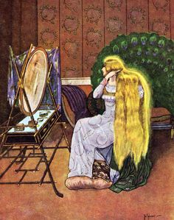

There was once an old king who was so wise that he was able to understand the speech of all the animals in the world. This is how it happened. An old woman came to him one day bringing him a snake in a basket.
"If you have this snake cooked," she told him, "and eat it as you would a fish, then you will be able to understand the birds of the air, the beasts of the earth, and the fishes of the sea."
The king was delighted. He made the old wise woman a handsome present and at once ordered his cook, a youth named Yirik, to prepare the "fish" for dinner.
"But understand, Yirik," he said severely, "you're to cook this 'fish,' not eat it! You're not to taste one morsel of it! If you do, you forfeit your head!"
Yirik thought this a strange order.
"What kind of a cook am I," he said to himself, "that I'm not to sample my own cooking?"
When he opened the basket and saw the "fish," he was further mystified.
"Um," he murmured, "it looks like a snake to me." He put it on the fire and, when it was broiled to a turn, he ate a morsel. It had a fine flavor. He was about to take a second bite when suddenly he heard a little voice that buzzed in his ear these words:
"Give us some, too! Give us some, too!"
He looked around to see who was speaking but there was no one in the kitchen. Only some flies were buzzing about.Just then outside a hissing voice called out:
"Where shall we go? Where shall we go?"
A higher voice answered:
"To the miller's barley field! To the miller's barley field!"
Yirik looked out the window and saw a gander with a flock of geese.
"Oho!" he said to himself, shaking his head. "Now I understand! Now I know what kind of 'fish' this is! Now I know why the poor cook was not to take a bite!"
He slipped another morsel into his mouth, garnished the "fish" carefully on a platter, and carried it to the king.
After dinner the king ordered his horse and told Yirik to come with him for a ride. The king rode on ahead and Yirik followed. As they cantered across a green meadow, Yirik's horse began to prance and neigh.
"Ho! Ho!" he said. "I feel so light that I could jump over a mountain!"
"So could I," the king's horse said, "but I have to remember the old bag of bones that is perched on my back. If I were to jump he'd tumble off and break his neck."
"And a good thing, too!" said Yirik's horse. "Why not? Then instead of such an old bag of bones you'd get a young man to ride you like Yirik." Yirik almost burst out laughing as he listened to the horses' talk, but he suppressed his merriment lest the king should know that he had eaten some of the magic snake.
Now of course the king, too, understood what the horses were saying. He glanced apprehensively at Yirik and it seemed to him that Yirik was grinning.
"What are you laughing at, Yirik?"
"Me?" Yirik said. "I'm not laughing. I was just thinking of something funny."
"Um," said the king.
His suspicions against Yirik were aroused. Moreover he was afraid to trust himself to his horse any longer. So he turned back to the palace at once. There he ordered Yirik to pour him out a goblet of wine.
"And I warn you," he said, "that you forfeit your head if you pour a drop too much or too little."
Yirik carefully tilted a great tankard and began filling a goblet. As he poured a bird suddenly flew into the window pursued by another bird. The first bird had in its beak three golden hairs.
"Give them to me! Give them to me! They're mine!" screamed the second bird.
"I won't! I won't! They're mine!" the first bird answered. "I picked them up!"
"Yes, but I saw them first!" the other cried. "I saw them fall as the maiden sat and combed her golden tresses. Give me two of them and I'll let you keep the third."
"No! No! No! I won't let you have one of them!"
The second bird darted angrily at the first and after a struggle succeeded in capturing one of the golden hairs. One hair dropped to the marble floor, making as it struck a musical tinkle, and the first bird escaped still holding in its bill a single hair. In his excitement over the struggle, Yirik overflowed the goblet.
"Ha! Ha!" said the king. "See what you've done! You forfeit your head! However, I'll suspend sentence on condition that you find this golden-haired maiden and bring her to me for a wife."
Poor Yirik didn't know who the maiden was nor where she lived. But what could he say? If he wanted to keep his head, he must undertake the quest. So he saddled his horse and started off at random.
His road led him through a forest. Here he came upon a bush under which some shepherds had kindled a fire. Sparks were falling on an anthill nearby and the ants in great excitement were running hither and thither with their eggs.
"Yirik!" they cried. "Help! Help, or we shall all be burned to death, we and our young ones in the eggs!" Yirik instantly dismounted, cut down the burning bush, and put out the fire.
"Thank you, Yirik, thank you!" the ants said. "Your kindness to us this day will not go unrewarded. If ever you are in trouble, think of us and we will help you."
As Yirik rode on through the forest, he came upon two fledgling ravens lying by the path.
"Help us, Yirik, help us!" they cawed. "Our father and mother have thrown us out of the nest in yonder tall fir tree to fend for ourselves. We are young and helpless and not yet able to fly. Give us some meat to eat or we shall perish with hunger."
The sight of the helpless fledglings touched Yirik to pity. He dismounted instantly, drew his sword, and killed his horse. Then he fed the starving birds the meat they needed.
"Thank you, Yirik, thank you!" the little ravens croaked. "You have saved our lives this day. Your kindness will not go unrewarded. If ever you are in trouble, think of us and we will help you."
Yirik left the young ravens and pushed on afoot. The path through the forest was long and wearisome. It led out finally on the seashore.
On the beach two fishermen were quarreling over a big fish with golden scales that lay gasping on the sand.
"It's mine, I tell you!" one of the men was shouting. "It was caught in my net, so of course it's mine!" To this the other one shouted back:
"But your net would never have caught a fish if you hadn't been out in my boat and if I hadn't helped you!"
"Give me this one," the first man said, "and I'll let you have the next one."
"No! You take the next one!" the other said. "This one's mine!"
So they kept on arguing to no purpose until Yirik went up to them and said:
"Let me decide this for you. Suppose you sell me the fish and then divide the money."
He offered them all the money the king had given him for his journey. The fishermen, delighted at the offer, at once agreed. Yirik handed them over the money and then, taking the gasping fish in his hand, he threw it back into the sea. When the fish had caught its breath, it rose on a wave and called out to Yirik:
"Thank you, Yirik, thank you. You have saved my life this day. Your kindness will not go unrewarded. If ever you are in trouble, think of me and I will help you."With that the golden fish flicked its tail and disappeared in the water.
"Where are you going, Yirik?" the fishermen asked.
"I'm going in quest of a golden-haired maiden whom my master, the king, wished to make his wife."
"He must mean the Princess Zlatovlaska," the fishermen said to each other.
"The Princess Zlatovlaska?" Yirik repeated. "Who is she?"
"She's the golden-haired daughter of the King of the Crystal Palace. Do you see the faint outlines of an island over yonder? That's where she lives. The king has twelve daughters but Zlatovlaska alone has golden hair. Each morning at dawn a wonderful glow spreads over land and sea. That's Zlatovlaska combing her golden hair."The fishermen conferred apart for a moment and then said:
"Yirik, you settled our dispute for us and now in return we'll row you over to the island."
So they rowed Yirik over to the Island of the Crystal Palace and left him there with the warning that the king would probably try to palm off on him one of the dark-haired princesses.
Yirik at once presented himself at the palace, got an audience with the king, and declared his mission.
"H'm," the king said. "So your master desires the hand of my daughter, the Princess Zlatovlaska, eh? H'm, h'm. Well, I see no objection to your master as a son-in-law, but of course before I entrust the princess into your hands you must prove yourself worthy. I tell you what I'll do: I'll give you three tasks to perform. Be ready for the first one tomorrow."
Early the next day the king said to Yirik:
"My daughter, Zlatovlaska, had a precious necklace of pearls. She was walking in the meadow over yonder when the string broke and the pearls rolled away in the tall grasses. Now your first task is to gather up every last one of those pearls and hand them to me before sundown."
Yirik went to the meadow and when he saw how broad it was and how thickly covered with tall grasses his heart sank for he realized that he could never search over the whole of it in one day. However, he got down on his hands and knees and began to hunt. Midday came and he had not yet found a single pearl.
"Oh dear," he thought to himself in despair, "if only my ants were here, they could help me!"
He had no sooner spoken than a million little voices answered:
"We are here and we're here to help you!"And sure enough there they were, the very ants that he supposed were far away!
"What do you want us to do?" they asked.
"Find me all the pearls that are scattered in this meadow. I can't find one of them."
Instantly the ants scurried hither and thither and soon they began bringing him the pearls one by one. Yirik strung them together until the necklace seemed complete.
"Are there any more?" he asked.
He was about to tie the string together when a lame ant, whose foot had been burned in the fire, hobbled up, crying:
"Wait, Yirik, don't tie the string yet! Here's the last pearl!"
Yirik thanked the ants for their help and at sundown carried the string of pearls to the king. The king counted the pearls and, to his surprise, found that not one was missing.
"You've done this well," he said. "Tomorrow I'll give you your second task."
The next day when Yirik presented himself, the king said:
"While my daughter, Zlatovlaska, was bathing in the sea, a golden ring slipped from her finger and disappeared. Your task is to find me this ring before sundown."
Yirik went down to the seashore and as he walked along the beach his heart grew heavy as he realized the difficulty of the task before him. The sea was clear but so deep that he couldn't even see the bottom. How then could he find the ring?
"Oh dear," he said aloud, "if only the golden fish were here! It could help me."
"I am here," a voice said, "and I'm here to help you."
And there was the golden fish on the crest of a wave, gleaming like a flash of fire!
"What do you want me to do?" it said.
"Find me a golden ring that lies somewhere on the bottom of the sea."
"Ah, a golden ring? A moment ago I met a pike," the fish said, "that had just such a golden ring. Wait for me here and I'll go find the pike."
In a few moments the golden fish returned with the pike and sure enough it was Zlatovlaska's ring that the pike was carrying.That evening at sundown the king acknowledged that Yirik had accomplished his second task.
The next day the king said:
"I could never allow my daughter, Zlatovlaska, the Golden-Haired, to go to the kingdom of your master unless she carried with her two flasks, one filled with the Water of Life, the other with the Water of Death. So today for a third task I set you this: to bring the princess a flask of the Water of Life and a flask of the Water of Death."
Yirik had no idea which way to turn. He had heard of the Waters of Life and Death, but all he knew about them was that their springs were far away beyond the Red Sea. He left the Crystal Palace and walked off aimlessly until his feet had carried him of themselves into a dark forest.
"If only those young ravens were here," he said aloud, "they could help me!" Instantly he heard a loud, "Caw! Caw!" and two ravens flew down to him, saying:
"We are here! We are here to help you! What do you want us to do?"
"I have to bring the king a flask of the Water of Life and a flask of the Water of Death and I don't know where the springs are. Do you know?"
"Yes, we know," the ravens said. "Wait here and we'll soon fetch you water from both springs."
They flew off and in a short time returned, each bearing a gourd of the precious water. Yirik thanked the ravens and carefully filled his two flasks.
As he was leaving the forest, he came upon a great spider web. An ugly spider sat in the middle of it sucking a fly. Yirik took a drop of the Water of Death and flicked it on the spider. The spider doubled up dead and fell to the ground like a ripe cherry. Then Yirik sprinkled a drop of Living Water on the fly. The fly instantly revived, pulled itself out of the web, and flew about happy and free once again.
"Thank you, Yirik," it buzzed, "thank you for bringing me back to life. You won't be sorry. Just wait and you'll soon see that I'll reward you!"When Yirik returned to the palace and presented the two flasks, the king said:
"But one thing yet remains. You may take Zlatovlaska, the Golden-Haired, but you must yourself pick her out from among the twelve sisters."
The king led Yirik into a great hall. The twelve princesses were seated about a table, beautiful maidens all and each looking much like the others. Yirik could not tell which was Zlatovlaska, the Golden-Haired, for each princess wore a long heavy white veil so draped over her head and shoulders that it completely covered her hair.
"Here are my twelve daughters," the king said. "One of them is Zlatovlaska, the Golden-Haired. Pick her out and you may lead her at once to your master. If you fail to pick her out, then you must depart without her."
In dismay Yirik looked from sister to sister. There was nothing to show him which was Zlatovlaska, the Golden-Haired. How was he to find out? Suddenly he heard a buzzing in his ear and a little voice whispered:
"Courage, Yirik, courage! I'll help you!" He turned his head quickly and there was the fly he had rescued from the spider.
"Walk slowly by each princess," the fly said, "and I'll tell you when you come to Zlatovlaska, the Golden-Haired." Yirik did as the fly ordered. He stopped a moment before the first princess until the fly buzzed:
"Not that one! Not that one!"He went on to the next princess and again the fly buzzed:
"Not that one! Not that one!"So he went on from princess to princess until at last the fly buzzed out:
"Yes, that one! That one!" So Yirik remained standing where he was and said to the king:
"This, I think, is Zlatovlaska, the Golden-Haired."
"You have guessed right," the king said.

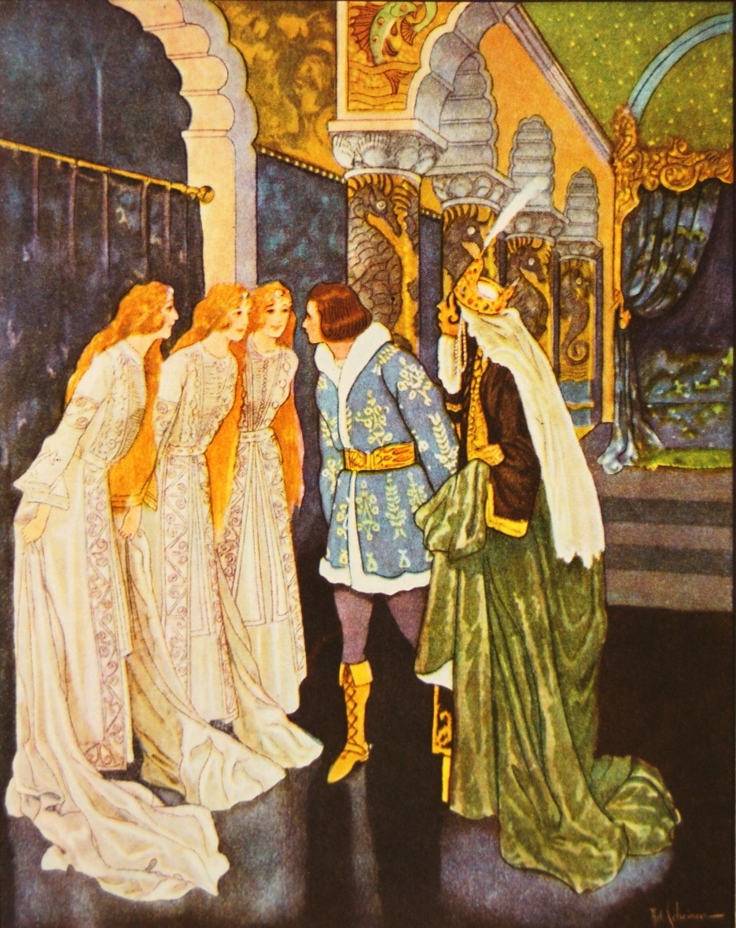

At that Zlatovlaska removed the white veil from her head and her lovely hair tumbled down to her feet like a golden cascade. It shimmered and glowed like the sun in the early morning when he peeps over the mountain top. Yirik stared until the brightness dimmed his sight.
The king immediately prepared Zlatovlaska, the Golden-Haired, for her journey. He gave her the two precious flasks of water; he arranged a fitting escort; and then with his blessing he sent her forth under Yirik's care.
Yirik conducted her safely to his master.
When the old king saw the lovely princess that Yirik had found for him, his eyes blinked with satisfaction, he capered about like a spring lamb, and he ordered that immediate preparations be made for the wedding. He was most grateful to Yirik and thanked him again and again.
"My dear boy," he said, "I had expected to have you hanged for your disobedience and let the ravens pick your bones. But now, to show you how grateful I am for the beautiful bride you have found me, I'm not going to have you hanged at all. Instead, I shall have you beheaded and then given a decent burial."
The execution took place at once in order to be out of the way before the wedding.
"It's a great pity he had to die," the king said as the executioner cut off Yirik's head. "He has certainly been a faithful servant."
Zlatovlaska, the Golden-Haired, asked if she might have his severed head and body. The king who was too madly in love to refuse her anything said: "Yes."
So Zlatovlaska took the body and the head and put them together. Then she sprinkled them with the Water of Death. Instantly the wound closed and soon it healed so completely that there wasn't even a scar left.
Yirik lay there lifeless but looking merely as if he were asleep. Zlatovlaska sprinkled him with the Water of Life and immediately his dead limbs stirred. Then he opened his eyes and sat up. Life poured through his veins and he sprang to his feet younger, fresher, handsomer than before. The old king was filled with envy.
"I, too," he cried, "wish to be made young and handsome!"He commanded the executioner to cut off his head and he told Zlatovlaska to sprinkle him afterwards with the Water of Life.
The executioner did as he was told. Then Zlatovlaska sprinkled the old king's head and body with the Water of Life. Nothing happened. Zlatovlaska kept on sprinkling the Water of Life until there was no more left.
"Do you know," the princess said to Yirik, "I believe I should have used the Water of Death first." So now she sprinkled the body and head with the Water of Death and, sure enough, they grew together at once. But of course there was no life in them. And of course there was no possible way of putting life into them because the Water of Life was all gone. So the old king remained dead.
"This will never do," the people said. "We must have a king. And with the wedding feast and everything prepared we simply must have a wedding, too. If Zlatovlaska, the Golden-Haired, cannot marry the old king, she'll have to marry some one else. Now who shall it be?"
Some one suggested Yirik because he was young and handsome and because, like the old king, he could understand the birds and the beasts.
"Yirik!" the people cried. "Let Yirik be our king!"
And Zlatovlaska, the Golden-Haired, who had long since fallen in love with handsome Yirik, consented to have the wedding at once in order that the feast already prepared might not be wasted.
So Yirik and Zlatovlaska, the Golden-Haired, were married and they ruled so well and they lived so happily that to this day when people say of some one: "He's as happy as a king," they are thinking of King Yirik, and when they say of some one: "She's as beautiful as a queen," they are thinking of.

