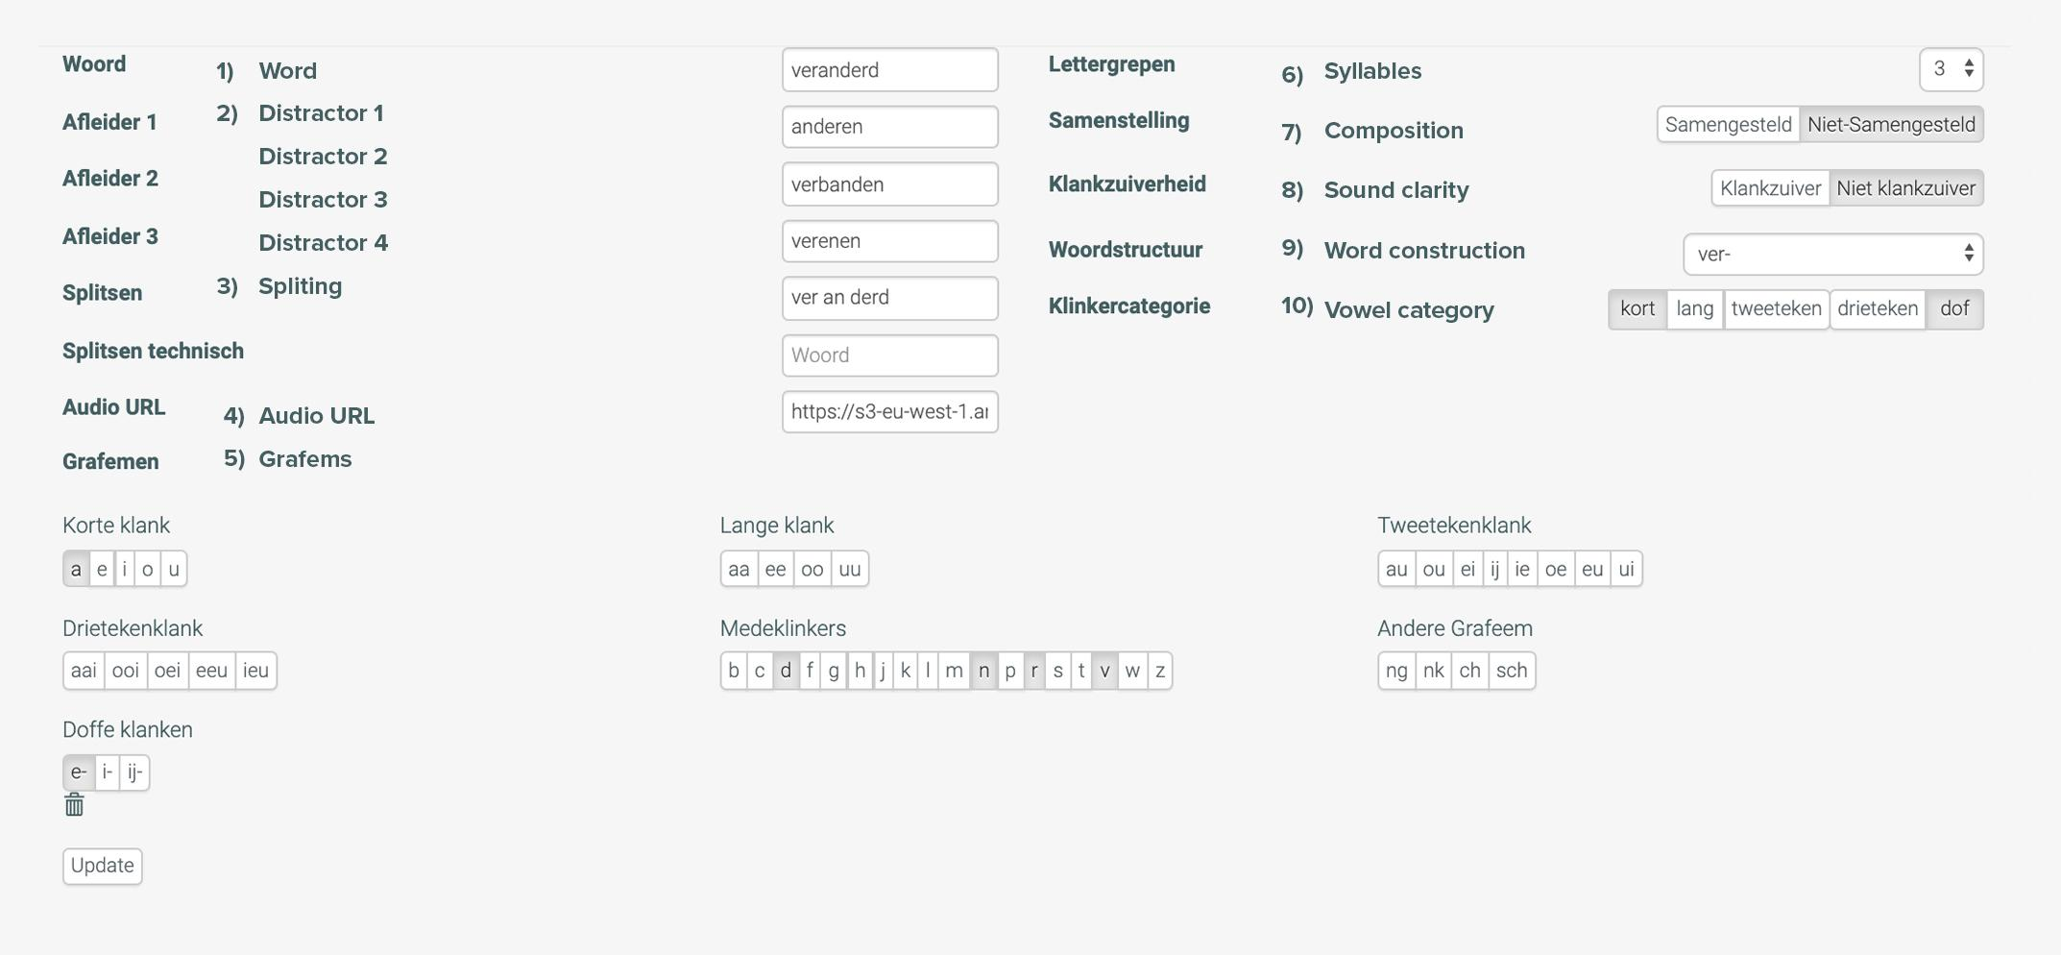

In this document I will explain how the word parameters work for each word and which settings are available. Every word in Karaton has 12 parameters. These exist to make sure very word is available in every reading exercises in Karaton.

1) Target word
This is the word children will see and is always the right answer in each exercises

2) Distractors
The distractors are words that look visualy or sound phonologically the same.
For example: target word can be “book” then a distractor can be “cook”. There always have to be 3 distractors imputed per word. if a new word is added for example “cook”. Book can now be used as a distractor.

3) Splitting
here the word has to be split by sylables. this is nesecary for the woord splitting games.
The word have te be writen per sylable with a ‘space’ to seperate them.

4) Audio URL.
All words need audio files. these files need to be in mp3 format. The main URL is always provided. Just enter the “word.mp3” at the end. All the audio files have to be deliverd to us so we can upload them to the server.

5) Graphemes
Select all the graphemes that are used in the word. For example for the woord ‘cook’ select C, OO, K. the OO is 1 grapheme. The graphemes can be different per language. In dutch there are long and short graphemes. These are called categories

Example
Long: aa, ee, oo, uu.
Short: a, e, o, u.
We will need a list of the graphemes and the specific naming of the categories for your language. Including special characters like é, è, à,.

6) Sylables
This is the amount of sylables that is used in a word. words with only 1 sylabe like ‘cook’ for example will not be used in the splitting mini game because this cant be split.

7) Composition
This is marks words that are composed out of 2 words or not. for example ‘football’ is a word that is composed out of 2 words ‘foot’ and ‘ball’. in this case the word is a ‘composed’ word. words as ‘cook’ is a none-composed word.

8) Sound clarity
This option is for words that you write a certain way but pronounce slightly different.

9) Word construction
This option can be different per amount of sylables. for example for 1 sylabe words this can be VC vowel consonant, or CV: consonant vowel. Other examples: cvc, ccv, ccvc,...
The options for this parameter is dependent on the university and how many different ones they want to include in the platfrom.

10) Vowel Category
This parameter was specifcly made for the dutch language. for describing a very specific sound of graphemes. its possible that this is not applicable in other languages

Please provide following information:

List of all graphemes, please write them below (example short letters: a, e, o, u, i,
Please write the names of the type of graphemes before each list)

write all graphemes here:

Does the option word composition needs to be available in your language?
yes / no

Does the option sound clarity needs to be available in your language?
yes / no

List all word construction options you want to be available in your language (with our academy partner we did not include all possible combinations only the ones most common)

Example
1 Syllable : cv, vc

2 Syllables: cvc, ccv, vvc

We use +3 syllables instead of 4 and 5 because at this point children will need to start learning to read sentences

Write word constructions here

1 Syllable:

2 Syllables:

3 Syllables:

+3 Syllables:

