Descartes strikes back: what is the soul?

0. A “forma assistens”?
- “forma assistens”, an “assistant form”, is the Latin expression used by medieval philosophers from the 13th century on, to designate Averroes’ position on mind:
- There is one intellect for all the human beings
- No personal intellect: no “personal destiny” = denial of the soul’s immortality, definition of human being as a bundle of sensitive powers, able to “reconnect” themselves to this higher intelligence, which is no personal intelligence
- Personal intelligence = forma corporis

I. Ens per se / Ens per accidens. (Loud) Medieval echoes in Descartes’ time

1. The definition of “ens per se”: what will become the “thing”, “res” or substance
What is not said of some other underlying subject—as what is walking is something different walking (and white), while a substance, and whatever signifies some ‘this,’ is just what it is without being something else. Thus, things which are not said of an underlying subject I call things in themselves, and those which are said of an underlying subject I call accidentals. [Aristotle, Posterior Analytics I, 4, 73b6-9]

2. Thomas Aquinas’ position: the union of soul and body is essential
(…) nothing operates except insofar as it actualized, each thing’s mode of operating (modus operandi) follows upon its mode of being (modus essendi ipsius). But even while a soul’s nature remains the same, its mode of being when it is united with a body is different from its mode of being when it is separated from its body—not in such a way that the soul’s being united to a body is incidental (accidentale) to it, but rather in such a way that it is by reason of its nature that the soul is united to a body. [Thomas Aquinas, ST Ia, q. 89, q. 1, Answer]

3. Utrecht, 1641: Regius, disciple of Descartes, pictures the accidental union of soul/body:
[IX] From the human mind and the body, it does not come out a being in its own right, but for accident (only); for, each of them, the soul and the body are perfect and complete substances. [X] When they are called incomplete, this must be understood in the wake of the compound, which is formed by their union. [H. Regius, Disputatio medica de illustribus aliquot quaestionibus physiologicis, III, art. 9-10, Utrecht, 1641]

4. What Descartes advises Regius to do:
You must believe as well that there is nothing more praiseworthy to a philosopher, then confessing sincerely her mistakes. For instance, when you say that man is a being for accident (ens per accidens), I know that you do not mean what all the other philosophers meant […] but, as schools do not understand by this term, being by accident, the same way you do, it is indeed better […] to confess honestly that you had not understood well such scholastic term than trying to hide this thing roughly, for instance, by claiming that you agree with them in general, but you use only different terms. Thus, every time that you will have the opportunity, you will have to claim, both privately and publicly, that man is a real being in its own right (ens per se) and not by accident. [R. Descartes, AT III, p. 492]

Why?

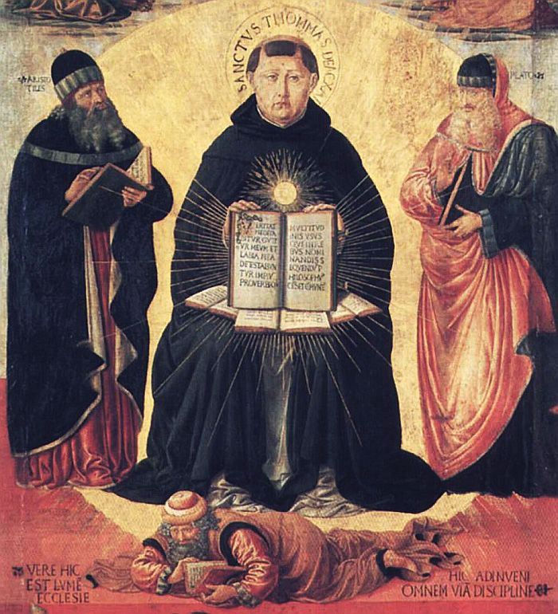
5. The scandal’s dimension:
To claim that man is not a substantial unity, would be the same than claiming that the soul can exist without the body, and consequently, to deny both resurrection of the body (dogma contested by the Socinians for instance) and hypostatical union of Christ (dogma denied by the Socinians, who did not believe to the divinity of Christ). [Th. Verbeek, Descartes et Regius. Autour de l’Explication de l’esprit humain, Amsterdam-Atlanta 1993, p. 9]

6. And last word to Thomas:

Plato, as his successors after him, claimed that the intellective soul is not united to the body as the form is united to the matter, but only as the mover [is united] to what is moved: for instance, as the sailor is united to its ship. (…) But this doctrine seems not to fit the facts. For, as a result of contact of power, a thing unqualifiedly one does not arise, as we have shown; whereas from the union of soul and body there results a man. On Plato’s theory, then, a man is not one unqualifiedly speaking, nor, consequently, is he a being unqualifiedly speaking, but a being by accident. [Summa contra Gentiles, II, chap. 57]

II. Descartes’ “involvement”: how far is his position indebted to Platonic/Arabic Dualism?

1. “Ens per se” or “Ens per accidens”? The 6th Meditation [1641]
Nature also teaches me through the sensations of pain, hunger, thirst and so on, that I am not merely present in my body as a sailor is present in a ship, but I am very closely joined and, as it were, intermingled with it, so that I and the body form a unit. If this were not so, I, who am nothing but a thinking thing, would not feel pain when the body was hurt, but would perceive the damage purely by the intellect, just as a sailor perceives by sight if anything in his ship is broken. Similarly, when the body needs food or drink, I should have an explicit understanding of the fact, instead of having confused sensations of hunger and thirst. For these sensations of hunger, thirst, pain and so on, are nothing but confused modes of thinking which arise from the union and, as it were, intermingling of the mind with the body. (R. Descartes, Meditations of First philosophy, tr. Cottingham, vol. II, p. 56)

2. The real distinction mind [soul] /body: Descartes’ metaphysic position on mind [1644]
[7] It is not possible for us to doubt that we exist while we are doubting; and this is the first thing we come to know when we philosophize in an orderly way. In rejecting – and even imagining to be false – everything which we can in any way doubt, it is easy for us to suppose that there is no God and no heaven, and that there are no bodies, and even that we ourselves have no hands or feet, or indeed any body at all. But we cannot for all that suppose that we, who are having such thoughts, are nothing. For it is a contradiction to suppose that what thinks does not, at the very time when it is thinking, exist. Accordingly, this piece of knowledge – I am thinking, therefore I exist – is the first and most certain of all to occur to anyone who philosophizes in an orderly way.
[8] In this way we discover the distinction between soul and body, or between a thinking thing and a corporeal thing. This is the best way to discover the nature of the mind and the distinction between the mind and the body. For if we, who are supposing that everything which is distinct from us is false, examine what we are, we see very clearly that neither extension nor shape nor local motion, nor anything of this kind which is attributable to a body, belongs to our nature, but that thought alone belongs to it. So, our knowledge of our thought is prior to, and more certain than, our knowledge of any corporeal thing; for we have already perceived it, although we are still in doubt about other things.
[9] What is meant by “thought”. By the term “thought”, I understand everything which we are aware of as happening within us, in so far as we have awareness of it. Hence, thinking is to be identified here not merely with understanding, willing and imagining, but also with sensory awareness. For if I say, “I am seeing, or I am walking, therefore I exist”, and take this as applying to vision or walking as bodily activities, then the conclusion is not absolutely certain. This is because, as often happens during sleep, it is possible for me to think I am seeing or walking, though my eyes are closed, and I am not moving about; such thoughts might eve be possible if I had no body at all. But if I take ‘seeing’ or ‘walking’ to apply to the actual sense or awareness of seeing and walking, then the conclusion is quite certain, since it relates to the mind, which alone has the sensation or thought that it is seeing or walking. [R. Descartes, Principles of Philosophy, I, §7-9, tr. Cottingham, p. 194-5]

2. The position of the mind: that is known before the body
How our mind is better known than our body. In order to realize that the knowledge of our mind is not simply prior to and more certain than the knowledge of our body, but also more evident, we should notice something very well known by the natural light: nothingness possesses no attributes or qualities. It follows that, wherever we find some attributes or qualities, there is necessarily some thing or substance to be found for them to belong to; and the more attributes we discover in the same thing or substance, the clearer is our knowledge of that substance. ///// Now we find more attributes in our mind than in anything else, as is manifest from the fact that whatever enables us to know anything else cannot but lead us to a much surer knowledge of our own mind. For example, if I judge that the earth exists from the fact that I touch it or see it, this very fact undoubtedly gives even greater support for the judgement that my mind exists. For it may perhaps be the case that I judge that I am touching the earth even though the earth does not exist at all; but it cannot be that, when I make this judgement, my mind which is making the judgement does not exist. And the same applies in other cases <regarding all the things that come into our mind, namely that we who think of them exist, even if they are false or have no existence>. [R. Descartes, Principles, I, §11, tr. Cottingham, p. 196]

3. And what about “the separate souls”?
Human minds separated from the body do not have sensation, strictly speaking. This does not apply to angels, nor is it conceivable by purely natural reason (ex sola ratione naturali), whether they were created as pure minds, distinct from the bodies, or like minds united to bodies; nor will I attempt at formulating any hypothesis, or to establish anything on these matters, upon which I have no certain ideas. [letter of Descartes to Henry More, AT V 402, my tr.]

Full text also in the following modern editions: Th. Verbeek, Descartes and the Dutch. Early Reactions to Cartesian Philosophy 1637-1650, Carbondale 1992; E.-J. Bos, The Correspondence between Descartes and Henricus Regius, Utrecht 2002.

