Autonomic nervous system

Laboratory exercise and seminar in medical physiology

Student protocol

Student:

Teacher:

Date:

Part 1: Basic tests of autonomic functions

Use PowerLab – Autonomic nervous system. Follow the instructions in PowerLab for recording and subsequent analysis of the ECG curve. At the end, download the Lesson report pdf as a protocol from today’s seminar.

1. Heart rate variability with breathing

When can you see higher variability of heart rate, during resting or deep breathing?
What is respiratory sinus arrhytmia?

2. Effect of posture on heart rate
Draw in the graph a curve of heart rate changes during the experiment.

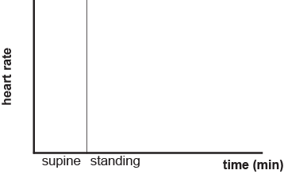

What is the mechanism of baroreceptor reflex? What structures take part in it?

3. Pupillary reflex
Which part of the ANS is responsible for this reflex response? Which center and which nerves are involved?

Part 2: Case study - Organophosphate intoxication

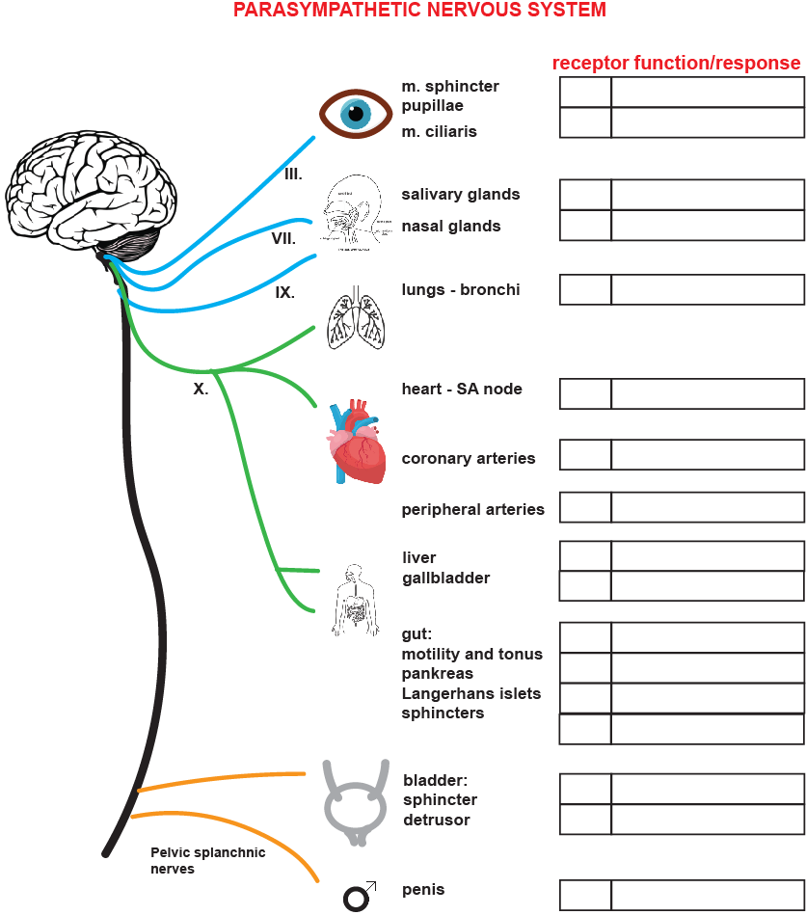

Fill in the figure the receptors and organ functions, for sure the type of receptor in SA node, the other receptors are not necessary.

Part 3: Case study - Fight-or-flight response – acute stress reaction

Experiment: Sympathetic activation using cold pain stimulus

https://backyardbrains.com/experiments/Sympathetic_Nervous_System

To activate your sympathetic nervous system, we will use the famous "ice water" stimulus. This is often used in pain studies as humans can tolerate it, everyone has experienced cold hands before, it is not scary and does not result in psychological damage, and is a good model stimulus easy to replicate in labs around the world. The longer you keep your hand in ice water, the more painful it becomes, activating your sympathetic nervous system, which will lead to an increase in heart rate.

Many of these reactions in both the sympathetic and parasympathetic systems are controlled by hormones, which can be helpful to think of as "neurotransmitters" but that enter the bloodstream instead of the synaptic cleft to find their targets, and instead of response times of 1 ms in the brain, hormones have response times in the scale of seconds to minutes on multiple structures in the body. For example, when the sympathetic nervous system is activated, the pituitary gland, which anatomically branches off of the hypothalamus in the brain, releases Adrenocorticotropic hormone (ACTH) into the bloodstream, increases cortisol levels, causing various physiological changes including heart rate increase. Simultaneously, the adrenal gland, a neural ganglion located on the kidneys, releases norepinephrine and has a similar effect on the heart.

Hypothesis – heart rate will increase after cold pain stimulus

Procedure:
1. Fill a bigger pod with ice up to 3/4 of the volume. Add cold water. Note that you are making ice water, not water with ice. Ice water ensures that the mixture is always in equilibrium at 0°C.
2. Place the electrodes for the ECG recording similarly to the previous experiment when testing the functions of the ANS. Use ECG recording setup for Heart rate variability.
3. Enter ECG measurement mode and start recording. Write "calm" and "ice" in the labels.
4. Wait a while for the resting heart rate to be recorded.
5. Immerse your hand in ice water so that the electrodes do not get wet.
6. Wait until the stimulus becomes painful so that it is almost impossible to tolerate. Stop the measurement. Remove your hand and wait until you feel your heart rate return to normal.
7. In the next window, perform a waveform analysis and read the heart rate at rest and during the painful stimulus. Write the values ​​in the table.
8. Repeat this 5 times to get average values.
9. If you repeat multiple observations, you can test a statistical hypothesis.

Part 4: Case study - Spinal cord injury and autonomic dysreflexia

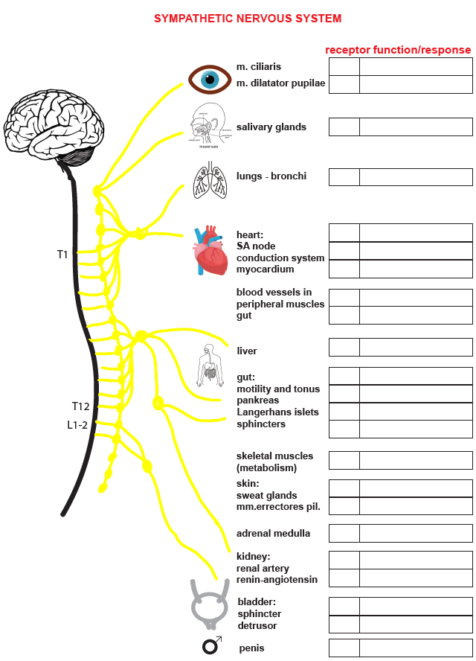

Fill in the figure the receptors and organ functions.

