(Follow up: on distinctness and basic notions)
Elizabeth to Descartes, 10.6.1643
But I’ve never been able to conceive of ‘what is immaterial’ in any way except as the bare negative ‘what is not material’, and that can’t enter into causal relation with matter!

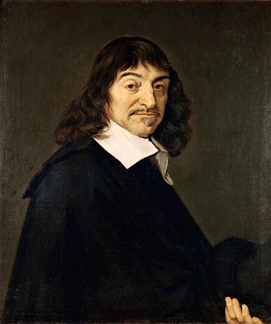
Descartes to Elizabeth (mash-up of 21.5. and 28.6.1643)
Certain basic notions…are like templates on the pattern of which we form all our other knowledge. There are very few of these. (…) the notion of extension, from which follow the notion of shape and movement; the notion of thought, which includes the notions of the perceptions of the understanding and the inclination of the will; and finally, for the soul and the body together, the notion of the soul’s power to move the body and the body’s power to act on the soul in causing its sensations and passions. […] I wrote as I did because I judged that it was these meditations, rather those other intellectually less demanding thoughts, that led you to find obscurity in our notion of their union [of body and soul of course]; because it seems to me that the human mind can’t conceived the soul’s (a) distinctness from the body and its (b) union with the body, conceiving them very clearly and both at the same time, etc.

to make things clearer, D. brings up the example of heaviness (“gravitas”)

- How does such example help us?

- Some features, which the Scholastics called “real qualities” (i.e. heaviness), are said by Descartes to depend solely on extension (or, on how a body is configurated)
- Among such features, we find movement, heaviness, sound, color
- But in order not to fall into error, we need to correctly attribute such features to the right notion (basically, either that of body or soul)
- These features, like the heaviness that bring a body to fall towards the center of the earth, are no real qualities (= are nothing “real”, like a thing, nor are they anything distinct from the body)
- There is only one real distinction, that between the first and the second “basic notions”
- Such notions reflect, mirror the (only and unique) two substances: body and soul

So, in conclusion, we learn something about distinctness and its methodological necessity
What is the place of the PA in Descartes’ philosophy?

1639: Discours de la méthode
1641: Meditationes de prima philosophia
1644: Principia philosophiae
1649: Passions de l’âme

I. A specific editorial plan: publishing a cursus of Cartesian philosophy
Letter to Mersenne, 11.11.1640 (AT III 233, l. 4-5)
My plan is to write, following a certain order, a whole course based on my philosophy in the forms of theses where, without anything superficial, I will only put all my conclusions, as well as the premises from which I derive them. I think I can do this without too many words. Also, in the same book, it will be printed a handbook of ordinary philosophy, like the one of Father Eustache, with my footnotes at the end of each question. In so doing I will correct the different opinion of the others; I will clarify what we have to retain of each and perhaps, at the end, I will make a comparison between the two philosophies (…)
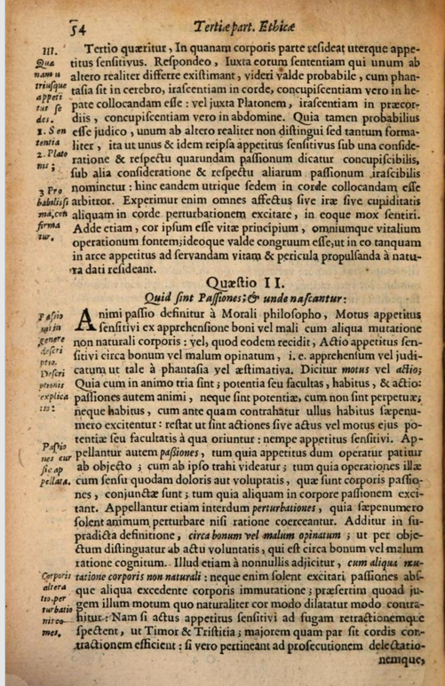
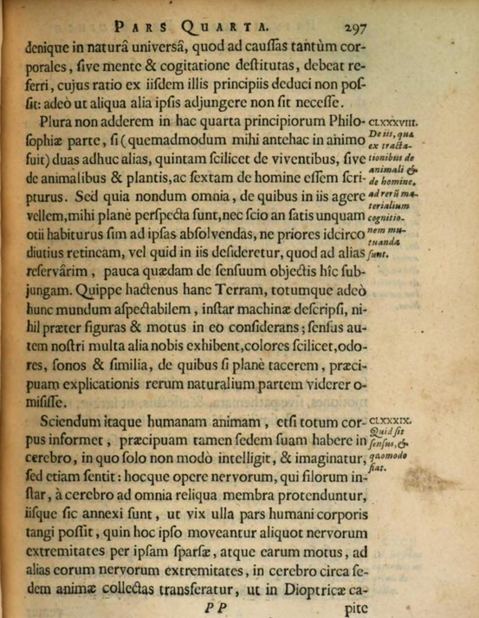

É. Gilson, Index scolastico-cartésien, p. 359:
(…) the last massive work by Descartes, the Principles of Philosophy (Principia Philosophiae), is like a handbook, destinated to replace in schools those that were usually employed to teach scholastic philosophy (…) the only way to reject Aristotle and the School, if this was the task, being that of replacing them.

What is a philosophy course? What did Descartes have in mind? He tells us. This:

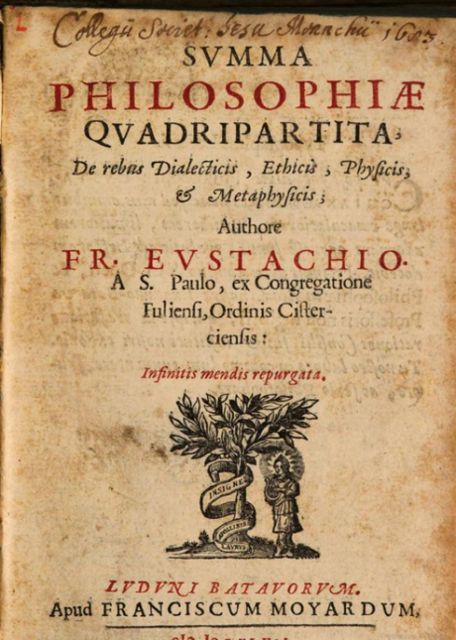
- Eustache de st. Paul (Paris, 1575 – 1640) is one of the few scholastics Descartes openly mentions (see letter quoted above)
- His Summa philosophiae quadripartita counts 13 editions from its first date of publication (1609) to 1649;
- Please mind the order of the disciplines therein treated: dialectics (logics), ethics, physics, metaphysics
- Please mind wherein Eustache treats the passions of the soul
- Moral or physics?
- Novelty of Descartes: treating the passions as a physician would do
- Passions de l’âme: a special follow up from the Principles of philosophy

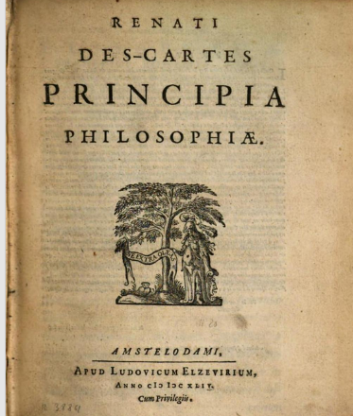
- The Principles of Human Knowledge (metaphysics)
- The Principles of Material Things (physics)
- The Visible universe (physics)
- The Earth (physics)
§188-199: constitute a small treatise on human beings’ sensitive faculty

What do you notice? What is missing?

Descartes, Principles of philosophy, IV, §188
I would not add anything further to this fourth part of the Principles of Philosophy if, as I originally planned, I was going on to write two further parts – a fifth part on living things, i.e. animals and plants, and a sixth part on man. (…)

Treating the passions as a physicist: this is the perspective Descartes wants to assume, in both PP and PA:
Descartes, Principles of philosophy, IV, §190
The wide variety in sensations is a result, firstly, of differences in the nerves themselves, and secondly of differences in the sort of motion which occur in particular nerves. It is not that each individual produces a particular kind of sensation; indeed, there are only seven principal group of nerves, of which two have to do with internal sensations and five with external sensations. The nerves which go to the stomach, esophagus, throat, and other internal parts whose function is to keep our natural wants supplied, produce one kind of internal sensation, which is called ‘natural appetite’ (e.g. hunger and thirst). The nerves which go to the heart and the surrounding area (including diaphragm), despite their very small size, produce another kind of internal sensation which comprises all the disturbances or passions and emotions of the mind such as joy, sorrow, love, hate and so on. For example, when the blood has the right consistency so that it expands in the heart more readily than usual, it relaxes the nerves scattered around the openings, and sets up a movement which leads to a subsequent movement in the brain producing a natural feeling of joy in the mind; and other causes produce the same sort of movement in these tiny nerves, thereby giving the same feeling of joy. Thus, if we imagine ourselves enjoying some good, the act of imagination does not itself contain the feeling of joy, but it causes the spirits to travel from the brain to the muscles in which these nerves are embedded. (…) In the same way, when we hear good news, it is first of all the mind which makes a judgement about it and rejoices with that intellectual joy which occurs without any bodily disturbance and which, for that reason, the Stoics allowed that the man of wisdom could experience <although they required him to be free of all passions>. But later on, when the good news is pictured in the imagination, the spirits flow from the brain to the muscles around the heart and move the tiny nerves there, thereby causing a movement in the brain which produces in the mind a feeling of animal joy. (…)

(Bonus: where are located the internal senses according to a long-durée tradition)

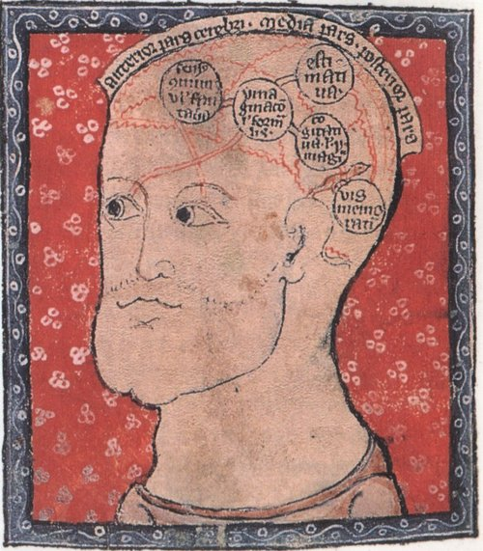
Common Sense (sensus communis)

Depository of the forms

Estimation (estimativa)

Memory (vis memorativa)

Cogitative (only for rational animals)

