Endokrinology I Student protocol
Classic endocrine glands
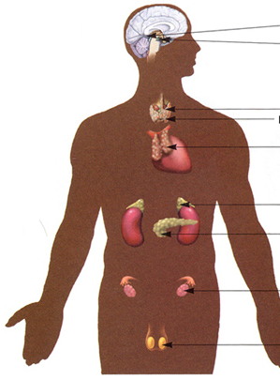
Other important hormones
heart
kidney
GIT
Adipose tissue
Endothelium
Chemical classification | Gland of origin | Hormones
Proteins, peptides,  Receptor | Hypothalamus
 | Pituitary
Thyroid
(parafollicular cells)
 | Parathyroid
 | Pancreas
 | Placenta
Amines  Receptor | Adrenal medulla
 | Pineal gland (epiphysis)
Thyroid  Receptor | Thyroid  (follicular cells)
Steroid hormones  Receptor | Adrenal cortex
 | Testes
 | Ovaries
 | Placenta

Regulation of hormone secretion
Simple negative feedback
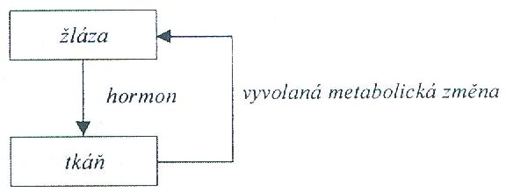

Complex negative feedback
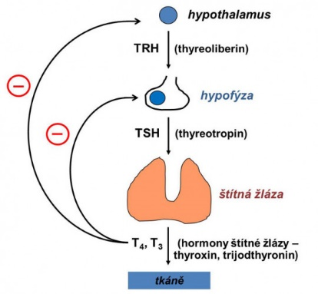

Adverse effects of Glucocorticoids

Estimate what adverse effects (resulting from their physiological function) you would be concerned about in patients taking glucocorticoids for long-term use to suppress immune responses.
a) when using local corticosteroids
b) systemic use of corticosteroids

