From darkness, dawn

http://www.economist.com/news/special-report/21566773-after-years-underachievement-and-rising-violence-mexico-last-beginning

After years of underachievement and rising violence, Mexico is at last beginning to realise its potential, says Tom Wainwright
Nov 24th 2012 |From the print edition

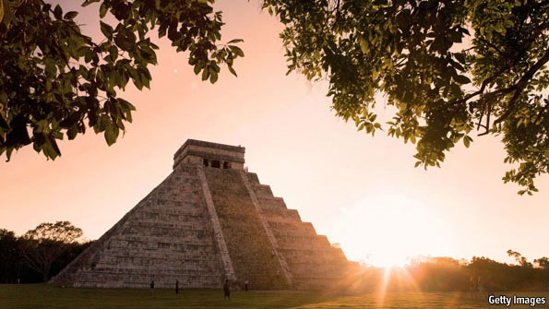
THE APOCALYPSE WAS on its way, and it would begin in Mexico. Where else? When archaeologists dug up Mayan calendars that ominously seemed to run out in the final days of 2012, some doomsayers predicted the end of the world. To many Mexicans it seemed like just another example of their country’s unending run of bad luck. The steepest recession on the American mainland, a plague of H1N1 swine flu and a deepening war against organised crime had made the preceding few years fairly grim. In 2009 the Pentagon had given warning that Mexico could become a “failed state”. Armageddon would be the icing on the cake.
But it turns out that the Mayan glyphs were misunderstood. The men with magnifying glasses now say that the world is not about to end—in fact, it seems that the Mayans were predicting something more like a renewal or a fresh start. Could the same be true of Mexico?
Special report
- From darkness, dawn
- Señores, start your engines
- Bureaucrats and backhanders
- A glimmer of hope
- The gain before the pain
- Stretching the safety net
- The ebbing Mexican wave
- The other American dream
- The 31 banana republics
Sources & acknowledgmentsReprints
Related topics
- Government and politics
- Felipe Calderon
- Politics
- Mexico
- World politics
This special report will argue that there is a good chance of it. Some awful years are giving way to what, if managed properly, could be a prosperous period for Latin America’s second-largest economy. Big, irreversible trends, from a falling birth rate at home to rising wages in China, are starting to move in Mexico’s favour. At the same time the country’s leaders are at last starting to tackle some of the home-grown problems that have held it back.
Many of the things that the world thinks it knows about Mexico are no longer true. A serially underachieving economy, repeatedly trumped by dynamic Brazil? Mexico outpaced Brazil last year and will grow twice as fast this year. Out-of-control population growth and an endless exodus to the north? Net emigration is down to zero, if not negative, and the fertility rate will soon be lower than that of the United States. Grinding poverty? Yes, but alleviated by services such as universal free health care. A raging drug war? The failure of rich countries’ anti-drugs policies means that organised crime will not go away. But Mexico’s murder rate is now falling, albeit slowly, for the first time in five years.
A vast country with deeply ingrained problems and unreformed corners, Mexico could yet squander the opportunities that are coming its way. But there are signs that it is beginning to realise its potential. With luck, the dire predictions made by the Pentagon and others may turn out to be as reliable as a misread Mayan calendar.
Preparing to lead Mexico into this brightening future is the party most associated with its past. The Institutional Revolutionary Party (PRI) ran Mexico without interruption for most of the 20th century, silencing opposition through a mixture of co-option, corruption and occasional violence. Only in 2000 did it give up its grip on power to the conservative National Action Party (PAN), which fielded two presidents in succession: Vicente Fox, a former executive at Coca-Cola, and Felipe Calderón, a lawyer whose father was a founding member of the party. On December 1st Mr Calderón will hand over the presidency to the PRI’s Enrique Peña Nieto, who won a clear election victory on July 1st. A handsome 46-year-old with a gift for communication, Mr Peña claims to be the opposite of the crooked party men who ran the country in its pre-democratic days. But will the change be more than superficial?
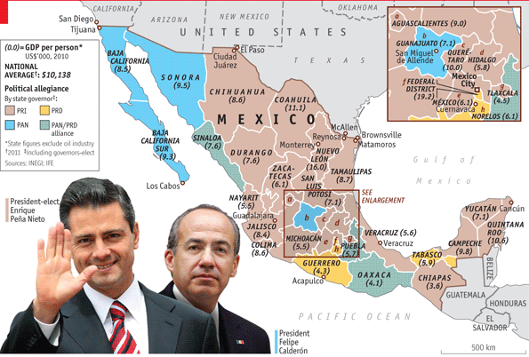
Mr Peña says his priority is to make the economy grow faster in order to reduce poverty. Nearly half the population are poor, many of them in the south (see map). To achieve more rapid growth he will need to introduce a series of big economic reforms, some of which Mr Calderón attempted during his presidency, only to see them get stuck in Mexico’s cantankerous Congress. The PRI had hoped to win a majority in the summer’s elections, but it fell short by 11 in the 500-member Chamber of Deputies and by four in the 128-member Senate. In any case, some of the most important reforms will need changes to the constitution, which require a two-thirds majority in Congress.
However, Mr Peña has reason to be optimistic. The opposition PAN shares much of Mr Peña’s agenda, and together the two parties have a two-thirds majority in both houses of Congress. A new power to fast-track two bills per congressional session will help. A lot will depend on who ends up leading the PAN, which is restive and rudderless after finishing third in the presidential election. The handover period between July’s election and December’s inauguration has been a model of presidential co-operation. Mr Calderón’s crackdown on Mexico’s vindictive criminals has given him a personal reason to stay on good terms with the new government, to make sure of the protection he and his family will need when he leaves office.
Fighting on two fronts
Mr Peña’s main problem in Congress may well be his own party. As this special report went to press Congress was about to pass a labour-law reform, which among other things would make hiring and firing easier. But linked measures to make Mexico’s over-mighty unions more transparent and democratic were voted down by congressmen from Mr Peña’s own PRI, which has strong ties to unions. If the unions cannot be tamed, Mr Peña’s other reforms—to open up the monopolised energy sector and overhaul the tax system—may be similarly diluted.
The runner-up in the election was the left-winger Andrés Manuel López Obrador, known as AMLO, who came a very close second to Mr Calderón in 2006 but lost to Mr Peña by 6.8%. After both defeats he claimed fraud. The evidence is thin. The left has about a quarter of the seats in Congress, but many of its congressmen have little patience with AMLO, whose magnetic personality repels as many voters as it attracts.
The government may also face opposition outside Congress. Though a majority of the political class now seems to be convinced of the need for economic reforms along the lines that Mr Peña proposes, the same may not yet be true on the street, in the public universities or in much of the press. “Mexico is a country where doctrine and principle matter more than practical considerations and results,” says Enrique Krauze, a historian. The state-run oil monopoly is the sort of sacred cow that could emit a deafening, destabilising moo if Mr Peña tried to tether it. Mexico City already sees an average of 14 protests a day.
The internet is making politics more unpredictable. During the election campaign Mr Peña paid a disastrous visit to a university and fled after being heckled. This gave rise to an anti-Peña student movement calling itself YoSoy132, or “I am the 132nd” (the initial protest was led by 131 students). It is now capable of summoning large crowds via Twitter and Facebook to march against Mr Peña (and often, it seems, for AMLO). During Mexico’s independence celebrations on September 16th anonymous hackers took down several government websites.
So it will not be an easy ride. Mr Krauze remembers that the optimism when the North American Free-Trade Agreement (NAFTA) came into force in 1994 was quickly punctured by the Zapatista uprising in Mexico’s south on New Year’s Day. “We thought we were there in the first world, on the final lap of our historic marathon. Then on January 1st we woke up to the astonishing news of a rebellion in Chiapas,” he says.
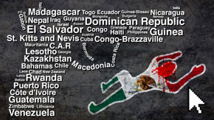Compare the murder rate and body count of each Mexican state against entire countries with our interactive equivalents map
Mexico has form in turning triumph to disaster, and could yet do so again. Its economy remains dependent on the fortunes of the United States, and financial crises in Europe make investors jittery. Promised reforms will depend on persuading entrenched interests to accept them. Corruption and bad government, especially at the local level, may cause good initiatives to fall at the last hurdle. And the drug war is by no means over. But Mexico deserves a fresh look—not least because its economy is revving up, as the next article explains.

http://www.economist.com/news/special-report/21566782-cheaper-china-and-credit-and-oil-about-start-flowing-mexico-becoming

The economy

Señores, start your engines

Cheaper than China and with credit and oil about to start flowing, Mexico is becoming a Brazil-beater
Nov 24th 2012 |From the print edition

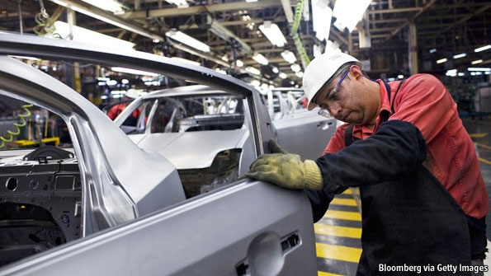Hecho en México
CUERNAVACA, A ONCE pretty, now sprawling city with volcano views just south of the capital, is a typical Mexican town. Hernán Cortés stopped off there after toppling the Aztec emperor Moctezuma in 1520; the conquistador’s stables have since been converted into a smart hotel. Yet on the outskirts of the city, in an enormous industrial park, a visitor could forget he was in Latin America. Nissan, a Japanese car giant, has created a factory the size of a village where from next year it will begin turning out thousands of yellow and chessboard-chequered New York City taxis.
Once shuttered off by tariffs and trade controls, Mexico has opened up to become a place where the world does business. The North American Free-Trade Agreement (NAFTA), which in 1994 eliminated most tariffs between Mexico, the United States and Canada, was only the beginning: Mexico now boasts free-trade deals with 44 countries, more than any other nation. In northern and central Mexico German companies turn out electrical components for Europe, Canadian firms assemble aircraft parts and factory after factory makes televisions, fridge-freezers and much else. Each year Mexico exports manufactured goods to about the same value as the rest of Latin America put together. Trade makes up a bigger chunk of its GDP than of any other large country’s.
Special report
- From darkness, dawn
- Señores, start your engines
- Bureaucrats and backhanders
- A glimmer of hope
- The gain before the pain
- Stretching the safety net
- The ebbing Mexican wave
- The other American dream
- The 31 banana republics
Sources & acknowledgmentsReprints
Related topics
- Pemex
- Brazil
- United States
- Mexico
- Asia
Normally that would be a good thing, but after the 2007-08 financial crisis it meant that Mexico got a terrible walloping. Thanks to its wide-open economy and high exposure to the United States it suffered the steepest recession on the American mainland: in 2009 its economy shrank by 6%. The country had already had a rocky decade. When China joined the World Trade Organisation in 2001, it started undercutting Mexico’s export industry. In the ten years to 2010 Mexico’s economy grew by an average of just 1.6% a year, less than half the rate of Brazil, which flourished in part by exporting commodities to China.
But now changes are under way, in Mexico’s factories, its financial sector and even its oil and gas fields, that augur well for a very different decade. Latin America’s perennial underachiever grew faster than Brazil last year and will repeat the trick this year, with a rate of about 4% against less than 2% in Brazil. Mr Peña is aiming to get annual growth up to 6% before his six-year presidency is over. By the end of this decade Mexico will probably be among the world’s ten biggest economies; a few bullish forecasters think it might even become the largest in Latin America. How did Mexico achieve such a turnround?
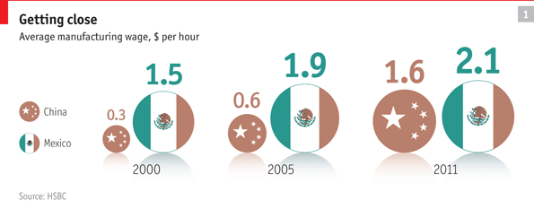
China’s cut-price export machine sucked billions of dollars of business out of Mexico. But now Asian wages and transport costs are rising and companies are going west. “The China factor is changing big-time,” says Jim O’Neill, the Goldman Sachs economist who in 2001 coined the “BRICs” acronym—Brazil, Russia, India and China—much to Mexico’s irritation. China is no longer as cheap as it used to be. According to HSBC, a bank, in 2000 it cost just $0.32 an hour to employ a Chinese manufacturing worker, against $1.51 for a Mexican one. By last year Chinese wages had quintupled to $1.63, whereas Mexican ones had risen only to $2.10 (see chart 1). The minimum wage in Shanghai and Qingdao is now higher than in Mexico City and Monterrey, not least because of the rocketing renminbi.
Right next door
Hauling goods from Asia to America is costlier too. The price of oil has trebled since the start of the century, making it more attractive to manufacture close to markets. A container can take three months to travel from China to the United States, whereas products trucked in from Mexico can take just a couple of days. AlixPartners, a consultancy, said last year that the joint effect of pay, logistics and currency fluctuations had made Mexico the world’s cheapest place to manufacture goods destined for the United States, undercutting China as well as countries such as India and Vietnam.
Companies have noticed. “When you wipe away the PR and look at the real numbers, Mexico is startlingly good,” says Louise Goeser, the regional head of Siemens, a German multinational. Siemens employs 6,000 people at 13 factories and three research centres around Mexico. From its recently enlarged facility in Querétaro, in central Mexico, surge-arrestors and transformers trundle up to warehouses in the central United States in two days. Ms Goeser says that Mexican workers are well qualified as well as cheap: more engineers graduate in Mexico each year than in Germany, she points out.
In Aguascalientes, not far away, Nissan is building a $2 billion factory. Together with an existing facility it will turn out a car nearly every 30 seconds. About 80% of the parts in each car are made in Mexico. By using local suppliers, the company is “armoured” against currency fluctuations, says José Luis Valls, head of Nissan Mexico. “If you are localised, you can navigate through floods and storms. If you depend on imports of components, you are very fragile.” In nearby Guanajuato Mazda and Honda are building factories; Audi is constructing a $1.3 billion plant in Puebla. This year Mexico will turn out roughly 3m vehicles, making it the world’s fourth-biggest auto exporter. When the new factories are up and running, capacity will be 4m.
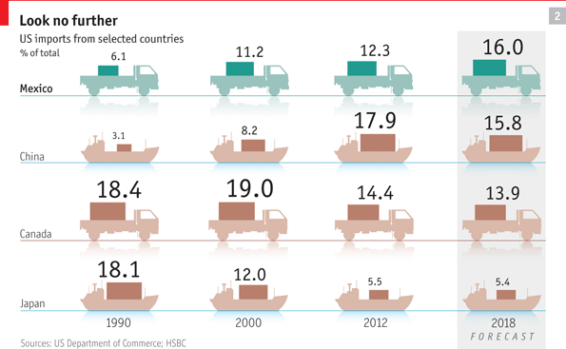
According to projections by HSBC, in six years’ time the United States will be more dependent on imports from Mexico than from any other country (see chart 2). Soon “Hecho en México” will become more familiar to Americans than “Made in China”.
On the opposite side of Cuernavaca from Nissan’s gigantic factory, Antonio Sánchez plays a smaller role in Mexico’s motor business. At his carwash customers queue to pay 46 pesos ($3.60) for their cars to gleam in the ever-present sun. Mr Sánchez seems to have enough business to open another branch, but credit is scarce and expensive. He explains that banks tend to charge interest rates of 25% or more and demand collateral worth three times the value of the loan. “It’s complicated, expensive and the risk is too much,” he says.
Mexican businesses have been fighting with one hand tied behind their backs, thanks to a chronic credit drought. Lending is equivalent to 26% of GDP, compared with 61% in Brazil and 71% in Chile. The drought started with the “tequila crisis” of 1994, when a currency devaluation triggered the collapse of the country’s loosely regulated banking system. Banks spent the best part of a decade dealing with their dodgy legacy assets and were nervous about making new loans.
But things are looking up. Inflation, now running at 4.6%, has been well under control for ten years. The conservatively run Mexican subsidiaries of foreign banks such as BBVA, Citigroup and Santander are all rated higher than their American or European parent companies. Now they are starting to turn on the credit tap. Loans to companies are growing at 12% a year and to individuals at 23%. Given that many enterprises are informal, many of these “personal” loans probably go to businesses, according to David Olivares of Moody’s, a ratings agency. “There are many financing opportunities in Mexico that are not tapped,” says Agustín Carstens, the governor of the central bank. This gives Mexico an advantage over other Latin American countries that are deep in debt. Five to six consecutive years of loan growth, coupled with macroeconomic stability, would increase Mexico’s annual growth rate by half a percentage point, the central bank estimates.
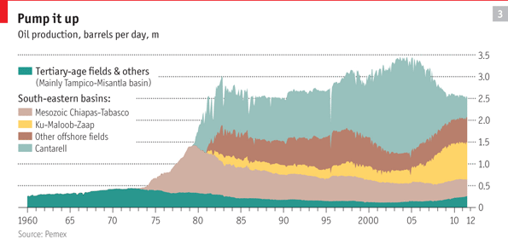
As credit starts flowing, so could oil. Since striking black gold in the 1970s, Mexico has been one of the world’s ten biggest oil producers. The revenues of Pemex, the state-run oil and gas monopoly, provide about a third of the government’s income. But that is part of the problem. The company is “horribly run”, says Juan José Suárez Coppel, its director. He complains that successive governments have milked Pemex rather than let it invest in exploration and technology. It takes between six and eight years from discovering oil to pumping it, so “no president who invests is going to see the barrels,” Mr Suárez points out. Each time a new field is discovered the company allows others to go into decline (see chart 3). Production has slipped from 3.4m barrels a day to 2.5m, and safety is wobbly: in September 30 people died in a gas explosion in Reynosa, near the Texan border.
Ten years ago a change in budgeting rules allowed more investment in exploration, and reserves have risen. This year production is expected to increase for the first time in eight years, but far more lies unexploited. Pemex reckons that there could be nearly 30 billion barrels under the Gulf of Mexico, more than half of the country’s prospective reserves. But starved of money, the company has been slow off the mark to exploit it. Between 2006 and 2011 it drilled 18 wells in deep waters; Petrobras, its opposite number in Brazil, drilled 101. Shale oil and gas, and “tight” oil, are further opportunities waiting to be exploited.
Plenty of foreign companies are keen to start drilling in Mexico, but since the nationalisation of the oil industry in 1938 Mexico has been wary of dealing with gringos. That might now change. Mr Peña has promised an energy reform early in 2013. Many would like Pemex to do as Brazil did and allow competition. Petrobras lost its monopoly in 1997 and made the world’s biggest share offering in 2010. Will Pemex follow suit? “I don’t see it in the immediate future,” says Luis Videgaray, Mr Peña’s closest aide. However, Pemex “has to take steps in that direction,” beginning with improving its corporate governance, he says.
There are some less radical options. Since 2008 Pemex has offered incentive-based contracts under which private firms are paid according to how much oil they extract. The next step would be contracts in which companies share the risk—and potential reward—of drilling in uncertain areas. “Incentive-based contracts have big limitations…We want a reform that allows the private sector to share more risk with Pemex in order to attract more capital and more technology,” says Mr Videgaray. Such a reform would probably mean changing the constitution, which defines oil as the property of the nation. It would be “a signal that echoed around the world: a before-and-after in the history of Mexico,” says Héctor Aguilar Camín, a historian.
What could stop Mexico on its march to growth? One risk is a protracted slowdown in the United States, the destination of four-fifths of Mexico’s exports. Mr O’Neill points out that consumption in the United States amounts to about 70% of GDP; in the long run it will probably fall to around 65%. “That’s not good if you’re setting yourself up as an exporter next door,” he says.
Slimming the monopolies
But Mexico has created a few obstacles of its own which it urgently needs to remove. Goldman Sachs’s “growth environment score”, which measures the likelihood of sustainable growth, ranks Mexico below Brazil, partly because it scores badly on technology. Mobile-phone penetration is 85%, about the same as in Iraq. A fast broadband connection in Mexico costs nearly twice as much as in Chile. It does not help that telecommunications are a near-monopoly. Carlos Slim, the world’s richest man, controls companies that account for about 80% of fixed phone lines, 75% of broadband connections and 70% of mobiles.
Excessive concentration afflicts many other sectors, sometimes as a hangover from the pre-democratic days when political support was bought by granting informal monopolies. Nearly all of Mexico’s bread comes from Bimbo, cement from Cemex and television from Televisa. Nearly a third of household spending goes on products with monopoly or tight-oligopoly suppliers.
The competition authorities have recently been given teeth, with bigger fines and even prison sentences for offenders. Mr Slim’s phone companies are being forced to compete with Televisa’s television empire as technology joins up the two markets. Mr Peña has promised special courts to settle competition disputes. He may also remove the ban on foreign ownership of companies in some industries. “It’s a good moment to review whether Mexico needs these sorts of restrictions,” says Mr Videgaray, pointing to fixed-line telephones and airlines as examples. If Mr Peña can dynamite a few monopoly bottlenecks, there will be a better chance of the 6% growth he wants.
From the print edition: Special report

http://www.economist.com/news/americas/21571880-three-months-after-taking-office-enrique-pe%C3%B1a-nieto-rewriting-his-reform-agenda-tearing-up

Mexico’s new president

Tearing up the script

Three months after taking office, Enrique Peña Nieto is rewriting his reform agenda
Feb 16th 2013 | MEXICO CITY |From the print edition

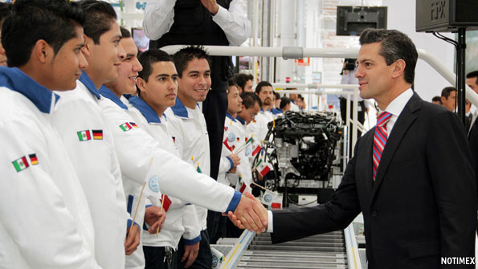
LAST summer Enrique Peña Nieto’s determined face stared down from election posters, promising Mexicans: “You know I will deliver.” Just over 38% of voters were convinced, enough to hand him the presidency. Since his inauguration on December 1st he has indeed delivered several new policies and reforms—just not the ones voters and pundits expected.
During the campaign Mr Peña’s aides in the Institutional Revolutionary Party (PRI) said that before Christmas of 2012 there would be a fiscal reform to increase the government’s meagre tax revenues. That would be swiftly followed by a shake-up of the energy industry to give a competitive nudge to Pemex, the state-run oil and gas monopoly, at whose headquarters a suspected gas explosion killed 38 people on January 31st. Mr Peña’s critics retorted that he was a puppet of special interests, such as the teachers’ union and powerful broadcasters.
In this section
- Tearing up the script
- Unstoppable?
- If you build it
- Now or never
Reprints
Related topics
- Pemex
- Andres Manuel Lopez Obrador
- Mexico
- Politics
- World politics
Today the situation seems to have reversed. The promised tax and energy reforms have been pushed back to the second half of this year, with assurances that Pemex will not be privatised (though joint ventures with private firms are likely). Meanwhile Mr Peña’s legislators have turned their guns on those they were expected to protect. In January Mexico’s states ratified a constitutional reform that paves the way for better training and stricter evaluation of teachers, which should undermine the power of the union. An enabling law is due before the summer.
Now the government has set its sights on telecoms. According to Aurelio Nuño, the president’s chief of staff, within two months the PRI will present a bill to attack the “great problem of concentration” in telephony, internet and television. It promises to chip away at the business empire of Carlos Slim, the world’s richest man, and that of Televisa, a broadcasting giant with mediocre soap operas but outstanding lawyers who have helped it to hold on to a 70% share of free-to-air viewers, as well as about half the pay-TV market.
Mr Peña’s change was partly prompted by the circumstances of his election. His 6.6% margin of victory fell short of the predicted landslide. Nor did the PRI manage to win a majority in either chamber of Congress. Andrés Manuel López Obrador, a left-wing candidate who came second, made unsubstantiated claims of fraud, which he later levelled against the electoral institutions when they dismissed his claims. Mr Peña’s strike against Televisa is partly designed to undermine the claim that he is too cosy with them. Similarly, a reform in December to beef up freedom-of-information laws, by allowing appeals at the federal level if states refuse requests, is geared towards countering the PRI’s secretive image.
The other reason for the change of tack is an unexpected alliance struck in December between the PRI and the two main opposition parties. The “Pact for Mexico”, which contains 95 policy proposals on subjects from health to human rights, is the government’s biggest achievement so far, Mr Nuño says. The three parties that have signed up hold nearly every seat in Congress. Only a few leftists are holding out.
Through the pact, the government has gained cross-party support for its raids on teachers and telecoms, which are not vital to the opposition’s electoral base. The agreement will come under strain when the time comes to attack a group tied to a specific party. The fiscal reform will mean raising sales taxes by some combination of higher rates, the inclusion of food and medicine or the abolition of a low-tax zone near the United States border. The centre-left Party of the Democratic Revolution (PRD) fears that its supporters may defect to Mr López Obrador, who quit the party in September, if it goes along. Reforming Pemex could prove still more controversial—not least with the rank and file of the PRI, which overlap heavily with the oil workers’ union.
Mr Peña must make the most of the pact before July 7th, when elections in 14 states will pit the three parties against each other. In Baja California the PRI hopes to unseat the conservative National Action Party (PAN) for the first time in 24 years. A bad showing could mean curtains for the PAN’s embattled president, Gustavo Madero. The left faces a bigger split, as Mr López Obrador goes about founding a party of his own. Co-operation will be harder if both opposition parties fall into disarray.
Mr Peña’s agenda could also be knocked off course by security, as happened to the previous president, Felipe Calderón. José Antonio Meade, an economist appointed to be foreign secretary, has begun to steer the conversation about Mexico onto happier subjects, such as the roaring export sector. The murder rate is at its lowest in three years. But new fronts of violence have opened on the edge of the capital and in Acapulco, where six Spanish women were raped by gunmen in a beach house on February 4th. Mr Peña is wise to have ditched Mr Calderón’s drug-war rhetoric, says Juan Pardinas, the head of IMCO, a think-tank, but he has gone “from the wrong narrative to no narrative at all”. On February 12th the government unveiled its second anti-crime plan in as many months, focused on the country’s 100 most violent towns. A promised “gendarmerie” of 10,000 former soldiers will not be created until the end of the year.
Less than 100 days into his presidency, Mr Peña’s unexpected course is bringing some dividends. His political ad-libbing in response to changing conditions has so far been deft. But many of the government’s boldest promises have not yet been achieved, and need to be.
From the print edition: The Americas

http://www.economist.com/news/special-report/21566783-paperwork-dwindling-bribes-persist-bureaucrats-and-backhanders

Bureaucrats and backhanders

The paperwork is dwindling, but bribes persist
Nov 24th 2012 |From the print edition

A BUDDHIST MONK, some neatly dressed Mormon missionaries and a young Guatemalan reading Nietzsche are among those waiting in the offices of the National Institute of Migration for their visas to be issued. Clerks tell visitors to take a seat—a mischievous joke, since there are vastly more people than chairs in the cramped waiting room. The air is thick with boredom and barely stifled rage.
Doing business in Mexico can be a frustrating experience, thanks to the country’s affection for trámites, or red tape. Woe betide anyone who seeks a permit without the requisite number of photocopies or a notary’s stamp. Until recently foreigners of both sexes who wanted to live in Mexico had to fill in a form that included questions on their style of moustache (thin, trimmed or bushy?).
As well as raising the national blood pressure, trámitesopen the door to corruption. If you don’t want to spend all day in the police station to pay a speeding fine, you can settle in cash by the roadside. An under-the-counter express service at the local council will quickly get you a permit for your restaurant to put tables on the pavement, for a small fee. Even Walmart, a multinational retailer, has been accused of paying backhanders to speed up the opening of new stores in Mexico.
Special report
- From darkness, dawn
- Señores, start your engines
- Bureaucrats and backhanders
- A glimmer of hope
- The gain before the pain
- Stretching the safety net
- The ebbing Mexican wave
- The other American dream
- The 31 banana republics
Sources & acknowledgmentsReprints
Related topics
- Mexico
Ending corruption will require cleaner public servants and a more indignant public. But the risk of graft can be lowered by removing the obstacles that tempt people to use illegal shortcuts. Registering a property in Mexico calls for seven separate trámites over ten weeks, whereas in America it involves four steps and takes a fortnight.
The queues are already shortening and the paperwork is thinning. Companies can file taxes online, which has cut the time it should take to about 340 hours a year. That sounds a lot, but in Brazil it takes 2,600 hours. Getting a construction permit in Mexico takes an annoying two-and-a-half months; in Argentina it takes a year. The World Bank ranks Mexico as one of the most straightforward places in Latin America to do business.
Petty corruption remains a gigantic problem. Transparency International, a graft watchdog, reckons that Mexican households spend about 32 billion pesos ($2.5 billion) a year on bribes, often to do things that ought to be free, such as having their rubbish collected or even sending their children to school. Worse, the burden falls disproportionately on the poor. The bonfire of the trámitesmust burn on.
From the print edition: Special report

http://www.economist.com/news/special-report/21566780-falling-ill-no-longer-economic-disaster-stretching-safety-net

Stretching the safety net

Falling ill is no longer an economic disaster
Nov 24th 2012 |From the print edition

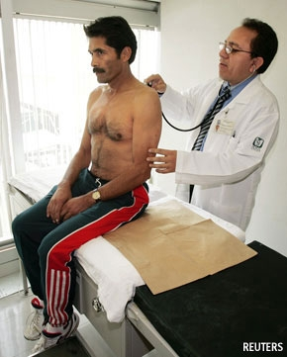Has the pain in the wallet stopped?
IN SOME RICH countries it remains a distant hope, but in Mexico free universal health care became more or less a reality this year. Having insurance used to be contingent on having a salaried job, which left about half of Mexico’s population with only the most basic care. But since 2004 a programme called Seguro Popular (Popular Insurance) has been gradually rolled out all over the country to provide better services to those without employment-linked insurance. The overwhelming majority of Mexicans are now covered—“a remarkable feat”, according to the Lancet, a British medical journal.
To cover the uninsured, the government has increased its spending on health from 5% of GDP at the turn of the century to nearly 6.5%, which is still lower than in most of the rich world. More than 200 new hospitals and 2,000 clinics have been built and thousands more renovated. The ratio of doctors to patients is up by more than half.
Special report
- From darkness, dawn
- Señores, start your engines
- Bureaucrats and backhanders
- A glimmer of hope
- The gain before the pain
- Stretching the safety net
- The ebbing Mexican wave
- The other American dream
- The 31 banana republics
Sources & acknowledgmentsReprints
Related topics
- Politics
- Mexico
- World politics
- Latin American politics
- Mexican politics
Mexicans’ health has perked up dramatically in some areas. Since 2008, when Seguro Popular began providing a vaccine against rotavirus, a common cause of diarrhoea, deaths from the illness have fallen by 60%. When the programme started to pay for treatment of acute leukaemia in children, the survival rate improved from three in ten to seven in ten. Nearly a third of women with breast cancer used to abandon treatment because they could not afford it. Since 2008, when treatment became free, the drop-out rate has come down almost to zero.
Insurance has saved many people from another affliction: poverty. When the poorer half of the population had to pay for medicines or procedures not covered by state hospitals, millions of families were bankrupted by illness. Julio Frenk, a former health secretary who oversaw the beginning of Seguro Popular and is now dean of Harvard’s School of Public Health, recalls meeting a family in which the mother had needed a Caesarean section and the baby had spent a couple of weeks in intensive care. The child survived, but the medical bill cost his father his animals and tools and meant that his brother had to be taken out of school. “People liquidated their productive assets and their poverty was transmitted to the next generation,” says Mr Frenk. Until the late 1990s nearly 7% of families were dragged below the poverty line each year by medical emergencies. By 2010 the figure had fallen to less than 3%.
Seguro Popular is still a work in progress. Quality is patchy and people in remote regions have to trek a long way to see a doctor. Mr Frenk estimates that about 5% of the population are still not covered. Some conditions are not yet being paid for. There is a shortage of specialist doctors, and some rural clinics are manned by students.
There are also big regional disparities. Nine out of ten pesos going on Seguro Popular are spent by state governments, and the results are mixed. “We need to work on accountability,” acknowledges Salomón Chertorivski, the health secretary. When some states inexplicably paid far more than the market value for certain drugs, the federal government set maximum prices for medicines. There have been reports of bent doctors tricking people into paying for their supposedly free care. The government has introduced a system of certification for clinics. But in rural areas it is still hit-and-miss—one reason why Mexico’s infant-mortality rate remains stubbornly high.
Success in treating communicable diseases has brought new problems. The biggest killer now is diabetes, brought on by sugary diets and sedentary lifestyles. Mexicans are among the world’s fattest people: 70% are overweight, more than in the United States. A third of women are obese, double the OECD average. On a per-head basis, Mexico has the world’s highest consumption of Coca-Cola. In rural areas seven out of ten children have a fizzy drink with their breakfast, according to Consumer Power, a civil organisation. Public sports facilities are scarce, which may help to explain why Mexico came only 39th in this year’s Olympics, level with Georgia, which has only a small fraction of its population. Health care may be expanding rapidly, but so are waistlines.
From the print edition: Special report

http://www.economist.com/news/special-report/21566781-worlds-biggest-migration-has-gone-reverse-ebbing-mexican-wave

Migration

The ebbing Mexican wave

The world’s biggest migration has gone into reverse
Nov 24th 2012 |From the print edition

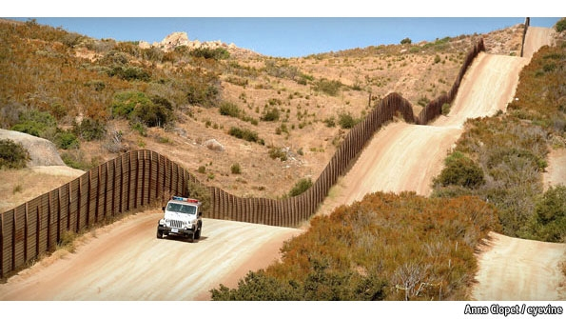
FROM A VANTAGE point on a scrubby hillside south of San Diego, Mike Jiménez, an agent with the United States Border Patrol, gazes across the Mexican frontier into Tijuana. For decades the poor neighbourhood of Colonia Libertad, rammed up against the border fence, has served as a base for illicit crossings. From its tin rooftops scouts peer over to the United States, monitoring the movements of Mr Jiménez and his colleagues and relaying their positions by mobile phone to migrants as they creep across the border. Mr Jiménez has little time for thecoyotes who guide people into the United States. “They don’t care about lives, they care about the money they’re going to make. If someone twists an ankle or breaks their leg, they leave them behind,” he says. On average, one person dies every day trying to cross the 2,000-mile border.
The decades-old game of cat and mouse between Mexican migrants and la Migra, as the American migration authorities are known, has historically been a fairly one-sided contest. About one in ten Mexican citizens, 12m in total, live in America, half of them illegally. This makes for the biggest immigrant community in the world. (The wider Mexican-American community, including the American-born offspring of immigrants, comes to about 33m.) After Mexico City, the world’s biggest collection of Mexican citizens is found not in Guadalajara or Monterrey but in Los Angeles.
Special report
- From darkness, dawn
- Señores, start your engines
- Bureaucrats and backhanders
- A glimmer of hope
- The gain before the pain
- Stretching the safety net
- The ebbing Mexican wave
- The other American dream
- The 31 banana republics
Sources & acknowledgmentsReprints
Related topics
- Border controls
- Tijuana
- Mexico
- United States
- San Diego
But the Mexican wave has ebbed. Between 1995 and 2000 some 3m Mexicans moved to the United States, vastly outnumbering the 700,000 or so who returned to Mexico. Yet in 2005-10 the number of newcomers slumped to 1.4m, whereas that of returners increased to a matching 1.4m, according to estimates by the Pew Hispanic Centre, a Washington, DC, think-tank. It thinks that now there are probably more people departing than arriving. La Migra has noted the same trend. In 2000 the Border Patrol foiled 1.6m attempts to cross the frontier. Last year the figure was just 286,000, the lowest for 40 years. The world’s biggest migration has gone into reverse.
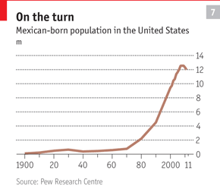
Back and forth
Mass migration from Mexico to the United States is a fairly recent phenomenon. Only 40 years ago the United States had more immigrants from Canada, Germany and Italy than from Mexico. The Mexican wave swelled in the 1970s and kept growing in the 1980s and 1990s (see chart 7) as a rocky Mexican economy propelled more migrants north and a relaxed American immigration policy made it easy for more to settle. In 2000, the peak year, more than 750,000 Mexicans crossed the border.
The flow has gone into reverse because the rewards for going north have diminished and the risks have increased. Mexicans emigrate for jobs, and there are fewer of them available than there used to be. In 2000 unemployment in the United States was around 4%; it is double that now, and almost double Mexico’s rate. The construction industry in the United States, in which many migrants toil, has been especially badly hit. Migrants are also missing out because Americans are eating out less, cleaning their own homes and firing their gardeners. Deportations have increased, to about 300,000 a year. But now even those who have been turfed out are lukewarm about going back. In past surveys by Pew, about eight out of ten of them said they would try to return as soon as possible. Now it is six out of ten.
At the same time getting into the United States has become much harder. Crossing from Tijuana into San Diego used to be a matter of dashing over the frontier in a group that was too big for the border agents to stop. These days the San Diego border is a fearsome thing to cross. Two lines of fencing, one topped with razor wire, are monitored by night-vision cameras mounted on towers. Border Patrol agents—more than 21,000 nationwide, making up America’s biggest law-enforcement agency—scoot around on quad bikes. There are seismic sensors to detect footsteps and ground-penetrating radar to scan for tunnels. Robots are sent into sewers to check for holes burrowed into the system. Americans caught helping migrants often used to be let off, but now they are usually prosecuted first time around.
The favourite place to cross now is the Arizona desert, which involves a 72-hour trudge with scorching days and freezing nights
Tijuana, which used to be the most popular place for illegal crossings from south to north, has fallen out of favour. In some years in the 1990s half a million Mexicans were apprehended trying to cross into San Diego, nearly half the total caught along the entire border. Last year Mr Jiménez and his colleagues stopped just 42,000, barely a tenth of the national total. The favourite place to cross now is the Arizona desert, which few people attempted in the past because it involves a 72-hour trudge with scorching days and freezing nights.
Getting into the United States has become dicier still since Mexico’s criminal gangs realised that migrants made good extortion targets. “The obstacle course doesn’t begin at the border, it begins in northern Mexico,” says David Scott Fitzgerald, a migration expert at the University of California at San Diego. His surveys in small Mexican towns have found that whereas the main perceived risk used to be natural hazards—rivers, animals, the desert—these days the biggest worry is gang violence. The fear is well-founded. Mexico’s human-rights commission estimates that each year some 20,000 Central and South American migrants are kidnapped while travelling through Mexico. Mass graves discovered in the border state of Tamaulipas in 2010 and 2011 contained nearly 300 bodies.
Meanwhile many rich Mexicans have fled from places that are no longer safe for the conspicuously wealthy. Texan cities such as Brownsville and McAllen have seen an influx of well-to-do Mexicans who live north of the border while continuing to manage their businesses in Matamoros or Monterrey. San Diego neighbourhoods such as East Lake are home to many wealthy exiles from Baja California.
Bienvenidos a Tijuana
Nowadays most of those who pass through Tijuana are on their way south. The Instituto Madre Assunta, a shelter for women and child migrants in Tijuana’s hilly outskirts, accommodates about 120 people a month, offering board and lodging along with legal advice and internet access. Ten years ago the centre dealt almost exclusively with migrants heading north, says Mary Galván, its director. Now virtually all are women who have just left the United States, many of them unwillingly. “Some were taken [to the US] as babies. They arrive in shock—some don’t even know the pueblo where they used to live,” says Ms Galván.
The women in the shelter have mixed plans. Ángela, in her 40s, is hoping to visit her family in Oaxaca before going back to San Bernadino, California, with the help of acoyote. There she had a job in a plastics-recycling plant, earning $250 a week, compared with the paltry 54 pesos ($4.20) a day that she says she would earn in Oaxaca. Rosa, who has lived in the United States for 24 years, is also determined to go back. “I’ve spent half my life in America. It’s so strange to be back. When they say 20 pesos I think 20 dollars,” she says. A younger woman who doesn’t give her name is planning to return to her home state of Guerrero with her four children. “It’s uglier here,” she admits. But crossing the border is so difficult these days that she will stay.
The increase in new arrivals has put pressure on the city. About 400 people are deposited there every day. Víctor Clark Alfaro, of the Binational Centre for Human Rights, estimates that about a third come from prisons or are members of gangs. Tattooed, speaking broken Spanish and sporting weird American fashions (enormous trousers currently seem to be in), they find it hard to get work. One willing employer is organised crime, which likes to recruit young men with links to the drug retailers of San Diego neighbourhoods such as Barrio Logan. To ease the pressure on the border, the American authorities have started flying some deported people to Mexico City. The Tijuana government is also trying to move them on. “It’s cheaper for the city to pay for a ticket and for them to go back to their places of origin,” says Carlos Bustamante, the mayor.
But even the millions of Mexicans who remain abroad are firmly plugged into life back home. Phone calls from the United States to Mexico add up to more hours than to the whole of western Europe. Mexican expats pay little attention to politics at home: only 40,000 bothered to vote in Mexico’s presidential election this year, even though if all of them had voted they could easily have changed the result. But they play an active part in their home country’s economic life. Last year Mexicans abroad, overwhelmingly in the United States, sent $22.8 billion to their families. Payments from the United States to Mexico make up by far the world’s biggest stream of remittances, bringing in more foreign currency than does tourism.
Inflows have not yet returned to the heights of 2007, when they topped $26 billion, but they are recovering. As in other parts of the world, remittances have been surprisingly resilient during the financial crisis, notes Marcelo Giugale of the World Bank. “Migrant workers [in the United States] have enough money to live on, but the people at home need every dollar. So they think, ‘I won’t do restaurants or movies any more, but I’ll keep sending money to Mamá’,” he says.
Remittances will be boosted by a growing trend for Mexicans in the United States to have their papers in order. According to Pew, between 2007 and 2011 the undocumented Mexican population there fell from 7m to 6.1m and the legal population rose from 5.6m to 5.8m. Being legally resident improves migrants’ potential earnings and entitles them to the same social-security benefits as other workers. (Fiscally, America has done rather well out of illegal immigrants: many of them pay social-security contributions under a false identity, so they cannot claim many of the benefits that they are paying for.) On present trends, by the time this report is published there will be more legal than illegal Mexican immigrants in the United States. That must be good for people on both sides of the border.
From the print edition: Special report

cookies information for more details

Special report: Mexico

The other American dream

Border traffic isn’t all one way
Nov 24th 2012 |From the print edition

“IN CHICAGO WE used to grind our teeth on our commute. Here we walk to work through cobbled streets, and the only traffic is the occasional donkey delivering firewood,” says Michael Coleman, who moved to Mexico two years ago with his wife Lisa. In sun-kissed San Miguel de Allende, a sumptuous colonial town in Guanajuato state, the Colemans have realised a new sort of American dream, abandoning careers in advertising and headhunting to open a small boutique in one of Mexico’s loveliest spots.
As fewer Mexicans try their luck in el Norte, more Americans are migrating south. In 1990 fewer than 350,000 foreigners were living in Mexico. By 2010 there were nearly a million, most of them Americans. The recession back home has slowed the flow. But hotspots such as Baja California Sur, which offers a rugged coastline for silver-haired surfers, have taken on a strong gringo accent. San Miguel, with around 10,000 American residents, even boasts a US consular agency.
Special report
- From darkness, dawn
- Señores, start your engines
- Bureaucrats and backhanders
- A glimmer of hope
- The gain before the pain
- Stretching the safety net
- The ebbing Mexican wave
- The other American dream
- The 31 banana republics
Sources & acknowledgmentsReprints
Related topics
- Border controls
- United States
- Mexico
Expats are drawn by Mexico’s good weather and low cost of living, which translates into nicer houses and plenty of help to clean them. In some places immigrants have pushed house prices beyond the reach of most locals: San Miguel’s grander places go for well over $1m, an extraordinary sum in apueblo in rural Mexico. But the newcomers have brought in tourism and provided employment, and many expats have set up charities for causes like children or the environment, says Irma Rosado, a local-government official.
Short-stay tourists have been surprisingly gung-ho in the face of Mexico’s well-publicised violence. Last year a record 23.4m of them visited the country. Deep discounting has kept them coming; lower prices mean that income from tourism this year is about 6% down on 2008, the all-time high. Some areas have suffered badly: Acapulco, where Bill and Hillary Clinton honeymooned during its heyday, is now one of Mexico’s most dangerous cities, and visitors have dried up. But the honeypots of Cancún and Los Cabos remain calm and are still getting plenty of sunbathers.
The number of day-trippers, though, has almost halved. The fall began after September 11th 2001, when America tightened its border controls and crossing became a question of hours, not minutes. On Tijuana’s Avenida Revolución, Jorge Bonillas charges tourists $1 for a photo with his donkey Silver, which he has painted as a zebra. He says that business is barely a tenth of what it was before 2001. Down the road Arturo Rendón tries unsuccessfully to tempt young tourists into a bar blaring out rock music and offering absinthe before noon. Tijuana used to be packed with young Americans at 4am, he remembers. These days, “at 1am you are alone.”
Speedier border crossings would help. Work is under way to install more checkpoints, and pre-clearance programmes are slowly expanding, despite Mexicans’ touchiness about American agents working on their soil. Foreign investment along Mexico’s coast is held back by a constitutional ban on foreigners owning property along the border, including the seafront (supposedly on grounds of national security). Expats get round the clause by buying their property through a trust. Repealing the ban would tempt more to invest in Mexican property.
A bigger opportunity lies in health care. Absurdly, many American expats drive from Mexico to the United States for cheap treatment because Medicare, America’s free health programme for the elderly, cannot be used in Mexican hospitals. If American citizens could use Medicare in Mexico, taxpayers back home would save money (and Mexico’s health-care industry would do more business). Alas, politics has so far made such a deal impossible: sending pensioners to get their teeth fixed in Juárez is a difficult sell.
From the print edition: Special report

The 31 banana republics; Mexico's states
The Economist405. 8812 (Nov 24, 2012): n/a.
Turn on hit highlighting for speaking browsers

Abstract (summary)
TranslateAbstract
Mexico suffered from deeply corrupt and often incompetent government for much of the 20th century because voters had very little say about who ran the show. Only in the 1990s was real political competition allowed to blossom, and not until 2000 did an opposition party win the presidency. Government has gotten better since then. But many Mexicans ask why, after more than a dozen years of fairly clean elections, some corners of their country are still as badly governed as the worst Latin American banana republics. Almost alone in the world, the country has a total ban on consecutive re-election that applies to anyone from the president to local incentives. The idea is to discourage dictatorial ambitions. But it means that once elected, Mexican politicians have little reason to maintain the support of the public. To take advantage of the economic opportunities ahead, Mexico will need effective government across the board. That will come only with deeper democracy.

Full Text
- TranslateFull text

Unreformed government could hinder Mexico's march forwardSUNBATHERS LOUNGING BY a lagoon near Acapulco last spring rubbed their eyes in disbelief. Skimming daringly close to the water, an AgustaWestland helicopter roared over the lagoon at 150mph with a whooping, wetsuited figure clinging on to a trailing tow-rope. The helicopter had been bought by the state health department to ferry doctors to indigenous communities in the mountains of Guerrero, where the maternal-mortality rate is among Mexico's highest. But on several days last year the aircraft was borrowed by the president of the Acapulco city environment commission to practise for, and eventually break, a world speed record in barefoot helicopter waterskiing.Mexico suffered from deeply corrupt and often incompetent government for much of the 20th century because voters had very little say about who ran the show. Only in the 1990s was real political competition allowed to blossom, and not until 2000 did an opposition party win the presidency. Government has got better since then. But many Mexicans ask why, after more than a dozen years of fairly clean elections, some corners of their country are still as badly governed as the worst Latin American banana republics.In theory, democracy forces politicians to act in the interests of the voters: if they don't, they get kicked out of office. But Mexico denies its citizens this right. The first part of the democratic process, electing politicians, it does pretty well. The Organisation of American States, a regional body, says that no Latin American country has stronger electoral institutions. But the second half--deciding whether politicians get to stay or have to go--is barred by Mexico's constitution. Almost alone in the world, the country has a total ban on consecutive re-election that applies to anyone from the president to local mayors.Perverse incentives
The idea is to discourage dictatorial ambitions. But it means that once elected, Mexican politicians have little reason to maintain the support of the public. It makes more sense to please party bosses, who nominate candidates for their next position, or other interests such as unions, business or the media, which provide campaign funds or support. Acapulco's waterskiing champion was so unconcerned about the voters' reaction that he uploaded a video of his slippery exploits to YouTube, where it attracted dozens of scathing comments. It didn't matter: no charges were brought, and his party later nominated him as a candidate for federal deputy, a more senior post (he lost).The ban on re-election is a problem at all levels of government, but the worst cases of corruption tend to emerge at the level of the states, which account for a large and growing proportion of government spending. Between 1989 and 2007 their share of the total national budget increased from about a fifth to nearly half, according to IMCO, a Mexico City think-tank. It wasn't because they got better at raising revenues--in fact, during the same period they slipped from generating about a third of their income to just a tenth, with most of the rest coming from the federal government. In spending this handout, governors are accountable only to their own state congresses. Since the congresses' single-term members exist to serve the interests of their parties, not of voters, their scrutiny of the governor--usually their party boss--is not exactly forensic. And failure is rewarded with federal help. "If you have a very serious problem in your state, the federal government is going to come and help you, and massively so," says Mr Calderon. "One of my conclusions as president is that our federal system does not have the incentives correctly aligned." The result is not federalism but "feuderalism", a term coined in a recent essay by Hector Aguilar Camin, a historian, and Jorge Castaneda, a former foreign secretary.This could yet undermine Mexico's budding success. Business is expanding, but is being held back by local red tape and corruption. Progress in health care and education is marred by vast regional inequalities. The fight against crime is hampered by bent police and mayors. Following a mass jailbreak in Coahuila in September Mr Calderon sent a telling tweet: "In the past six years more than 1,000 inmates have escaped from state prisons. From federal prisons, not a single one."One answer is to beef up the federal government's role. Mr Calderon hopes to have 50,000 inmates in federal prisons by December, up from fewer than 5,000 at the beginning of his term in 2006. Some federal security funding is now contingent on states vetting their staff for corruption. State health clinics are certified by federal assessors. Schools' exam results are published online so that parents in Chiapas can ask teachers why children are so far behind those in Nuevo Leon.A better answer is to force states to do their jobs. In October Congress passed a law to make state and local governments publish their financial records and to toughen penalties for account-fiddling. The next step should be to grant Mexicans the missing part of their democracy by allowing them to choose whether politicians stay or go. Mr Calderon introduced a bill to allow re-election (except for the president), but it was blocked in Congress. Mr Pena opposes it. Some in his party reason that governors and mayors, the majority of whom belong to the PRI, will be more co-operative with the new president than they were with Mr Calderon, and that PRI congressmen will obey presidential orders. Mr Pena's aides hint that the PRI's historic ties to interest groups such as unions and the media make it the best party to keep them in line. It is here that the new president is least convincing. Using the old corporatist network to force change is unlikely to work as long as politicians have so little incentive to respond to voters' concerns. PRI congressmen have already proved reluctant to vote for curbs on union power in an impending labour reform. Mr Pena may yet show that he can bring Mexico's mighty interests to heel. But without political reform there is a risk that he could be the one who ends up taking orders.To take advantage of the economic opportunities ahead, Mexico will need effective government across the board. That will come only with deeper democracy. "For most of the country's life it has been a federal republic that in reality is a centralist monarchy," says Enrique Krauze, the historian. Mr Pena must decide whether he wants to be the frustrated king of an old, unreformed country or the president who set its vast potential free.
Block quote: " The helicopter was borrowed by the president of the Acapulco city environment commission to practise for a barefoot waterskiing speed record "
Word count: 1109
(Copyright 2012 The Economist Newspaper Ltd. All rights reserved.)

