- ECG recording

Interval | PR | QRS | ST | TP
Duration (ms)

- Pulse curve recording

Interval | From R to upstroke of pulse curve | From T to dicrotic notch
Duration (ms)

- Electrical axis of the heart

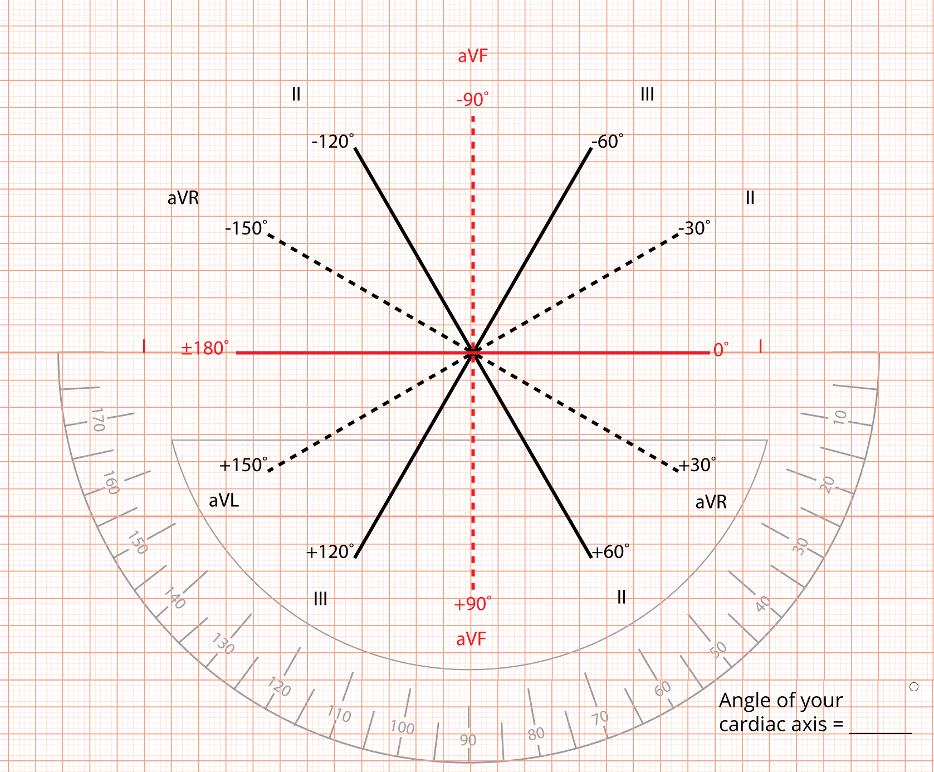

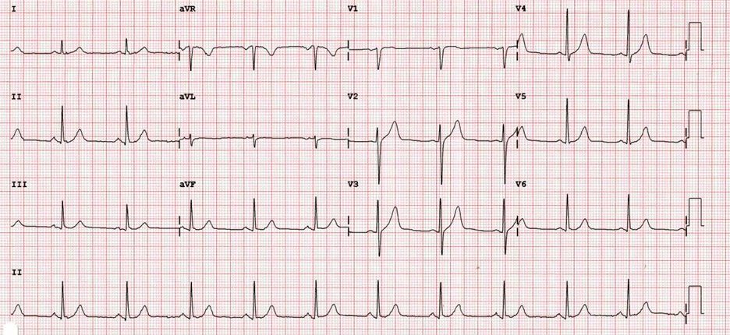
4. Physiological ECG

- Type of rhythm:
- Heart rate:
- Lead closest to the heart axis:
- Lead perpendicular to heart axis:
- Draw and annotate the ECG curve

............................................
Teacher signature

