The Passions of the Soul: Descartes vs Aquinas
BA+Erasmus module
Winter Term 2019
Exams modalities:

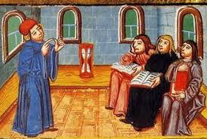
1/ Oral presentation

If you want to make a short oral presentation (ideal length: 25’+ 15’ of discussion), the possible slots are: December 5th and December 19th.
About what. Ideally, you might introduce one passion of the soul (love for instance) and 1) expound to the class what are the main characteristics of such passion either in Descartes’ Passions 2) or in Thomas Aquinas’ “Treatise on Passions” [Summa theologiae Ia, q. 22-41 – cf. moodle or our “Apparatus” in the library]. But 3) nothing prevents you to attempt at comparing them! Or, 4) you might pick up a passion in Descartes’ book, and attempt a comparison between the way it is described in Passions, Part II and in Part III. Also, if you can illustrate more into-depth a text we have briefly touched. You can use a handout, like I usually do; please just make sure to send it to me before your presentation takes place (at least 24h in advance).
How to. In any case, please come to talk to me previously, so that I can help you out shape your topic and guide you. You can contact me by email (anna.tropia@ff.cuni.cz) or visit me during my office hours: every Wed. 13h-14h. If you cannot come, ask me and I will try to schedule an appointment with you.
NB: if the presentation is not fully satisfactory, or, if you want to receive a higher mark, you can (= not compulsory) also pass an…

2/ Oral Exam
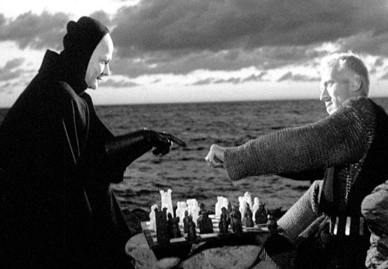
The dates are to establish yet, but it will be taking place in January and February. You will be notified as soon as I know them via the SIS website. The usual length is about 30’ for each student; the themes discussed, will be those we have touched together during the courses. You will be asked about the texts we read together, and the exam modality is similar to a conversation. I usually start by asking if there is a topic you would like to begin with, and then I move on asking one or two questions. You might find useful to go through all the handouts I distributed during the course: I will leave a copy in a folder for our “Apparatus” in the library, but you already have them all on our moodle. Also, you can bring texts with you. Please mind moodle: you find there all the extra readings (upper part), papers that might help you or provide you with a starting point, but also full accessible PDF of Descartes’ and Aquinas’ texts. If you have any doubts or uncertainty, please contact me.

