Handout 9 Contracts

Terminology

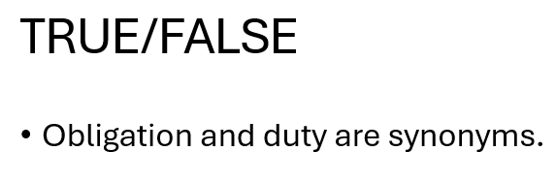
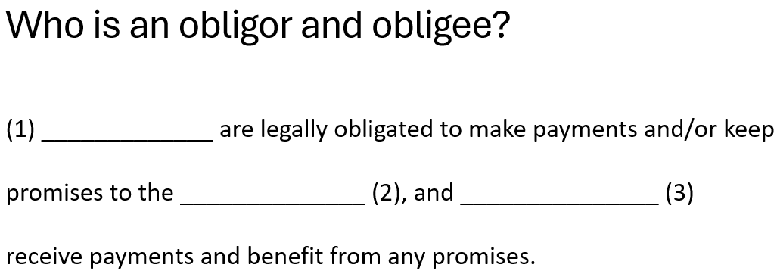
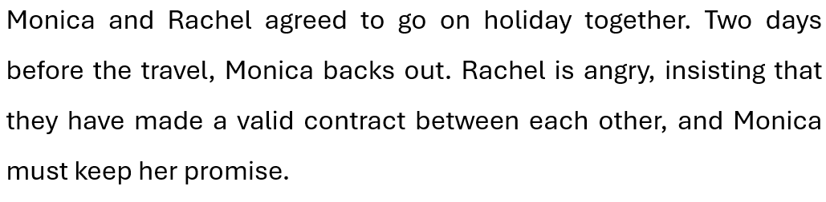
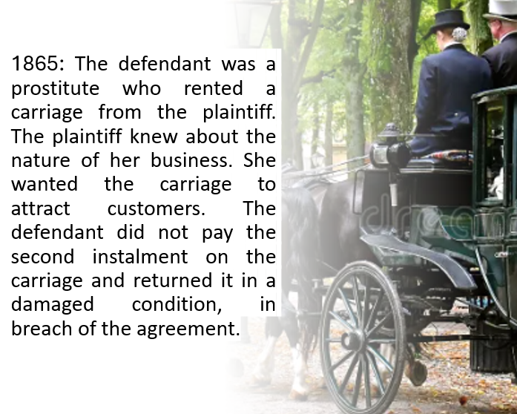
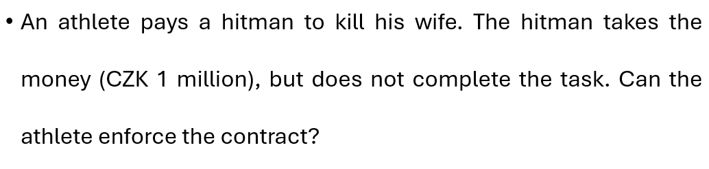
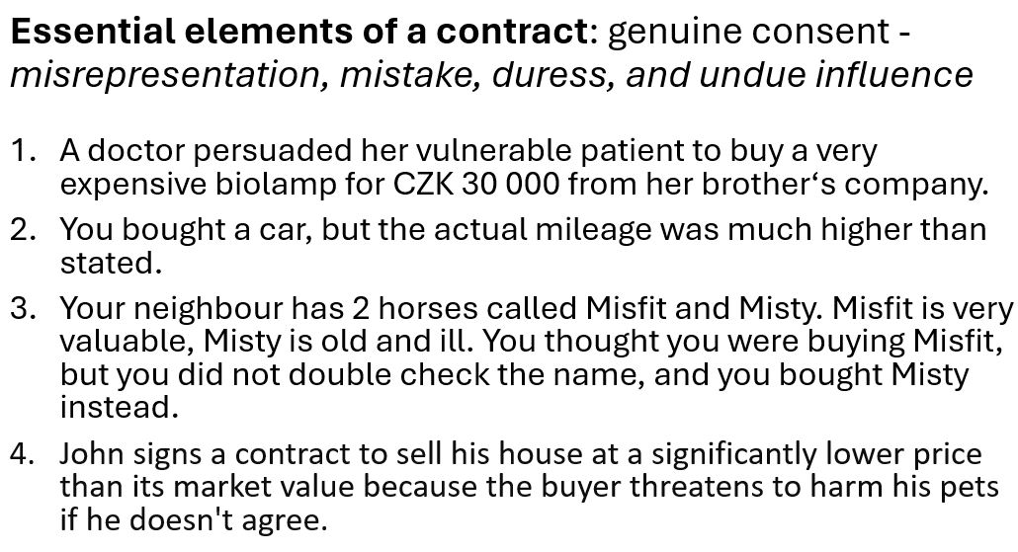
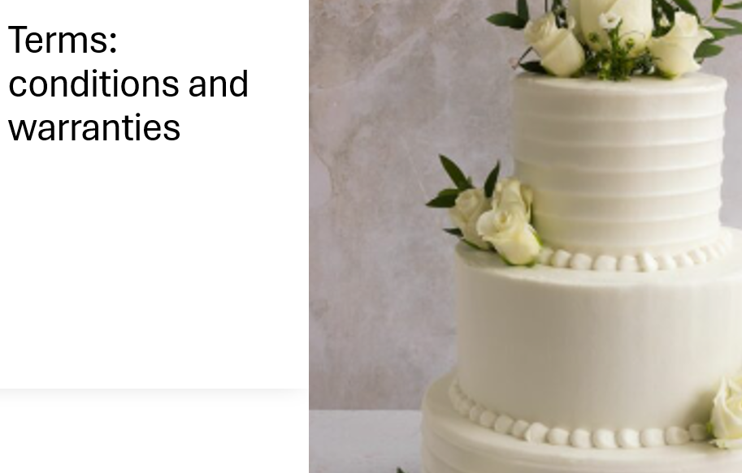
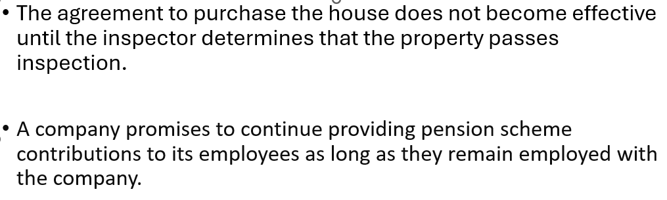
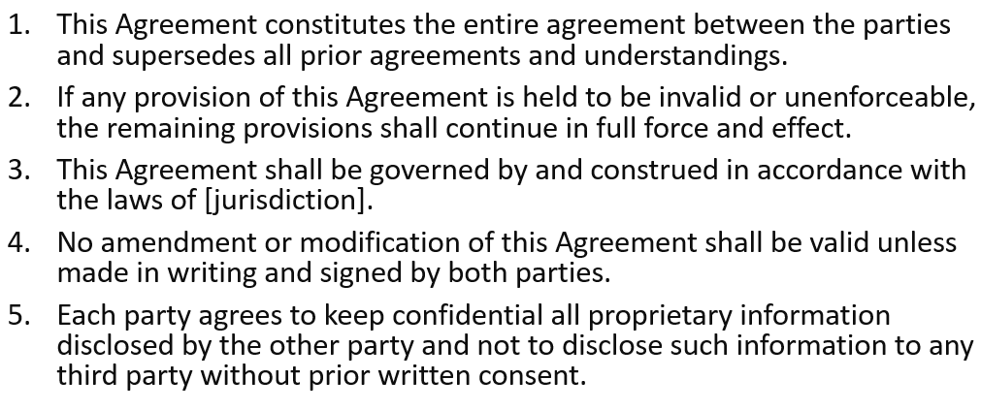
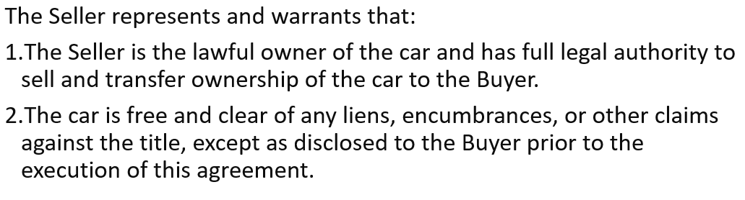
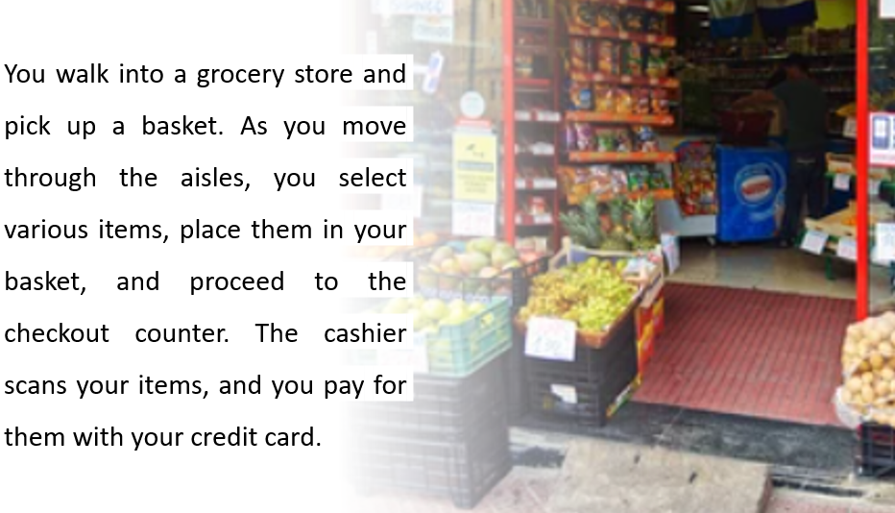
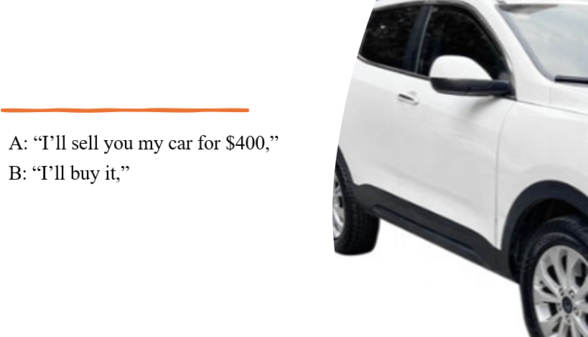
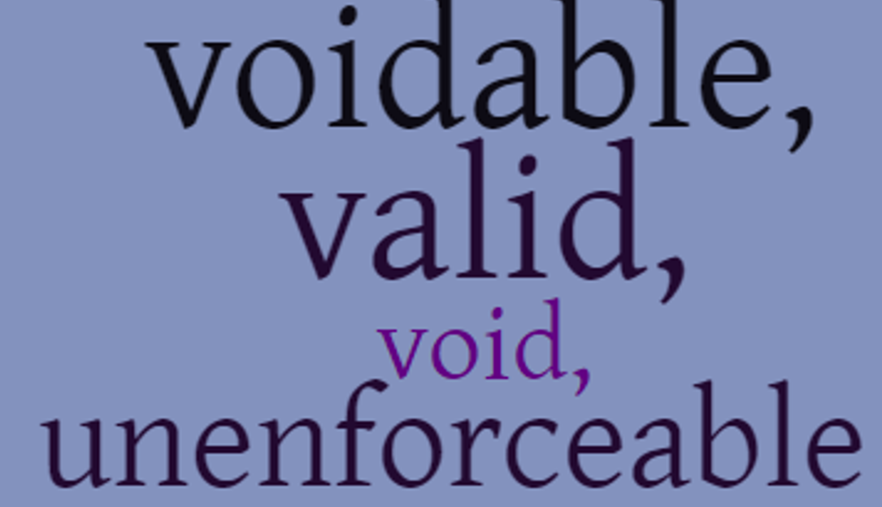

Video: Common Contract Clauses (3-13:10)
- The Complete Agreement
- Notices
- Amendments, Additions, Changes
- Dispute Resolution
- Time is of the Essence
- Indemnify
- Legally Binding
- Counterparts
- Severability
- Governing Law, Jurisdiction, Venue
- Title and Headings
- Event of Default
- Terms and Scope of Work
- Background

Common contract clauses: examples

- Amendment
- Dispute resolution
- Entire agreement
- Force majeure
- Governing Law
- No waiver
- Indemnification
- Non-compete
- Non-disclosure
- Severability
- Counterparts
- Successors and assigns

Provide an appropriate heading for each provision.
- This Agreement … cancels and supersedes any prior understandings and agreements between the parties. There are no representations, warranties, terms, conditions, undertakings or collateral agreements, expressed, implied or statutory, between the parties other than those set forth in this Agreement.
- …. shall be valid or binding if they are in writing and executed by all of the parties.
- If any provision of this Agreement is found to be invalid or unenforceable in whole or in part, such invalidity or unenforceability shall attach only to such provision or part thereof and the remaining part of such provision and all other provisions of the Agreement shall continue in full force and effect.
- This agreement, and any dispute or claim arising out of or in connection with it or its subject matter or formation, shall be … construed in accordance with the law either of England and Wales or of the Territory at the sole discretion and choice of the Company.
- Neither the Company nor Puxin shall … (=transfer) this Agreement or any rights or obligations hereunder without the prior written consent of the other parties.
- The obligations of confidentiality will apply during the Term and will survive indefinitely upon termination of this Agreement.
- Neither party shall be liable for any failure to perform its obligations where such failure occurs because of events beyond the reasonable control of the party.
- During the term of this Agreement and for a period of twelve (12) months following the Director’s removal or resignation from the Board of Directors of the Company or any of its subsidiaries or affiliates (the “Restricted Period”), the Director shall not, directly or indirectly, (i) in any manner whatsoever engage in any capacity with any business competitive with the Company’s current lines of business…
- This Agreement may be executed in two or more …, each of which shall be deemed to be an original but all of which, taken together, constitute one and the same agreement.

Reconstruction of a case
What is the remedy of “specific performance”?
- It is a legal remedy. True/false
- It is awarded when damages are not a satisfactory remedy. True/false
- This remedy can be used in contract cases or in tort cases. True/false
- The purpose is to compel the defendant to perform a contractual obligation. True/false

- Lucy took a partly filled bottle of whiskey into the restaurant with him for the purpose of giving Zehmer a drink if he wanted it. Zehmer did, and he and Lucy had one or two drinks together. Lucy said that while he felt the drinks he took he was not intoxicated, and from the way Zehmer handled the transaction he did not think he was either.
- This suit was instituted by W. O. Lucy and J. C. Lucy, complainants, against A. H. Zehmer and Ida S. Zehmer, his wife, defendants, to have specific performance of a contract by which it was alleged the Zehmers had sold to W. O. Lucy a tract of land owned by A. H. Zehmer in Dinwiddie county containing 471.6 acres, more or less, known as the Ferguson farm, for $50,000.
- December 20 was on Saturday. Next day Lucy telephoned to J. C. Lucy and arranged with the latter to take a half interest in the purchase and pay half of the consideration. On Monday he engaged an attorney to examine the title. The attorney reported favorably on December 31 and on January 2 Lucy wrote Zehmer stating that the title was satisfactory, that he was ready to pay the purchase price in cash and asking when Zehmer would be ready to close the deal. Zehmer replied by letter, mailed on January 13, asserting that he had never agreed or intended to sell.
- Lucy asked him if he would put it in writing that he would sell him this farm. Zehmer then wrote on the back of a restaurant receipt, "I agree to sell the Ferguson Place to W. O. Lucy for $50,000.00 cash." Lucy said, "All right, get your wife to sign it." Zehmer came back to where she was standing and said, "You want to put your name to this?" She said "No," but he said in an undertone, "It is nothing but a joke," and she signed it.

Tasks for the whole team:
- Briefly summarise your fragment.
- Who was Lucy? (man/woman/a party to the case?)
- Who were the parties to the case? (plaintiff and defendant)
- What happened in the restaurant?
- Why did the plaintiff sue the defendant?
- What was the defendant’s argument?
- What issue did the court have to resolve in this case?
- In what sense does “specific performance” apply to this case?
- In your opinion, how has the court adjudicated the case?

Ambiguity, vagueness

Team 1 | - “Subject to the termination provisions of this Agreement, this Agreement shall be effective from the date it is made and shall continue in force for a period of five (5) years from the date it is made, and thereafter for successive five (5) year terms, unless and until terminated by one year prior notice in writing by either party.”  - “Subject to the termination provisions of this Agreement, this Agreement shall be effective from the date it is made and shall continue in force for a period of five (5) years from the date it is made, and thereafter for successive five (5) year terms unless and until terminated by one year prior notice in writing by either party.” | What is the difference between a) and b)?  Can this difference give rise to a different interpretation?
Team 2 | - “The tenant must replace all worn carpets in the premises.”  - “The said shareholder shall thereupon be obliged to deliver forthwith to the Company the share certificates.”  - “Company A shall pay the balance to company B and company C and company D shall be given additional information in due time.”  - “There are several flights per hour over the house.” (from a contract to buy a house near the airport) | Identify the weaknesses of these contractual provisions that could lead to litigation.

