Who is Sigmund Freud?

Sigmund Freud (1856-1939) was an Austrian neurologist and psychiatrist, primarily known as the “father of psychoanalysis”. Psychoanalysis was derived from his own theory and research, and was used to cure neurosis.

His main concepts:

Structure of Mind (Iceberg Metaphore)

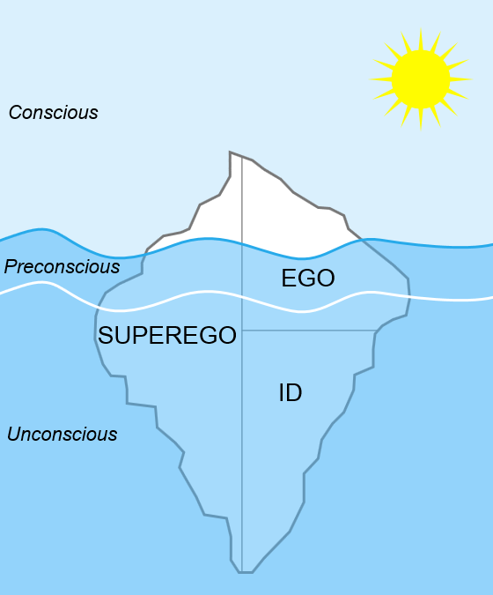

- The conscious mind includes everything that we are aware of. This is the aspect of our mental processing that we can think and talk about rationally.
- The preconscious mind is the part of the mind that represents ordinary memory. While we are not consciously aware of this information at any given time, we can retrieve it and pull it into consciousness when needed.
- The unconscious mind is a reservoir of feelings, thoughts, urges, and memories that outside of our conscious awareness. Most of the contents of the unconscious are unacceptable or unpleasant, such as feelings of pain, anxiety, or conflict.

The id is the only component of personality that is present from birth which is entirely unconscious (includes the instinctive and primitive behaviors). The id is driven by the pleasure principle, striving for immediate gratification of all desires, wants, and needs (particularly sexual drives), which need to be satisfied immediately.

The ego is the component of personality that is responsible for dealing with reality, functioning in the conscious, preconscious, and unconscious mind. The ego develops from the id and ensures that the impulses of the id can be expressed in a manner acceptable in the real world through defense mechanisms.

The superego is our sense of right and wrong, the aspect of personality that holds all of our internalized moral standards and ideals that we acquire from both parents and society. The superego provides guidelines for making judgments and standards for good and bad behaviors, which are learned through parental and authoritative approval/disapproval.

Psychosexual Development in 5 Stages

During the five stages of early childhood development, the child's behavior is oriented towards certain parts of his or her body, e.g. the mouth during brest-feeding, the anus during toilet-training. Each stage has its crisis point. Wrong or not completed passage through a stage can develop into adult neurosis.

Stage | Age Range | Explanation
Oral | Birth to 1 year | The infant's primary source of interaction occurs through the mouth, so the rooting and sucking reflex is a form of pleasurable oral stimulation. The infant develops a sense of trust and comfort through this oral stimulation and its association with its caretaker/parent.
Anal | 1 – 3 years | An individual’s primary focus of the libido is controlling bladder and bowel movements. A positive experience with toilet training is essential for people to become competent, productive, and creative adults. The child has to learn to control his or her bodily needs, leading to a sense of accomplishment and independence.
Phallic | 3 – 6 years | The primary focus of the libido is on the genitals and the difference between males and females. Boys develop the Oedipus complex, which describes these feelings of wanting to possess the mother and the desire to replace the father. Girls experience the Electra complex, similar to the Oedipus complex, along with penis envy.
Latency | 6 to Puberty | During the latent period, the libido interests are suppressed due to the development of the ego and superego. This period is used for exploration in which the sexual energy is still present but directed into other areas (intellectual pursuits and social interactions).
Genital | Puberty to Death | The individual now develops a strong sexual interest in the opposite sex. The interest in the welfare of others grows during this stage. The goal of this stage is to establish a balance between the various life areas.

Defense mechanisms

Defense mechanisms are used to protect ourselves from feelings of anxiety or guilt, which arise when we feel threatened, or when our id or superego become too demanding (not under our conscious control).

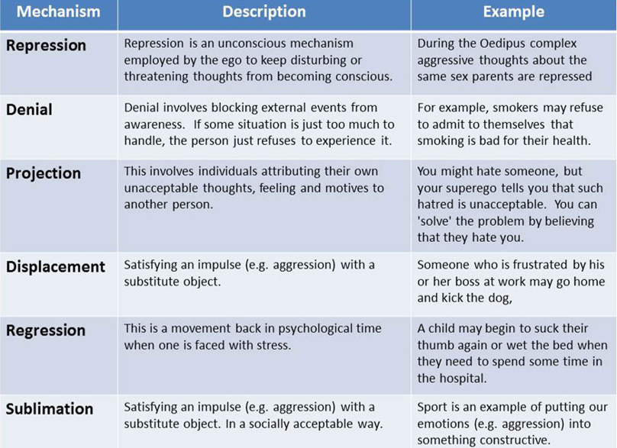

Splitting - separation of one item into two such that they can be handled separately. When a person holds two thoughts in the mind that are contradictory or otherwise so uncomfortable, the person will cognitively separate them, not thinking of the separate thoughts at the same time. (a common split is the fairytale perspective of good and bad).
Identification - process whereby the subject assimilates an aspect, property, or attribute of the other and is transformed, after the model the other provides. It is by means of a series of identifications that the personality is constituted and specified. (Children are typicaly identifying themselves with fairytales or other stories protagonists.)

Compensation - a strategy whereby one covers up weaknesses, frustrations, desires, or feelings of inadequacy or incompetence in one life area through the gratification or (drive towards) excellence in another area. (Through fairytale stories, people are compensating their own lives.)

