PART 1: SCANDINAVIA
Over the last few weeks, I have been in Oslo, twice; Helsinki, twice; Stockholm, twice; and Copenhagen, once. One of the trips to Stockholm was limited to press interviews and television (see here). The other six trips were part of my 12 Rules for Life tour, which has now covered 100 cities. The reason for the dual visits? We arranged relatively smaller venues for the lectures in those Scandinavian towns, and they sold out immediately. Scandinavians appear particularly interested in what I am saying. They are radically over-represented among those who view my YouTube lectures.
In the last lecture, in Helsinki, it was Finland’s Father’s Day, so I talked about masculine virtue. In Stockholm, I concentrated more on what has come to be known as the “gender paradox.” Here is the paradox in a nutshell: as societies become more gender-equal in their social and political policies, men and women become more different in certain aspects, rather than more similar. (There is an extensive but by no means complete listing of papers relevant to this issue at the site of my interview with James Damore, the Google engineer who was fired for possessing accurate knowledge of the psychological literature).
Had you asked any group of social scientists–left-wing, centrist, conservative (if you could find them)–30 years ago “Will egalitarian social policies in wealthy countries produce men and women who are more similar or more different?” it is a certain bet that the majority would have said “more similar.” And, to some degree, that has happened. Women have entered the workforce en masse, and are participating at levels approaching or exceeding equality in many of the domains that were male majority prior to the 1960s. But…
And there is a major but. We seem to have reached the point of diminishing, or even reversing returns. Over the last five decades or so, psychologists have aggregated great numbers of personality trait features, using adjectives, phrases and sentences, throwing virtually every descriptor contained in human language into the mix, in a remarkably atheoretical manner. The method? Describe people every which way imaginable, and then use large samples and powerful statistics to sort out the resulting mess. The results? Something approaching a consensus among psychologists expert in measurement, known as psychometricians (or, less technically, as personality psychologists). The latter happens to be my field, in addition to clinical psychology. When you ask thousands of people hundreds of questions (or ask them to rate themselves using descriptive adjectives such as “kind,” “competitive,” “happy,” “anxious,” “creative,” “diligent,” etc.) powerful statistics can identify patterns. People who describe themselves as “kind” tend not to consider themselves “competitive,” for example, but are likely to accept “cooperative” and “caring.” Likewise, creative types might regard themselves as “curious” and “inventive,” while the diligent types are also “dutiful” and “orderly.” A trait-like phenomenon was also identified: that of interest — interest in people vs. things.
Once a relatively standard model had been established, and been deemed reliable and valid, then differences, such as those between the sexes, could be investigated. What emerged?
First, men and women are more similar than they are different. This is true, cross-culturally. Even when men and women are most different —in those cultures where they differ most, and along those trait dimensions where they differ most — they are more similar than different. However, the differences that do exist are large enough so that they play an importance role in determining or at least affecting important life outcomes, such as occupational choice. Here’s a paper, for example, indicating that more gender-equal countries produce comparatively fewer women in the STEM fields. Here’s another, showing that at least some of the much-vaunted gender gap in pay, which is caused by many factors, can be attributed to male/female personality differences and not to simple discrimination.
Where are the largest differences? Men are less agreeable (more competitive, harsher, tough-minded, skeptical, unsympathetic, critically-minded, independent, stubborn). This is in keeping with their proclivity, also documented cross-culturally, to manifest higher rates of violence and antisocial or criminal behavior, such that incarceration rates for men vs women approximate 15:1. Women are higher in negative emotion, or neuroticism. They experience more anxiety, emotional pain, frustration, grief, self-conscious doubt and disappointment (something in keeping with their proclivity to experience depression at twice the rate of men). These differences appear to emerge at puberty. Perhaps it’s a consequence of women’s smaller size, and the danger that poses in conflict. Perhaps it’s a consequence of their sexual vulnerability. Perhaps (and this is the explanation I favor) it’s because women have always taken primary care of infants, who are exceptionally vulnerable, and must therefore suffer from hyper-vigilance to threat.
There are other sex differences, as well, but they aren’t as large, excepting that of the aforementioned interest: men are comparatively more interested in things and women in people. This is the largest psychological difference between men and women yet identified. And these differences drive occupational choice, particularly at the extremes. Engineers, for example, tend to be those who are not only interested in things, but who are more interested in things than most people, men or women.
It’s very important to remember that many choices are made at the extreme, and not the average. It’s not the average more aggressive/less agreeable male that’s in prison. In fact, if you draw a random man and a random woman from the population, and you bet that the woman is more aggressive/less agreeable, you’d be correct about 40% of the time. But if you walked into a roomful of people everyone of whom had been selected to be the most aggressive person out of a 100 almost every one of them would be male.
So even though men and women are more the same than they are different, the differences can matter.
What happens if you look at sex differences in personality and interest by country? Are the differences bigger in some countries and smaller in others? Would the differences between men and women be larger or smaller in wealthier countries? In more egalitarian countries?
The answer: the more egalitarian and wealthier the country, the larger the differences between men and women in temperament and in interest. And the relationship is not small. The most recent study, published in Science (by researchers at Berkeley, hardly a hotbed of conservatism and patriarchy) showed a relationship between a wealth/egalitarian composite measure and sex differences that was larger than that reported in 99% of published social science studies. These are not small-scale studies (here’s another, equally recent). Tens of thousands of people have participated in them. And many different groups of scientists have come to the same conclusions, and published those results in very good journals.
Given that differences in temperament and interest help determine occupational choice, and that difference in occupational choice drives variability in such things as income, it follows that political doctrines that promote equality of opportunity also drive inequality of outcome.
This is a big problem — particularly if the goal of such egalitarian policies was to minimize the differences between men and women. It’s actually a fatal problem, for a particular political view. The facts can be denied, but only at the cost of throwing out social science in its entirety (given that the entire field is predicated on the same methods used in the studies currently being discussed) and a good bit of biology as well. That is simply not a reasonable solution.
The best explanation, so far, for the fact of the growing differences is that there are two reasons for the differences between men and women: biology and culture. If you minimize the cultural differences (as you do with egalitarian social policies) then you allow the biological differences to manifest themselves fully. I have seen social scientists struggle to offer a cultural explanation, but I haven’t heard any such hypothesis that is the least bit credible, and have been unable to formulate one myself.
There are also those who insist upon believing that we just haven’t gone far enough in our egalitarian attempts—that even Scandinavia and The Netherlands, arguably the world’s most egalitarian societies, are still rampantly patriarchal — but that doesn’t explain why the sex differences have grown, rather than shrunk, as those cultures have become demonstrably more equal in social policy.
Those who adopt this viewpoint, despite its apparent logical impossibility, maintain that we must redouble our efforts to socialize little boys and girls in exactly the same manner–rendering all toys gender-neutral, questioning even the idea of gender identity itself–and believe that such maneuvering will finally bring us to the ideal utopia, where every occupation and every strata of authority within every occupation is manned (so to speak) by 50% men and 50% women. Why should we launch large-scale experiments aimed at transforming the socialization of children, when we have no idea what the outcome might be? And why should we presume that we know how in any manner to eliminate gender identity among young children? Finally: Why exactly is it a problem if men and women, freed to make the choices they would freely make when confronted with egalitarian opportunities, happen to make different choices?
So, this is the Scandinavian conundrum—one that also affects broader Western society (and the remainder of the world, soon enough). Policies that maximize equality of opportunity make equality of outcome increasingly impossible. The doctrine, ever more radically and loudly insisted upon by the politically correct, that sex differences are only socially constructed is wrong. Get it? Wrong.
It’s no wonder that when I came bearing this news the Swedish Foreign Minister (a proud member of the world’s only self-proclaimed feminist government) suggested publicly that I crawl back under my rock, and that one of Sweden’s leading female politicians objected on primetime TV that her daughter could be raised to be anything she wants to be. But facts is facts, I’m afraid, and no amount of neo-Marxist leftist postmodern suggestion that social science is a patriarchal construction is going to make the ugly truth disappear:
Men and women are similar. But they are importantly different. The differences matter, particularly at the extremes, particularly with regard to occupational choice and its concomitants. There are going to be more male criminals, and more male engineers, and more females with diagnoses of depression and anxiety, and more female nurses. And there are going to be differences in economic outcome associated with this variance.
Game over, utopians.
And that’s why the information that I publicized in Scandinavia caused a scandal that continues to reverberate.
PART 2: CANADA AND TRUDEAU’S CABINET
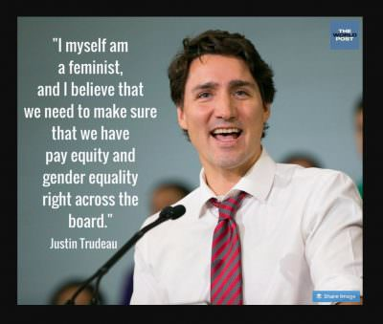
We all remember that our current Prime Minister, the Right Honorable Justin Trudeau, decided early on when he formed his government to make his cabinet 50% women, because “it was 2015.” And he got a hall pass for this, no doubt because of his boyish charm and modern mien. But it was a mistake of unforgivable magnitude and here are some of the reasons why:
- The job of the Federal government is important, necessary and difficult.
- To make important, difficult decisions properly, competence is necessary.
- There is no relationship between sex and competence. Men and women are essentially equal in their intelligence, and they differ very little in conscientiousness (which is the second-best predictor of success, after intelligence). Thus, selection for competence should optimally be sex-blind, if competence is the most important factor.
- The possibility of identifying a competent person increases as the pool of available candidates increases.
- Only 26% of the elected MPs in Trudeau’s government were women.
- By selecting 50% of his cabinet from 26% of the pool of available candidates, Prime Minister Trudeau abdicated his responsibility to rank-order all of his elected officials by competence (which could have been done by blind, multi-person rating of their resumes, including education and accomplishments) and staffing his cabinet from the most qualified person downward.
Given that only 26% of the elected MPs were women, the selection of half the cabinet from this pool means that it is a statistical certainty that the cabinet members chosen were not the most competent available.
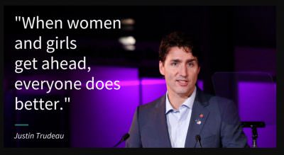
It might also be pointed out that such a move is particularly appalling, given its source. Let’s assume (which I don’t) that there is “patriarchy,” and with it, generally undeserved privilege. Let’s even assume (which I don’t) that much of this is accrued unfairly by straight white men, as the identity politics players, such as our Prime Minister, self-righteously and vociferously insist.
Is it truly unreasonable, therefore, to point out that the absolute poster boy for such privilege is none other than our Prime Minister, Justin Trudeau—a man who dared run for the highest office in the land despite his utter lack of credentials (other than good looks, charm and a certain ability to behave properly in public) merely because his father, Pierre, turned the Trudeau name into the very epitome of status unearned by his sons?
Is it also unreasonable to point out that the women who accepted those positions, granted to them unfairly, in a prejudiced and discriminatory manner, took that as their due, despite the unlikelihood, statistically, of their suitability for the positions in question, and thus betrayed themselves, men and women everywhere striving fairly for advancement and authority, and their country?
All in the name of redress for some hypothetical prejudice, a consequence of the patriarchal tyranny, experienced in large measure by vaguely apprehended women of the past and definitely other than themselves.
Appalling. All of it. Appalling.
Here’s a full list of the cabinet members, in case you want to contact them and let them know what you think.
Here’s a list of the most dangerous jobs by fatality rate and sex (source). Why isn’t this a focus of gender-inequality outrage?
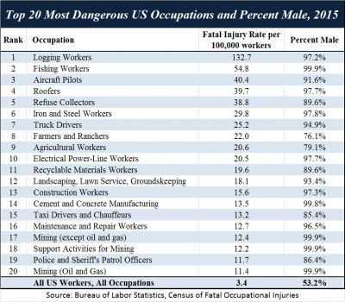

Jordan Peterson Mailing List Signup:

Zdroj: https://www.jordanbpeterson.com/political-correctness/the-gender-scandal-part-one-scandinavia-and-part-two-canada/

