Q: WHAT IS PROSE?
Like anything that is hard to define, PROSE seems to be best described negatively, i.e. in terms of what it is not: whatever lacks the beauty and stylistic/metrical sophistication of POETRY is PROSE.
An inspection of the two respective entries in a dictionary seem to confirm this interdependence of poetry and prose when it comes to definitions:
Oxford English Dictionary at https://www.lexico.com/
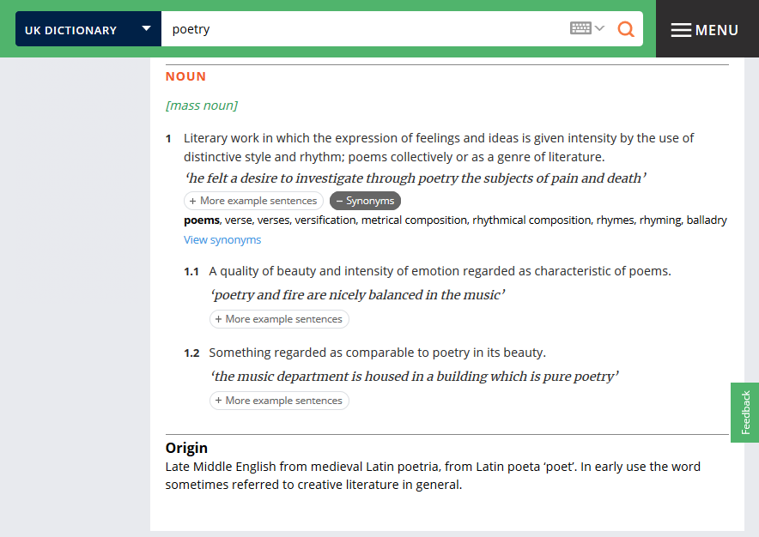

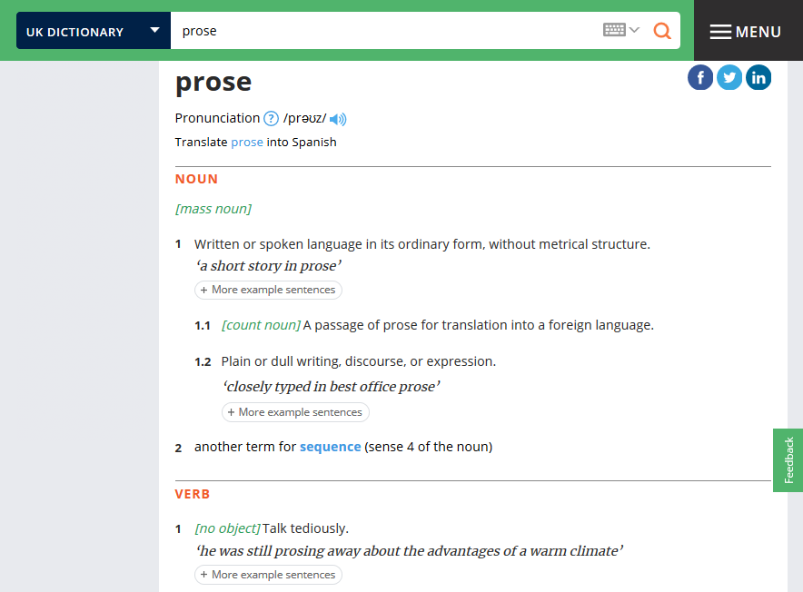

Here is Molière’s Mr. Jourdain in Le bourgeois gentilhomme and his reaction to one of his refining lessons, this time on the distinction between poetry and prose: “My faith! For more than forty years I have been speaking prose while knowing nothing of it, and I am the most obliged person in the world to you for telling me so” (Par ma foi ! il y a plus de quarante ans que je dis de la prose sans que j'en susse rien, et je vous suis le plus obligé du monde de m'avoir appris cela). Although he has been told by his “Master of Philosophy” that prose is the opposite of poetry in being devoid of its intricacy and aesthetic qualities, Mr. Jourdain is overjoyed to have learnt there is a sophisticated term to apply to his common speech.
But for all the differences between poetry and prose that lie at the base of the cited definitions, the margins between the two remain blurred. The quality of literary prose writing is often assessed by the “higher” criteria of poetry (e.g. “Kafka writes sheer poetry”). But prose writers have often opposed this view that whatever is deficient in the formal sophistication of poetry is not good enough (e.g. Máirtín Ó Cadhain: “Nothing could be said by a lyric what could not be said equally well in modern prose”).
Even dictionaries of literary terms are not of much help when looking for detailed definitions of “prose”. Note the laconism of the entry on “prose” in Cuddon’s Dictionary of Literary Terms which focuses on the etymology of the word and inevitably brings up poetry as well.
The original version of the definition in the earlier editions of the same dictionary included the following phrase which suggests that prose is also an extremely versatile and changeful category: “In theory there are as many different kinds of prose as there are people to write it.”
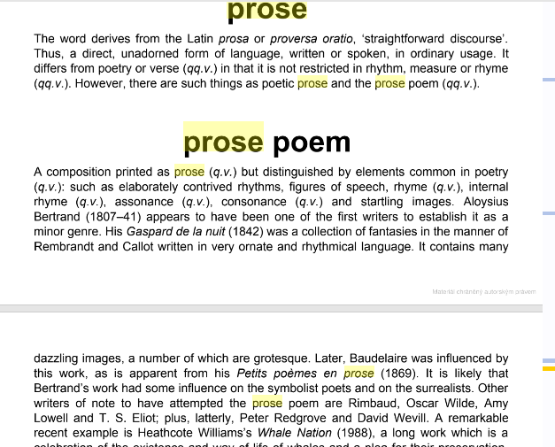
J. A. Cuddon, A Dictionary of Literary Terms and Literary Theory, 5th ed. (London: Wiley & Blackwell, 2020). E.book.

Prose is also difficult to define because of its GENERIC DIVERSITY and it is useful to explore its development as a genre.
MAJOR PROSE GENRES
The two triads of the basic literary genres as they evolved throughout history:
epic, drama, lyric >> fiction, drama, poetry
The most important form of serious literary fiction since the 18th c. has been the NOVEL. It had its precursors in some of the earlier literary forms and some of the oldest texts in world literature.
EPIC
- etymology – Greek epos = word/song >> Latin eipein = to say;
EPIC (adj.) – late 16th c. from French = “pertaining to or constituting a lengthy heroic poem”; the extended sense (epic as “grand”, “heroic”) first appears in Engl. in the 18th c.
- classic epics are mostly character-oriented and episodic
- have their roots in myth, history and religion
- they represent a complete worldview (Weltanschauung)
- are mostly in verse – but differ from other forms of poetry on account of
- length
- narrative structure & plot patterns
- depiction of character
ROMANCE
- developed as a separate genre by the late Middle Ages
- mostly composed in verse
- but romances had been written in the classical times – then mostly in prose
- in the English tradition, the best-known examples are tales from the Arthurian cycle, e.g. Sir Gawain and the Green Knight (14th c., anonymous), La morte d’Arthur (15th c., Sir Thomas Malory)
- these would fall within the category of CHIVALRIC ROMANCE – of Old-French origin – the term “roman” originally meant “not in Latin”, i.e. written in the vernacular
- medieval romances are stories of chivalry and love (formalized courtly love) – often with historicising elements as well as fantastic features, including supernatural beings, dragons, metamorphosing characters, parallel worlds etc.
- the stock elements of the romance (heroic knight; damsel in distress; the motif of the journey) gave base to the 18th-c. development of Gothic fiction
NOVEL
- characterised by “realism” and “individualism” – as opposed to the cosmic, allegorical dimensions of the epic
- origins in Spain, 17th c. (Miguel de Cervantes, Don Quixote); started out as a synthetic genre parodying some of the conventions of both the epic and of chivalric romance
- cf. the 18th c. parallel developments of MOCK-EPIC/ comic epic / comic romance
- early English novels are all based on parody or synthesis of pre-existing genres
- S. Richardson, Pamela, Clarissa
- D. Defoe, Robinson Crusoe, Moll Flanders, Roxana
- H. Fielding, Joseph Andrews (comic epic/romance)
- Laurence Sterne, Tristram Sandy
- The novel remains one of the most innovative genres to this day, which is reflected in its diverse SUBGENRES.

