Czech in Exile: Language contact of Czech and English in Texas
Eva Eckert

Languages of immigrants overtly refer to languages with which the speakers have had a sustained contact. They reveal the imperfect and ordinary state of a language. They model real languages that feed onto lexical and grammatical resources of their neighbors and leak out into them, at the same time. Czech in Texas represents a particular code of Czech that illustrates a gradual atrophy and its outcomes. The goal of the contribution is to highlight tombstone inscriptions, such as those in Texas cemeteries, as a relevant source of primary language data showing that the immigrant vernacular explored several linguistic resources through its language contacts, at any given time period as well as across the decades. Tombstones in central Texas document Czech immigrants’ language over the period from the 1860s to the 1960s. The inscriptions trace not only language contact and shift but also the community’s sustenance and disintegration.

Keywords: atrophy, language contact, social network, tombstone inscription

Introduction: Czech in exile and Czech in contact
The concept of Czech in exile evokes all sorts of historical connotations recalling primarily migration of Czech Brethren necessitated by religious persecution of non-Catholics in Bohemia until the middle of the 19th century. At that time, pastor Ernst Bergmann chose Texas as the destination for his family and congregation from the region of Prussian Kladsko (Klumpp and Blaha 1981). Although his fate in Texas was rather unfortunate the spark he ignited caught on fire in the neighboring regions of northern Moravia from where first migrants reached Texas in the early 1850s, mostly in pursuit of free land and an opportunity to farm on one’s own.

Mass migration to the agricultural regions of the U.S., South America, Russia and elsewhere that occurred mostly during the second half of the 19th century and lasted about fifty years created conditions for the formation of cultural enclaves, especially in agricultural settings. The communities flourished for up to four generations before its members began to abandon them and convert gradually to the majority culture. The eventual atrophy of the immigrant language resulted from cultural marginalization, isolation from the resource culture of the homeland, contact with English or another majority language and the pressure of assimilation. It is manifested in borrowing words and grammar patterns, language mixing and hybridization, and eventually a displacement.

Cemetery data on the language of the immigrants
The shape and extent of languages exiled or migrating along with their speakers can be predicted from a set of the migration factors of time, space, distance and motivation (Kerswill 2006). In the conditions of agricultural migrations, such as that from Bohemia and Moravia to Texas, the factors of community and social networks of its members are relevant in the process of language contact and atrophy as well. The particulars of language atrophy and shift can be predicted from the basic framework and interaction of the migration factors. The process of language contacts in Texas Czech can be studied through various primary sources, among them tombstone inscriptions that externalize the presence and usage of the immigrant language at any given period, and, at the same time, trace the contact, atrophy and change from the 1860s to the 1960s.

What is nowadays being referred to as Texas Czech was a hybrid that originated mostly from Moravian dialects that once led rather insular lives within their respective isoglosses of rural regions of northern Moravia and upon immigration came into contact with English in central Texas. In Texas the dialects of exiled farmers changed through the mutual contact and contact with English and created a distinct language variant (see also Mendl, 1978). Among the immigrant languages, Czech in Texas represents a particular code of Czech that has gradually atrophied due to its distance from the homeland (that further increased once the immigration quota was imposed in the 1920s), the immigrants’ mobility, susceptibility to new socio-cultural demands and contact with English. It is one of the the best researched varieties of Czech abroad that has been documented through published research and an online archive (Cope 2012-2015). The designation Czech refers to the superordinate concept of Czech as the national and literary language of Bohemia and Moravia. The inscriptions are a relevant source of data showing that the immigrant vernacular drew upon several linguistic resources at any given time period as well as across the decades, i.e., the homeland dialects, standard literary language and English. The inscriptions document not only language contact and shift but also the community’s sustenance and eventual disintegration.

Languages of immigrants overtly refer to the immigrant community and the majority society that received them and with which they have sustained contacts. As such, immigrant languages reveal the imperfect and ordinary state of a language. They model real languages that feed onto lexical and grammatical resources of their neighbors and leak out into them, at the same time. The real language of Moravian immigrants is documented in tombstones in central Texas where Texas Czechs maintained a community for one hundred years. They cover the entire Texas Czech territory where they record dialectal contacts, contact with English and language displacement. They represent archives that stand unedited amidst the Texas landscape where they refer to a community in the process of its transformation and a gradual disintegration. Finally, they reflect also a cultural shift in ethnic identification (Cox 2010, p. 20).
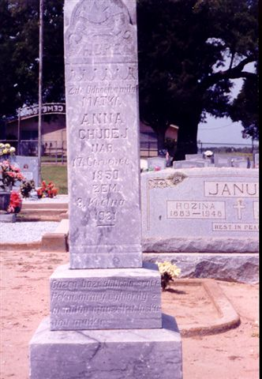
Fig. 1 The contrast between textual narrative inserted into the semantic schema of kinship (using a descriptive adjective), name, dates and a rare epitaph engraved in 1921 contrasts with English framed inscription of a minimal textual content that uses Czech spelled first and last names.
My corpus of inscription data numbers about two hundred tombstones collected over thirty cemeteries known as Czech in central Texas rural regions and characteristically marked by a Catholic or Brethren church along with the Catholic cross or the Brethren chalice. When the first settlers arrived they marked their land by a church and its cemetery. The laying out of a cemetery entailed claiming a stake in the land in which one’s ancestors would be buried, and establishing foundation for the new homeland. The stone texts traced kinship relations and the details of one’s origin and destination. They were selected and carved with the awareness of being private as well as public, shared and read by others. The cemetery functioned as a public chronicle compiled by four successive generations (Eckert 2007).

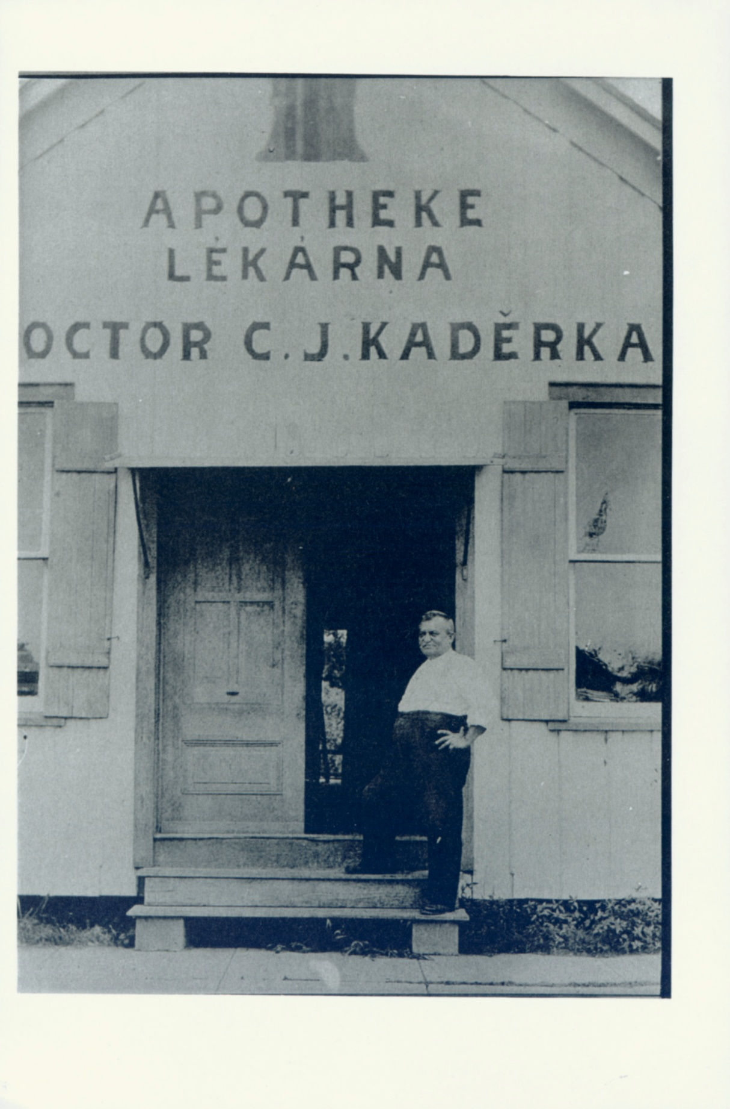

Fig. 2 Texas Czech in its hybridized Czech-English variant appeared in inscriptions, articles in the press and city signage. Kaderka Pharmacy in Fayetteville in the 1930s.

Inscription language and authorship
Tombstone inscriptions represent speech communities of their own that operate according to particular rules of membership manifested through language usage. Their boundaries are continually reinforced through a shared dynamics of language, the margins of time and borders of geography. In the speech community of the cemetery inscriptions conform to the norms of tombstone writing that presuppose certain style and content. Yet, the immigrants’ tombstones in Texas went beyond the ritualistic language one expects to encounter. Semantic data engraved consisted not only of dates, names and epitaphs but also personalized biblical verses and greetings. Vernacular texts and features of Moravian dialects predominated over the formal features of standard Czech. This represented a contrast to the polished language of immigrant press in several periodicals that were edited with care to eliminate dialectal pronunciation and lexical items. Immigrant press writing was edited to produce official formal texts and to clean readers’ letters of dialectal pronunciations and vernacular spellings. Texas Czech speakers invested considerable resources into cultivating formal Czech in press, teaching, preaching and official speeches (these documents are available for research; for the shape of Texas Czech standard and its local dialectal flavor, see Eckert & Hannan, 2009).

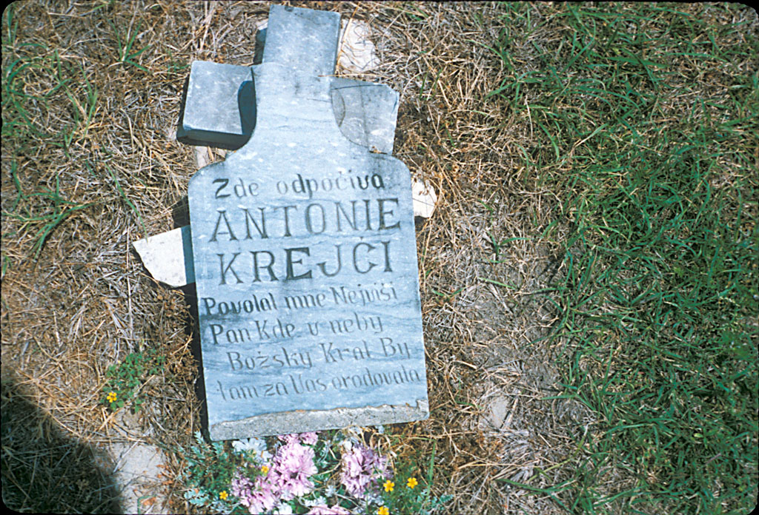
Fig. 3 The collapsed cross marking this grave indicates that it may be one of the earliest memorials. Semantically it omits both dates and kinship. The spelling and morphology (odpočiva, nejviši, v neby, by orodovala) reveal dialectal pronunciation and usage.
No primary language data, and not even stone-engraved ones can be considered objective and self-evident, no matter how unambiguously they stand out. Language ideology, understood as a set of beliefs held by the community (Woolard 1994) finds way into the very phrases and grammars of the stone inscriptions. For Texas Czech it helps explain why the texts show so much heterogeneity and express meanings through mixed language codes that disable separating one language from the other. Writing is secondary to speaking in terms of spontaneity of language production. It is also affected by self-censorship. Carving texts into the stone imposed additional breaks upon one’s creativity. Tombstone texts document not only ritualistic language of transition from life to death but also free-flowing vernacular spoken by the pioneers and descendants of several generations. Not only are they symbolic of cultural traditions but they also reveal the immense appreciation the community had for language. They hold a symbolic value reflecting cultural attitudes and the role of language in the ritual of venerating ancestors and ensuring intergenerational transmission. Inscriptions thus reveal viable evidence of values ascribed to language and the meanings it held in the community for the immigrants as well as their descendants. Unlike Moravian regional dialects, the immigrants saw Czech as a multifunctional code that enabled speakers’ congruence into a nation.

Authorship and editorship of the inscriptions remain ambiguous, and interpretation of language usage and meanings that the writings suggest is cumbersome. The individual authors were unknown, and so was the length of their stay in America, but it can be derived with some certainty from historical evidence. Due to the stable pattern of migration and settlement the inscriptions are best to be interpreted as products of communal creativity and authorship of the deceased, the survivors and the carver. Factors that muddy up textual transparency and restrict the free flow of writing are authors’ literacy, financial considerations and stone materials (whether the stone was soft or hard, locally available or imported from afar affected the style and length of the engraved texts). On the one hand, some texts suggest that the descendant felt compelled to sound formal because he or she used (or, at least, attempted to) some of the Czech standard features familiar from school. On the other hand, the need of textual authenticity as a veritable expression of sorrow seemed to overpower this Czech gate-keeping and opened up to the flow of dialectal vernacular. Another question is whether the deceased had a chance to draft the text that was then copied over (often with missing letters or diacritic marks), or whether the decision about the style and content ended in the hands of the survivors or the stone cutter.
Types of language contact
In inscriptions, Standard Czech was used marginally although the immigrants revered it as their mother tongue and the language to teach, preach and publish in. But it was not unusual to insert dialectal pronunciations retelling biblical verses in between formulaic ritualistic openings and closings. The narrative content specifying reasons for migration or death, if included, yielded to the vernacular embellished with idiosyncratically chosen lexical items, oddly positioned diacritic marks and phonetic spellings. Even if the inscription signaled stylistically that it was meant to sustain the ritualistic norm established over several generations for the purpose of venerating ancestors (Cox 2010, p. 8), the vernacular writing embellished it through idiosyncratically chosen lexical items, oddly positioned diacritic marks and phonetic spellings. The link between language and identity is intimate and deep. Propensity to vernacular inscriptions shows that this identity went uncontested for as long as the settlements prospered. Their authors seemed to take advantage of stone permanency and visibility to maintain historical memory and continuity of the Czech cultural identity.
The impact of German was rather negligible in the tombstone language. Paucity of documented social contact between Czech and German immigrants may seem unexpected but interethnic relations in families were rare indeed (for German immigration to Texas, see Gilbert 1972 and Jordan 1966). At first, the Czech immigrants latched onto the villages of German immigrants who preceded them and established their own in between, which was a pattern very much like the one in the homeland, and particularly in the migration source territory. Thus, they benefitted from a civilized residence with a basic infrastructure and shared the resources of church and school but only until they amassed sufficient finances to build their own. Historical distrust and a sense of inadequacy on the part of Czechs enhanced the establishment of separate institutions operating through the respective immigrant languages (for the distance in the homeland, see Jeleček 2002). Intra-ethnic contact left linguistic traces in placenames but very few in intermarriages and tombstone inscriptions (Jordan 1982). Several tombstones where Czech lines alternate with German ones are documented in town cemeteries (such as Industry or Fayetteville). Anti-German hysteria that accompanied World War One didn’t spill over to the Czech community where the farms kept expanding territorially and farming remained the occupation for a great majority of immigrant descendants in the interwar years.
However, the ever-present contact with English is uncontested. Except for the earliest tombstones raised from the 1850s to 1870s, all inscriptions contain traces of English although they may not be self-evident on the first sight. With an exception of a couple of tombstones engraved fully in English in the 1960s (and there were many more from the subsequent decades that I have no longer recorded), they were inscribed in Czech with English lexical and grammatical patterns mixed in. Once the immigrant quota took hold and immigrants stopped arriving, the only innovation in the immigrants’ language happened through English.
Language contact usually affects the languages disproportionately because one of them tends to dominate in the relationship and gradually restructure the grammar and lexicon of the subordinate language, i.e., the heritage language, that takes on certain features of the dominant language (see Poplack a Sankoff 1984). As it ceases to function as the primary language and atrophies in the majority language, the immigrants eventually converge onto the new majority language. This happens as they reach out into the public and other domains, and rework their social networks (for the theory of social network, see Milroy 1987). The model of lexical restructuralization involves both morphology and syntax. The contact yields also to codeswitching and convergence, i.e., usage of morphemes of the primary language channelling new processes of lexicalization into the secondary language (Myers-Scotton 1998: 290, 315) that thus becomes a hybrid.

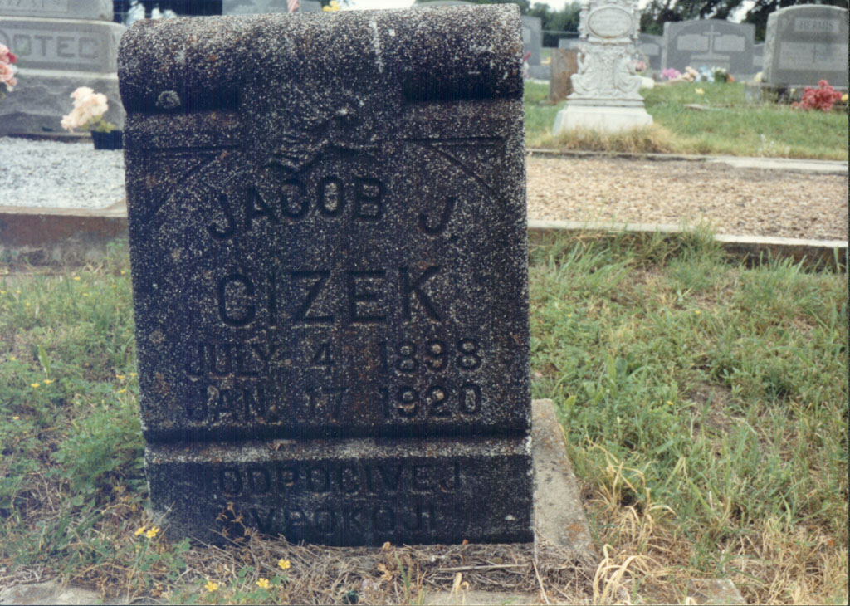

Fig. 4 The above inscription represents a merger of English naming and dating conventions with a Czech epitaph, all in the same type of lettering. Czech last name and the epitaph lack Czech diacritics.

Tombstones raised between the 1880s and the 1930s display stable internal variation rather than gradual attrition. Demise of Czech happened when immigrant descendants lived in American Texas towns where they found Czech useless. It was relevant only within the remaining social networks that tied them back to the Texas Czech community and that were naturally sustained through Czech. The Czech hybrid characteristic of most of the period of language contact was characterized by lexical borrowings that were incorporated grammatically to diverse degrees, English morphosyntax in patterns designating names and dates, and Czech syntax in the narrative passages. Variation in the inscription language reflected the actual variation among usages of individuals who mixed English placenames, idioms, locally relevant vocabulary items and administrative phraseology into their Czech (as expected, the community used English to access the institutions of law, higher education and trade that were located outside the Czech space). Some of them were resilient to or aware of the English influence, and their Czech appeared more conservative and carried fewer English marks. However, rather than turning bilingual the community used its Czech with English mixed in until the middle of the 20th century when its members were mostly elderly and its life cycle exhausted (see also Hannan 2003; cf. Kloss 1977). At that time, those in the productive age traded farming for city living.
Displacement of the language and the community
Conditions of immigrants arriving to the U.S. and Texas during the period of mass migration differed radically from those migrating to Europe today. Although the discourse on foreigners who were in conflict with the image of the American nation was inimical to the immigrants (and so were the activities of the Know Nothing political movement, see Texas State Historical Society), immigrants’ presence and labor were in demand. The very fact that the Czech immigrants committed themselves to long-term cultivation of Texas land enabled them being eventually accepted socially among the Americans in Texas. However, during the Americanization campaign of the 1920s Moravians in Texas were criticized for continuing to live in seclusion rather than socializing with the majority society and speaking English. But the fact is that they hardly had to and could have built settlements based on local Czech infrastructure because their non-integration was tolerated. They had their language space clearly delineated. Within this space they worshipped the God, worked the fields, attended schools, banked, schooled their children and all else necessary to sustain their speech community.
The Texas Czech community was sustained in this manner for almost a century, for half of which new immigrants kept streaming in by thousands until after WWI. They remained clustered over a relatively small territory in settlements where they farmed on small lots inherited by their children. Particular features of cemetery texts and tombstones illustrate ongoing non-integration. The inscriptions communicate this linguistically and demarcate the eventual language shift characterized by an increase of English borrowings, stylistically flat texts and compressed textual content. Tombstones reflect language atrophy and provide a cultural context emblematic of individuals’ integration into American social networks. The descendants’ social networks reaching into the homeland weakened until they became irrelevant.
Appearance of English features in the inscription language is related to when its primary author left the community. Since most of them did not start leaving until the 1940s we typically do not see inscriptions revealing speakers’ truncated repertoire of Czech until the 1950s. It is then that inscriptions reveal a growing distance from the written word and unfamiliarity with the syntax of the Czech sentence. In summary, the older the inscription, the more common are the following linguistic features: use of full sentences, phonetic spellings revealing underlying dialects, diversity of adjectives used to describe the deceased or the death itself, indication of the place of birth and/or death, entangled family relations and the cause of death. The more recent the inscription, the less likely it is to encounter correctly placed diacritic signs and suffixes, uncommon descriptive adjectives and personal detail, and finally, the harder the stone, the more fragile the language that was engraved in it.

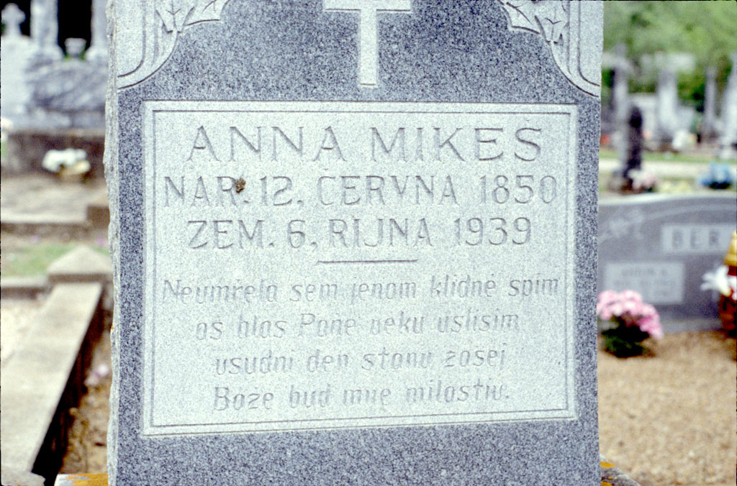
Fig. 5 This1939 inscription provides no overt information about the origin of the deceased but the dialectal pronunciation reveals it beyond any doubt. The noteworthy features of the inscription are its spelling indicating a lack of familiarity with how words would be spelled in the Czech standard (sem, aš, uslišim) as well as dialectal pronunciation (vsudni, zasej).
By the fourth generation the descendants replaced Czech with English and the farms for towns and cities. Abandonment of the community and transfer to Houston, Dallas or other cities eventually had specific linguistic repercussions. It resulted in a transformation from Czech monolingualism and Czech-German bilingualismto English monolingualism that marked “true Americans”. To become “fully American” immigrants were expected to abandon their social networks and “foreign languages”, refrain from using them in public and master American political concepts while gaining English fluency (Leibowitz 1974). This transformation of local Czech identity to American identity, i.e., of “foreign” and “Catholic” farmers ignorant of the American ideals of democracy, freedom and individual success to Americans happened through the process of Americanization and assimilation (cf. Olm, 2000). Imposition of immigrant quota sealed the Czech community in time since very few additional immigrants joined it in the 1920s and later. The towns and farms were gradually abandoned and the core of the community, i.e., the church, school and farm ceased to function as its adequate support. The linguistic data of inscriptions attesting gradual abandonment of traditional Czech settlements are supported by articles in the immigrant press reporting on priests leaving and schools closing, and readers’ letters bemoaning instability of families and a lack of intergenerational transfer of Czech. Growing ossification of Texas Czech could never be turned back after that. Texas Czech sounded in the settlements for as long as people had worthwhile reasons to remain on their farms and talk to their neighbors. But after WWII and agricultural restructuring of the American South very few did. In addition to that, by the 1950s the U.S. political ideology allowed little tolerance for ethnic and cultural diversity (see also Kloss 1940-1942). At that time, it was self-evident that pioneer descendants chose not to remain different.
Czech marked the territory and defined the immigrants’ identity in Texas for as long as it was the language of the community. The language displacement is documented throughout the cemeteries. After WWII the inscriptions were authored or commissioned increasingly by individuals returning occasionally to the Czech settlements to celebrate Czech religious holidays and to bury their parents and grandparents. Their Czech was naturally overpowered by English of their new neighborhoods and social networks to the degree that, as the stones attest, they inscribed Czech texts without understanding their literal meanings.
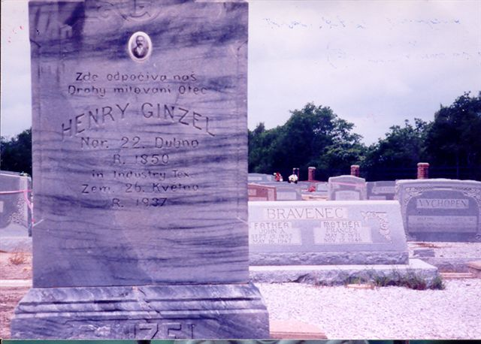
Fig. 6 An interesting feature in the tombstone text displayed above is the insertion of the placename marking a Texas settlement in the oblique case marked by an English preposition. This commonly occurs when American toponyms are used. The text shows the Czech morphosyntactic frame supporting declension of all the other nouns.

Time  Identity | the 1860’s-1880s  Czechs in Texas | 1880s–1950s  Texas Czechs | 1950s and later  Americans
Language variation | Homeland dialects  Features of standard Czech  Detailed content  Personal detail | Compressing the content and style  Converging to E morphosyntax  Borrowing from E Codeswitching | Czech replaced by E  Czech used in occasional phrases, spellings and diacritics
Semantic Data | Diverse openings, kinship terms, biblical verses,  personal greetings&  epitaphs  detail in places of birth & death, | Reduction of diversity, move to homogeneity | Predictable type and order of semantic data:  Kinship: Father/Mother or Otec/Matka  Names  Birth and death dates Epitaph: Zde odpocivaji ‘Here rest’ or Odpocivejte v pokoji ‘Rest in peace’
Production  Stone material  Esthetic impact | Domestic, creative production  Lime or sand stone  Metal&wooden crosses, artistic reliefs  Catholic &Brethren symbols | Soft and hard stones  Occasional photos  Religious symbols | Commercially produced  granite or marble  Occasional photos  Predictable pre-cut decoration
Textual lay-out | Diverse  Textual narrative or  chunks of text  focus on the place of origin and kinship |  | Basic prototypes  Surname  Mother Father  Birth Date Birth Date  Death Date Death Date  Odpocivejte v pokoji ‘Rest in Peace’

Table 1. Language variation and shift in tombstone inscriptions (for the linguistic detail, see Eckert 2007).

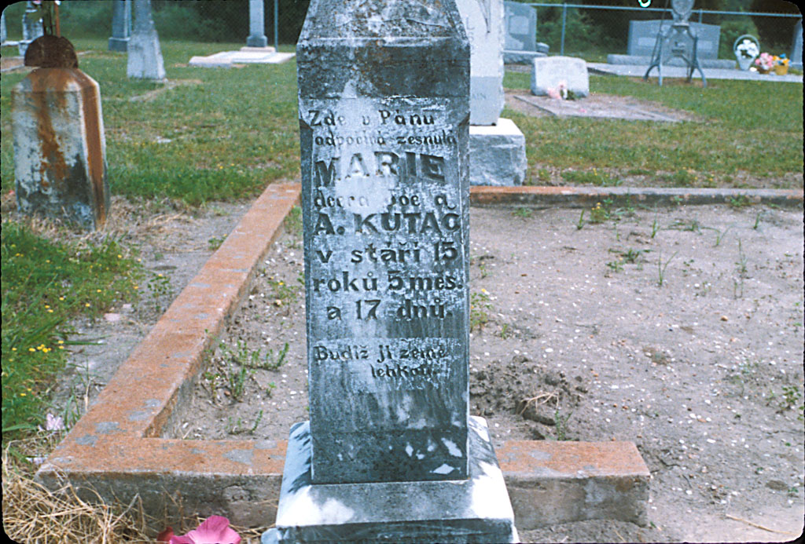
Fig.6 The tombstone can be dated only through the indirect indications of the Czech textual layout and uncommon usage of the phrase indicating the age of the deceased. Neither the date of birth nor that of death are given. English syntax underlines the kinship phrase that lacks inflectional features, i.e., dcera Joe a A. Kutač.
Comparison of the 1870s and 1950s tombstones and texts reveals a turnover in the type of stone from the soft to engrave limestone to marble that affected how long and detailed the inscriptions could be and who was capable of carving them. Czech dialectal and phonetically spelled texts were replaced by standardized and predictably outlined and worded texts in English. Czech features occurred irregularly in spelling, names and epitaphs and merely in a symbolic meaning. Czech and English became fused, and English eventually dominated as the matrix language of the inscriptions (Myers-Scotton 1997) where suffixes marking dates, names and places were misplaced, grammatical agreement ignored, prepositions omitted, word boundaries obliterated and words decomposed. The texts tend to include Czech phrases translated verbatim from English, Czech words and even epitaphs transferred out of context from stone to stone with the result or mismatched gender endings on nouns and verbs. Majority of tombstones inscribed after 1950 show the data inserted into a predictable textual outline. Tombstones for couples predominate and imply the authorship of sons and daughters. The language content is reduced at the expense of a monumental presence of the tombstone itself.
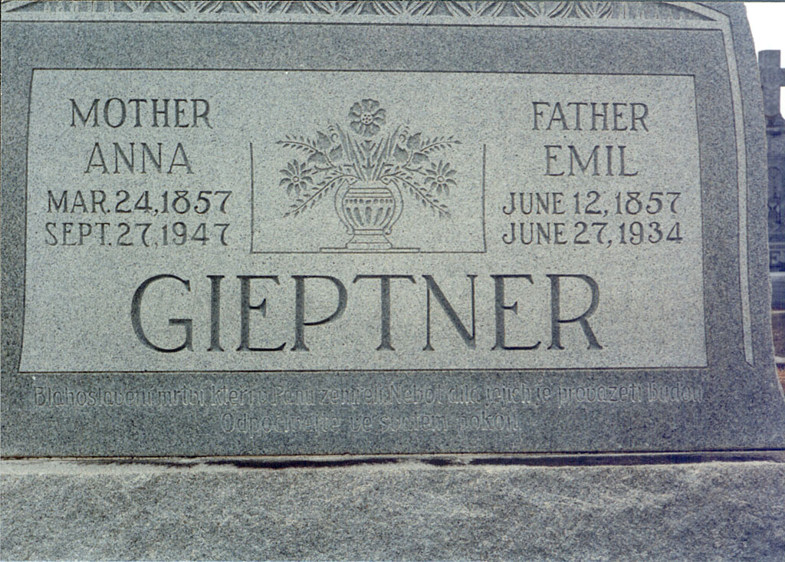
Fig. 7 The tombstone engraved in 1947 arranges the text into two columns that include only a minimal semantic content. However, the epitaph is engraved in a different type of lettering in archaic Czech.
Although it is questionable whether actual stages of language replacement can be delineated at all, several tendencies of the progress towards shift are transparent. The earliest feature of the eventual displacement appears to be usage of English first names. In spelling three processes are apparent, i.e., (1) omission of diacritics due to dialectal or phonetic spelling and eventually also unawareness of how they function in the Czech system of spelling, (2) inconsistent anglicization of spelling and, finally, (3) reintroduction of diacritics as identity symbols in the post 1950 inscriptions. In morphology attrition seems to progress from (1) leaving English placenames undeclined in oblique cases to (2) reducing usage of case and gender markers in proper names, (3) obliterating grammar distinctions of case, number and gender (manifested in misplacing endings and ignoring grammatical agreement) and (4) merging or decomposing words (typically, prepositions are rendered as first syllables of nouns). Semantic data are (1) gradually reduced with only three types of data remaining, i.e., names, dates and an epitaph, (2) textual amount is condensed to a bare minimum and (3) epitaphs become used irrespectively of their meaning and often as truncated or unfinished sentences.
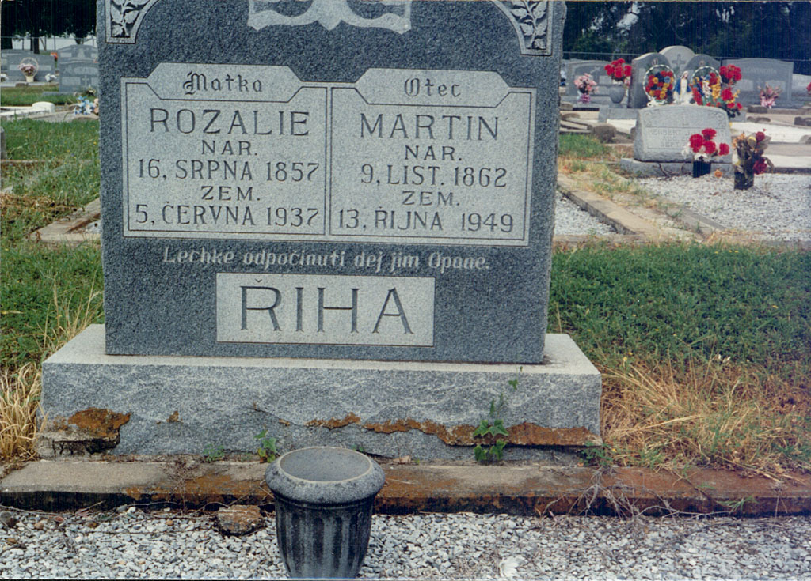
Fig. 8 Although the text is minimal and predictable, the epitaph includes a phonetically spelled adjective lechke ‘easy’ and the phrase Opane ‘Oh Lord’ where O instead of P is capitalized although the epitaph is the most frequently used one. This usage suggests that the author did not live in the settlement or was no longer a member of the local community.
Features of attrition in Czech morphology are congruent with those proposed for atrophying languages in general (Polinsky 1995, Dutkova 2001 et al.). Eckert 2007 applied them to the morphology of tombstone inscriptions; they spelled out a decline in inflectional morphology through disintegration of Czech suffixation. The process is summarized, as follows. The order proceeds from features most likely to the least likely to undergo language shift:
- Word boundaries are obliterated and words merged or decomposed (for instance, the misspelled ztřateli zme tebe... tyš by Stid a vudče náši snahy nezapomene te ‘We lost you here... you were our shield and leader of our effort [we] will not forget you‘);
- Fleeting vowel is not deleted and the full form adopted in all case positions (Narozen 16 řijena... 26 srpena);
- Prepositions are omitted (for instance, Spěte sladce otče a matka hrobě svem ‘Sleep sweetly father and mother (in) your grave’, or Rozena Listopadu 1874 ‘born (in) November’);
- Verbal endings are merged (for instance, the –ej is used to mark the imperative (singular as well as plural) and 3 plural indicative, as in odpočívej;
- The honorific distinction in the 2nd singular and plural is violated (for instance, Tedy sladce spi otče drahy tys byl štít… nikdy nezapomenem na vas);
- Grammatical agreement is obliterated (for instance, in the mismatched phrase Drahý matko, past participle masc sg neumřel designating deceased males, females, as well as couples), and the plural je ‘them’ is used instead of ho ‘him’ and ji ‘her’ respectively;
- Noun endings other than nominative continue to appear irrespective grammatical context. For instance, either the vocative address Otče or the nominative Otec are used as to introduce the data about the deceased father; nominative and genitive are juxtaposed in a single date with no apparent difference (Born 1, Červ’ce ‘July’ Died 10, Červen ‘June’);
- The genitive suffix –teho (used in Standard Czech with several allomorphs) is adopted as the marker of day numbers in dates (28teho or 1teho ‘28^{th’} or ‘1st’).

Despite compromises in grammar and spelling, inscription authors seemed obstinate about writing in what they understood to be Czech or including it in their texts symbolically, motivated by their parents’ last wishes and perception of Czech identity. But they used Czech words, names, diacritics and suffixes to decorate the stone and to mark Czechness rather than to render meanings integral to Czech grammar. It is important to emphasize that to draw a line between the processes of internal language ossification and those caused by exposure to English (constantly intensified through the media) is impossible. As a consequence, speakers replaced Czech for English as the matrix language channeling their ideas.
Czech was used in ritual meanings in the inscriptions at the time when those who authored them no longer spoke Czech, i.e., they did not use it as an inflective language, did not decline nouns, conjugated verbs in a limited manner and did not use diminutives. In the final stages of atrophy Czech was symbolically used in abbreviations standing for the names of months, terminology of family relations (otec and matka) and stagnated epitaphs (Odpočivejte v pokoji and Lehke odpočinuti). They were passed on orally and spelled out as pronounced (for instance, Od/tpočivey v/fpokoj/yi nebo Leh/chke od/tpočinuti), diacritic marks were left out or used to decorate words.

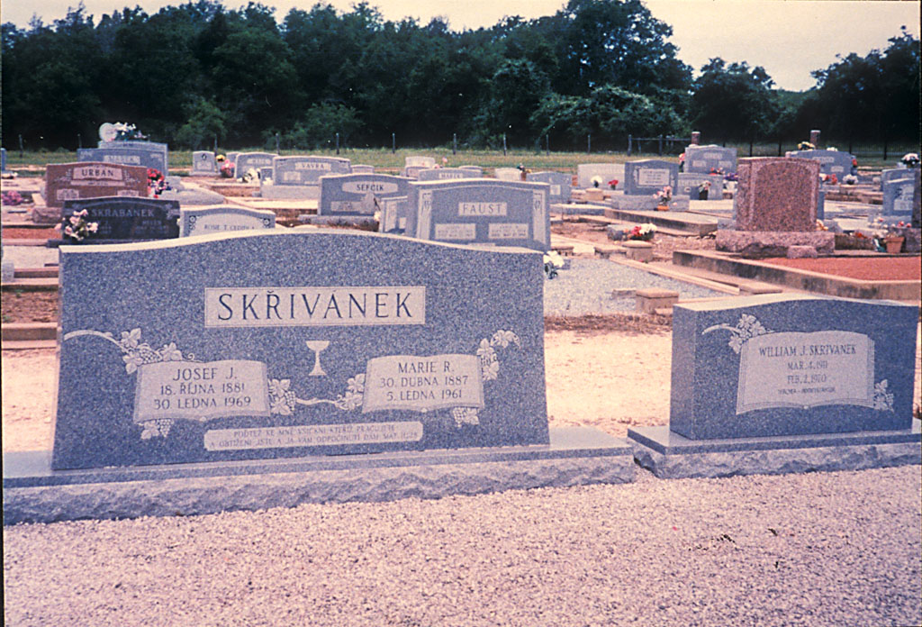
Fig. 9 The tombstone is placed at the Brethren cemetery of Snook and was engraved in 1969. The religious affiliation is symbolized by the chalice. Despite the text dating back only to the 1960s its underlying syntax is Czech, names are spelled in Czech, the nouns are declined and the epitaph was copied from a biblical source. Such usage is indeed rare in the 1960s.
The age of the settlement predicts outcomes of language contact and the distance between the stages of language atrophy and shift. Having collected data from forty-seven cemeteries and examined them decade by decade Cox 2010 sought to establish the rate of language change and test applicability of the wave theory. He mapped out language shift and the rate of change geographically and determined local factors influencing it by means of a statistical analysis of primary data collected from almost ten thousand inscriptions at forty seven historically Czech communities in Texas. The author reached the conclusion that the life span of cemetery inscriptions was longest where it was oldest, i.e., in the early Czech settlements of the Fayette County (p. 15). Thus, the younger the community was and the further it was established from the core settlement area the quicker it progressed in shifting to English. He proposed that noticeable changes in the inscription language appeared in the 1920s and progressed on average by 15 per cent per decade until the 1960s, and that usage of Czech was minimal in the 1970s and later (p. 16). He further came to the conclusion that the rate of change was affected by rural vs. urban cemetery type with rural areas experiencing language shift less quickly (p. 20) and by Catholic or Brethren religious affiliation. Statistically the best predictor of language used in the inscription was the date of birth in combination with the date of death, i.e., the earlier the individual was born and the longer he or she lived, the greater a chance of the inscription being in Czech or the Czech-English hybrid. As the settlements were shrinking in the 1950s and later, the cemeteries nearby kept expanding. As the living kept leaving, the elders and eventually their tombstones remained for posterity.
As part of shedding the original ethnic identity of locally engaged farmers Texas Czechs moved out of central Texas to cities and out of Czech practices, habits and conceptual frames into English and American Texas, as other assimilated Americans did as well. Until today the space occupied between the 1850s and 1950s retains its Czech character through the linguistic and cultural symbolism that tombstones raised during that time contain. Until today, Czech cultural space in Texas can be retracted through buildings of the religious Catholic and Brethren institutions (KJT and SPJST), and through crosses and chalices of the churches, cemeteries and lodges. In 1946 252 Czech settlements existed in Texas, as identified by the presence of Czech ethnic organizations (Czech Contribution 1996).
Cemeteries record cultural assimilation in a disturbing fashion. Modern tombstones obliterate distinctive elements of ethnic traditions, take away choices of individuals in inscribing texts and replace lavender bushes with commercially produced plastic flowers. The cemetery protocol is dictated by marble tombstones predefined in size, shape, lettering and text arrangement. Photographs, greetings of the bereaved, personal identities of the deceased, biblical verses, vernacular terminology, dialectisms, grammatical mistakes and misspellings characterizing the early stones have vanished. Language of late inscriptions is controlled and monotonous. Informal messages in stones of various sizes, shapes and materials yield to formal language and content, as dictated by new social expectations. The extent of tombstone writing does not go beyond pre-defined phrases and epitaphs; geographical data, references to the bereaved family or lengthy verses appear rarely; the range of phrases is minimal and predictable. The function of cemetery inscriptions has changed. The goal of the early ones was to elaborate upon one’s life for posterity and to define the individual in relation to others in the community replicated by the cemetery; but the goal of the modern ones is to keep track of those who died. The inscriptions are no longer meaningful to a community because it ceased to function as a social unit. As artifacts of vernacular culture tombstone inscriptions literally stand, at the same time, for a speech community that once exhibited a certain unique culture and language but that no longer exists.
REFERENCES
Cope, Lida, Mark Hopkins, and Ryan Miller. 2012-2015. Texas Czech Legacy Project.
http://laits.utexas.edu/txczechproject/home. Austin: University of Texas.
Cox, G., Giordano, A. & Juge, M. (2010). The geography of language shift: A quantitative cemetery study in the Texas Czech community. Southwestern geographer 14, 3-22.
Czech Contributions to Texas Music 1996: Czech Contributions to Texas Music, Fort Bend County Czech Fest, Czech Heritage Society of Fort Bend County, May 4 and 5, 1996, Rosenberg, TX.
Dutkova, Lida, 2001. Texas Czech, Southwest Journal of Linguistics 20 (1):29-69.
Eckert, E. & Hannan, K. (2009). Vernacular Writing and a Sociolinguistic Change in the Texas Czech Community, Journal of Slavic Linguistics, 87-161.
Eckert, Eva. 2007 Stones on the Prairie: Acculturation in America, Slavica Publishers, Inc., Bloomington
Hannan, Kevin, 2003, Reflections on Ethnicity, Assimilation and Bilingualism, Kosmas, 16, 2,
Gilbert, G.G. (1972). Linguistic atlas of Texas German. Austin/London: University of Texas Press.
Jeleček, L. (2002) Trocha faktografie nikoho nezabije - Češi a čeští Němci do roku 1918, Accessed Jan. 12, 2016 from http://archiv.neviditelnypes.lidovky.cz/clanky/2002/04/20619_78_0_0.html
Jordan, Terry G., 1966, German Seed in Texas Soil: Immigrant Farmers in 19th Century Texas, University of Texas Press, Austin and London.
Jordan, Terry G., 1982, Texas Graveyards: A Cultural Legacy, University of Texas Press, Austin, Texas.
Kerswill, P. (2006). Migration and language. In Mattheier, K., Ammon, U. & Trudgill, P. (Eds.) Sociolinguistics/Soziolinguistik. An international handbook of the science of language and Society. 2nd ed., v. 3. Berlin: De Gruyter.
Kloss, Heinz, 1940-1942, Das Volksgruppenrecht in den Vereinigten Staaten [Ethnicity rights in the United States], v. 1, Essen.
Kloss, Heinz, 1977, The American Bilingual Tradition, Newbury House, Rowley, Mass.
Klumpp, Dorothy and Albert J. Blaha, Sr., The Saga of Ernst Bergmann (Houston, 1981).
Leibowitz, A. H. (1974). Language as a Means of Social Control: The United States Experience. Washington, D.C.: ERIC Document ED 093 168, Clearinghouse.
Mendl, J., 1978, Moravian Dialects in Texas, in Clinton Machann (ed.), The Czechs in Texas, ASymposium, College Station, pp. 128-141.
Milroy, Leslie, 1987, Language and Social Networks, 2nd ed., Basil Blackwell, Oxford; University Park Press, Baltimore.
Myers-Scotton, C. 1998. A theoretical introduction to the markedness model. In Myers-Scotton, C. (ed.) Codes and Consequences. Choosing Linguistic Varieties. New York and Oxford“ Oxfor University Press.
Overland, Orm, 2000, Immigrant Minds, American Identities: Making the United States Home, 1870-1930, University of Illinois Press, Urbana and Chicago.
Polinsky, Maria, 1995, Cross-linguistic Parallels in Language Loss, in Southwest Journal of Linguistics, 14, 1, pp. 87-123.
Poplack, Shana and David Sankoff, 1984, Borrowing: The Synchrony of Integration, Linguistics, 2, pp. 99-135.
Texas State Historical Society. American Party. Accessed Jan. 12, 20016 vfrom https://tshaonline.org/handbook/online/articles/waa01
Woolard, K.A. (1994). Language ideology: Issues and approaches. Pragmatics 2 (3), 235-249.

