Národnost a menšina – hodina 5
Sylva Švejdarová, PhD

The man who hated Britain: Red Ed's pledge to bring back socialism is a homage to his Marxist father. So what did Miliband Snr really believe in? The answer should disturb everyone who loves this country
By GEOFFREY LEVY FOR THE DAILY MAIL
PUBLISHED: 21:50 GMT, 27 September 2013 | UPDATED: 12:53 GMT, 1 October 2013

On a hot summer day, a young man made his way alone to Highgate Cemetery in North London to make a lifelong vow.
Solemnly, he stood at the grave of Karl Marx at a moment when, in his own words, 'the cemetery was utterly deserted . . . I remember standing in front of the grave, fist clenched, and swearing my own private oath that I would be faithful to the workers' cause'.
The year was 1940. The young man was Ralph Miliband, a Jewish immigrant who, with his father, had fled to London from Belgium just weeks earlier to escape the Nazi Holocaust.

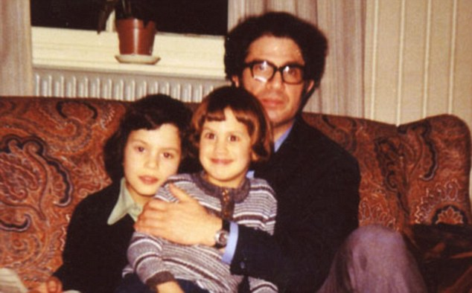
The Miliband boys: David with Ed (centre) and father Ralph

=============================== ČÁST 1 ================================================
Miliband, father of Ed and David Miliband, died in 1994, aged 70, soon after the publication of his last book, Socialism For A Sceptical Age. In it, the venerated Marxist philosopher and academic continued to espouse his lifelong 'socialist' cause.
One voice, however, vehemently informed him that he was still pursuing a lost cause. It was that of his elder son David. He did not mince his words.
Having read the manuscript before publication, David wrote to his father asking, 'whether you are restating a case that has been traduced in theory or practice, or whether you are advancing a new case. I think that the book reads like the former . . .'

=============================== ČÁST 6 ================================================
The word 'traduced' - which means 'disgraced' or 'denigrated' - was surely rather harsh, considering his aged father had always included his two sons (even when they were small), in the trenchant political discussions with ever-present academics and Left-wing thinkers that took place round the basement dining table of the family home in Primrose Hill, North London.
=============================== KONEC ČÁSTI 6 =======================================
Indeed, some family friends feel this episode, not long before their father died, could have been a contributory factor towards the younger - and considerably more Left-wing - son Ed unexpectedly deciding to fight his elder brother for the leadership of the Labour Party in 2010, and, of course, beating him.
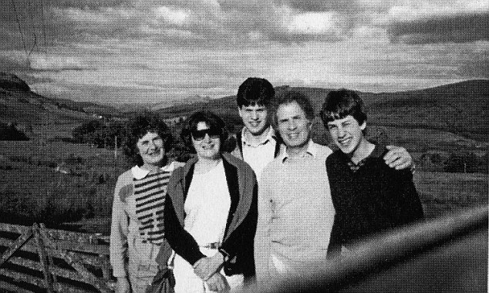
On holiday: David (centre) and Ed, pictured with their mother Marion, their aunt Hadassa and father Ralph in Scotland, 1987

In his explosive memoirs, serialised last week in the Mail, Gordon Brown's spin doctor Damian McBride argued that Ed Miliband was obsessed with maintaining his father's legacy. Winning the leadership was Ed's 'ultimate tribute' to his father - an attempt to 'achieve his father's vision and ensure David Miliband did not traduce it'. Again, that word 'traduce'.
Ed is now determined to bring about that vision. How proud Ralph would have been to hear him responding the other day to a man in the street who asked when he was 'going to bring back socialism' with the words: 'That's what we are doing, sir.'
Ed's victory over David, made possible only with the unions' block votes, was perfectly in step with his father's fervent and undimmed conviction that 'alliance with the trade unions is not only one of the party's great strengths; it is by far its greatest strength'.
Ralph's Marxism was uncompromising. 'We want this party to state that it stands unequivocally behind the social ownership and control of the means of production, distribution and exchange,' he told the 1955 Labour conference, as the delegate from Hampstead. 'We are a socialist party engaged on a great adventure.'
=============================== KONEC ČÁSTI 1 =======================================

=============================== ČÁST 4 ================================================
This was the immigrant boy whose first act in Britain was to discard his name Adolphe because of its associations with Hitler, and become Ralph, and who helped his father earn a living rescuing furniture from bombed houses in the Blitz.
=============================== KONEC ČÁSTI 4 =======================================

=============================== ČÁST 2 ================================================
As for the country that gave him and his family protection, the 17-year-old wrote in his diary: 'The Englishman is a rabid nationalist. They are perhaps the most nationalist people in the world . . . you sometimes want them almost to lose (the war) to show them how things are. They have the greatest contempt for the Continent . . . To lose their empire would be the worst possible humiliation.'
=============================== KONEC ČÁSTI 2 =======================================

This adolescent distaste for the British character certainly didn't stop him availing himself of the fine education that was on offer in this country, or spending the rest of his life here.
Quickly learning English, he got a place at the London School of Economics (LSE), which had then moved temporarily to Cambridge to avoid the bombing, and there he was taught politics by Harold Laski, a giant of Labour's Left, whom some Tories considered to be a dangerous Marxist revolutionary.
Laski was Miliband's mentor, his inspiration, the figure who encouraged his growing interest in Karl Marx.
Ralph Miliband then served three years in the Royal Navy, returning when the war was over to his studies at the LSE, and within a few years was teaching there himself.
He was already on his way to becoming a heavyweight thinker in the kind of political and academic circles whose pronouncements often attracted attention.
Joyfully, Miliband described Labour's 1945 post-war election victory as 'the country's capture from its traditional rulers'.
He relished what he called the 'genuine sense of outrage . . . of bourgeois England', adding that 'the nationalisation proposals of the government were designed to achieve the sole purpose of improving the efficiency of a capitalist economy'.
In later years, he chose to ignore the lamentable performance of nationalisation, which proved to be anything but efficient.
But how passionately he would have approved today of his son's sinister warning about some of the policies he plans to follow if he ever becomes Prime Minister. Such as giving councils draconian new powers to seize into public ownership land held by developers who fail to build on it.
Miliband senior's academic career took him away for several years to be professor of politics at Leeds University, where he missed the stiffer intellectual clashes he enjoyed in London, and to America.
Meanwhile, in 1961, he had married Marion Kozak, one of his former students at the LSE, and their first son David was born in 1965, with Ed following four years later.
David was given a second name, Wright. As Miliband's biographer Michael Newman explains, this was in honour of his father's American friend, the sociologist C. Wright Mills, whose 1956 book, The Power Elite, suggested that the political, military and economic elites control power at the expense of ordinary people.

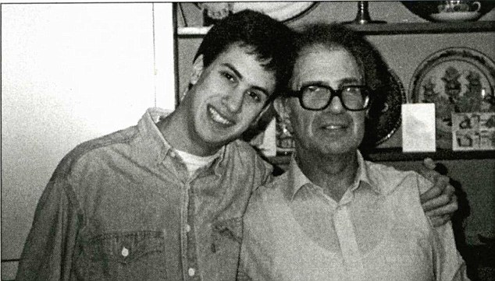
'Ultimate tribute': Ed, pictured with Ralph in 1989, is determined to bring about his father's vision of socialism

Mills claimed that these elites see themselves as separate from, and superior to, the rest of society, and manipulate events to suit their own interests.
Ralph Miliband himself, in his 1969 book The State In Capitalist Society, declared: 'Advanced capitalism is all but synonymous with giant enterprise; and nothing about the economic organisation of these countries is more basically important than the increasing domination of key sectors ... industrial, financial and commercial ... by a relatively small number of giant firms, often interlinked.'
So he would also have applauded his son Ed's proclamation that, as Prime Minister, he would cap energy prices - an announcement that has already knocked billions off share prices, affecting many ordinary workers' pension funds.
As for the class war, Ralph Miliband declared: 'Class success means the ability of a dominant class to maintain its position in society, and to contain and subdue any challenge to its power and privileges. This is what has happened in Britain.'

=============================== ČÁST 8 ================================================
He also made plain his disdain for the Establishment, which was, to his mind, nothing less than the old boy network.
This included, he wrote in a letter to his old friend Wright Mills, 'Eton and Harrow, Oxford and Cambridge, the great Clubs, the Times, the Church, the Army, the respectable Sunday papers . . . It also means the values . . . of the ruling orders, keep the workers in their place, strengthen the House of Lords, maintain social hierarchies, God save the Queen, equality is bunk, democracy is dangerous, etc.
'Also respectability, good taste, don't rock the boat, there will always be an England, foreigners, Jews, natives etc are all right in their place and their place is outside . . .'
Given this tirade, one is entitled to wonder whether Ralph Miliband's Marxism was actually fuelled by a giant-sized social chip on his shoulder as he lived in his adoptive country.
=============================== KONEC ČÁSTI 8 =======================================

He opposed the Falklands War with such a ferocity that he even swore - a rare occurrence - at the sight of Margaret Thatcher's soaring popularity.
'I won't write about the f****** Falklands now. It's a most depressing and bitter business and it seems to have turned Thatcher into a major political figure,' he said.
'I mean that her brand of Toryism may now come to predominate. The Falklands has served her well . . . if she is returned at the next election England will look a very different country than even in 1979.'
Though they were friends, he never agreed with his fellow Marxist Eric Hobsbawm over the latter's refusal to condemn Stalinism's 30 million dead, or the brutal Soviet invasion of Hungary in 1956, on the grounds that the socialist end always justified the means. Relations between them deteriorated when Hobsbawn suggested in an article in Marxism Today in 1983 that the Left might prefer 'a Thatcher government to a reformist Labour government' in which they had lost faith.
Hobsbawn was invited to the Milibands' for New Year's Eve and the two ended up having a terrific row, but they later made it up.
Like all Left-wing thinkers, Ralph Miliband knew how to explain away awkward events.
Mikhail Gorbachev's dismantling of Soviet socialism and the worker state should have shocked Miliband, but he managed to find an argument welcoming it.
He proclaimed that the Cold War had always been a useful 'bogey' for the Right, and that, 'the success of Mikhail Gorbachev in democratising Soviet society . . . would deprive conservative forces of one of their most effective weapons'.
Of course, both his sons went to the 'Establishment' Oxford University. And in recent times there have been embarrassing allegations involving how the ownership of the family house was altered - albeit perfectly legally - which experts say enabled his sons to avoid death duties.
Hardly the behaviour of tax-loving socialists.
The fact is, with all his brilliance, his Marxist teaching and his books, Ralph Miliband died a disappointed man. Labour, he conceded, remained 'a party of modest social reform in a capitalist system within whose confines it is ever more firmly and by now irrevocably rooted'. No party or grouping existed that was 'capable of posing an effective challenge'.
But right to the end, he hadn't entirely given up. Nothing had changed in his mind since his pilgrimage, in 1940, to Karl Marx's grave.
Significantly, his own tombstone now lies just 12 yards from it in Highgate cemetery.
It is engraved with the three-word inscription: 'Writer Teacher Socialist.'
Years after that early visit to the cemetery, he wrote: 'I have not, from that day to this, departed from the view that this was the right cause and that I belonged to it.'
Even his adoptive country, Britain, could still one day realise his Marxist dream. There was, he said, 'no reason for the resigned acceptance' of defeat.
'On the contrary,' he wrote, 'what it requires is to begin preparing the ground for the coming into being of such an alternative.'

=============================== ČÁST 3 ================================================
As his son, Red Ed - who lives less than a mile away from Highgate cemetery in a £1.6 million townhouse - talks of 'socialism' being the key word for the next Labour government, perhaps that ground is indeed now being prepared.
=============================== KONEC ČÁSTI 3 =======================================

=============================== ČÁST 5 ================================================
Isn’t it permissible to surmise that a man who had expressed such views joined the Royal Navy not so much to fight for Britain as to fight, like the Soviet Union, against the Nazis?
(‘An evil legacy and why we won’t apologise’, Daily Mail, 1.10.2013 (http://dailymail.co.uk/debate/
article-2439714/Ed-Miliband-evil-legacy-wont-abologisee.html).)
=============================== KONEC ČÁSTI 5 =======================================

=============================== ČÁST 7 ================================================
We do not maintain, like the jealous God of Deuteronomy, that the iniquity of the fathers should be visited on the sons. But when a son with primal ministerial ambitions swallows his father’s teachings, as the younger Miliband appears to have done, the case is different. (ibid.)
=============================== KONEC ČÁSTI 7 =======================================

=============================== ČÁST 9 ================================================
That’s why the Mail – which is not Pravda – said that readers who love this country would be
truly disturbed if they understood about Miliband’s father’s views (ibid.)
=============================== KONEC ČÁSTI 9 =======================================

=============================== ČÁST 10 ===============================================
If he crushes the freedom of the Press, no doubt his father will be proud of him from beyond the grave, where he lies 12 yards from the remains of Karl Marx. But he will have driven a hammer and sickle through the heart of the nation so many of us genuinely love.
=============================== KONEC ČÁSTI 10 =======================================

