EU

Structure of an EU legal act

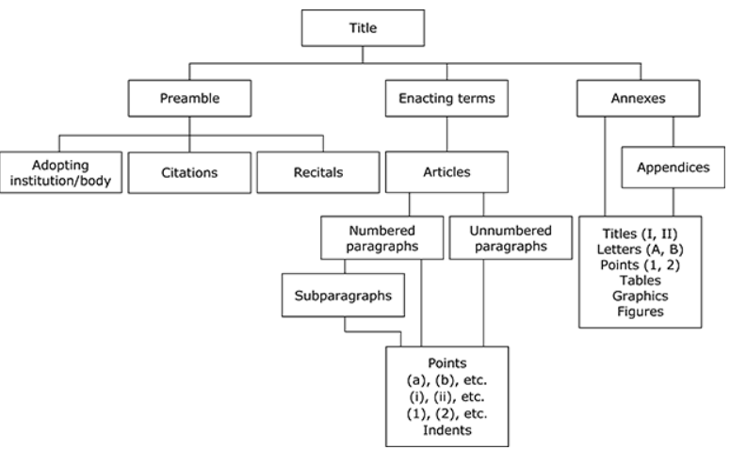

Structure of an EU legal act - examples
Articles
Citations (legal basis)
Explanatory memorandum
Recitals

In which parts of an EU legal act can you find the following elements?
- “Artificial Intelligence (AI) is a fast evolving family of technologies that can bring a wide array of economic and societal benefits across the entire spectrum of industries and social activities.”
- “Having regard to the opinion of the European Economic and Social Committee”
- “The notion of AI system should be clearly defined to ensure legal certainty, while providing the flexibility to accommodate future technological developments.”
- “The following artificial intelligence practices shall be prohibited:”

EU law
Decide whether the statements are TRUE (T) or FALSE (F). Be ready to correct the false ones.
- Regulations must be transposed into national law before they can apply. ___
- Directives are binding as to the result to be achieved, but Member States can choose the form and methods. ___
- Decisions are addressed to all Member States. ___
- Recommendations and opinions are legally binding. ___
- The TFEU is generally more detailed than the TEU. ___
- The Charter of Fundamental Rights of the European Union is legally binding and has the same legal value as the Treaties. ___
- Direct effect means that EU law must first be implemented by national law before individuals can rely on it. ___
- Regulations are directly applicable in all Member States. ___
- Directives do not have direct effect. ___
- Transposition means incorporating EU directives into national law. ___
- Treaties are primary law, while regulations and directives are secondary law. ___
- All EU legal acts have direct effect. ___
- The European Parliament is the main body adopting EU legislation. ___

7 EU institutions

- The __________ checks any person or organisation handling EU funds – including spot checks in EU institutions, EU countries and countries receiving EU aid.
- Most decisions in the __________ require a qualified majority: 55% of countries representing at least 65% of the EU population.
- The __________ is a directly elected EU body with legislative, supervisory, and budgetary responsibilities.
- The __________ draws up the EU’s annual budget for approval by the Parliament and the Council.
- Each EU country holds the presidency of the __________ on a 6-month rotating basis.
- The __________ ensures that EU law is properly applied in all Member States.
- In the __________, government ministers from each EU country meet to discuss, amend and adopt laws, and coordinate policies.
- The __________ is mainly responsible for proposing new EU legislation.
- The candidate for President of the European Commission is proposed by the __________.
- The __________ interprets EU law and settles legal disputes between Member States and EU institutions.
- The __________ audits EU finances and ensures that EU funds are used properly.
- The __________ brings together EU leaders to set the EU’s overall political direction.
- The __________ shares legislative and budgetary powers with the Council.

EU legislative process
Explain the relevance of these expressions to the EU legislative process:

- first reading
- conciliation
- special legislative procedure
- amendments
- DGs
- subsidiarity, proportionality
- right of initiative
- unanimity, QMV
- explanatory memorandum
- transposition
- MEP

Features of EU English
- Legalisms:
- The requirement to record the information under this field shall apply from one year after the entry into force of this regulation.
- Those rules are laid down in Regulation (EU, Euratom) 2018/1046 of the European Parliament and of the Council (6) (‘the Financial Regulation’)
- Without prejudice to the rules on decommitment, where those conditions are not fulfilled, expenditure related to operations under the related specific objectives should not be reimbursed by the Commission.
- (hereinafter referred to as ‘structured data’)
- Terminology:
- Member States should prevent, detect and deal effectively with any irregularities, including fraud committed by economic operators.
- In order to maintain a favourable investment framework, the continued fulfilment of the enabling conditions should be monitored regularly.
- The Member State or the managing authority shall carry out evaluations of the programmes related to one or more of the following criteria: effectiveness, efficiency, relevance, coherence and Union added value,…
- Popular EU expressions:
- Programme authorities, beneficiaries and stakeholders in Member States should raise awareness of the achievements of Union funding and inform the general public accordingly.
- Poverty is a particularly important challenge in the Union.
- Sentence structure:
- Further, as the Commission is precluded from making payments for the expenditure incurred by beneficiaries and paid in implementing operations linked to specific objectives for which enabling conditions are not fulfilled, which is included in payment applications, the time limit for the Commission to make payments should not be triggered for such expenditure.
- Mistakes in the original version:
- If actual data pursuant to Regulation ( EC ) No 3605/93 indicate that an excessive deficit has not been corrected by a participating Member State within the time limits specified…
- Prohibition of State aids under Article 87(1 ) of the EC Treaty…
- It appeared to be necessary to give the Member States a supplementary delay for transposing the provisions of Directive 83/201/EEC into their national legislation.

