Handout 8 – Intellectual property

Vocabulary
- How would you define a patentee? Provide a synonym. Do you know any other words with the -ee suffix?
- What is the difference between work and a work? Which of these words is more frequent in the area of IP?
- What are royalties?
- Which IP rights are covered by industrial property?
- What do people usually get patents for?
- What is meant by design in the area of IP?
- What is the purpose of a trademark?
- There is a car. What can be protected by patent, design and trademark about this car?
- Provide 2 examples of geographical indications.
- Have you ever held copyright to a work?
- When does copyright arise?
- A ________________ is a contract through which the artist or copyright holder grants certain rights to another party.
- What does it mean if you hold an exclusive right to use or authorize others to use a certain work?
- What is meant by fair use?
- Which verb is often used in IP to refer to a breach or violation?
- “A trademark must be distinctive and not descriptive.” Explain and provide an example of a distinctive and non-distinctive trademark.
- Who are counterfeiters? Which form of IP protection is normally associated with counterfeiting?
- Economic Rights vs Moral Rights: What is the difference?
- Which invention is patentable? Can you think of any criteria?
- Which IP right deals primarily with authorship?
- Provide an informal equivalent for copyright infringement.
- John Doe wrote a novel. Provide an example of a derivative work based on that book.
- Explain what passing off is in IP and provide an example. What is the difference between trademark infringement and passing off?
- What is a work for hire?

Identify the relevant IP rights

1 | 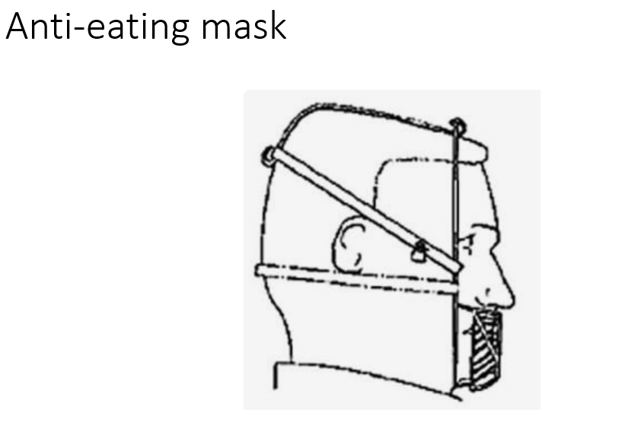
2 | 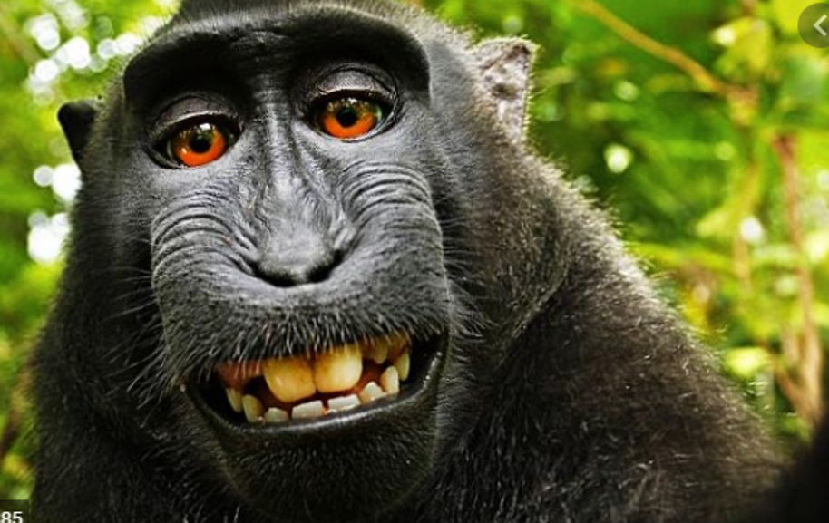
3 | 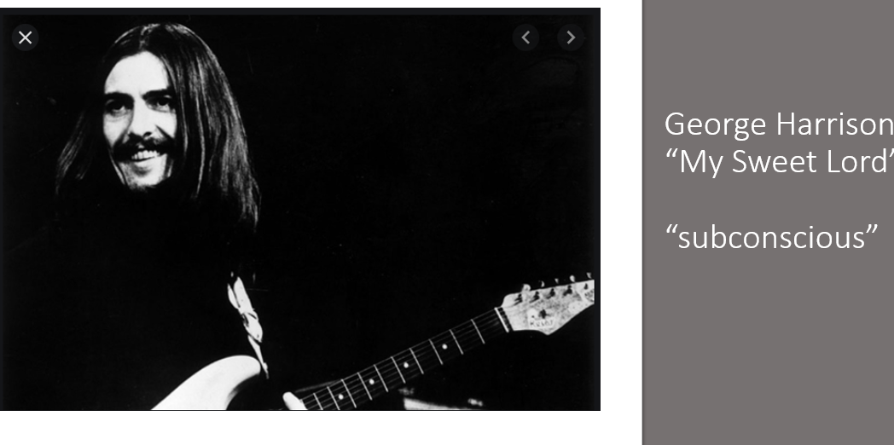
4 | 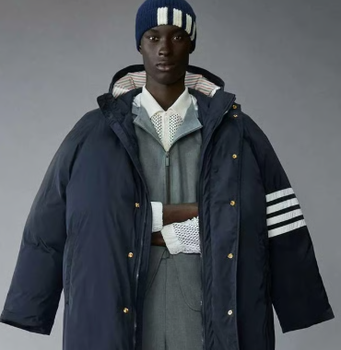
5 | 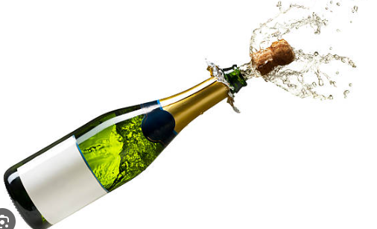
6 | AI
7 | 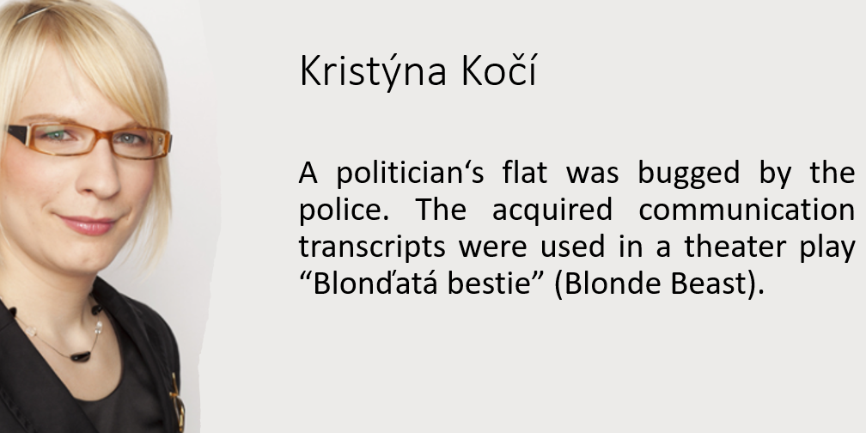
8 | - A Charles University law professor wrote a bestseller legal thriller…  - b. A Charles University law professor wrote a bestseller law textbook…

Legal advice (The Trademark Act)

Regulation (EU) 2017/1001 of the European Parliament and of the Council of 14 June 2017 on the European Union trade mark
Article 4 Signs of which an EU trade mark may consist
An EU trade mark may consist of any signs, in particular words, including personal names, or designs, letters, numerals, colours, the shape of goods or of the packaging of goods, or sounds, provided that such signs are capable of:
- distinguishing the goods or services of one undertaking from those of other undertakings; and
- being represented on the Register of European Union trade marks (‘the Register’), in a manner which enables the competent authorities and the public to determine the clear and precise subject matter of the protection afforded to its proprietor.
Article 7 Absolute grounds for refusal
1. The following shall not be registered:
(a) signs which do not conform to the requirements of Article 4;
(b) trade marks which are devoid of any distinctive character;
(c) trade marks which consist exclusively of signs or indications which may serve, in trade, to designate the kind, quality, quantity, intended purpose, value, geographical origin or the time of production of the goods or of rendering of the service, or other characteristics of the goods or service;
(d) trade marks which consist exclusively of signs or indications which have become customary in the current language or in the bona fide and established practices of the trade;
(e) signs which consist exclusively of:
(i) the shape, or another characteristic, which results from the nature of the goods themselves;
(ii) the shape, or another characteristic, of goods which is necessary to obtain a technical result;
(iii) the shape, or another characteristic, which gives substantial value to the goods;
(f) trade marks which are contrary to public policy or to accepted principles of morality;
(g) trade marks which are of such a nature as to deceive the public, for instance as to the nature, quality or geographical origin of the goods or service;
[…]
3. Paragraph 1(b), (c) and (d) shall not apply if the trade mark has become distinctive in relation to the goods or services for which registration is requested as a consequence of the use which has been made of it.

Task: A client would like to obtain trademark protection for the following designations. Try to explain briefly why some of the designations cannot be registered based on the EU Trademark Regulation (2017/1001).

- A maple tree leaf image for clothes made in China;
- a special smell used in Mango stores;
- Anti-TICK for a new product against ticks (insects);
- FCUK for fashion clothes;
- JESUS for a range of goods;
- CHEESUS CRUST for sandwiches in Prague;
- LAWYER for a newly opened law firm;
- ORLWOOLA for clothes made partly from wool;
- Policie privat for a private security agency;
- Scotch Whisky for beverage manufactured by Božkov;
- the shape of scissors facilitating the use by left-handed consumers;

Reading: Alexander, the Ingenious Inventor
In the town of Bellington lived a young inventor, Alexander Finch. One day, he developed a device that could harness sunlight to produce clean, renewable energy. He called it the Solar Radiance Converter and realised it had real potential.
To protect his invention, Alexander applied for a patent. For the invention to be patentable, it had to meet several requirements under patent law. First, it had to be novel, meaning it was not identical or substantially similar to existing technologies. Alexander therefore carried out prior research. Second, it had to involve an inventive step, meaning it would not be obvious to a person skilled in the field. Finally, it had to be capable of industrial application, meaning it could be used in practice.
Alexander prepared and filed his patent application with the patent office. He understood that, once granted, a patent would give him exclusive rights to his invention for a limited period (typically around 20 years), subject to the payment of maintenance fees. He also learned that third parties could challenge the patent through opposition proceedings. After several months, the patent was granted. This meant that others could not make, use, or sell the Solar Radiance Converter without his permission.
As he prepared to launch the product, Alexander turned to branding. He chose the name “SolarEco” and created a distinctive logo. He then registered “SolarEco” as a trademark. Trademarks protect distinctive signs – such as names, words, or logos – that distinguish goods or services. Registration prevents others from using confusingly similar signs. To be valid, a trademark must be distinctive, lawful, and not misleading. Trademark protection can last indefinitely, provided it is used and renewed.
Alexander also created promotional materials for his product. These were protected by copyright, which arises automatically upon the creation of original works fixed in a tangible form. Copyright gives the author exclusive rights and typically lasts for the author’s life plus 70 years. Copyright law also allows limited use without permission under doctrines such as fair use. For example, a university professor, Leila, used excerpts from Alexander’s materials in a lecture on renewable energy. Because the use was for teaching and illustrative purposes, it fell within fair use.
With patent, trademark, and copyright protection in place, Alexander launched SolarEco. The product was a success, and his invention soon gained wide recognition.

License agreement – language focus

- Who is a Licensor and a Licensee?
- Comment on the use of capital letters: “Licensor”, “NOW, THEREFORE”
- “under the terms and conditions hereinafter set forth”
  - What are “terms and conditions”?
  - Do you know any other legal binomials?
  - Provide a synonym for “set forth”.
  - Provide a synonym for “under”. What is the opposite?
- “in full compliance with all applicable laws, regulations and ordinances”
  - Provide a synonym for “applicable”.
  - Is there any difference between laws, regulations, and ordinances?
- “Except as specifically provided for herein” – Rephrase the sentence using plain English.
- “and paid no later than sixty (60) days after the applicable Due Date” – provide a synonym for “no later than”. What is a “Due Date” and why is it capitalized?
- “Licensee shall be obligated to pay Licensor a minimum License Fee” – is “obligated” a synonym for obliged?
- “Licensee shall keep proper books of record and account … and permit Licensor during normal business hours and upon reasonable notice to review, examine, audit and make copies of Licensee's books and records” – explain “upon reasonable notice”
- “This License Agreement shall commence on the Effective Date and shall continue for an initial term of one and one-half (1.5) years…” – what does “commence” mean?
- “provided that Licensee is not in breach of any material obligation under this License Agreement” – what is a “material obligation”?
- “All terms and conditions of this License Agreement shall remain in full force and effect for the First Renewal Term,” – are the words “force and effect” synonymous?
- “Notwithstanding any language contained herein to the contrary, if Licensee shall fail to meet the Minimum Net Sales requirement set forth herein for the applicable year of this License Agreement, then Licensor shall have the absolute right during the Initial Term, the First Renewal Term or the Second Renewal Term to terminate this License Agreement upon ninety (90) days written notice from Licensor to Licensee…” –explain the phrase “Notwithstanding any language contained herein to the contrary”
- “Licensee recognizes the great value of the goodwill associated with the Trademark” – what is “goodwill”?
- “In the event that the quality standards of the Trademark are not met….” – provide a synonym for “in the event that”.
- “Licensee agrees that the style and quality of all Licensed Products and their Packaging Materials shall be subject to Licensor's approval” – what does “subject” mean here? Rephrase.
- “including but not limited to” – why do lawyers love this phrase?
- “The selection of counsel and resolution of any such actions shall be controlled solely by Licensor in its discretion.” - explain “counsel”, “in its discretion”.
- “All notices, requests, consents demands, approvals and other communications, including the service of process, hereunder shall be deemed to have been duly given, made or served if in writing and delivered personally…” - translate “shall be deemed to have been duly given”. What is “service of process”?
- “Any dispute shall be heard in the district court…” Explain the word “heard”

Revision – key words

Read the scenarios. For each one, write the correct legal term from intellectual property law.
- Martin runs a tech startup in Brno. His company has developed a new type of battery and is officially registered as the owner.
- Petr starts a clothing brand called “UrbanFox” and registers both the name and logo so other companies cannot use them.
- Lucie creates a unique perfume bottle with a very distinctive curved shape, and her company registers that shape for legal protection.
- Tomáš opens a wine shop and labels sparkling wine from Spain as “Champagne” to attract customers.
- Eva finishes writing her first novel at home. She doesn’t register anything.
- Martin is teaching at a university. He copies two paragraphs from a textbook and gives them to students for discussion in class.
- Lenka buys a “Louis Vuitton” handbag at a market in Prague, but later discovers it is not genuine.
- A famous Czech novel written by Jan Novák is later adapted into a Netflix film.
- A startup called “Adibas” sells sportswear and uses branding very similar to Adidas, even though the original mark is not registered in that country.
- Martin works as a programmer for a company. As part of his job, he develops a new app, but the company - not Martin - owns the rights.
- Jana is an architect who designed a modern office building in Prague. A few years later, the new owner decides to significantly change the façade by adding bright colours and large advertising panels. Jana objects.
- David writes a successful textbook and earns money every time a copy is sold.
- Karel invents a new type of medical device. Before applying for protection, he must show that it is new, inventive, and can be used in industry.
- A farmer tries to register the word “Apple” as a trademark for selling fresh apples. The authority refuses.

