Test RM

Date 19.2.2026, Name and Surname______________________________,

FSV PMV graduate? YES, NO ; IF “NO”, specify your BA program__________________

- T-test is used (1 p):
  - To compare the means of two samples
  - To compare the variability of two samples
  - To compare the proportions of certain discrete variables among two samples
  - Find the absolute maximum value of a sample

- Chi-test (1 p)
  - Compares the means of two samples
  - Estimates the minimal value of a discrete variable
  - Tests if the empirical distribution (of a discrete variable) fits the expected distribution
  - Measures the level of homoscedasticity

- What is the mean and median for this sample: 2, 5, 1, 19, 6, 8, 1 ? (2 p)
  - Mean___________
  - Median_________

- Line Charts are a great visual tool to display (1 p)
  - Differences in distributions of two or more variables
  - Correlation (or lack of a correlation) between two or more variables
  - Proportions of values of a categorial variable (from its whole)
  - Comparison of the development of the total or relative values of one, or several variables over time

- See the chart below (4 p)
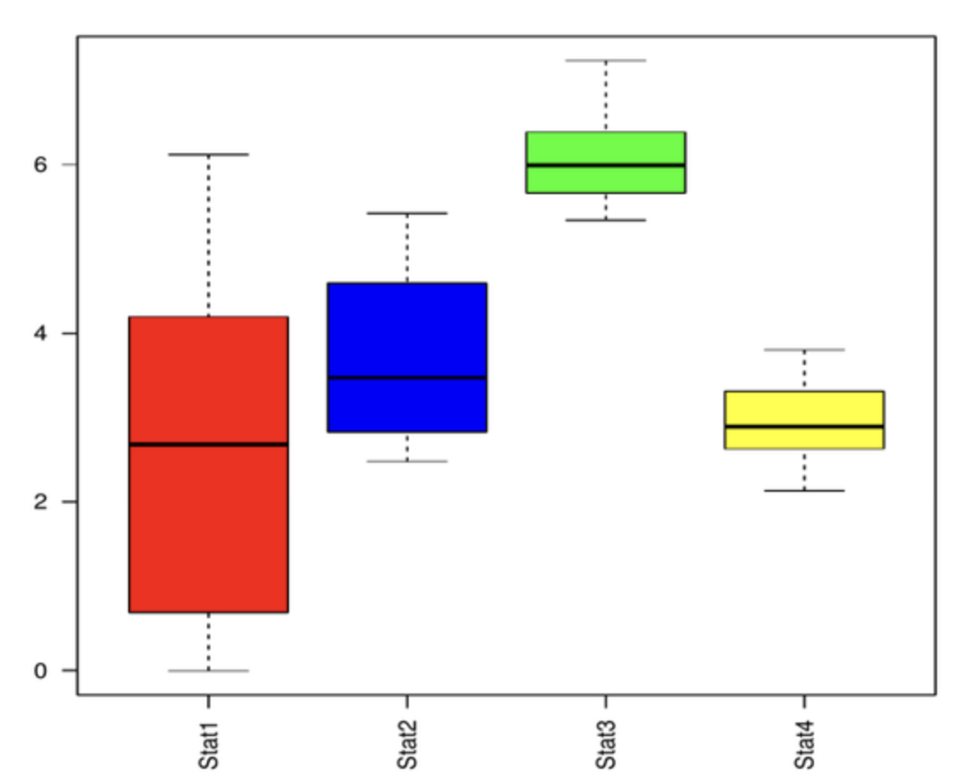

  - Which group has the highest variability? __________
  - Which group has the highest median value __________. Estimate the median value of this group __________
  - What is the (approximate) minimal value of the Stat1 group? ____________

- See the regression table and the chart below
Table | Model 1 | Model 2 | Model 3
(Intercept) | 1.00 *** | 2.34 *** | 0.48
 | (0.11) | (0.24) | (0.64)
log10(GDP_pc14) | 1.03 ***
 | (0.09)
log10(Milex_pct_avg) |  | 0.04
 |  | (1.14)
log10(Eq_pct_avg) |  |  | 1.46 **
 |  |  | (0.50)
N | 30 | 30 | 30
R2 | 0.79 | 0.00 | 0.27
Note: *** p < 0.001; ** p < 0.01; * p < 0.05.

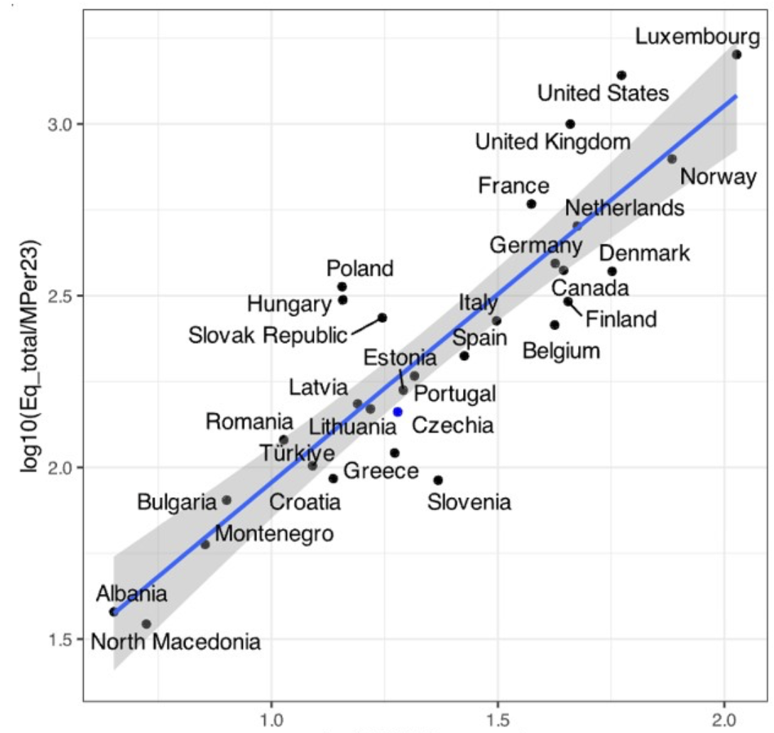

- Which of the three models explains the most/least of the variability?
MOST____________, LEAST____________
- Write down the corresponding regression equation for Model 1:

- Which (if any) model corresponds to the chart, and why?

