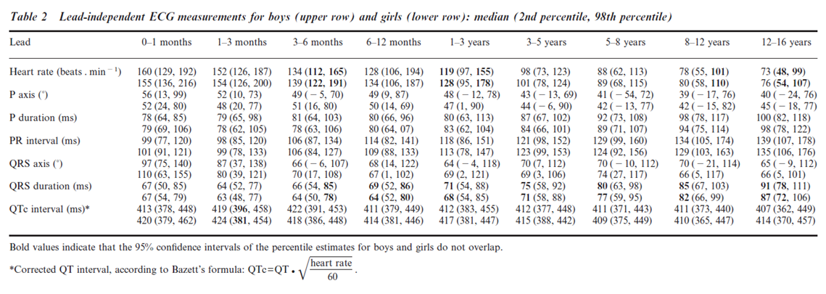

http://hqmeded-ecg.blogspot.com/2014/09/great-chart-of-pediatric-ecg-intervals.html

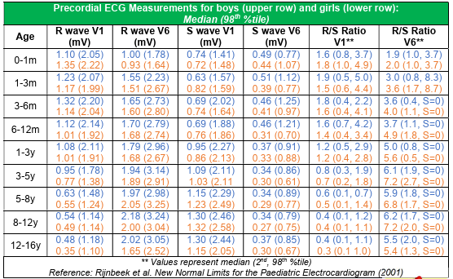
https://pedscases.com/sites/default/files/Key%20ECG%20norms%20infographic%20PDF%20Final.pdf

