A) Download the protein sequence Q6DV79.
- What does this sequence encode and from which organism does it originate?
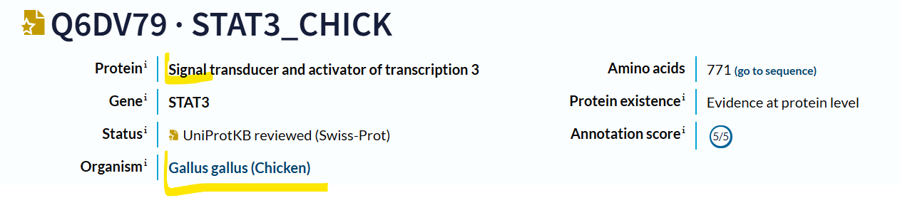
- What is the length of the coding sequence (CDS) of the respective gene?

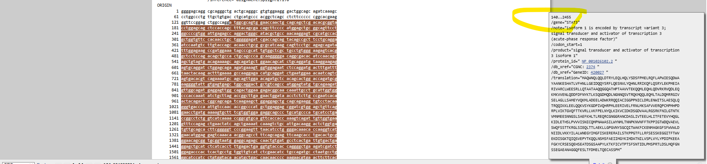
2455-140+1=2316nt
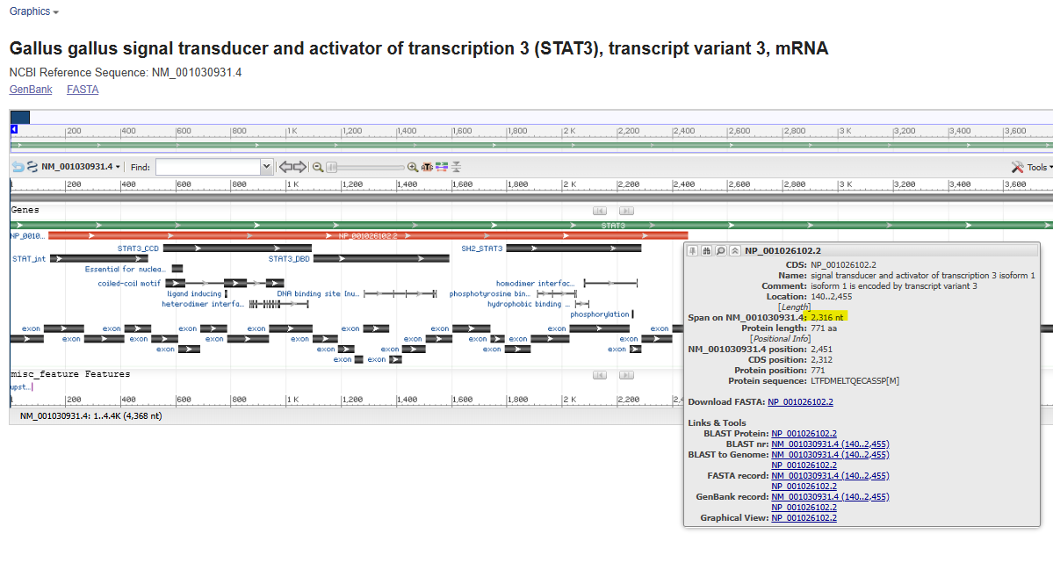

- Will the corresponding nucleotide sequence (CDS only) be cleaved by the enzymes BamHI, KpnI, and NcoI?
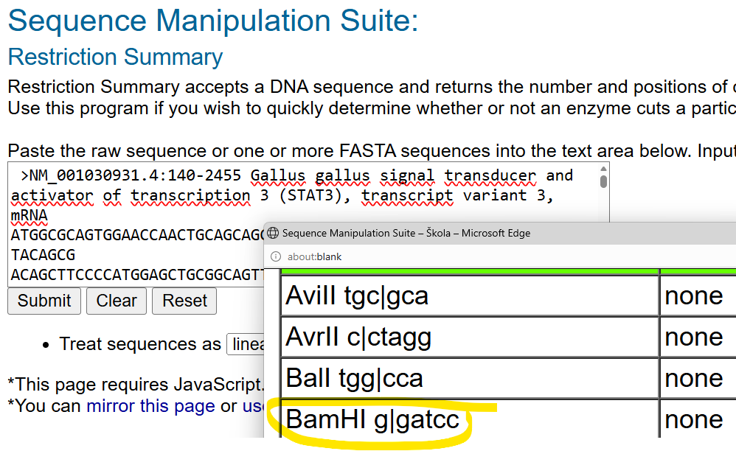

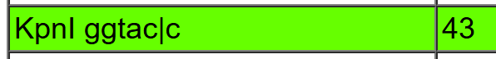
- What fragments will be produced by digestion with all three enzymes simultaneously?
4 fragments: 1636+600+42+38
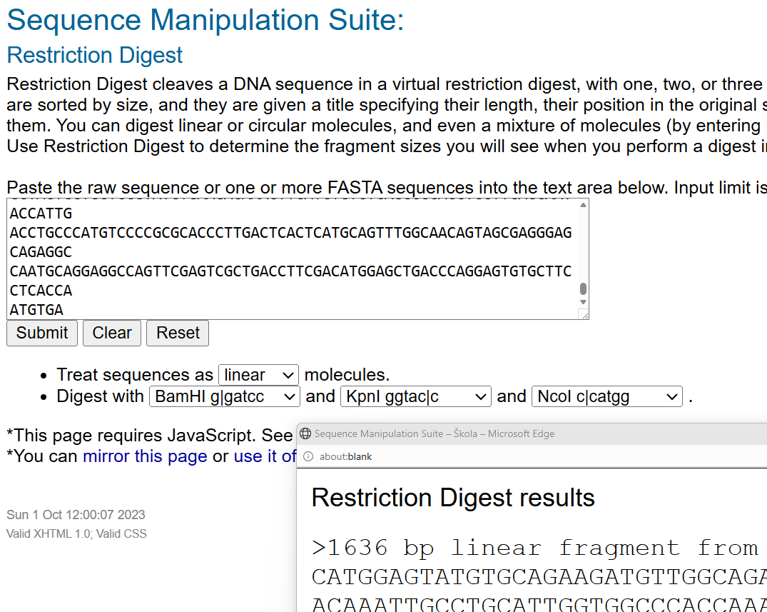

- Compare it with the corresponding human homolog; how similar (expressed numerically) are these proteins?
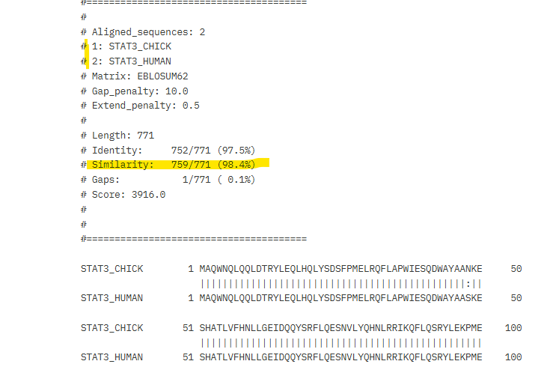
B) Work with following nucleotide sequence:

181 gcccttcaac ctgtcctccc tgcggggcaa ggtgctgctc attgagaacg tagcatcgct
241 ctgaggcaca acggtgcggg actacaccca gatgaatgac ctgcagcggc gccttggacc
301 ccggggcctg gtcgtgctcg gcttcccctg caaccagttt gggcatcagg aaaacgccaa
361 gaacgaggag atcctgaatt gcctgaagta cgtccgacca ggcggcgggt tcgagcccaa
421 ctttatgctc ttcgaaaagt gcgaggtgaa tggcgagaag gcgcatccgc tcttcgcctt
481 ccttcgggag gttctgccca cgccaagtga cgacgccact gctctcatga ccgaccctaa
541 gttcatcacc tggtccccgg tgtgccgcaa cgacgtctcc tggaacttcg agaagttcct
601 ggtgggccca gacggtgtgc ccgtgcgcag gtacagccgc cgctttctga ccatcgacat

- Convert this sequence into FASTA format.
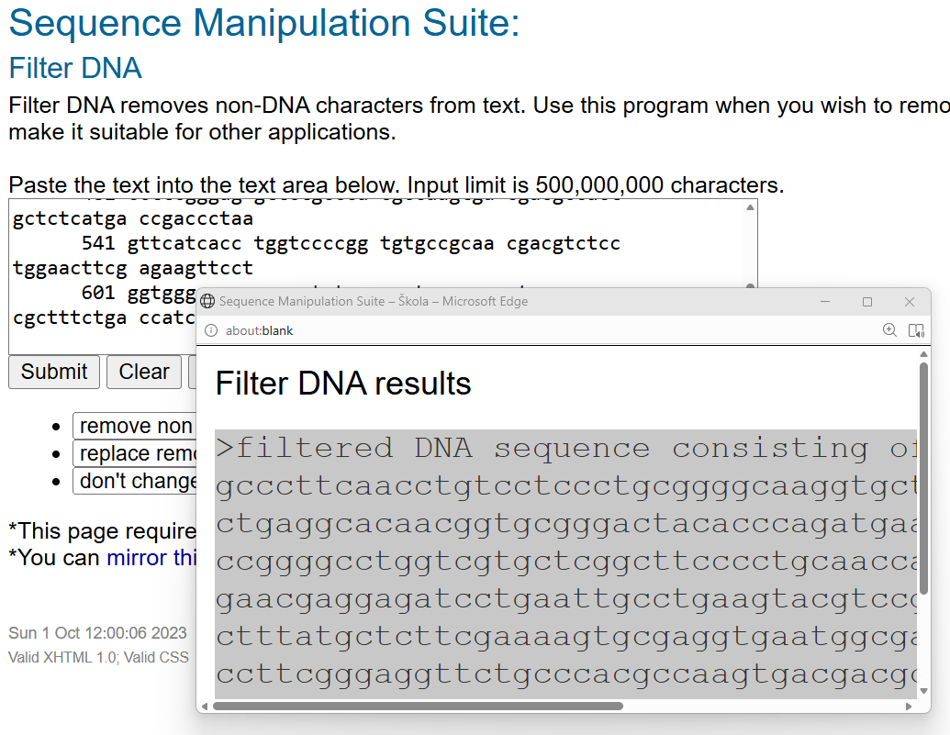
>filtered DNA sequence consisting of 480 bases.
gcccttcaacctgtcctccctgcggggcaaggtgctgctcattgagaacgtagcatcgct
ctgaggcacaacggtgcgggactacacccagatgaatgacctgcagcggcgccttggacc
ccggggcctggtcgtgctcggcttcccctgcaaccagtttgggcatcaggaaaacgccaa
gaacgaggagatcctgaattgcctgaagtacgtccgaccaggcggcgggttcgagcccaa
ctttatgctcttcgaaaagtgcgaggtgaatggcgagaaggcgcatccgctcttcgcctt
ccttcgggaggttctgcccacgccaagtgacgacgccactgctctcatgaccgaccctaa
gttcatcacctggtccccggtgtgccgcaacgacgtctcctggaacttcgagaagttcct
ggtgggcccagacggtgtgcccgtgcgcaggtacagccgccgctttctgaccatcgacat

- Identify what it encodes (search for the reference sequence) and specify its organism of origin.
Glutathione peroxidase 1, Bos taurus
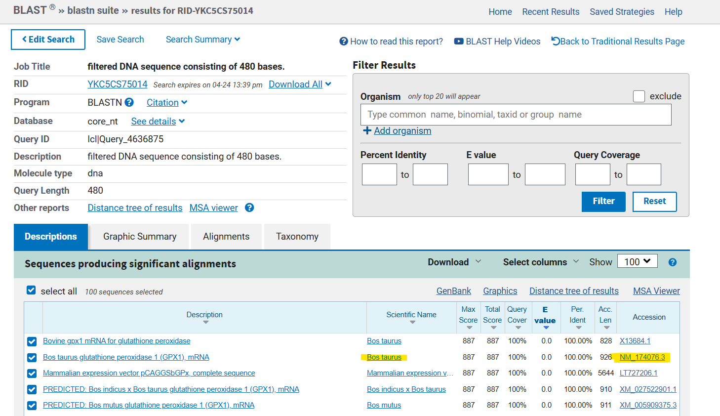
- Manually design primers to amplify the CDS of the identified sequence, ensuring their melting temperature does not exceed 65°C.
>NM_174076.3:89-706 Bos taurus glutathione peroxidase 1 (GPX1), mRNA
ATGTGCGCCGCTCAGCGCTCGGCGGCCGCCCTGGCGGCGGCAGCCCCGCGCACAGTGTACGCCTTCTCCG
CGCGCCCTCTGGCCGGCGGGGAGCCCTTCAACCTGTCCTCCCTGCGGGGCAAGGTGCTGCTCATTGAGAA
CGTAGCATCGCTCTGAGGCACAACGGTGCGGGACTACACCCAGATGAATGACCTGCAGCGGCGCCTTGGA
CCCCGGGGCCTGGTCGTGCTCGGCTTCCCCTGCAACCAGTTTGGGCATCAGGAAAACGCCAAGAACGAGG
AGATCCTGAATTGCCTGAAGTACGTCCGACCAGGCGGCGGGTTCGAGCCCAACTTTATGCTCTTCGAAAA
GTGCGAGGTGAATGGCGAGAAGGCGCATCCGCTCTTCGCCTTCCTTCGGGAGGTTCTGCCCACGCCAAGT
GACGACGCCACTGCTCTCATGACCGACCCTAAGTTCATCACCTGGTCCCCGGTGTGCCGCAACGACGTCT
CCTGGAACTTCGAGAAGTTCCTGGTGGGCCCAGACGGTGTGCCCGTGCGCAGGTACAGCCGCCGCTTTCT
GACCATCGACATCGAGCCTGACATTGAAACCCTGCTGTCCCAGGGGGCCTCTGCCTAG

F primer: ATG TGC GCC GCT CAG CGC T
R primer: CTA GGC AGA GGC CCC CTG
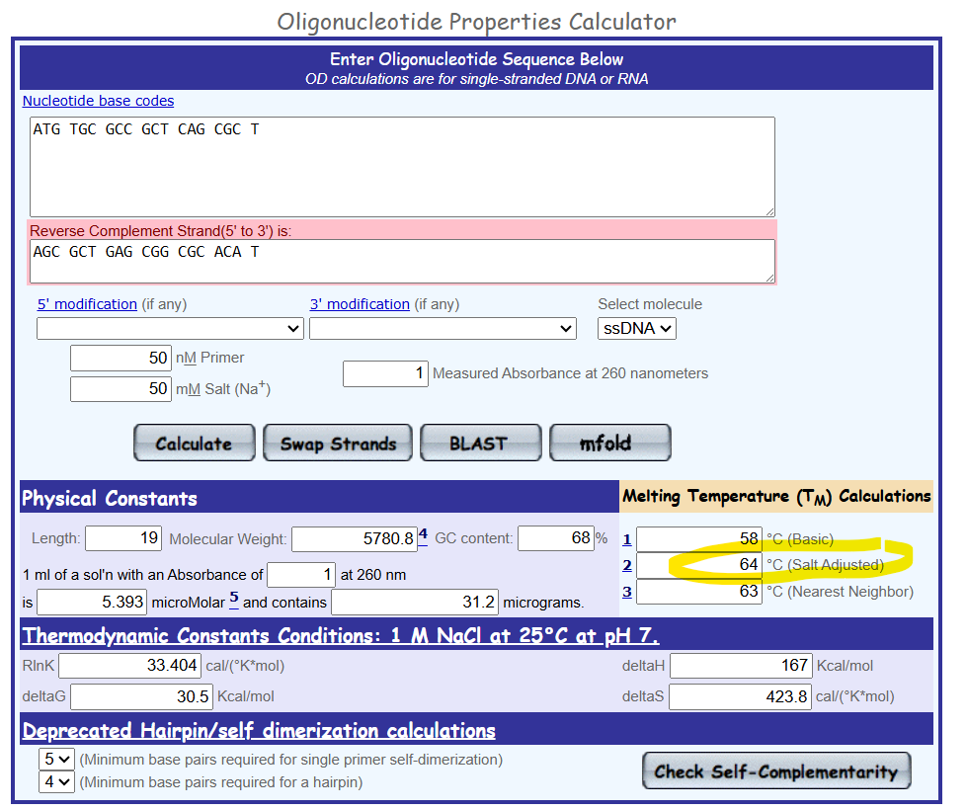
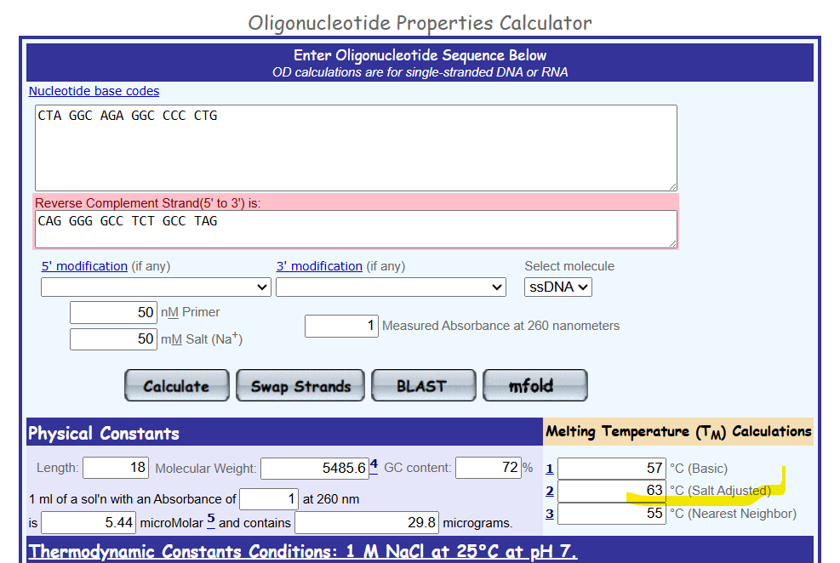

- Where is the respective protein localized within the cell?
Cytoplasm..
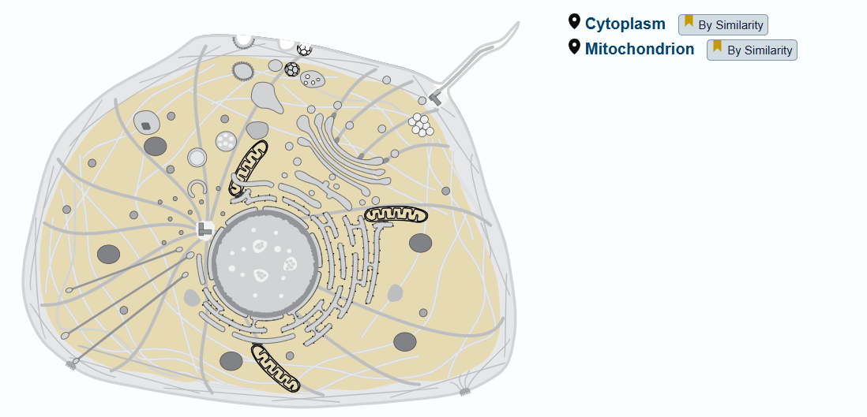
- Does the respective protein contain any transmembrane domains
NO
