Handout 11 – EU

Basic legal terminology

- The _____________________ is the main legislative procedure by which directives and regulations are adopted.
- In the case of total or partial non-payment, Member States may _____________________ from this rule.
- This requires the _____________________ approval of all member states.
- Business agreements are intended to be legally _____________________.
- _____________________ are addressed to the member states and usually leave to the national authorities the choice of form and methods to implement.
- The Regulation has been _____________________ more than 25 times since 1975.
- These rules are inconsistent with the _____________________ of the CPR Regulation.

Discussion
- Have you ever considered working for the EU?
- Where can you find some information about recruitment to EU institutions?
- Is English an official language of the EU?
- How many official and working languages are there in the EU?
- Which languages should you speak if you wish to work for the EU?

Internet search

- EU institutions (Commission, Parliament, Council, European Council, CJEU, Court of Auditors, ECB)
- EU legislative process (ordinary/special legislative procedure)
- EU law (treaties, secondary law – regulations, directives, decisions)

EU institutions: quiz

- The ____________ checks any person or organisation handling EU funds – including spot checks in EU institutions (especially the Commission), EU countries and countries receiving EU aid.
- Most ____________’s decisions require a qualified majority : 55% of countries (with 28 current members, this means 16 countries) representing at least 65 % of total EU population.
- The ______________ is a directly-elected EU body with legislative, supervisory, and budgetary responsibilities.
- The _____________ draws up annual budgets for approval by the Parliament and Council.
- Each EU country holds the presidency of the _____________ on a 6-month rotating basis.
- The _______________ ensures that EU law is properly applied in all the member countries.
- In the ______________, government ministers from each EU country meet to discuss, amend and adopt laws, and coordinate policies.
- The _____________ is alone responsible for drawing up proposals for new European legislation.
- The _____________ interprets EU law to make sure it is applied in the same way in all EU countries, and settles legal disputes between national governments and EU institutions.
- The ___________ manages the euro and frames and implements EU economic & monetary policy.
- The _____________ brings together EU leaders to set the EU's political agenda. It represents the highest level of political cooperation between EU countries.
- The ____________ promotes the general interest of the EU by proposing and enforcing legislation.

Features of EU English

- Legalisms:
- The requirement to record the information under this field shall apply from one year after the entry into force of this regulation.
- Those rules are laid down in Regulation (EU, Euratom) 2018/1046 of the European Parliament and of the Council (6) (‘the Financial Regulation’)
- Without prejudice to the rules on decommitment, where those conditions are not fulfilled, expenditure related to operations under the related specific objectives should not be reimbursed by the Commission.
- (hereinafter referred to as ‘structured data’)
- Terminology:
- Member States should prevent, detect and deal effectively with any irregularities, including fraud committed by economic operators.
- The Member State or the managing authority shall carry out evaluations of the programmes related to one or more of the following criteria: effectiveness, efficiency, relevance, coherence and Union added value,…
- The EU budget shall be implemented in accordance with sound financial management, comprising the principles of economy, efficiency and effectiveness.
- Popular EU expressions:
- Programme authorities, beneficiaries and stakeholders in Member States should raise awareness of the achievements of Union funding and inform the general public accordingly.
- Poverty is a particularly important challenge in the Union.
- Sentence structure:
- Further, as the Commission is precluded from making payments for the expenditure incurred by beneficiaries and paid in implementing operations linked to specific objectives for which enabling conditions are not fulfilled, which is included in payment applications, the time limit for the Commission to make payments should not be triggered for such expenditure.
- Mistakes in the original version:
- If actual data pursuant to Regulation ( EC ) No 3605/93 indicate that an excessive deficit has not been corrected by a participating Member State within the time limits specified…
- Prohibition of State aids under Article 87(1 ) of the EC Treaty…
- It appeared to be necessary to give the Member States a supplementary delay for transposing the provisions of Directive 83/201/EEC into their national legislation.

Terminology
- The European Commission is a supranational institution. What does “supranational” mean?
- What is “legal personality”, and does the EU have legal personality?
- The EU is based on the rule _______________: every action taken by it is founded on treaties approved voluntarily and democratically by all EU member countries.
- Which entity was created by the Treaty of Rome of 1957?
- Explain what is meant by the College of Commissioners.
- The Commission is organised into policy departments, known as _______________________ (DGs), which are responsible for different policy areas.
- The European Commission is responsible for planning, preparing and proposing new European legislation. This is called the “right _________________”.
- Who is an MEP?
- What is meant by a configuration in the context of the Council?
- What is a trio in the context of the Council’s presidency?
- What does the acronym CJEU stand for?
- What is meant by the General Court?
- As the EU's independent external auditor, the European __________________ looks after the interests of EU taxpayers.
- What is maladministration?
- Which EU body investigates complaints from individuals, businesses and organisations about maladministration by the institutions, bodies and agencies of the European Union?
- Does the EU have a Foreign Affairs Minister?
- Which body investigates fraud against the EU budget, corruption and serious misconduct within the European institutions?
- Two committees provide opinions of the Commission’s legislative proposals. Their acronyms are EESC and CoR. What do the letters stand for?
- A motion of censure in respect of the Commission may be submitted to the President by one tenth of the component Members of Parliament. Explain the meaning of motion of censure.
- The European Parliament co-legislates, in the vast majority of areas, on an equal footing with the Council of the European Union. What does “on an equal footing” mean?
- Parliament meets in plenary session every month in Strasbourg. What does “plenary session” mean? Before a discussion in a plenary session, a Commission’s proposal is considered in a __________________ .
- The ___________________ (CAP) is the policy concerning farming in the European Union. It implements a system of agricultural subsidies and other programmes. Explain the word “subsidies”.
- In the Council, a ____________________ is reached if two conditions are simultaneously met: 55% of member states vote in favour and the proposal is supported by member states representing at least 65% of the total EU population.

- Video: Interpretation at the European Parliament (28:10-33:00) https://www.youtube.com/watch?v=1w-FsFRZuwo

Structure of EU legal acts (from the Interinstitutional Style Guide)

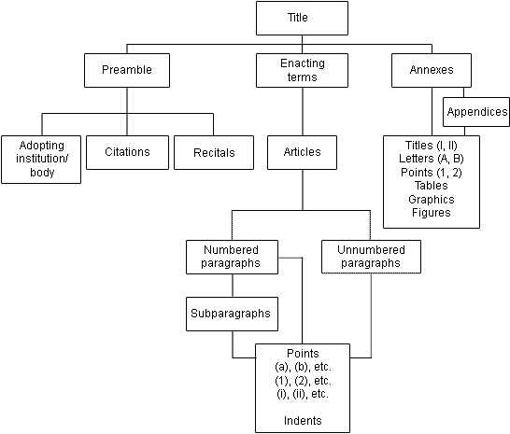

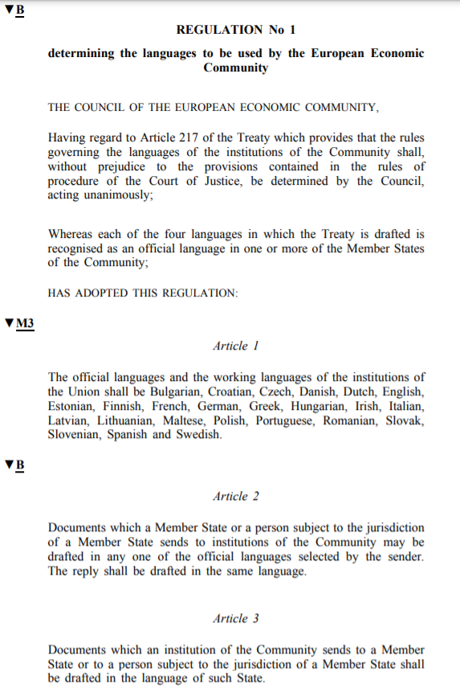
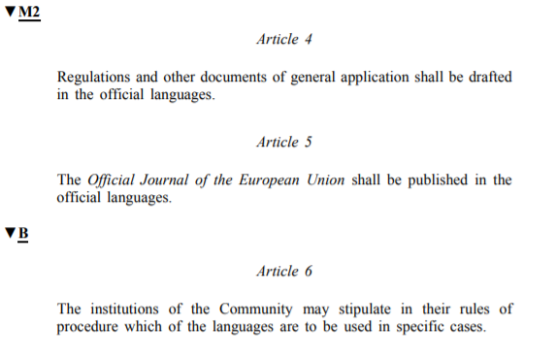
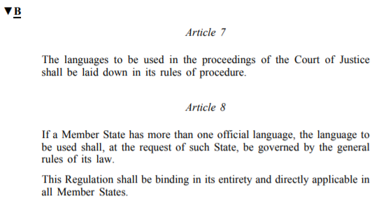

Match the terminology with the specific parts:

amendment – corrigendum – enacting terms – explanatory memorandum – legal basis – recitals

1. | Title III: Programming  The content of programmes will be more streamlined and strategic.
2. | Having regard to the opinion of the Committee of the Regions
3. | In order to contribute to Union priorities, the Funds should focus their support on a limited number of policy objectives in line with their Fund-specific missions pursuant to their Treaty-based objectives.
4. | Each Member State shall prepare a Partnership Agreement which sets out arrangements for using the Funds in an effective and efficient way.
5. | for:  read:
  ‘(22) | “request for payment” means a payment application or declaration of expenditure submitted by the Member State to the Commission;’,
  ‘(22) | “payment application” means a payment application or declaration of expenditure submitted by the Member State to the Commission;’;
6. | in Article 154, the following subparagraph is added:  ‘Articles 92a and 92b shall not apply to or in the United Kingdom.ʼ

The verbs: which word is the odd one out?

- to set up – to set out – to lay down – to provide – to stipulate
- referred to in Article 1 – provided for in Article 1 – proscribed in Article 1 – prescribed in Article 1
- to implement a project – to carry out a project – to deliver a project – to promote a project
- to promote – to foster – to envisage – to support – to further
- to amend – to alter – to modify – to repeal – to adjust
- to conclude – to infringe - to enter into – to sign
- to deem – to disclose – to presume – to suppose
- to file a complaint – to withdraw a complaint – to submit a complaint – to lodge a complaint
- to confer powers – to grant powers – to exercise powers – to give powers
- to control – to check – to inspect – to verify
- to preclude – to prevent – to refrain
- to revoke – to repeal – to derogate – to cancel

Vocabulary consolidation

Sound financial management
Ordinary legislative procedure
DGs
General Court
Court of Auditors
Maladministration
Motion of censure
Qualified majority
Subsidies
Directive
Unanimity

