12th week, BONUS Christmas materials

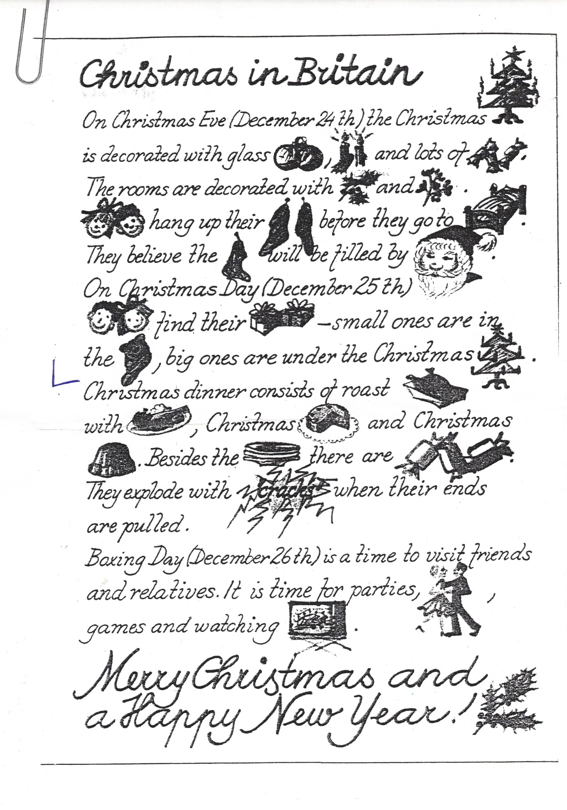

HOW MUCH DO YOU KNOW ABOUT Christmas in Britain (and in our country/ the USA)? compare + vocabulary
- December 24th, 25th and 26th (read: the twenty-fourth, -fifth, -sixth) are known as
a/ Christmas Day, Christmas Eve (= evening), Boxing Day
b/ Christmas Day, Boxing Day, Christmas Eve (= evening)
c/ Boxing Day, Christmas Day, Christmas Eve (= evening)
d/ Christmas Eve (= evening), Christmas Day, Boxing Day

- Boxing Day is called ´boxing´ because
a/ you have to throw away a lot of empty boxes get rid of
b/ there are a lot of boxing matches on that day football match/safety matches/to match
c/ we give people who deliver post, milk, newspapers, etc. postman/milkman x postperson/milkperson
some money into their Christmas box
d/ you visit your friends and relatives and give them a box of chocolate or biscuits relatives and in-laws

- The traditional food at Christmas is food/meal x meat/dish/
a/ turkey the first, second, main course
b/ fish fish soup/fried carp/salmon
c/ ham ham´n´eggs/bacon and eggs
d/ beef

- The traditional second course at Christmas dinner is breakfast/brunch/lunch/dinner/supper
a/ Christmas cake
b/ mince(d) pies minced meat/apple pie
c/ ice-cream
d/ Christmas pudding pudding in Britain (different)

- A Christmas cracker is fire crackers/cheese crackers
a/ a dry biscuit you eat with cheese
b/ someone who eats the hard skin (=crackling) of the bacon that covers the roast turkey
c/ a coloured roll of paper with a hat, a toy, and a joke in it a hat, a cap/a cover, a lid
d/ someone who is not happy at Christmas

- Young children believe that presents are brought by
a/ Baby Jesus Virgin Mary/ The Holy Family
b/ the angels the Nativity (scene) in Bethlehem
c/ Father Christmas
d/ Saint Nicholas What/Where does he look like/come from?
- Father Christmas is also known as (in English-speaking and in other countries)
a/ Saint Nicholas b/ Santa Claus or Santa c/ Daddy Christmas d/ Old Nick

- Father Christmas is supposed to live
a/ at the North Pole b/ at the South Pole c/ in Scotland d/ in Canada

- Father Christmas travels
a/ over the roof tops on a horse to ride a horse/camel/motorcycle/bike
b/ through the sky on a sleigh pulled by reindeer to drive a car/bus x to fly a plane
c/ through the sky on a carpet pulled by angels Christmas carol: Jingle Bells .. oh, what fun
d/ through the sky on the Christmas star it is to ride in a one-horse open sleigh…

- Father Christmas drops his presents
a/ outside the entrance door
b/ under the Christmas tree
c/ through the window
d/ through the chimney chimney sweeper/to sweep (swept) the floor

- A Christmas stocking is
a/ socks or tights with Christmas patterns on it patterns: stripes, dots, stars, checkers…
b/ the custom/habit of giving your father new socks for Christmas
c/ a sock in which Father Christmas puts some sweets, fruit and small presents
during the night of Christmas Eve
d/ a red candle for children in the snape of Father Christmas´ sock snappy – unpleasant, moody

- You can take your child to see a ´real´ Father Christmas Christmastide = period of 12 days
a/ on shopping days in big shops before Christmas days beginning on December 25th, ending by
b/ in the theatre at night The Twelfth Night (evening and night before
c/ in the town centre, on Christmas Eve January 6th – The Three Kings/The Magi
d/ in the local cinema every afternoon (read: medžaj, sg. magus),
The Three Wise Men bringing gold, (frank)incense/olibanum and myrrh (see also: wisdom)

- A Christmas pantomime is
a/ a play without words about the birth of Jesus
b/ the school play at Christmas time
c/ a Christmas story played by puppets a puppet/a marionette
d/ a play for children based on a well-known fairy tale

- Many people complain that Christmas has become too commercial. They mean that
a/ shops, TV and magazines make us think that giving and getting expensive presents is more important than
being together with your family
b/ shops, TV and magazines make us think that we should all do the same things at Christmas
c/ shops are too busy just before Christmas busy shops/busy traffic/busy people
d/ too many people go to restaurants or hotels for their Christmas instead of staying at home

- ´Think before you drink before you drive´ is an advertisement which wants to
a/ encourage people to use taxis en/dis courage/encouragement
b/ discourage people from using their cars
c/ discourage people from drinking alcohol
d/ stop drunken driving

- It is a custom to wish your friends and relatives ´Happy/Merry Christmas and a Happy New Year´
a/ on the telephone
b/ in person
c/ by postcard/Christmas card/a Christmas letter once a year (relatively new tradition in Canada)
d/ by email, sms, mms/ on social media – FB, Twitter, Instagram, etc.

- A lot of organizations sell Christmas presents for charity. It means
a/ the money raised is given to the person with the winning number winner x loser
b/ the poor, the old, the sick, etc. are given those presents
c/ the money raised is used to help the poor, the old and the sick, etc.
d/ they become very rich

AND A TRADITIONAL CHRISTMAS CAROL TO SING

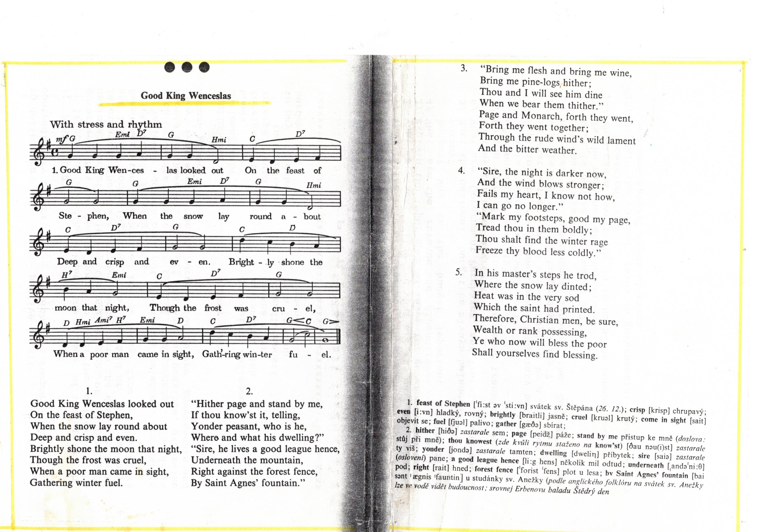

HAVE WONDERFUL CHRISTMAS AND ENJOY THE PRESENCE OF ALL YOUR RELATIVES, IN-LAWS AND FRIENDS

