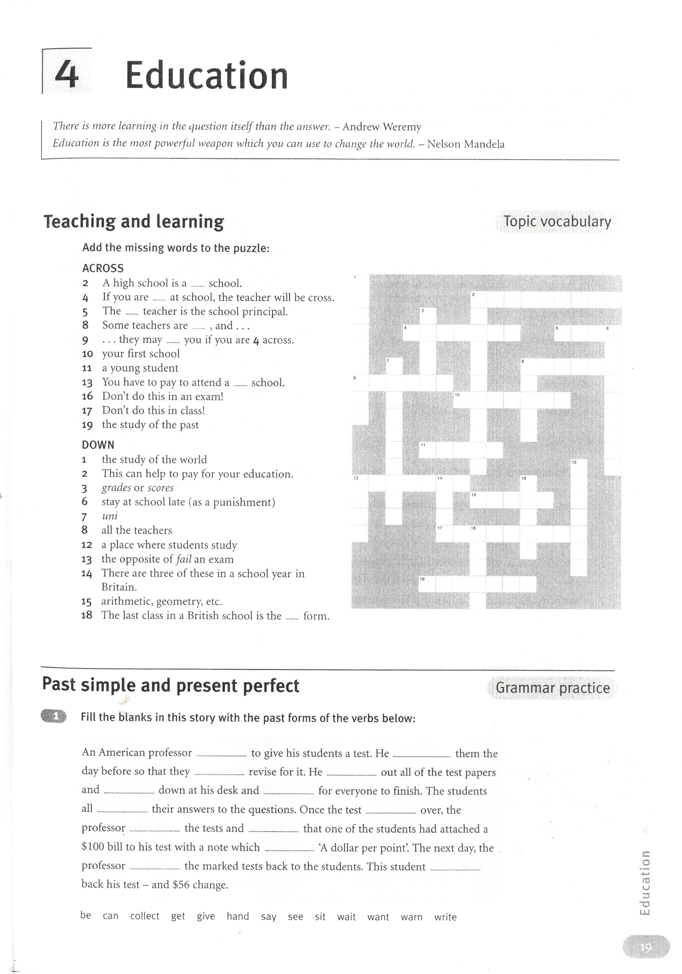
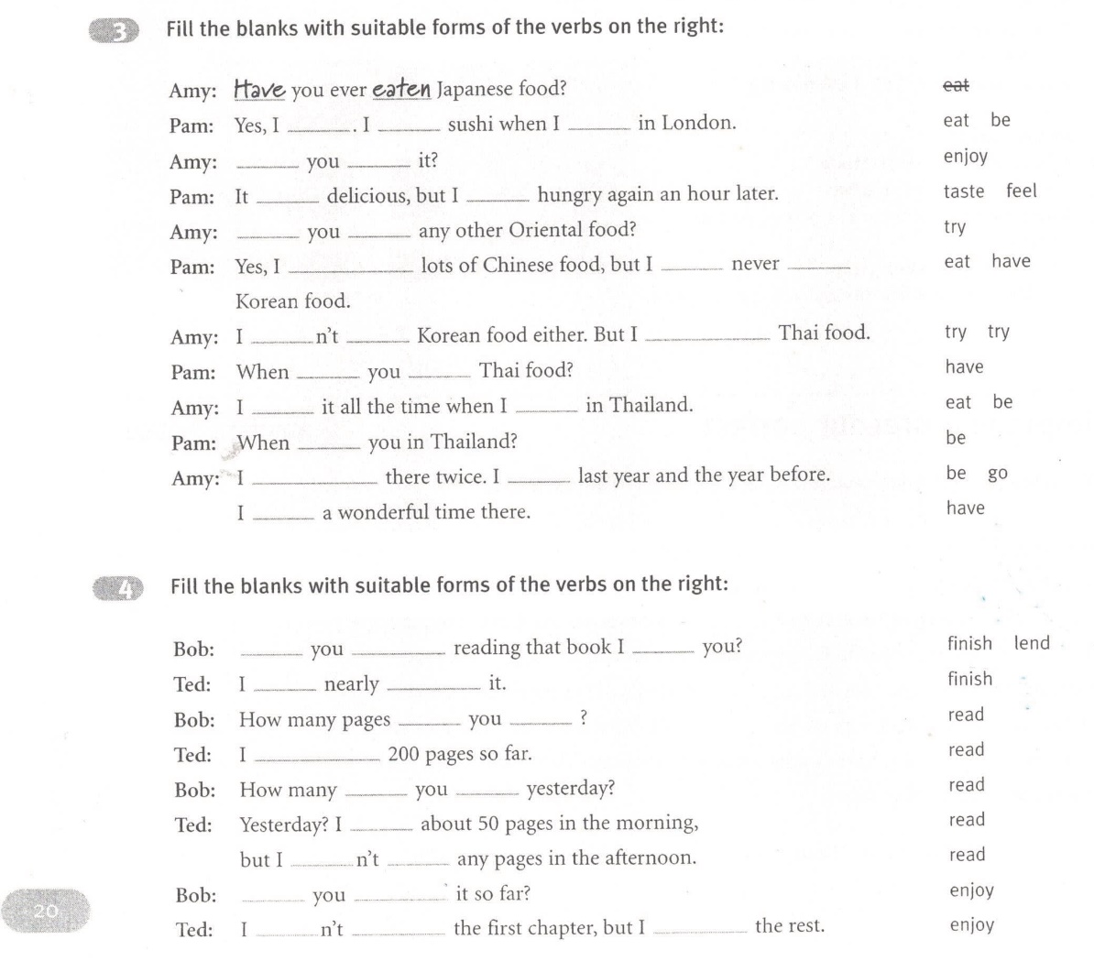

KEY:
- wanted, warned, could, gave/handed, waited, wrote, was, collected, saw, said, handed/gave, got
- Have you ever eaten, have, ate, was, Did you enjoy, tasted, felt, Have you tried, I´ve eaten, I´ve never had, I haven´t tried, have tried, did you have, ate, was, were, I´ve been, went, had
- Have you finished, lent, I´ve nearly finished, have you read, I´ve read, did you read, I read, I didn´t read, Have you enjoyed, I didn´t enjoy, have enjoyed (CAREFULL WITH THE PRONUNCIATION: READ READ READ (RI:D, RED, RED)

