Reading 1
Based on “Coleridge’s Love Poetry.”

Romantic ideal of spontaneous perception and emotionality is contradicted by the rationalist models of perception and subjectivity (David Hartley’s theory of the association of ideas, based on Locke; the concept of organic form based on German organicism, especially Kant’s Critique of Judgement) Wordsworth and Coleridge were using. In this context, love is often identified with sensuality. Such identification involves the problems of “apprehension” – perception, grasping, arrest; and also of distrust, skepticism.

“Love” (1799)
Written shortly after Coleridge’s return from Germany and the quarrel with his wife Sara Fricker. They were returning home via Sockburn (a village close to Durham in the North) and there he fell in love with Sara Hutchinson , the sister of Mary Hutchinson who later married Wordsworth. The earlier version of the poem called “Introduction to the Tale of the Dark Ladie” was published on 21 December 1799 in The Morning Post, a Whig newspaper to which a number of radical journalists, including William Hazlitt, were contributing. This version of the poem refers to the 1798 unfinished poem “The Ballad of the Dark Ladiè: A Fragment” (1798). According to J.C.C. Mays - introduction in Poetical Works I: Poems (Reading Text, Part 1), The Bollingen Series (Princeton University Press, 2001) 605, “the poem celebrates the energy needed to complete the Dark Ladiè – i.e. a sense of emotional renewal for Coleridge himself – but otherwise its relation [to Dark Ladiè ] is oblique. The ruined tower and the statue of an armed knight are reminiscences on a “folly” (artificial ruin) in Tilbury Park on the side of Bagborough Hill in Somerset, close to Nether Stowey, where Coleridge and the Wordsworths lived before Coleridge’s departure for Germany.
The poem had a great success among readers, it was often reprinted in newspapers and it inspired George Dawe to the painting entitled Genvieve (1812) and named after the heroine. It became a favourite topic of conversation among men and women: Sir Walter Scott told the actress Sarah Smith that “the verses on Love… are among the most beautiful in the English language.”
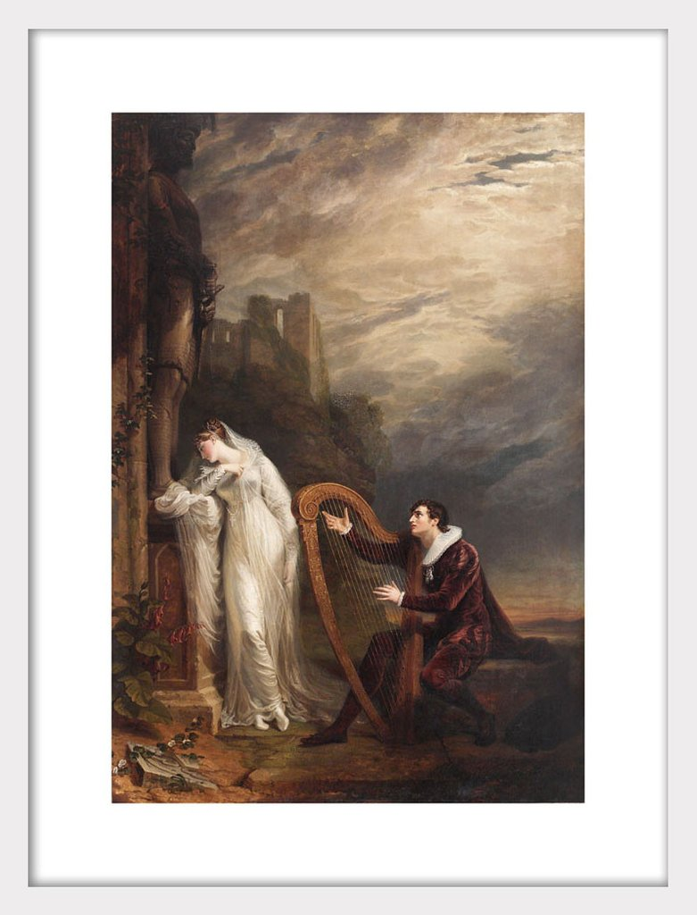
George Dawe, Genevieve (1812)
The poem’s ideology (shared with German Romanticism):
Rationalist universalism of the Enlightenment caused the disaster of the French Revolution and should be supplanted by the “universal message of the recuperative power of love” (23). However, the poem does not convey any such message, rather, it is an allegorical tale of the unsuccessful quest for Sovereignty: a failed attempt to confirm the centrality of the poet’s subject.
Nonetheless, the subdued eroticism of the poem “meek embrace,” feeling (rather than seeing) “the swelling of her heart” does not allow us to read it as a mere allegory (of the effects of the song on the listener) or a symbolic text (the poet is united with the creation of his imagination - the symbol of moonlight).
The poem contains discourses subverting one another: the message of the recuperative power of love is subverted by “a tale of Man’s perfid’ous cruelty”, a reference to “The Ballad of the Dark Ladie” in the first version of the poem (a poem which is closer to German ballads). The allegory of the emotional effect on a female audience subverted both by the excessive dwelling on the erotic aspects and a masculine representation of the maid as a passive being to whom all rationality is denied (connected with “Fancy” and “Tumult … of Mind” – from the draft version of “Love”). The intimacy of the contents is subverted by the poem’s publication in a newspaper, in the final 1799 version, erotic experience is changed into sentimental clichés.
Coleridge made a feeble attempt at a thematic unification: the 1828 version (Sybilline Leaves, 2d ed.) moves the generalizing stanza starting “All thoughts, all passions, all delights…” to the beginning of the poem.
Love as a magic power summoned from the medieval ruin (representing the nostalgia of the chivalrous culture of the past – Edmund Burke’s Reflections on the Revolution in France, 1790) can hardly become more than an attribute of the romantic concept of the self (in the 1828 edition Coleridge changed “our mortal frame” – referring to all humanity to “this moral frame” – referring to himself)
Love is imagined as mutual glorification of individual subjects and their merging in a “complete” soul. However, Coleridge maintains a Christian view of marriage: symbol of the unity of God with the world – “God is Love” – merger of the Subject and the Object.
Thus, self-fulfillment is a mere stage on the way to the absolute subjectivity of God: hierarchy God-Man-Woman and Woman becomes a mere means of Man’s self-fulfillment. As a result, Coleridge is more conservative than Goethe (referring “Eternal Womanhood” in the epilogue to Faust II, as the incentive of all spiritual progress). Unlike Goethe, Coleridge sees erotic love as A MERE METAPHOR, based on analogy between eroticism and the inexpressible COMMUNION with God.

Glossary “The Ballad of Dark Ladiè” and “Love”:
“Dark Ladie”
griffin – a heraldic animal, a hybrid of lion and eagle, symbol of supremacy (“kings” of mammals and birds). Linked with wealth – gold, constancy in marriage, the dual nature – divine and human – of Jesus (medieval)
crest – the image above the shield in a coat of arms worn on a helmet of a knight
Falkland – the name of a perfidious and cruel aristocrat, representing the corruption of contemporary aristocracy and scornful intellectual pride in Caleb Williams, or, Things as They Are (1794), a persecutory Gothic novel by Coleridge’s friend the anarchist philosopher William Godwin (other associations in another MS version are with the figure of Albert in Coleridge’s drama Osorio (1797) and Mortimer in Wordsworth’s drama The Borderers (1796). There is no doubt Coleridge thought of making the lover of the Dark Ladie a disagreeable figure – a marginal note at l. 33 of the MS: “a solemn scoundrel”. Some scholars think that this is a part of his critique of Godwin’s rationalism, but such interpretations are overstrained and far-fetched.
The Dark, the twinkling stars – associated with delusion (breach of the marriage vow), sexual passion. Ll. 45-60 of “The Ballad of Dark Ladie” are supposed to represent the thoughts of the deceived heroine.
the asterisks – may represent a “forgotten stanza” or may indicate a fragmentary nature of the poem
“Love”
Elder-bloom – elder tree wards off evil and protects from witches. Blossoms used to make a cordial (sambuca in Italy) believed to have healing effects.
“Introduction…” – deliberately fragmented, contains ambiguous images of suffering: the knight “crazed” with “cruel scorn” and roaming in “mountain woods” vs. the “cruel wrong” that “befell the Dark Ladie”.
“Love” – the completion of the fragmented “Introduction” – the old chivalrous tale of scorn, cruelty and suffering transposed into the “present” imaginary love scene (the illusion of the play of moonshine with the evening light and the narrator’s imagination in the state of reverie, ll. 10-14).
burning brand – a mark burned on the skin, the tool for making such a mark. Indicating slavery, vagabonds (Gypsies), later - army deserters, punishments for crime, shame (prostitution), heresy and blasphemy (Anabaptists branded by a cross). In eastern cultures (India) a sign of religious initiation. In Coleridge’s time it was used also to mark the culprits of higher rank – guilty, e.g., of manslaughter in a duel. Compare with “griffin” in “The Ballad”.
And hopes and fears that kindle hope / An undistinguishable throng – a reference to the difficulty to separate the positive and the negative in erotic love. This “undistiguishable throng” can only be manipulated / ?harmonized? by art (but this is a “bashful art” – coy, demure, introverted). Otherwise it may result in madness, like that of the medieval knight (taking an “Angel” for a “Fiend”).

“Christabel” (1798, rewritten and expanded in 1800)
The poem is contemporary with “Dark Ladie” and “Love” – but more sophisticated in narrative technique and style. With these poems it shares didactic orientation at the readers of medieval romances.
The chief problem of the poem is the identification of the reader with a beautiful heroine who is in peril. Christabel is a conventional “blonde” heroine of romances (contrasted with the “dark” heroine who is tragic and/or demonic). However, she is not primarily the object of desire. This object is Geraldine. Did her abduction include rape? What if she is only Christabel’s indecent rape fantasy? These questions problematize the straightforward and hierarchized relationship of the sexes we saw in “Love”.
Technique of the poem includes more than the Gothic “suspense”. The difference between the two heroines can neither be conceptualized, nor even imagined. Geraldine may be a SYMBOLIC representation of the OTHER SIDE of Nature (appears on the other side of the oak, connected with the other world of Christabel’s dreams and fantasies). But she cannot harm Christabel which may be explained by the romantic idealism of the poem. Nonetheless, the otherness of Geraldine is not fully developed into a symbol: it is subverted by a rhetorical figure: the simile – Christabel sleeps with Geraldine not as lovers do but “As a mother with her child” (l. 301). The simile brings the wild energy of fantasy under the control by using a trivial, lexicalized comparison, and thus submitting Geraldine as a mere idiosyncrasy to the power of a quasi-divine authority: Mother Nature. Similar to the divine authority in mystical texts, this authority is expressed by negative metaphors referring to Christabel as a “youthful hermitess” (hermits tend to be old) who “prays in sleep” (paradox) and the prayer is compared to erotic excitement producing rapid blood circulation. In this way, the fearful dreaming of Christabel (“Asleep and dreaming fearfully / Fearfully dreaming… Sorrow and shame…” ll. 292-5) is rhetorically harmonized, but this harmonization cannot neutralize the problematic nature of the feeling evoked by the poem.
All this can be considered as a preparation for the disputing of male authority in the second part of the poem: corruption of manliness and chivalrous values connected with patriarchy. Male friendship (Sir Rowland of Triermaine) and paternal love give way to Sir Leoline’s lust for Geraldine. The power of patriarchy is rational and is characterized by the distrust of dreams and imagination: Bard Bracy no longer listened to. All this leads to fragmented inauthentic existence, contrasted with the being of the child who is in communion with nature (conclusion). This feature is typical also of other poems: “The Nightingale” (a girl in communion with nature) and “Frost at Midnight” – sleeping baby (harmony as well as uncontrollable force of nature). The child will not have to accept the symbols of Nature-God as signs of social authority but will get used to their RANDOMNESS and ARBITRARINESS.
In “Christabel” the child becomes a symbol of the renunciation of patriarchal authority. The meaning of this symbol is not derived from any METAPHYSICAL HIERARCHY as we saw in “Love” and related reflections. Instead, the poem becomes a SYMBOLIC representation of the dynamic nature of the universe: fluxes and refluxes, reciprocations of energy (voices of birds in “The Nightingale”).
In this way, the poem is ON THE VERGE of becoming a discourse of SEXUALITY as THE POLITICS OF LIFE. However, it remains a utopian alternative to the “technologies of power” which collapsed at the time of the French Revolution. As Michel Foucault has it in his essay “The Subject and Power,” the relationship of power is “NOT A MANIFESTATION OF CONSENSUS” but “A MODE OF ACTION UPON THE ACTION OF OTHERS”, consequently, freedom is necessary for this exercise. As a result, “Christabel” can be read as symbolic poem about the “power of life” and not “power of love”.

“The Eolian Harp” (1795):
In this poem, the power of life is METAPHORIZED as “ONE INTELLECTUAL BREEZE” and the union of “soul” and “God” (soul for each – God for all). It is of a “plastic” – shaping, formative, creative – nature, Coleridge calls imagination (“esemplastic power” – shaping everything into a living wholeness). The metaphors of breeze and harp are connected with those of seduction and pre-marital sex “coy maid half-willing to be woo’d.” This power of metaphors is intensified in “Effusion 36” where the “evening gale” caresses the girl under her clothing. While these erotic, seductive connotations are qualified as “wrong” in the first draft of the poem, in the second draft they are constructed as aspects of DIVINE PERSONALITY (input of romantic Pantheism) – “the great consent” – harmonious whole of the universe. In the later versions the emphasis shifted from “consent” to “JOY”. In Coleridge’s late reflections (Theory of Life, 1816) “life” and “joy” or “joyance” are synonymous. The individual versions reveal the shift in the orientation of the poem: it ceases to be private love poetry and emphasizes the public mission (“life and role”) of the poet. The most important part of the argument is the confrontation of “the freedom of individuals” and the all-pervasive power of “animated Life”. God is not seen as a spiritual principle (Fichte, Hegel), but the cumulative power of individual differences. In the second draft of the poem we can read: “Mechaniz’d matter as th’organic harps / And each one’s Tunes be that”. In other words, the metaphor of “intellectual breeze” can be read both in a sensual, affective way and on the basis of rationalist model (“mechanic” vs. “organic”) and none of the readings results in a privileged meaning. Especially the nature of the central metaphor, the Eolian harp (or lyre) becomes unclear: is it an analogy of poetic mind? or an object of poetic representation? (M.H. Abrams, The Mirror and the Lamp). Shelley uses the metaphor in the following way: “harmony of the sounds and …. the impressions exciting them”. But the poem also implies the otherness of the girl (Coleridge’s later wife Sara Fricker) – “faith that inly feels” able to overcome the skepticism of reason. An important revision of this theme occurs in “Dejection: an Ode” (1802).

