Orthodontics - What is Orthodontics  Orthodontics is a specialised branch of dentistry concerned with the development and management of irregularities and abnormalities of the teeth, jaws and face. Its aim is to produce a great smile, as well as a healthy and functional bite thus creating greater resistance to disease, improving personal appearance and self-confidence.  This is achieved by using braces, either fixed or removable, to straighten the teeth and correct the bite, both children and adults of any age can benefit from orthodontic treatment.  Braces work by exerting very gentle pressure on to the teeth, which slowly eases them into the desired position. The severity of the case determines treatment time but in most fixed cases this is usually between 12-24 months. Our patients attend every 6-8 weeks to have their braces adjusted.  Orthodontic treatment gives the best results when the patient gives total co-operation. Patients who fail to attend regular appointments or do not wear elastics when instructed will not get the desired results. | 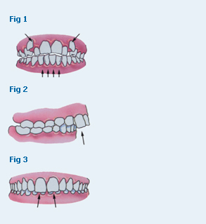
  Orthodontics - Orthodontic problems
  Fig. 1 Crowded or spaced teeth
  A narrow jaw may mean there is insufficient room for the teeth in your mouth, resulting in crowding. Conversely some patients have significant gaps between their teeth.
  Fig.2 Protruding Upper Teeth
  Excessive protrusion of the upper front teeth is one of the most common orthodontic problems, often caused by thumb sucking or the result of a small lower jaw.
  Fig. 3 Deep bite
  Your upper teeth may cover the lower teeth too much, so that the lower teeth are barely visible when you bite together.
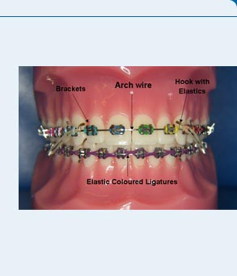

Looking after your brace - Foods to avoid
To prevent breaking your fixed brace you must:
1: Avoid all hard foods such as:
Crusty bread, pizza crust, hard biscuits
Corn chips and other types of hard crisps or popcorn
All nuts unless they are ground
2: Avoid any sweets or sticky foods such as:
Chewing gum, sticky toffee, chewy sweets or boiled sweets
3: Avoid any fizzy drinks, even diet fizzy drinks as these contain alot of acid or excessive amounts of fruit juice as these are also acidic.
4: Avoid biting into any thing with your front teeth as this can dislodge the brackets on the front teeth
Corn on the cob or meat you eat off the bone must be avoided
Biscuits – break into small bits and chewed on your back teeth
Apple –slice thinly and chewed on your back teeth
Raw carrot – should be grated
Nail biting and pen chewing must be avoided
Remember, when a brace is broken your treatment time may increase. Please check daily that your brace is not broken. If it is contact the practice and make an appointment to have it repaired as soon as possible.

 | 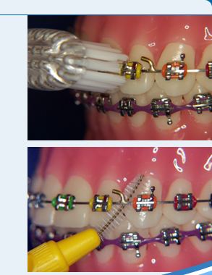
  Looking after your brace - Fixed brace
  Brushing your teeth will take much longer when you have a fixed appliance, as it is more difficult to clean around the brackets. We recommend a number of different techniques and shaped brushes to make it easier. Braces should be cleaned three times a day, after each meal. If this is not possible at lunchtime, then rinse with water and clean your teeth as soon as you can.
  Using an orthodontic tooth brush place the grooves over the bracket and brush back and forth, then brush above the bracket (upper teeth) and below the bracket (lower teeth) at gum level, to ensure the gum remains pink and healthy. After the outer tooth surface has been cleaned continue as normal with the inner surfaces and biting surfaces of all the teeth.
  Using a small interdental brush or Tepe brush, carefully pass under the wire, against the tooth to remove any trapped debris. This should be repeated between every tooth on the upper and lower arch. You will not be able to use conventional floss with fixed braces; however you can use super floss.
 | 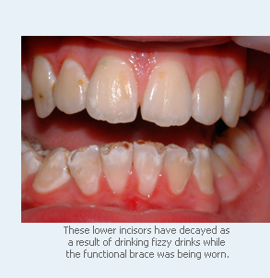
  Looking after your brace - Removables
  Take the braces out and brush your teeth as usual. Before going to bed use a fluoride mouth rinse to help strengthen and protect your teeth. Clean your removable appliance with your toothbrush and cold water.
  A brace cleaner, soaking solution Retainer Brite™ can be used to keep your brace fresh.
  Do not drink eat or drink sugary foods with your braces in as this can lead to tooth decay.

