Changing the map, changing identity: Immigration, language and conflicting ideologies
Eva Eckert
Anglo American University
eva.eckert@aauni.edu, or eeck233@gmail.com
Abstract: Mass migration to the agricultural regions of the U.S. and elsewhere that occurred mostly in the second half of the 19th century created conditions for the formation of cultural enclaves. These enclaves typically flourished for up to three generations before they began to merge with the majority culture. Their speakers exhibited particular attitudes to the home language and nation as well as strategies of maintaining self-identity and defending a parallel linguistic presence. The eventual atrophy of the immigrant language (resulting from cultural marginalization, isolation from the resource culture of the homeland, contact with English or another majority language and the pressures of Americanization) is an expression of assimilation. Sociolinguistically it is manifested in language variation and change affecting the lexicon, grammar, and the range of available styles as well as expansion of one’s social networks. Among the immigrant languages, Czech in Texas represents a particular code of Czech that illustrates these characteristics and outcomes. Tombstone inscriptions in Texas cemeteries map out the layout of the once prosperous enclave and represent an unusual source of primary written language data. As artifacts of vernacular culture they literally stand for a culture and language that no longer exist. They also attest to the practices of ethnic and religious exclusion, social non-integration, and economic non-cooperation that is a survival strategy by social autarchy.

Keywords: cemetery inscription, identity, ideology, immigration, language contact
1 Introduction: Languages, maps, and identities
Mass migration to the agricultural regions of the U.S., South America, Russia, and elsewhere occurred mostly during the second half of the 19th century and early 20th century. It created conditions for the formation of stable cultural enclaves established in agricultural settings. Tombstone inscriptions in Texas cemeteries map out the layout of the once prosperous enclaves and represent an unusual source of primary written language data. Among the information revealed through the tombstone inscriptions I focus on those documenting the local policy of non-integration practiced by Czech Moravians immigrating to Texas between 1850 and 1920. This de facto practice is evident in the displacement of the Czech language that happened relatively late (mostly from the 1950s on) and fairly quickly. The displacement occurred out of the community rather than within at the time when the community dissipated in the process of a gradual transfer of its members to Texas towns. The program of non-integration that had preceded the transfer is evident, among others, in the paucity of Czech-German and Czech-American narratives of intermarriage, including those engraved into cemetery tombstones.

Wright 2014 explains the interrelationship between maps, groups, and language ideologies noting that our position in a particular setting and in relation to our neighbors determines our self-identity; maps give us a certain view of ourselves as part of larger groups (p. 81). This proposition is relevant to the position and identity of Czechs in the homeland and in Texas. From the center of Europe, Czechs and Moravians migrated to the center of Texas where they joined the German speaking migrants (see also Konecny & Machann, 1993; Rippley, 1994). The territory settled by Moravians is layered over that settled by Germans two decades earlier that, however, extends far beyond the overlap (Baird, 1996 and Gilbert, 1972). The edges and corners of the Moravian land indicate areas into which they moved when the center became congested. While this overlap, illustrated in the map below, left linguistic traces in placenames, it left very few in intermarriages and tombstone inscriptions (only a handful of Czech-German marriages was recorded among the Fayetteville Catholic church records for 1872 to 1896, for instance). The tombstones where the lines of script in Czech alternate with German ones, documented in several town cemeteries such as Industry or Fayetteville, are rare. Modern placenames such as Czech Praha, Moravia, Breslau, Dubina, Rosanky, Roznov or Nechanitz, and German Frederichsburg, Shiner, Ammansville, Frelsburg, Ellinger or Weimar continue to recall the intra-ethnic pattern of settlement, characteristic of the early stages of immigration (see also Praszalowicz 2005). However, the tombstones also illustrate the subsequent stage of Czech-German ethnic disintegration and socio-economic dissociation.
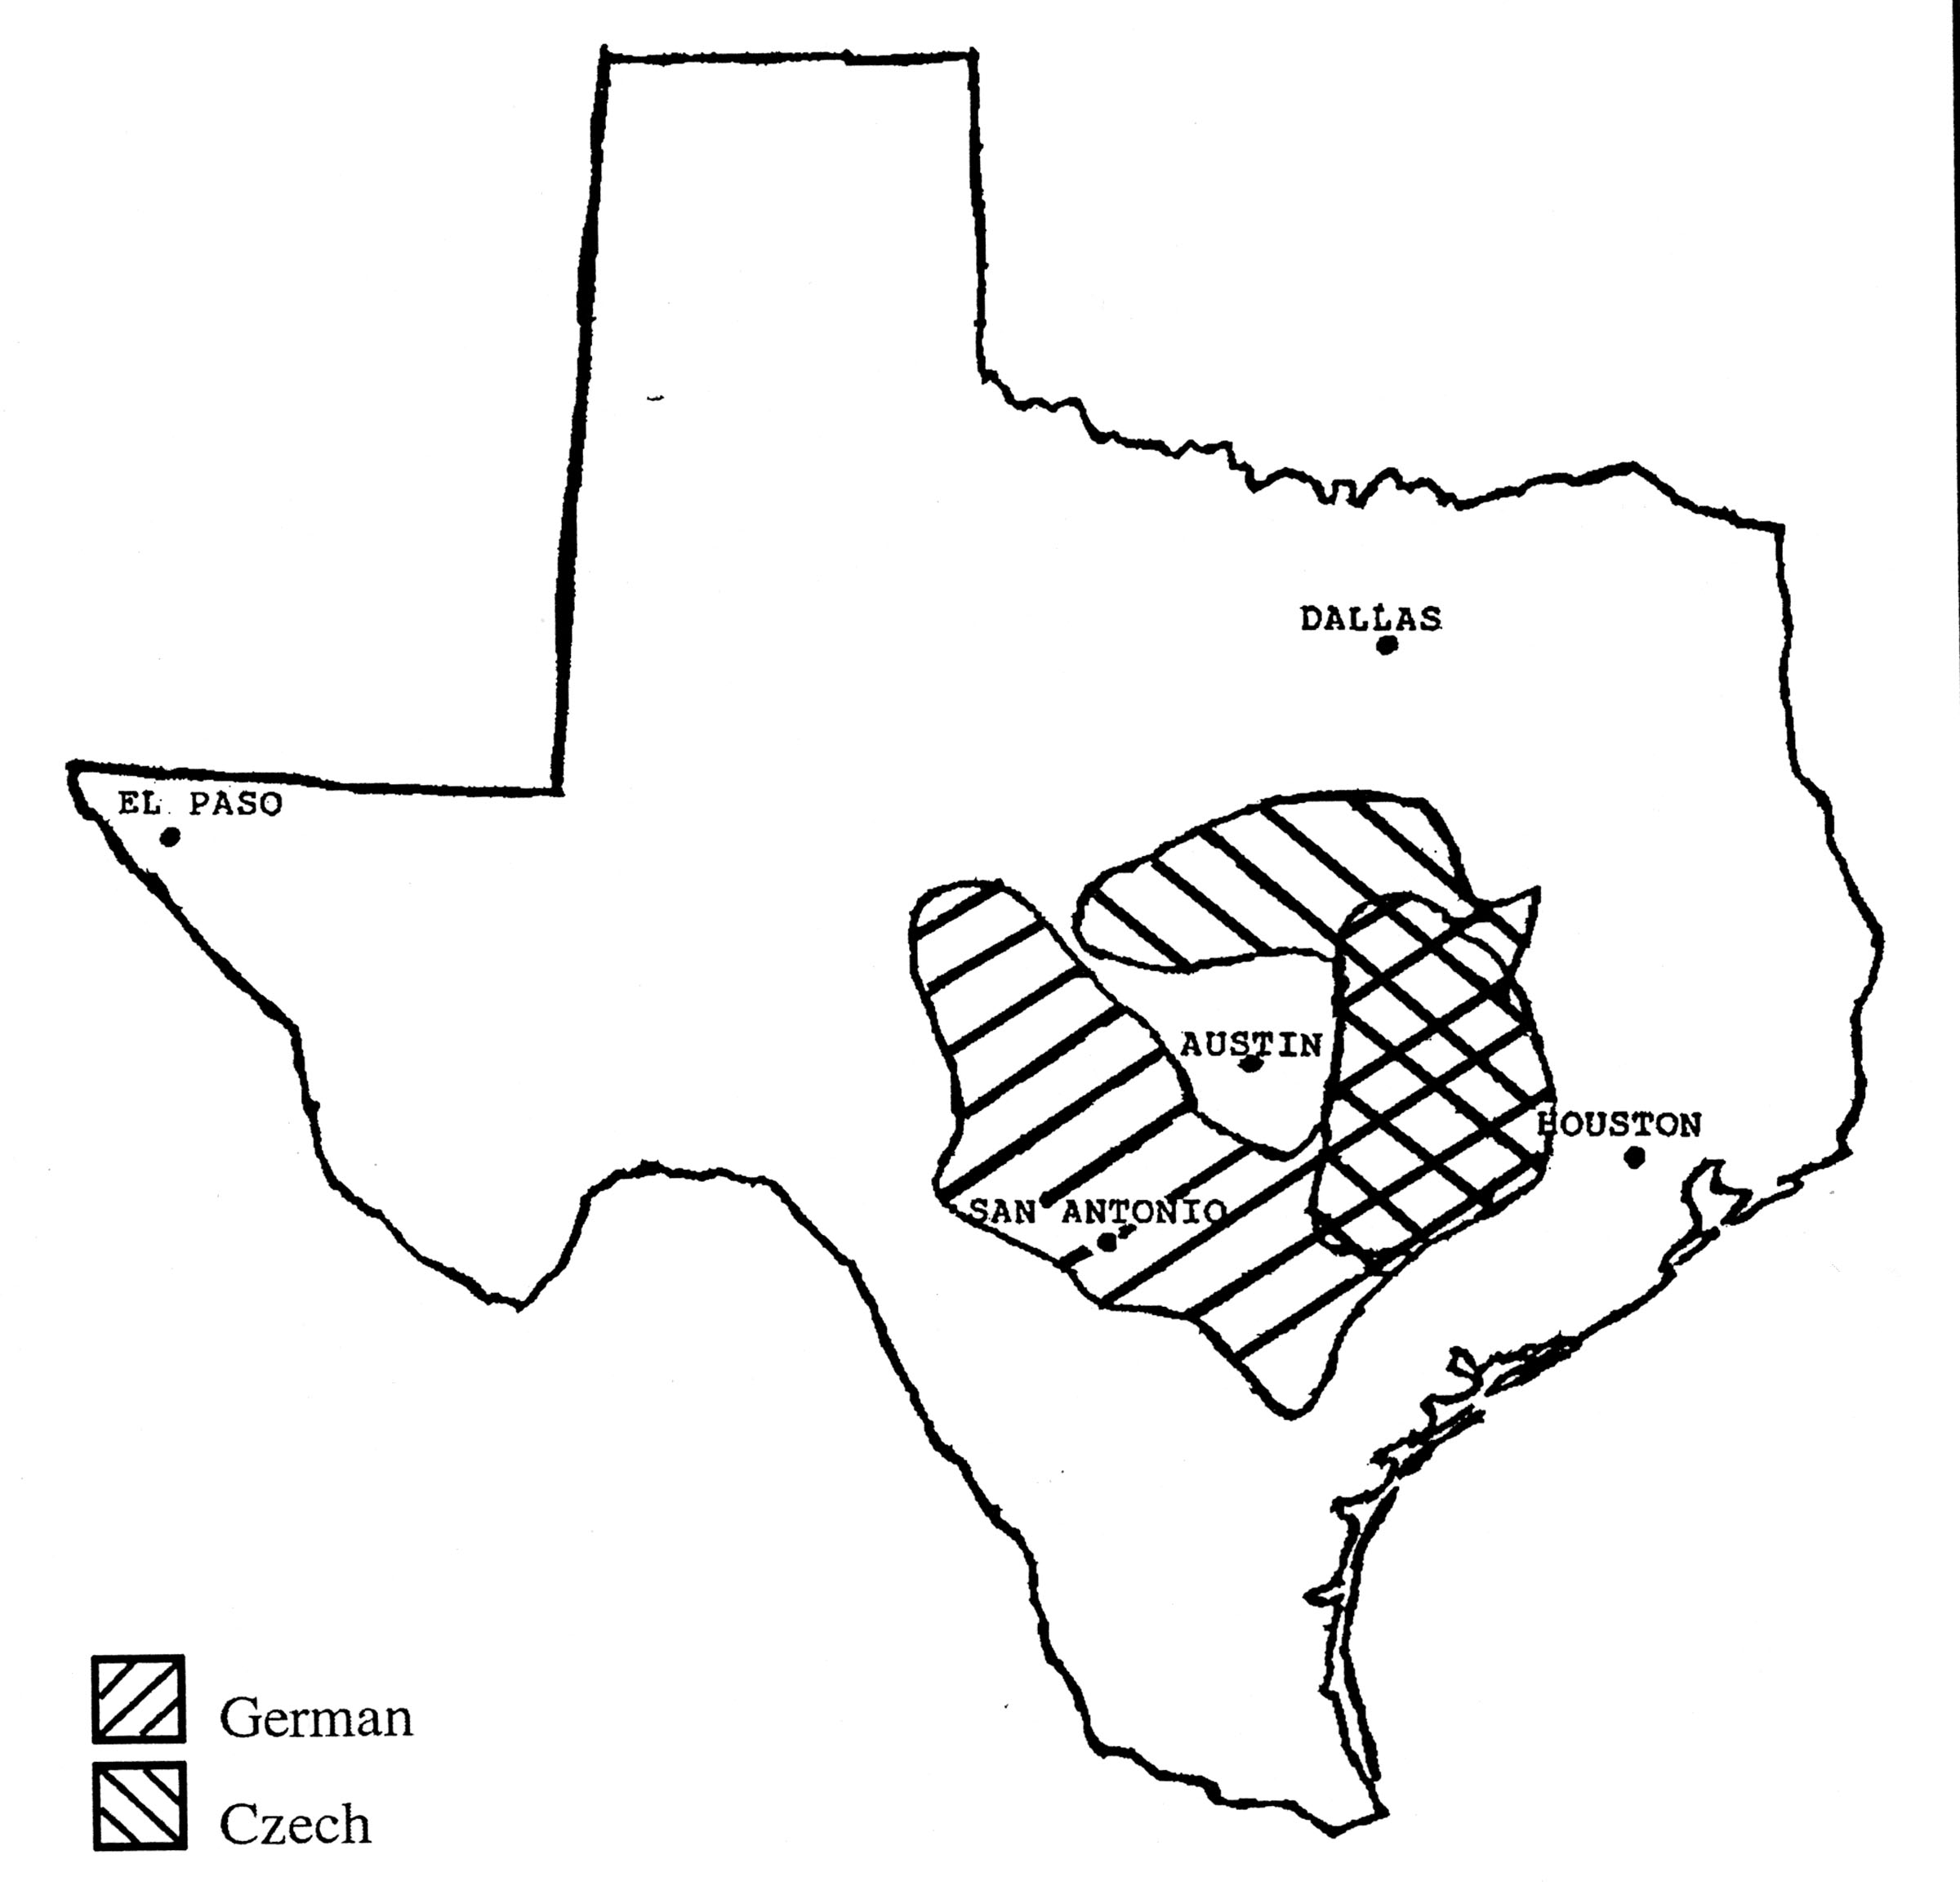
Map 1. Overlapping settlements of Czech and German immigrants. Baird, 1996, 11 (used with permission).
Comparing maps of 1810 with those of subsequent decades reveals a sudden onset of European “civilization” in Texas. Not a single town as known today appears on a Texas map from 1810. In the 1830s the Spanish opened a colony to immigrants in Central Texas, safely shielded from Indian territories, that became a nucleus of European settlement. Further settlements arose along migration trails, around fortifications built for colonizers’ protection and in vicinity of Spanish Catholic missions.
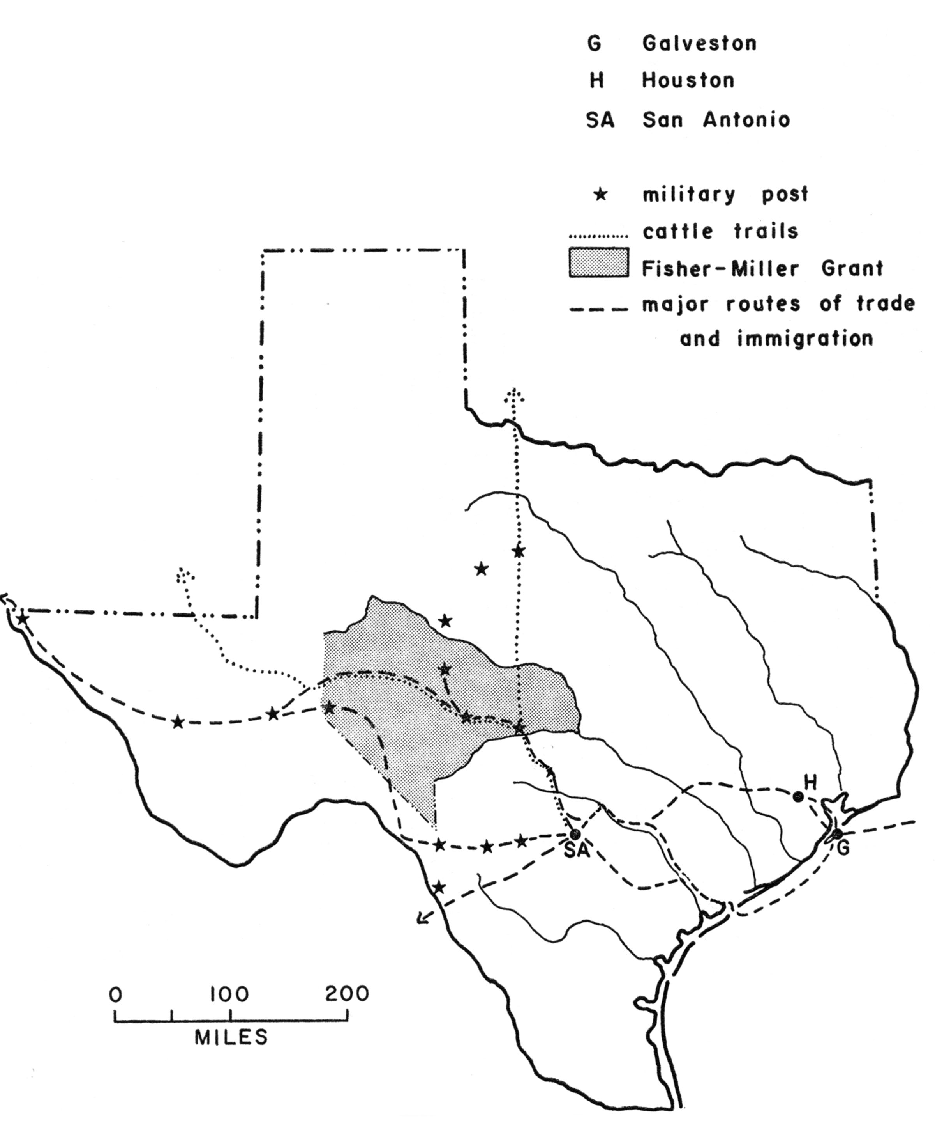

Map 2. Major routes of trade and immigration. Adopted from Jordan, 1966 (used with permission).

The first German settlers came in the 1830s and the 40s, sponsored by the Prussian noblemen’s society seeking out new markets for Germany and supporting its maritime trade. Thousands of immigrants from northern and central Germany were recruited to settle down where Castroville, Fredericksburg, and New Braunfels stand today. The migrant population was diverse in terms of geographical origin, religion and socio-economic status and thus very much unlike that of Czech immigrants, which gave them an integration edge and advantage over Czech settlers. By the 1850s when the very first immigrants from Bohemia and Moravia arrived, the eastern, southern and central regions of the state were sparsely settled by Anglo-Americans and European immigrants primarily from Germany. Unlike Germans, Czechs didn’t establish a single settlement prior to the Civil War, and their earliest grave markers date from the 1860s.
2 Language, distance and cooperation
The triade of language, distance and wealth, and are powerful factors determining migration outcomes and predicting the degree of socio-economic cooperation among communities. The theories of economic geography and its gravity models of spatial interaction account for the practical implementation of this idea. The basic model of economic gravity explains the determining factors of cooperation through the concept of “attractors” and “detractors.” The factors causing mutual attraction are closeness of languages, legal systems, religions or cultural habits. The detractors are represented by the actual geographic distance and various physical and institutional impediments to cooperation. The empirical and quantifiable relevance of these factors has driven research in economic development focused on cooperation. For instance, Egger & Lassmann 2012 claim that a shared language increases cooperation on average by 44%, and Fidrmuc & Fidrmuc 2014 estimated that learning the partner’s language can boost cooperation by 30-60%. However, the gains achieved through attractors can be curtailed if the detractors of linguistic, cultural, economic or social distance dominate.
Thus, the proximity of the Czech and German communities in Texas, higher income per capita in the German communities, and Czechs’ proficiency in German would imply that the Czech community benefitted from socio-economic attraction, and the negative role of geographic distance was small. In theory, Czechs and Germans in Texas were bound to cooperate. In contrast, the potential for the Czech-American cooperation would be much weaker. Had the Czech community taken advantage of the favorable attractors, its socio-economic development and social integration could have been considerably faster.
In Texas Czech immigrants positioned themselves well inland, in the immediate neighborhood of German speakers and on the relatively fertile blackland ideal for the purpose of intensive farming (Kulhavy, 2000). Despite geographical proximity and Czech Moravians’ familiarity with German as the school-imposed and the official administrative language, the distance of Czechs from Germans was perceived in both communities as culturally, socially, and economically immense (see also Hannan 1993, Jeleček 2002). This finding, confirmed by tombstone data on kinship and also by ethnic press, is unexpected. Also, maintenance of the distance appears counter-productive to the mutual benefit of socioeconomic cooperation yielding advancement and stability.
These factors indicate that the Czech immigrants pursued not only economic success, which implied ownership of fertile land, but also the vision of freedom and independence. They yearned to free themselves from German sociopolitical dominance, military service and economic bondage to their overlords they had experienced in Moravia. Texas represented their chance of independence so that they could realize their nationalistic aspirations and those of exclusive land ownership (see also Řepa 2003). Although the factor of religious freedom was of an utmost relevance to Moravian Brethren, for Moravian Catholics an unrestrained practice of religious faith seemed self-evident. However, this expectation collided in Texas with the Protestant majority (of mostly Anglo-American Baptists and Methodists, and German Lutherans. The immigrants transferred to Texas the essential aspects of their European identity characterizing them in terms of ethnicity, religious faith, and agricultural setting (see also Anderson 1993). Unlike the national self-confidence of German speaking immigrants related to German Confederation at home, that of Moravian immigrants was constructed only in Texas within a new community representing the homeland. It may seem as a paradox, that they did not acquire an American identity until the time they left their community in the second half of the 20th century.
The immigrants have not advanced further out from central Texas until the end of the 19th century when the soil to farm was all used up in the nucleus location. In the 1860s through the 1890s they chose to settle within other immigrants from the Czech homeland in order to reinforce the practices of collective farming and sharing, and the religious and cultural habits (see Kulhavy 2000 for relevant maps). With time, they perceived certain geographical spaces in Texas as well and, at that time, they clarified their boundaries with respect to German speakers, Americans as well as Czechs living in the neighboring states. In Texas they endowed the Czech space with a particular ideology of language, land, and nationhood. They emphasized intentional cultivation of the home language through engagement of community members in amateur theater and opera, local Czech press, religious practices and music bands. Traditional values attached to language, culture, and religion served to exclude German and English speakers, and prolong non-integration of their community.
3 The politics of non-integration
In sum, the trade-off between cultural sustainability and economic prosperity was biased in favor of the former. A powerful detractor delaying Moravians’ integration into the American culture was not knowing English, and perceiving the cultural, religious, and economic distance between them and the Americans as a chasm. But that they distanced themselves from German speakers in Texas is not readily comprehensible. Language familiarity is a critical factor inducing integration and cooperation, and most Czechs from Moravia were familiar with German, which could have served as an early bridge for them into the American space. However, in the Moravian homeland Germans and Austrians were economically in the position of over-lords entitled to an upper social status, access to which was closed off for the Moravian village population of the emigration regions. Social status of subordination thus served as the detractor of cooperation, and remained powerful even in Texas where the social and economic distance automatically decreased; Texas was well established by then as a land characterized by democracy and free-trade capitalism.
The refusal to associate with Germans was a powerful obstacle that prevented ethnic cooperation in Texas. This distance grew even larger through mutual unwillingness to acknowledge different religious affiliations, i.e., mostly Lutheran among the Germans and Catholic or Brethren among the Moravians. When the Moravians finally established their own parallel institutions they did so emphatically through national and religious attachments. Nationalistic attitudes and religious affiliation formed boundaries of the community and determined the shape of individuals’ social networks (Milroy 1987, Milroy & Gordon 2008). They also served as the factors rationalizing an explicit self-exclusion from potential local and statewide networks of economic cooperation. The situation did not change until external factors of historical events (such as World War Two), infrastructure of roads and attractions of the city life (such as to study and develop professionally) became viable options attracting immigrant descendants away from the community. These lowered the geographic barriers distance, which motivated the younger generation to change the strategy and enter the Anglo-American community in Texas cities.
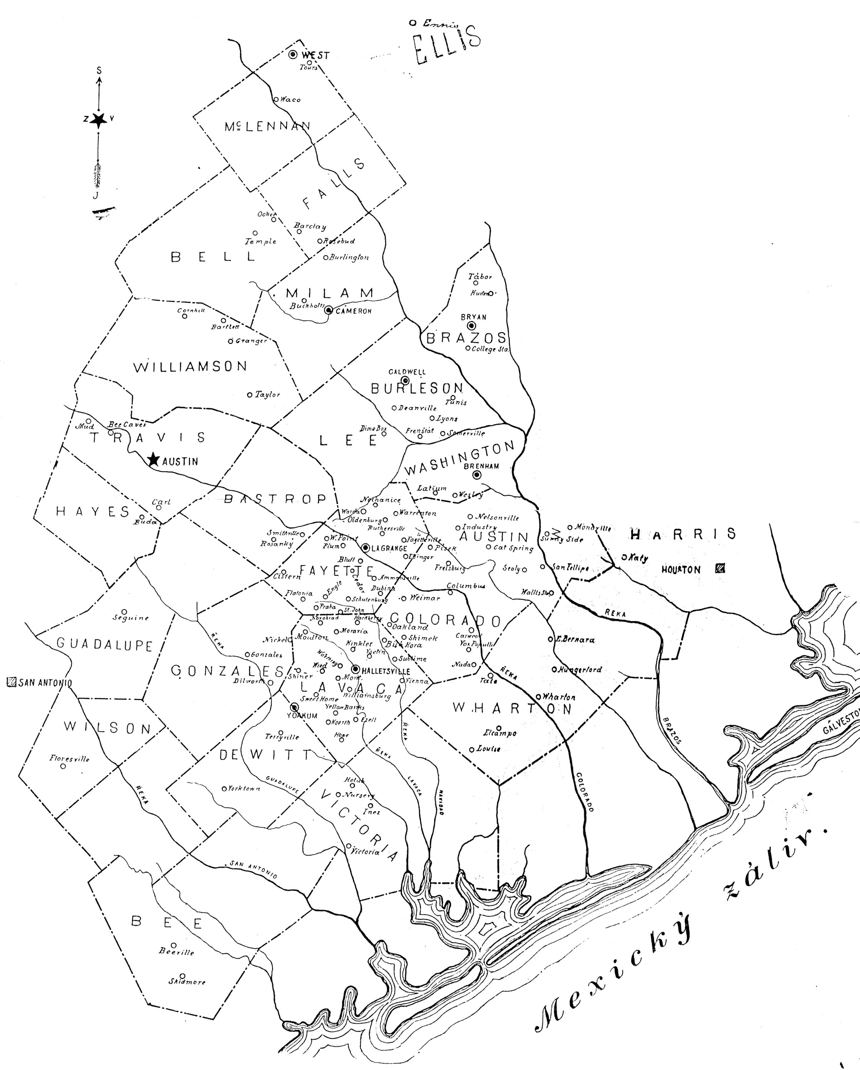
Map 3. Texas counties with most Czech and German settlements. Habenicht, 1911, n.p.
4 Changing the maps and creating a speech community
Czech reached Texas through the Moravian dialects that led rather insular lives within their respective isoglosses of rural regions of northeastern Moravia until they came into daily contact in central Texas. Despite a presupposition of regional and ethnic homogeneity, the Moravian immigrants shared neither a dialect nor an ethnic identity although they came from neighboring regions in Moravia. Their identity was local and related to regional dialects, dress, and traditions until the Czech national revival reached into Moravia in the late 19th century (Eckert, 2003). For that reason and to be able to form a well collaborating community in Texas, the immigrants first had to come to terms with their national identity. The designation “Texas Czechs” refers to Moravian ethnic groups unified in Texas through the shared landscape within which they formed a single speech community. They agreed upon being unified not only through the agricultural setting but also their respect for standard literary Czech that had been elevated in Bohemia to the status of national language already by the middle of the 19th century. Culturally they were aligned much more closely with the distant Moravia in Europe than with the American cultural progress before the World War I. Their “wealth” was used to attract more migrants (and their labor) from Moravia rather than to benefit from the capital abundant in the U.S.. This strategy tied the Moravians to intensive farming (in contrast to extensive farming of the Texas cowboys that was more capital-intensive).
The Moravians were moving into Texas by large groups drawing from particular homeland villages. For instance, 10% of the population of the village of Mniší emigrated already before the Civil War and almost 25% came from Mniší by 1900, which depleted its population down to mere 454 individuals in 1900. Twenty-five percent population (i.e., 1,422 individuals) emigrated from the nearby town of Frenštát by 1914. Similar proportions have been recorded for the villages of Bordovice, Tichá, Vlčovice and others (Šimíček, 1996: 36, 87-89, and Šimíček, 1999a). The settlement pattern in Texas was shaped by massive population transfers and as a result that as many as two hundred and twenty Moravian families lived in the town of Fayetteville by 1904. Hostyn counted fifty families already in 1869 and one hundred and fifteen families in 1939 (Naše dějiny, 1939: 243-253). The town of Ellinger had one thousand and two hundred mostly Moravian inhabitants by 1890 although it was established by German immigrants thirty years earlier. In 1858 German Lutherans established High Hill into which Moravian families immigrated already in 1860 (Lotto 1902, Fayette County, 1996: 67). Moravian immigrants gradually expanded out from their original locus by adding land to their property rather than subdividing it when they were in need of sharing the land within the family.
5 Mapping Czech onto the ideological space of the American nation
At the time of their arrival immigrants became targets of the Know Nothing movement of Protestant nativism active throughout the 19th century and directed mainly against Catholics (Daniels, 1997: vii-viii). By the end of the 19th century specific actions were directed against speaking and teaching foreign languages, in particular German that was most visible and as if representative of the foreign languages in the U.S., (in particular in states such as Pennsylvania, Iowa, Nebraska, Texas, et al.). Teachers of German, German parochial schools and German speakers per se experienced accusations and attacks since speaking foreign languages was considered anti-American and disloyal. For instance, in Nebraska a German teacher was tried in 1919 for teaching German to a minor (below 14 years of age), which was considered a particularly vulnerable age, detrimental to one’s psychological growth due to exposure to non-American concepts (Leibowitz, 1974). The German immigration peaked in the 1880s while the Czech immigration continued until the 1920s. Towards the end of that period immigration flow experienced a profound conflict with the American ideology of national unity that required English fluency and assimilation for the sake of achieving civic homogeneity understood as the foundation upon which to solidify the American nation. The only language supposedly capable of rendering its unique political concepts was English. The nationality Act of 1906 required aliens seeking naturalization to speak English; the relationship between languages and thought was understood in the folk linguistic theory as deterministic (Mertz, 1982). Texas public schools followed the English-only law since 1918.
The ideology of American English as the exclusive channel of cultural awareness and the road to citizenship was overtly prioritized. Americanization emphasized the pledge of allegiance to the flag, teaching American history and government in English and the restriction on teaching foreign languages. Speaking in a foreign language in public was discouraged. Immigrants became visible and vulnerable. Across the U.S. teaching German was proscribed in all educational institutions and in many states it was prohibited even to speak German in public. In comparison to Germans the numbers of Czechs were insignificant. Yet, it was Czechs who sought to build an ethnocentrically oriented nation within the American national context and whose national awareness peaked in Texas. Americanization of the 1920s conflicted head on with building ethnic nations locally, and with alternative lifestyles of immigrants practicing their traditions in agricultural settings. Leibowitz (1974) notes that The Language Act of 1920 followed recommendations of the Survey Commission directed against foreign language schools in Hawaii that, in sum, accused such schools of putting loyalty to the U.S. in jeopardy through exposure to foreign ways of thinking, behaviors and cultural traditions (1974: 14). At that time, the Department of Education limited foreign language education to one hour a day, and prescribed courses, textbooks as well as teacher qualifications such as the ability to speak, write and read English, and know American history (1974: 24).
Practicing one’s existence in a cultural niche through particular traditions, habits and religion, and sustaining its ethnic and national networks and institutions exposed Moravians in Texas to criticism and mockery, especially for continuing to live in seclusion and not speaking English well. But the fact is that they hardly had to and could have built settlements based on a non-American infrastructure because their non-integration had so far been tolerated. They had their language space delineated, and worshipped God, worked the fields, attended schools, banked, schooled their children and all else necessary to sustain their speech community in Czech. The hysteria directed against Germans didn’t spill over to the Czech community in Texas where the farms kept expanding and farming remained the occupation for a great majority of immigrant descendants even in the interwar years.
As a result of the pressure to mingle and the need to escape notice, German settlers became urbanized already by the turn of the 19th century, as Census reports and cemetery data indicate. This social strategy is documented by the inscriptions. For instance, in the town cemetery at Ellinger sixty percent of inscriptions were in German in the 1880s while the Czech ones accounted for twelve percent. In the 1920s, half of the inscriptions were in Czech but only two percent in German (Janak 1997).

6 Language contact
Language contact is a complex phenomenon whose individual strains, intensity and onset of effect are difficult to disentangle. Languages of immigrants overtly refer to people with whom they have sustained contacts. Immigrant languages thus reveal the imperfect and ordinary state of a language. They model real languages that feed onto lexical and grammatical resources of their neighbors and leak out into them, at the same time. Tombstones in central Texas document Czech immigrants’ language over the period from the 1860s to the 1960s. My inscription data number about two hundred tombstones, divided between Czech, Czech hybrid, and English, collected over thirty or so Czech cemeteries in central Texas rural regions, all marked by a Catholic or a Brethren church. Only with subsequent decades was the periphery of the enclave moved further to the north (where the town of West was established) and other directions as well. Texas Czech thus represents a particular contact language that originated due to the immigrants’ mobility unto a new socio-cultural context.

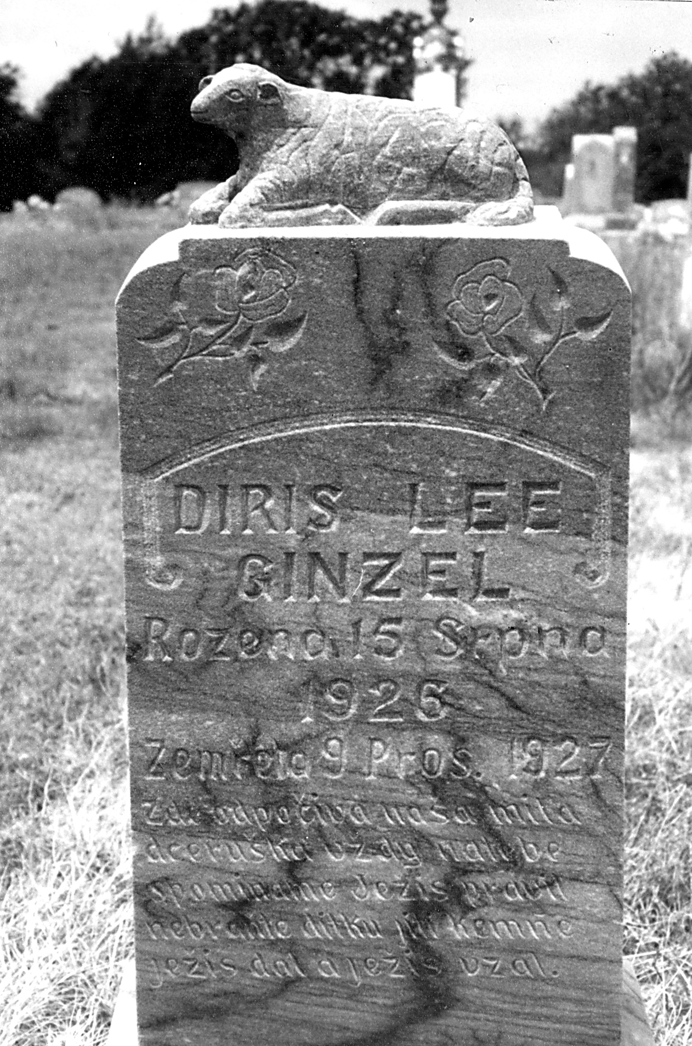

Figure 1. The inscription seems to be entirely in Czech but a closer inspection shows that the dating follows an English (or German convention) convention, and so does the name that does not record the child’s gender by an ending on the last name Ginzel. The standard epitaph contains dialectal features of regional pronunciation, i.e., vocalic shortness, pronominal morphology in naša for naše and phonetic spellings.

The inscriptions that go back to the 1860s spread over the Texas Czech territory where they record language contact and shift. The eventual atrophy of the contact language resulted from its cultural marginalization, isolation, and distance from the resource culture of the homeland, ongoing contact with English and the pressure of assimilation. It is manifested in borrowing words and grammar patterns, language mixing and hybridization, and eventually a shift. Tombstone inscriptions go beyond the ritualistic language one typically encounters in tombstones. Semantic data engraved consist not only of dates, names and epitaphs but also personalized biblical verses and greetings. Vernacular texts and features of Moravian dialects predominate over formal features of standard Czech. Unlike Moravian regional dialects, the immigrants saw Czech as a multifunctional code that gave a shape to their nation, and invested considerable resources into cultivating formal Czech in immigrant press, in teaching, preaching, and formal speaking. In the inscriptions it is not unusual that formulaic ritualistic openings and closings interlay with dialectal pronunciations retelling biblical verses. However, the narrative content specifying reasons for migration or death, developing kinship in detail and personalizing epitaphs yielded to the vernacular. Even if the style was meant to sustain the ritualistic norm established over several generations for the purpose of venerating ancestors (cf. Cox & Juge, 2010: 8), the vernacular writing embellished the style through idiosyncratically chosen lexical items, oddly positioned diacritic marks, and phonetic spellings.

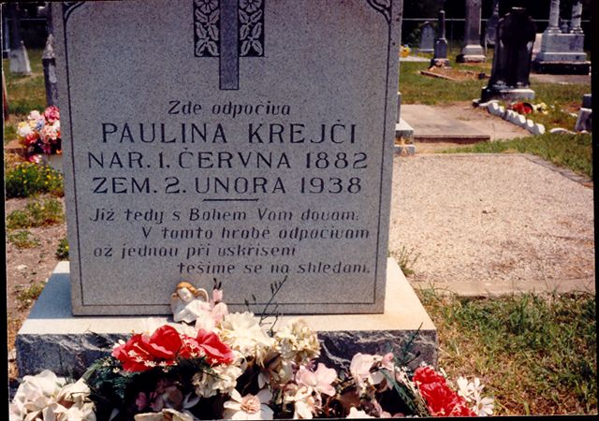

Fig. 2 The inscription excludes almost all the vocalic length markers, which is likely a reflection of dialectal shortness.

The ever-present contact with English is uncontested. Except for the earliest tombstones raised from the 1850s to the 1870s, all inscriptions contain traces of English. With an exception of a couple of tombstones engraved fully in English in the 1960s (and there were many more from the subsequent decades), they were inscribed in Czech with English lexical and grammatical patterns mixed in. They also revealed the intention of recording Czech ethnicity. Their authors seemed to take advantage of stone permanency and visibility to maintain historical memory and continuity of Czech cultural identity. Once the immigrant quota took hold and immigrants stopped arriving, the only innovation in the immigrants’ language happened through English. Czech showed stable internal variation rather than gradual attrition until the 1930s on average. It was only in the 1920s that Czech ceased renewing itself through authentic Moravian Czech. The Czech hybrid was characterized by lexical borrowings (that were incorporated grammatically to diverse degrees), English morphosyntax of names and dates but Czech syntax in the narrative content. Variation in the inscription language reflected the actual variation among usages of individuals who used English placenames, idioms, locally relevant vocabulary items and administrative phraseology and English to access the domains of law, higher education, and trade that were located outside the Czech community space.
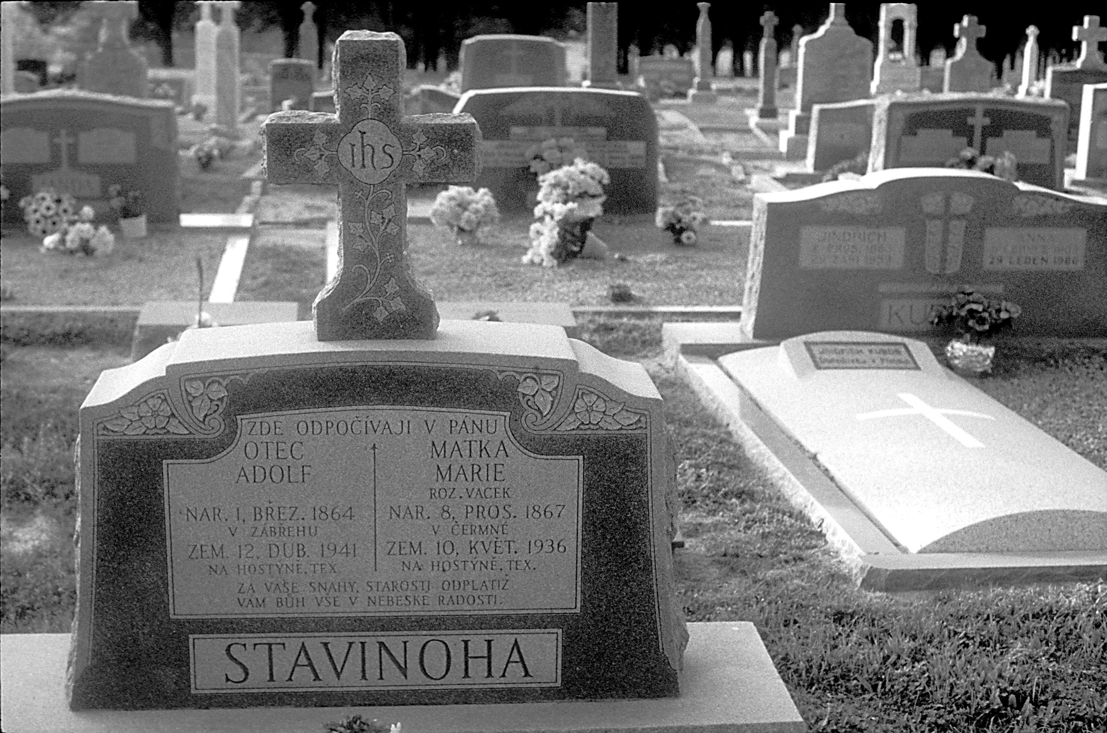
Figure 3. The inscription is in standard Czech and does not stray away from it, and uses all declensional endings correctly. However, the text layout follows an American standard design that arranges the information into parallel texts describing the father and the mother.
The most important breakthrough that came in the 1930s was that those in the productive age started trading farming for city living. Demise of Czech thus happened when immigrant descendants lived in American Texas towns where they found Czech useless and irrelevant. Although their shift to English was detected in the cemetery inscriptions, it happened outside of the rural community (cf. Janak, 1997).
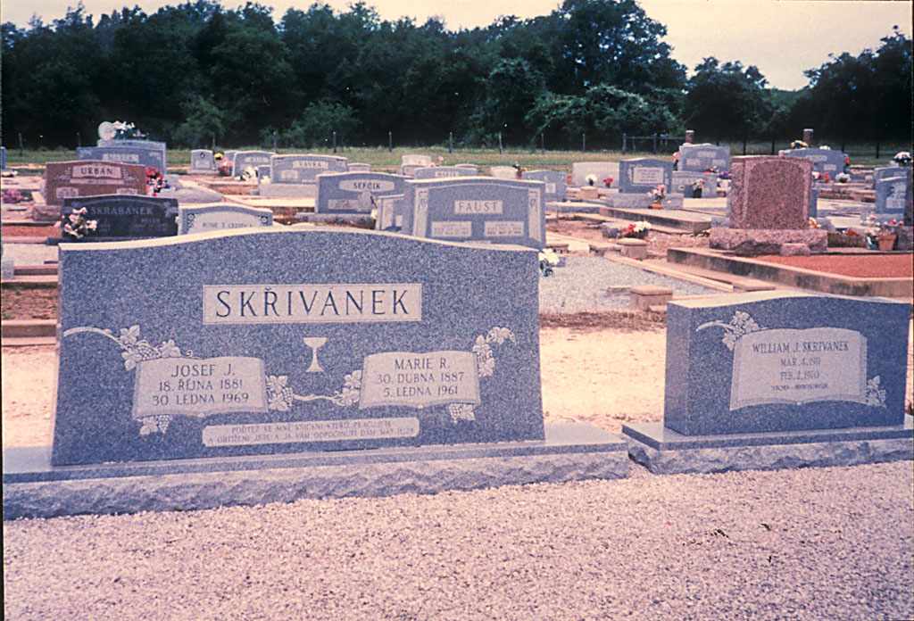
Fig. 4 Minimal text is entered onto this tombstone, engraved in 1961 and 1969. In contrast to the stone on its right, it records all the data in Czech (and places the diacritic signs correctly). The chalice stands for the Moravian Brethren faith.
7 Changing Texas Czech identity: Displacing the language and land
To become “fully American” and benefit from the opportunities opened to rising opulence, immigrants had to give up their social networks and foreign languages, refrain from using them in public and master American political concepts in the process of learning English. Transformation of local Czech identity to American identity, i.e., that from foreign Catholic farmers ignorant of the grand American ideals of democracy, freedom, and individual success to true Americans, happened through the process of required assimilation. Imposition of Americanization and immigrant quota sealed the Czech community in time and space since very few additional immigrants joined it in the 1920s and later (see also Carpenter 1927). Growing ossification of Texas Czech could never be turned back after that. Texas Czech sounded in the settlements for as long as people had worthwhile reasons to remain on their farms. But after WWII and agricultural restructuring of the American South very few did.
The very fact that the Czech immigrants committed themselves to long-term cultivation of Texas land -- and this contribution was acknowledged -- enabled them to be eventually accepted as American citizens. The community finally began to integrate into the Anglo-American spaces, as it was long expected to. When Texas Czechs mostly of the third and fourth generation stopped relating to the space as only theirs and entered the geographical context of American Texas they naturally ceased to maintain the language attached to the Texas Czech space as well.
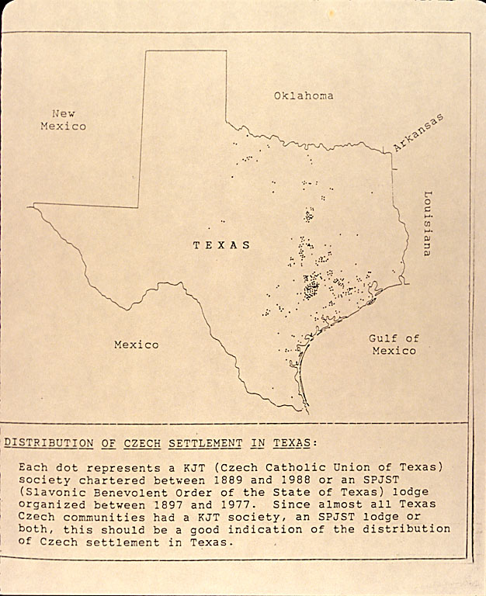
Map 3 Czech settlements with KJT and SPJST lodges. Janak, 1991, 117 (used with permission).
The Texas Czech community was sustained for over a century. The immigrants continued migrating into rural areas in high numbers until after WWI. They remained clustered over a relatively small territory in settlements where they farmed on small lots they passed on to their children. Individuals used their Czechlish up to the middle of the 20th century. Rather than turning bilingual the community used its Czech with English mixed in until the middle of the 20th century when its members were mostly elderly and its life cycle had exhausted. Depopulation of the community went hand in hand with a transformation from Czech monolingualism to English monolingualism that marked true Americans. After WWII the inscriptions were authored or commissioned increasingly by individuals returning occasionally to the settlements to celebrate Czech religious holidays and to bury their parents and grandparents. Their Czech was naturally overpowered by English of their new neighborhoods and social networks to the degree that, as the stones attest, they inscribed Czech texts without understanding their literal meanings. The towns and farms were gradually abandoned since the core of the community consisting of the church, school and farm ceased to function as its adequate support.
Particular features of cemetery texts and tombstones illustrate the ongoing non-integration. The inscriptions demarcate the eventual language shift characterized by an increase of English borrowings, stylistically flat texts and compressed textual content. Tombstones reflect language atrophy and provide a cultural context emblematic of individuals’ integration into American social networks. The descendants’ social networks reaching into the homeland weakened until they became irrelevant. Czech marked the territory and defined the immigrants’ identity in Texas for as long as it was the language of the community. Comparison of the early and late tombstones and texts reveals a turnover in the type of stone from simple limestone to stately marble that affected how long and detailed the inscriptions could have been and who was capable of carving them. Czech dialectal and phonetic texts were replaced by standardized and predictable English texts in which Czech features in spelling, names, and epitaphs occurred irregularly and merely with a symbolic meaning. Inscriptions estimated as authored by fourth-generation descendants suggest that their authors were unable to untie Czech and English in the way they used words and syntactic patterns. Czech and English became fused, and English eventually dominated as the matrix language of the inscriptions (Myers-Scotton 1997) where suffixes marking dates, names, and places were misplaced, grammatical agreement ignored, prepositions omitted, word boundaries obliterated and words decomposed. English phrases were translated literally, and Czech words and even epitaphs transferred from inscription to inscription, regardless their context, with the result of mismatching age, status or gender.
Despite compromises in grammar and spelling, inscription authors seemed obstinate about writing in what they understood to be Czech, motivated by parents’ last wishes and their own image of Czech identity. But they used Czech words, names, diacritics, and suffixes to decorate the stone and to mark Czechness rather than as features integral to Czech grammar. It is impossible to draw a line between the processes of intra-language ossification and the simultaneous external exposure to English, since the 1950s increasingly through the media. Czech migrants’ image of bounded spaces marked by in-depth farming of small fields, churches, and cemeteries gradually dissolved and was replaced by that of unbounded Texas farmland and pasture, English fluency, and American citizenship. They began to enter the global American context and reformulate the mental image they had of their geographical niche (Wright 2014: 91).
In sum, Czechs and Germans in Texas could have cooperated intensively. In contrast, the potential for the Czech-American cooperation was weak from the start. In addition to that, the Czech community in Texas challenged the natural process of integration via intensive cooperation and exchange with the close German neighborhood. They sacrificed their potential economic gains to cultural and religious integrity, and the sense of collective independence. The Czech Anglo-American cooperation evolved at a slow pace and was not used as a substitute for the Czech-German cooperation. The immigrants imposed a new shape onto the land and prairie of the Texas interior, marked out their fields and laid out the cemeteries to root down their existence. Blank maps of the beginning of the 19th century were gradually filled with new toponyms by its end. Over the second half of the 20th century migration out of the agricultural regions changed Texas maps once again. Today the placenames they record on maps refer mostly to cemeteries.

References
Anderson, T. G. (1993), Czech-Catholic cemeteries in East-Central Texas: Material culture and ethnicity in seven rural communities. Material Culture, 25 (3), 1-18.
Baird, S. J. (1992). Language codes in Texas German graveyards. Markers, 9, 217-254.
Baird, S. J. (1996). The Taylor, Texas, City Cemetery: A language community. Markers, 13, 113-141.
Carpenter, N. (1927), Immigrants and their children 1920. A study based on Census Statistics Relative to the Foreign Born as the Native White of Foreign and Mixed Parentage. Census monographs VII. Washington, D.C.: U.S. Government Printing Office.
Cox, G., Giordano, A. & Juge, M. (2010). The geography of language shift: A quantitative cemetery study in the Texas Czech community. Southwestern geographer 14, 3-22.
Daniels, R. (1997). Not like us: Immigrants and ninorities in America, 1890-1924. Chicago: Ivan R. Dee, Inc.
Eckert, E. & Hannan, K. (2009). Vernacular writing and a sociolinguistic change in the Texas Czech community, Journal of Slavic Linguistics, 87-161.
Eckert, E. (2003). Life of a language in emigration: Taking the national revival a step further. American Contributions to the 13th International Congress of Slavists in Ljubljana, 1. Linguistics. Slavica Publishers, 37-50.
Egger, P. & Lassmann A. (2012). The language effect in international trade: A meta-analysis. Economics Letters, 116, 221–224.
Fayette County, Texas Heritage (1996). 1-2. Dallas: Fayette County History Book Committee.
Fehrenbach, T. R. (1968). Lone star: A history of Texas and the Texans. New York: American Legacy Press.
Fidrmuc, J. & Fidrmuc, J. 2014. Foreign languages and trade. CESifo Working Paper Series 4670. http://ssrn.com/abstract=2411407 accessed January 6, 2016.
Gilbert, G. G. (1972). Linguistic atlas of Texas German. Austin/London: University of Texas Press.
Hannan, K. (1993). The language question in nineteenth century Moravia, Czechoslovak and Central European Journal, 11, 116-120.
Janak, R. (1991). Czech Texas and Texas Czechs. Stirpes, 31, 106-119.
Janak, R. (1997). Czech inscriptions on Texas tombstones, n.p., Beaumont, Texas.
Jeleček, L. (2002) Trocha faktografie nikoho nezabije - Češi a čeští Němci do roku 1918 [A few facts won’t hurt anyone – Czechs and Czech Germans until1918]. http://archiv.neviditelnypes.lidovky.cz/clanky/2002/04/20619_78_0_0.html accessed January 12, 2016.
Jordan, T. G. (1966). German seed in Texas soil: Immigrant farmers in 19th century Texas. Austin and London: University of Texas Press.
Konecny, L. H. & Machann, C. (1993). German and Czech immigration to Texas: The Bremen to Galveston route, 1880-1886. Nebraska History, 74 (3-4), 136-141.
Kulhavy, A. (2000). Czech settlements and cemeteries in Texas related to soils. SVU Congress, Tabor. http://svu2000.org/conferences/tabor2010/July1n-6-kulhavy.pdf accessed Jan. 9, 2016.
Leibowitz, A. H. (1974). Language as a Means of Social Control: The United States Experience. Washington, D.C.: ERIC Document ED 093 168, Clearinghouse.
Lotto, F. (1902). Fayette County. Her History and Her People. Schulenburg, Texas: Sticker Stem Press.
Mertz, E. (1982). Whorfian Folk Theory in US Language Law.
http://ccat.sas.upenn.edu/~haroldfs/540/theory/mertz1.html accessed Jan. 8, 2016.
Myers-Scotton, C. (1997) Code-switching. In Coulmas, F. (Ed.), Handbook of sociolinguistics. Oxford-New York: Blackwell, 217-37.
Milroy, L. (1987). Language and social networks. 2nd ed. Oxford: Basil Blackwell.
Milroy, L. & Gordon. M. (2008). The concept of social network. Sociolinguistics: Method and interpretation. Oxford: John Wiley & Sons, 116-133.
Praszałowicz, D. (2005). Old neighbors in the New World. Germans, Jews, Poles and Ruthenians on Manhattan Lower East Side. Przegląd Polonijny 31 (4), 77-92.
Řepa, M. (2003). Hory, věrozvěstové a bodří Moraváci [Hills, prophets and sturdy Moravians]. Dějiny a současnost, 3, 23-26.
Rippley, La V. J. (1994). The ethnic frontier: Rural Germans and the settlement of America. In Walch, T. (Ed.), Immigrant America: European ethnicity in the United States. New York & London: Garland Publishing, Inc., 197-214.
Shepherd, B. (2013). The gravity model of international trade: A user guide. New York: United Nations Publ.
Wright, S. (2014). The map, the group and language ideology. Journal of World Languages 1 (2), 81-98.

The Old San Felipe Trail that connected San Felipe and Bastrop, and stimulated heavy German immigration in the 1830s. Fayetteville was originally settled by Germans with the first Czechs living there in 1854, for more see Fehrenbach (1968).
Germans in Texas benefitted from having participated on conquering the Indian prairie and pushing the American frontier further west.
Policy of the Know Nothing movement was taken on by the American Party in 1854 that proposed a twenty one year minimum stay in the U.S. to qualify for citizenship, national offices being held only by Americans as the “native born citizens”) and restrictions on Catholics or Protestants married to them not being eligible to run for any office.
In 1850 Texas had 213 000 inhabitants, in 1860 it had 604 000 inhabitants and 3050 thousand in 1900, https://en.wikipedia.org/wiki/Demographics_of_Texas. In 1880 2,700 “Bohemians” and 35,000 Germans lived in Texas out of which over 10,000 owned farms and more than half lived in towns (10th Census 1880, Population, v. 1: 847). Twenty years later 23,000 Texas Czechs (who had at least one parent born in Bohemia or Moravia) practiced agriculture and only 120 of them lived in cities larger than 25,000 inhabitants. According to a 1927 report, over 77% “Bohemians and Moravians” were engaged in farming and accounted for 3,2% of the total of American farmers. This proportion was higher than for the English, Scots or Germans (Immigrants and Their Children, 1927: 285). The number of Germans declined between 1900 and 1930 (to 157,000, i.e., 6,5% of the total Texas population, Jordan, 1966: 54). In 1930 49,000 Czechs and more than three times as many Germans lived in Texas (judged by the “country of origin”), out of which 60,000 Germans were urban and 94,000 rural, compared to 6,000 urban and 43,000 rural Czechs (15th U.S. Census, 1930: v. 2, Population).
Such usage contrasts with the polished language of immigrant press that was edited with care to eliminate dialectal pronunciation and lexical items (Eckert & Hannan, 2009).
The texts in immigrant press manifested contact of several language codes, i.e., Moravian dialects, standard Czech, English and German, and it was within the editors’ power to determine the final shape of the printed word and the degree to which these codes were left to interact.
My data on gradual abandonment of traditional Czech settlements come also from immigrant press reporting on priests leaving and schools closing, and from readers’ letters bemoaning instability of families and a lack of intergenerational transfer of Czech language.

