INVITATION

You and your colleagues and friends are cordially invited to the lecture

“Greenland – A Self-governed Country in the Arctic”
by
Ms Tove Søvndahl Gant
Head of Greenland´s Representation in Denmark

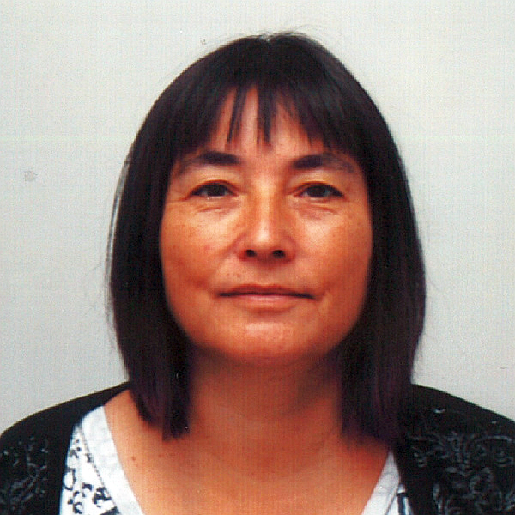

on Tuesday 19 November 2013 at 17.30
at the Faculty of Arts, Charles University
Prague, nám. Jana Palacha 2, 3rd floor, room 319

The Head of Greenland's Representation in Copenhagen, Ms Tove Søvndahl Gant, will present an overview of the process which led to Home Rule and later to Self-government in Greenland, while providing a perspective on the opportunities and challenges of exercising self-determination. The presentation will also include accounts of Greenland's contribution to promoting the rights and issues
of indigenous peoples.

